Sale Programs
Before you Start

- Creating or printing a sale program is part of the Sale Order process. Before being included in a Sale Order, entries must be marked with Sale Participation = Auction. If you use placings to determine your sale order, results must also be entered. If no entries are marked for sale, the Sale Order will save, but will not show any entries.
- Each Sale Order comes with a pre-configured Custom Sale Program that includes the fields on the Standard Reports Sale Program (Sale #, Exh/Class/Awards, Entry #, Club/Parents/City, Animal ID, Check-in Weight, Floor Price/lb, Floor Price, Bid Price, Buyers). Those can be edited to change the fields included, or to print landscape if needed.
- Both Custom and Standard Sale Programs can be printed from the Sale Order screen, or the Standard Sale Program (without any edits made in the Sale Order) can be printed from Standard Reports.
- For more information about setting up Sale Orders, please see the Help Desk article Sale Order.
- Click on the Sale menu.  - Select the Order tab.  - Create a new sale order, or click Edit beside a sale order that is already created.  - The standard pre-formatted sale program contains 10 fields (Sale #, Exh/Class/Awards, Entry #, Club/Parents/City, Animal ID, Check-in Weight, Floor Price/lb, Floor Price, Bid Price, Buyers) and is shown below Step 10.  - To customize the sale program, click Edit in the Custom Sale Program box. |  | 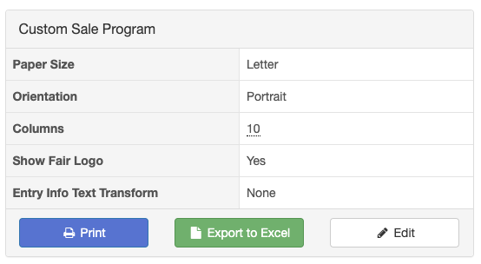
- Your options include:  - Paper size and orientation  - Whether or not to print your fair logo (from Setup>>Fair Details) at the top of the page.  - To use all upper case, lower case, or title case. (“None” leaves the text as it was entered.)  - Which columns (and the order of columns) to include in your program. Remove the standard fields by using the red X, and add fields by choosing them from the drop-down, then be sure to click Add Column. |  | 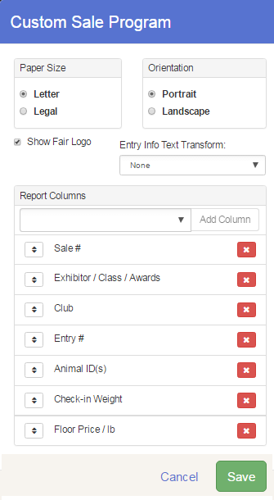
- Available fields for custom sale programs: Those shown with an asterisk are the ones on the standard Sale Program. Most of the Sale fields are more useful for reports printed after the sale is complete, because they will be blank until bid information is recorded.
Exhibitor Info  - Address (Full)  - Address (Line 1)  - Address (Line 2)  - City  - Club  - Club/Parents/City*  - County  - Exhibitor  - Exhibitor #  - Exhibitor/Class/Awards*  - Exhibitor and Grade  - Exhibitor Type  - Parent Names  - Postal Code  - State | Entry Info  - Animal ID(s)*  - Award(s)  - Check-in Weight*  - Department Division  - Entry #*  - Placing(s)  - Ribbon(s)  - Show Class |  | Sale Info  - Add-ons  - Add-ons with Amounts  - Bid Price*  - Bid Price/lb  - Buyers*  - Buyers with amounts  - Floor Price*  - Floor Price/lb*  - Sale #*  - Sale Weight
- After you have made your selections, click Save.  - You have options for printing the Sale Program:  - Print – brings up a PDF (Custom Sale Program) ready to print, using whatever fields are selected. The columns will shorten up (and wrap) to accommodate all the fields you selected in step 7.  - Export to Excel – “clean” Excel spreadsheet (Custom Show Program in table format. Each sale entry will be in one row, so that if you need to move an entry/change order, you can do that easily.  - Download As... (PDF)—(Standard sale program, does not include any changes you made to edit the Sale Program). It is the same as using Standard Reports>>Sale>>Sale Program.  - Download As... (Excel) Standard Sale Program as a formatted Excel sheet, with combined cells, etc. |  | 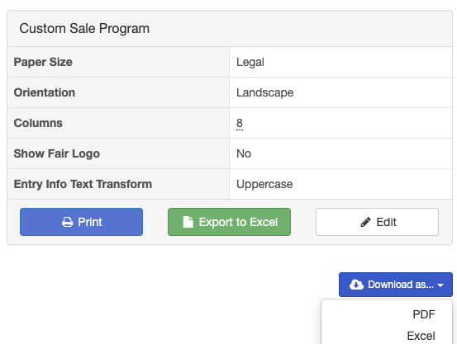
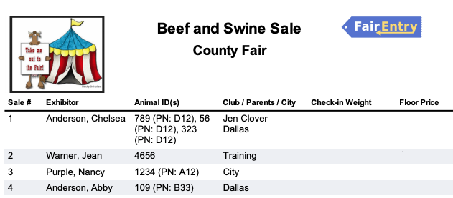
Custom Sale Program using the Print button (with Logo added)

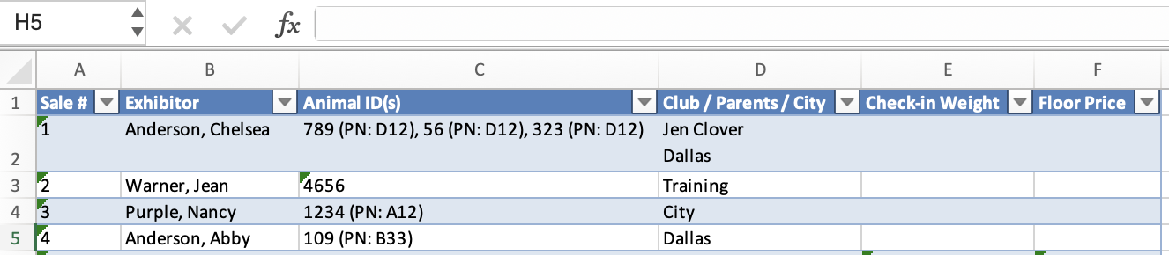
Custom Sale Program Export to Excel
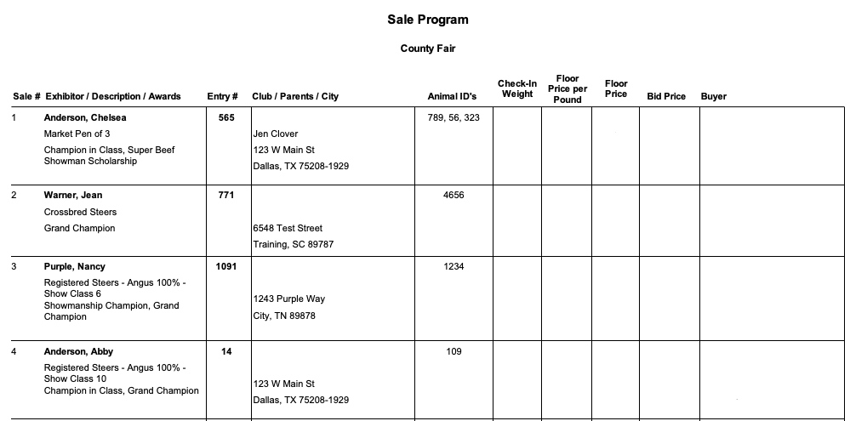
Download As (PDF) and Standard Reports>>Sale>>Show Program (includes standard 10 fields, no custom options).
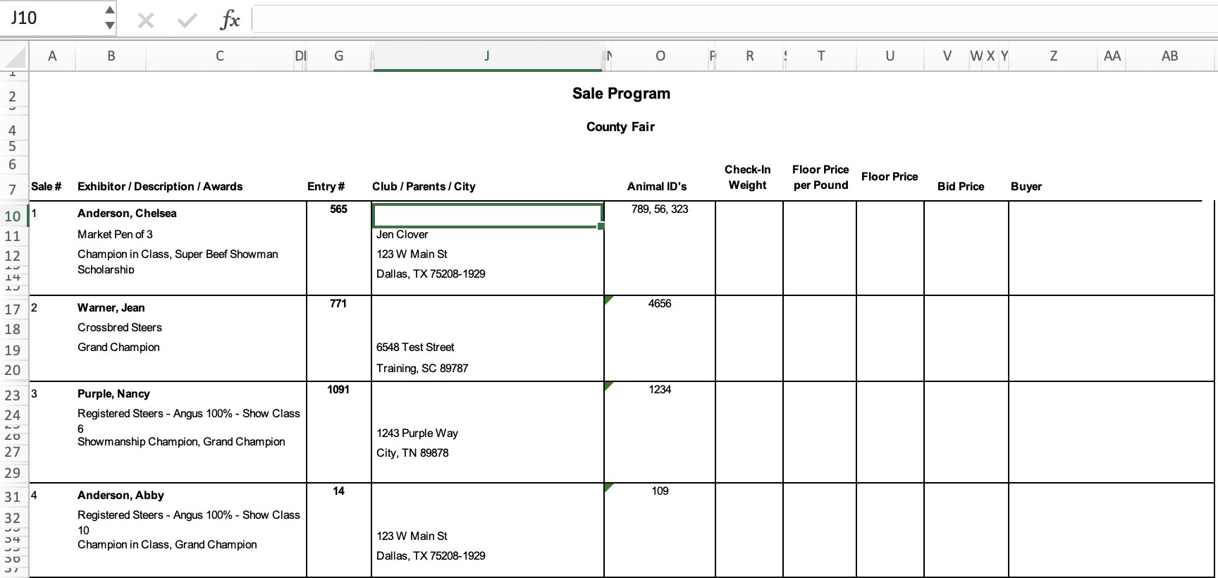
Download as.. Excel or Standard Reports>>Sale>>Sale Program (Excel) creates a spreadsheet, standard fields, with some combined cells and formatting. Each entry can will be spread over multiple rows, and it will not be possible to move the entries into a different order because of the merged cells. You may be able to adjust the width of the columns and/or delete columns, however.

Tips

After the sale is complete, you can export this custom sale program again, and it will include all the sale information. At that time, you can use Excel sorting options to get the information into the order that you need.

Custom Sale Programs are the only custom reports that include some of the fields listed above, which may be useful for more than just the Sale—an example is the combined Exhibitor/Class/Awards field.

