Adding a Range to Premiums
Before You Start

If you pay premiums based on the size of the class, you can set up a range to automatically calculate that for you, whether you use straight-dollar or sliding scale (points) calculations.

Steps  - Select the area of the hierarchy that you want to add your range setup, remembering that you want to set it at the highest level possible so the settings will trickle down the hierarchy to the lower levels.  - If there are already settings configured at a higher level, select the “Inherited” dropdown choose “Override”. | 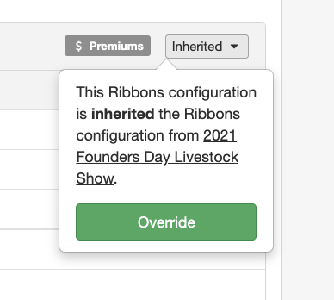
- Select either Premiums or Points. | 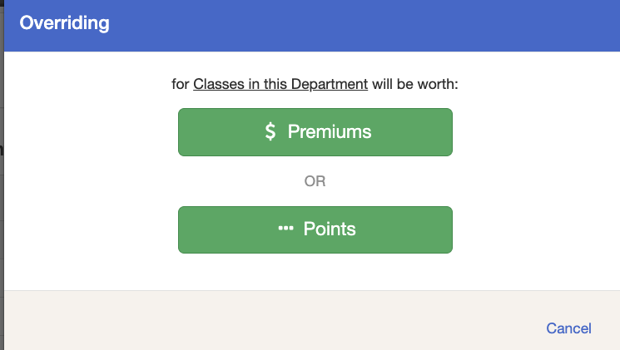
- In the lower right-hand corner, click Edit, then “Add a Range” in the lower left corner. Use that option as many times as you need to get the correct number of ranges for your premiums. | 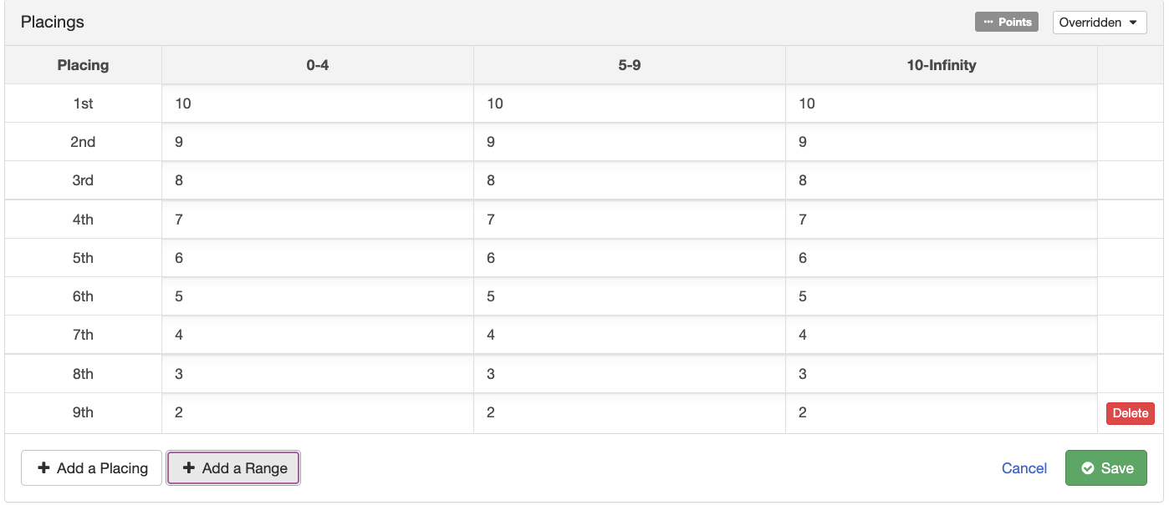
- To edit the ranges from the defaults, click on the top title bar containing the range info. The lower and upper bounds are the number of entries in the class. The lower bound for the first range must be zero, and the upper bound for the last range must be infinity. | 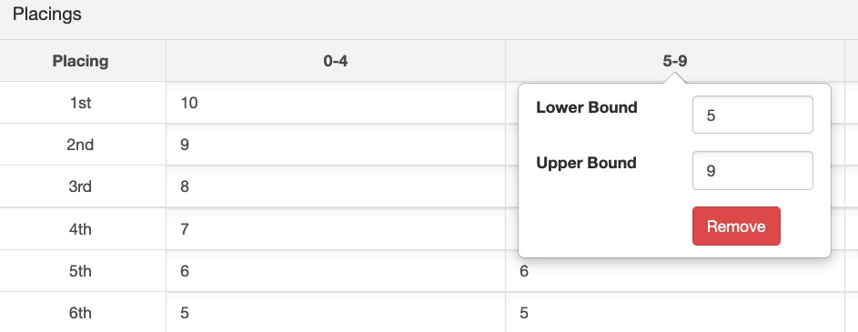
- Set the values for your placings or ribbons for each range.  - Be sure to Save when finished.  - In the example, first place would receive 5 points if there were 0-4 entries in the class, 7 points if there were 5-9 entries in the class, and 9 points if there were 10 or more entries in the class. | 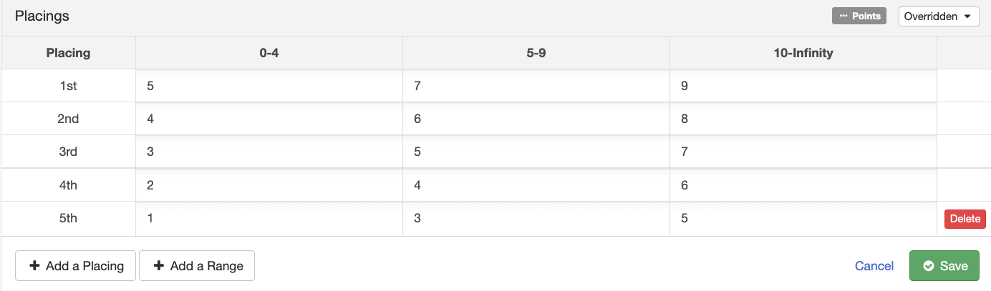
Tips
Ranges can be set up for either ribbons or placings, but not for awards.

