Using Excel PivotTables for Point Totals
Before You Start
Using PivotTables in Excel can help you get quick summaries (counts and totals) of various fields on reports, listed by whatever criteria you need—ribbon color, exhibitor, department, etc. Although the term “PivotTable” is not terribly user-friendly, these are not difficult to create, once you have exported a report containing the correct data to Excel.
The menu bars and options vary slightly between versions of Excel. The screenshots in this document are from Excel for Windows®
**NOTE: If you are summarizing Results data, and using a custom report, you must have finalized your budget(s) before the results fields (ribbon, placing, points, premiums, etc.) will appear on custom reports.
Steps  - Begin by creating a Custom Report that includes (at least) these fields:  - Exhibitor: Exhibitor Number and Exhibitor: Full Name (Last, First)  Including the Exhibitor Number solves any problems that arise if you have 2 exhibitors with the same name; Last, First is for alphabetizing.  - Entry: Entry Number  Including that field solves any problems that might arise if you have an exhibitor with 2 entries into the same class.  - Results: Points  If you have not finalized your Budgets, this field will be blank.  - You may wish to include other fields, depending on how you want the data summarized. For example, if you need the total points for the exhibitor in each department separately, you would include the Entry: Department field.  - If your goal is to summarize points for an animal (typically a horse), you would include the Animal: Animal Name field.  However, there is a higher chance that there are 2 horses named Star than that there are 2 exhibitors named Jeremiah MacKenzie, so we’ll look at a solution for that in steps 15 and 16.  - If you want to limit your summary to a specific portion(s) of the hierarchy, use the Specify Hierachy button.  - Save and Download the Excel file. | 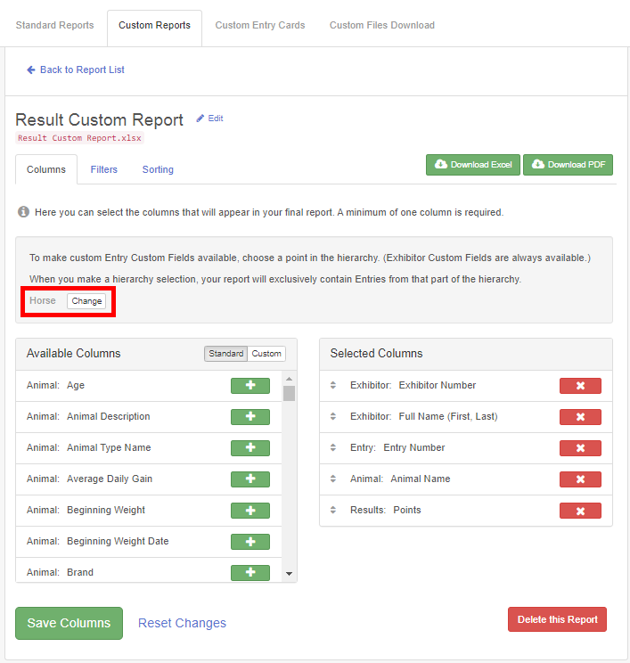
- When you open the workbook in Excel, the Points will be in a text format. Select the column containing those fields then use the Data tab, Text to Columns option (Next, Next, *General-Finish). If it’s not a long list, you can also highlight the first number through the last number in the column, then click on the yellow diamond-shaped icon beside the top entry and “Convert to Number”.  - Notice that the rows in the spreadsheet represent any sets of results entered for an entry--if an entry receives results at both the class level and division level, there are two rows in the spreadsheet for that entry. That ensures that all points are counted, whether they were entered at the class level, division level, or both. | 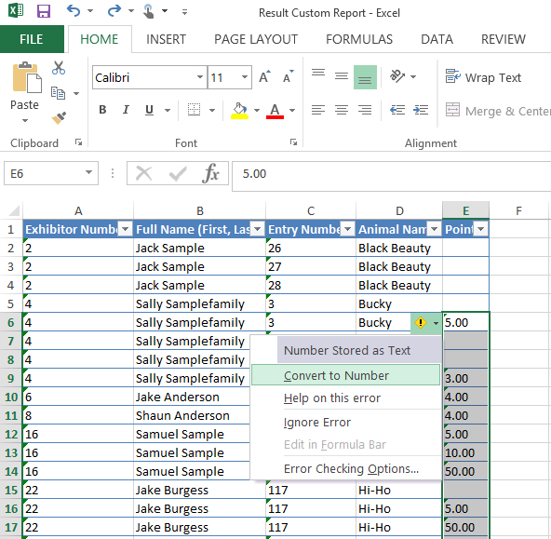
- Use either the Insert tab or the Data tab (depending on the version of Excel that you are using) to find and click on PivotTable. Be sure you do not accidentally choose the PivotChart option instead of PivotTable. | 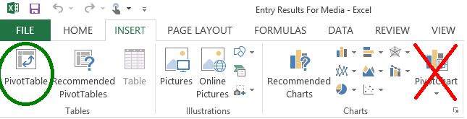
- On the dialog box, be sure that Table1 and New Worksheet are selected as the default options, and click OK. Since you have clicked into the worksheet to change the points to numbers, you may have to enter the Table/Range. You can do that by typing in Table1 (no spaces) or you can click the button at the right of the input box and highlight the cells in the table. | 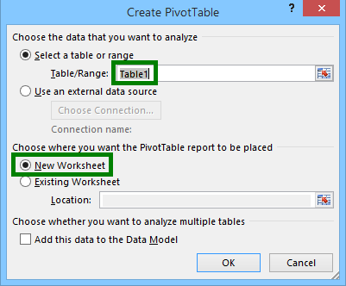
- In the PivotTable builder, scroll through the field list and drag the Exhibitor Name field to the Row box (bottom left).  - Drag the Points field to the Values box (bottom right).  - In the Values box, click on the drop-down arrow beside Points and choose Value Field Settings, then Sum.  Excel Hint: If your PivotTable builder box goes missing, look on your menu bar for PivotTable Tools>>Analyze, and click Field List. | 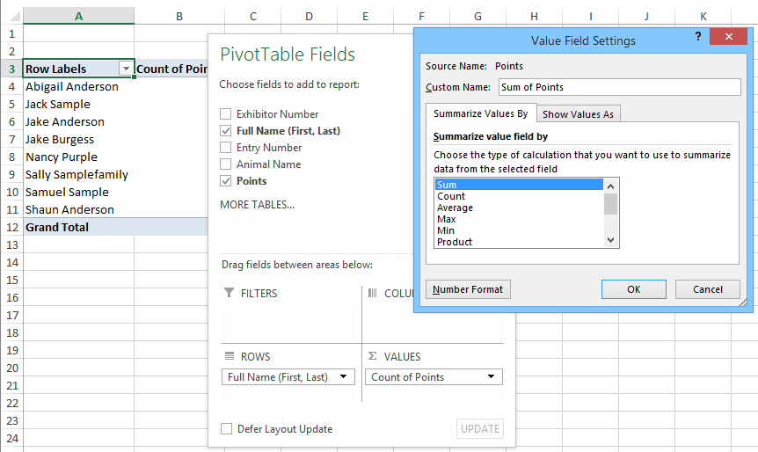
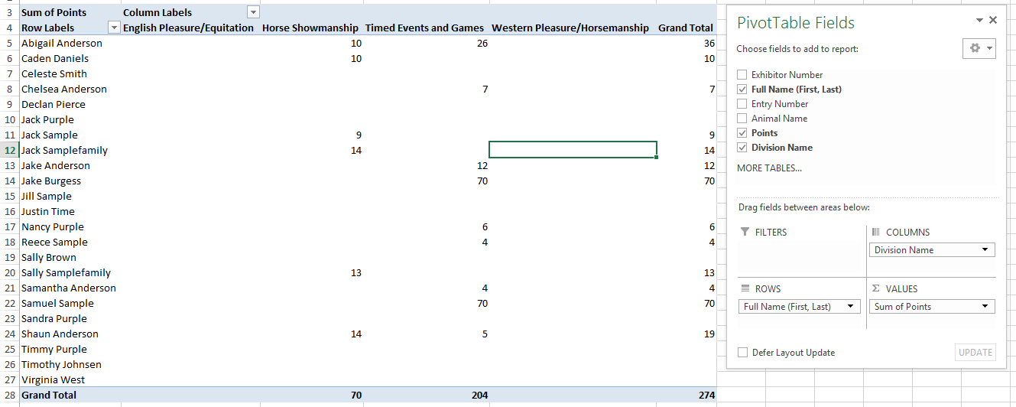
- A Little Fancier—if you would like to have the points separated out by Division--how many points for each exhibitor were awarded in the Halter division, Pleasure & Equitation division, Games division, etc., one option is to drag the Entry: Division field to the Columns box in the Pivot Table builder. This allows you to find the high-point exhibitor for each division, as well as overall.
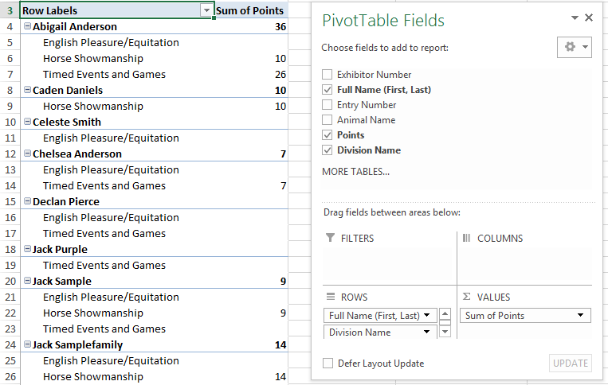
- A Little Fancier, v.2—you can organize the same information just a bit differently by moving the Entry: Division field to the Rows box, below the Exhibitor Name field. This just gives a breakdown of each exhibitor’s total points. Which leads to…

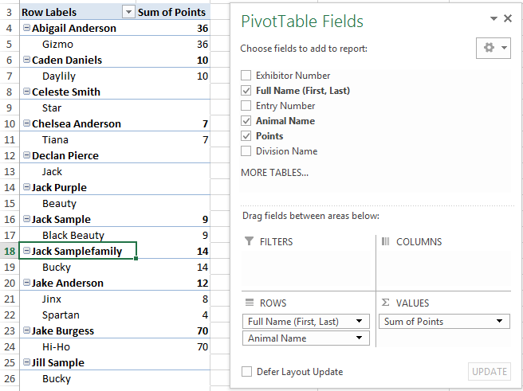
- What about the horses? If you replace the Division Name field in step 14 with the Animal Name, you now have a chart that shows each horse, below their exhibitor, and the points earned by that horse. Having the horses listed below the exhibitor means that you don’t have to worry about two horses named “Star”—they’d each be listed with their exhibitor.
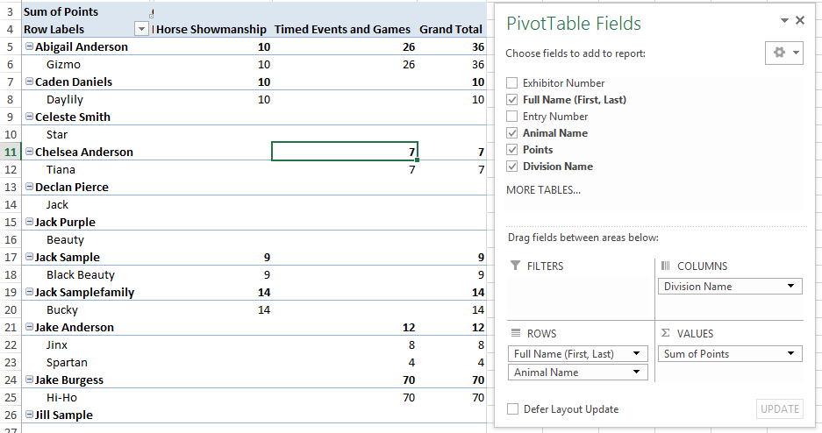
- Just to show there’s never too much of a good thing, here’s an example of how to find the high-point horse for each division separately, combining steps 14 and 16 above. Exh. Name and Animal Name are in the Rows box, Division is in the Columns box, with Points in the Values box.
Tips
Exporting reports to Excel, then creating PivotTables can be a great tool for answering the “How many…” questions that typically come after a fair. Remember that if you plan to use a Custom Report to summarize (count or total) Results or Premiums fields, you can only do that after Budgets are finalized. Those fields will be blank on Custom Reports until then.

