Using Excel PivotTables for Ribbon Counts
Before You Start
Using PivotTables in Excel can help you get quick summaries (counts and totals) of various fields on reports, listed by whatever criteria you need—ribbon color, exhibitor, department, etc. Although the term “PivotTable” is not terribly user-friendly, these are not difficult to create, once you have exported a report containing the correct data to Excel.
The menu bars and options vary slightly between versions of Excel. The screenshots in this document are from Excel for Windows®
**NOTE: If you are summarizing Results data, and using a custom report, you must have finalized your budget(s) before the results fields (ribbon, placing, points, premiums, etc.) will appear on custom reports.
Steps  - For this report, begin by exporting the Standard Report>>Results>>Entry Results for Media report to Excel.  The reason for using this standard report is that it contains ribbon colors, even before the budgets are finalized. | 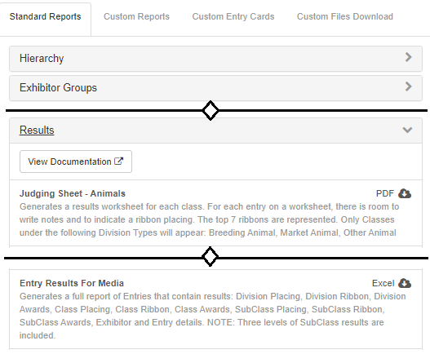
- When you open the file in Excel, use either the Insert tab or the Data tab (depending on the version of Excel that you are using) to find and click on PivotTable. Be sure you do not accidentally choose the PivotChart option instead of PivotTable. | 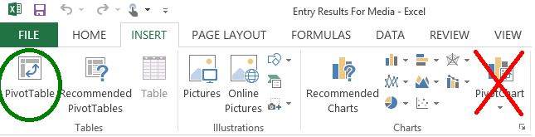
- On the dialog box, be sure that Table1 and New Worksheet are selected as the default options, and click OK. | 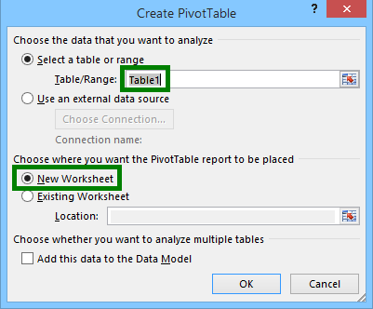
- In the PivotTable builder, scroll through the field list and drag the Class Ribbon field to the Row box (bottom left).  - Drag the Class Ribbon field to the Values box as well (bottom right).  - In the Values box, the function should default to “Count”. If it does not, click on the drop-down arrow and choose Value Field Settings, then Count. | 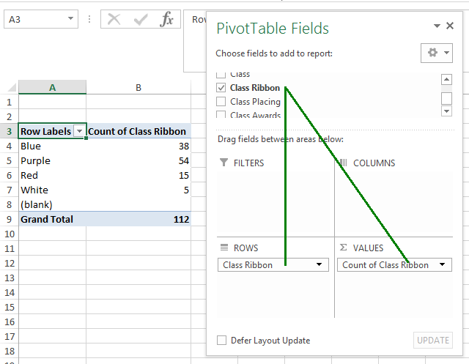
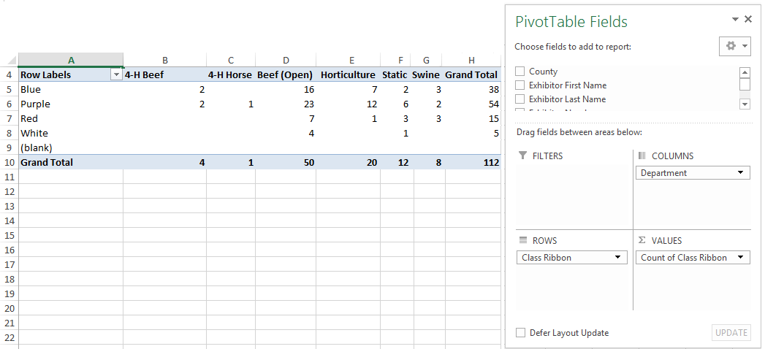
- A Little Fancier--if you need your ribbon count broken down by Department, drag the Department field into the Columns box on the PivotTable builder (top right box). Then your departments will be listed in separate columns, with the grand total ribbons for each department at the bottom, and total ribbons of each color at the right.

Tips
Exporting reports to Excel, then creating PivotTables can be a great tool for answering the “How many…” questions that typically come after a fair. Remember that if you plan to use a Custom Report to summarize (count or total) Results or Premiums fields, you can only do that after Budgets are finalized. Those fields will be blank on Custom Reports until then.

