Assigning Credit Card Fees to Buyers
Before You Start
For Fairs with auctions, credit card fees can be a burdensome expense item, but more and more buyers prefer using credit cards instead of checks or cash. Transferring the credit card fees to the purchaser allows the Fair to offer that convenience, without incurring additional expense. Only purchasers who choose to use credit cards will be charged the fee.

Steps  - Select the Setup menu, then the Fair Details tab. There are 3 options below the Start and End date of the fair. Select Yes on “Recover Buyer Fees” to have credit card processing fees added to buyers’ statements.  - If you have not previously accepted credit card payments at your fair, go to the Setup/Payment Integration tab, click Connect with Stripe, and enter your information for the account. | 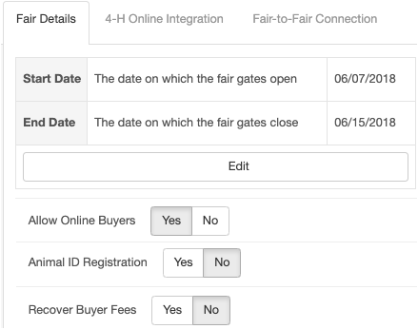
- Buyer logs in and pays online: When your buyers log in to pay with their credit card, they will see the processing fee as a separate line item, added to the total amount of their bids and/or add-ons. | 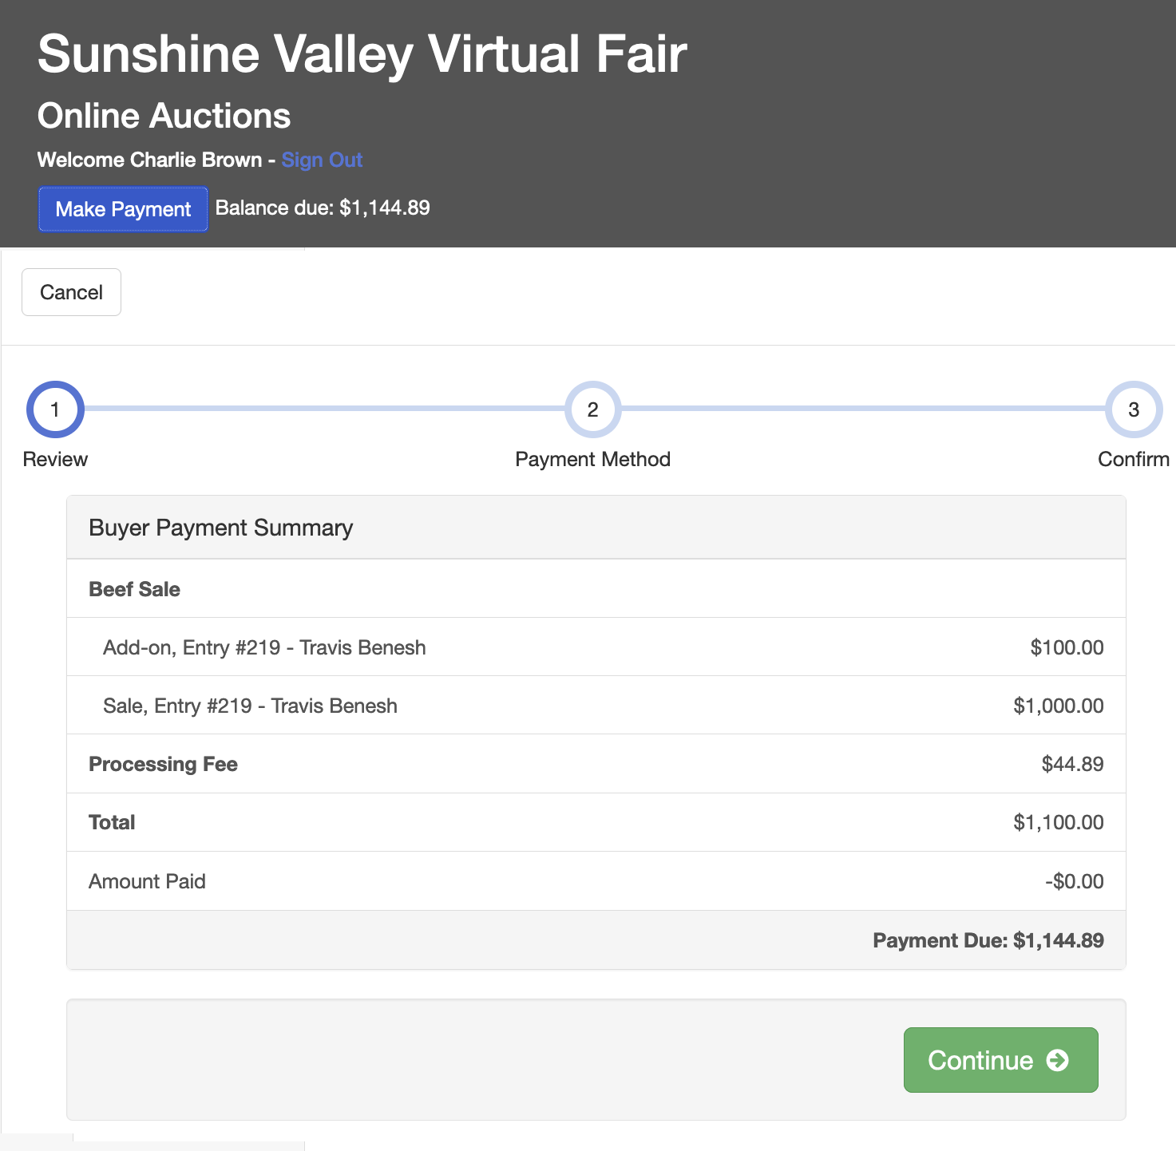

- After selecting the payment method, the final screen displays the total payment, including the processing fee, as well as the check-out Terms message that is set for your fair. After the buyer clicks Submit, their card will be charged that amount, and they will receive an email receipt at the email address they used to log in. | 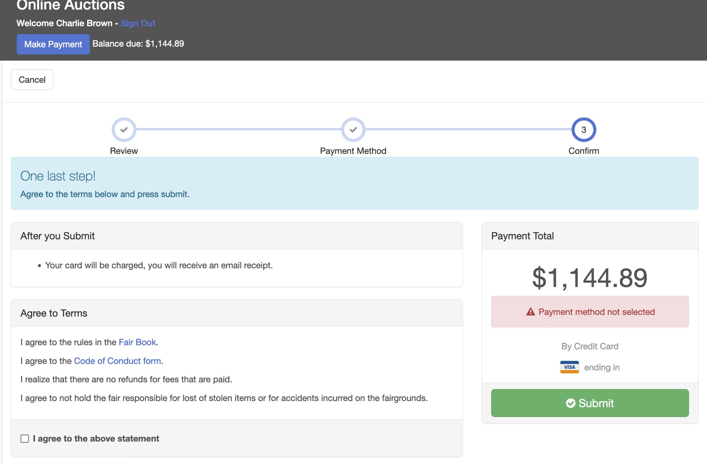
- Printed Invoices and Buyer Statements: These do NOT reflect the credit card processing fee, since the buyer may not be planning to pay with a credit card. They simply reflect the total amount of bids/add-ons for the buyer. | 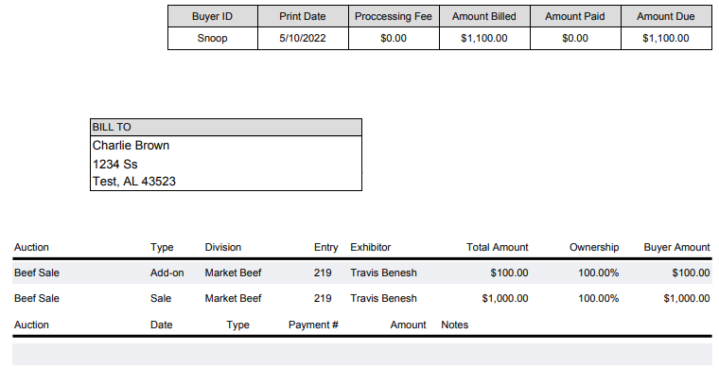
- Managers Recording Check Payments: If the buyer is paying by check, the total amount due (bids and add-ons) is shown on the Outstanding Balance and Invoice(s) line, and does not include the processing fees that would be added if the buyer had paid by credit card. If the buyer does a partial payment by check, and then pays the balance by credit card, the credit card payment will include only the processing fee for the amount paid by credit card. | 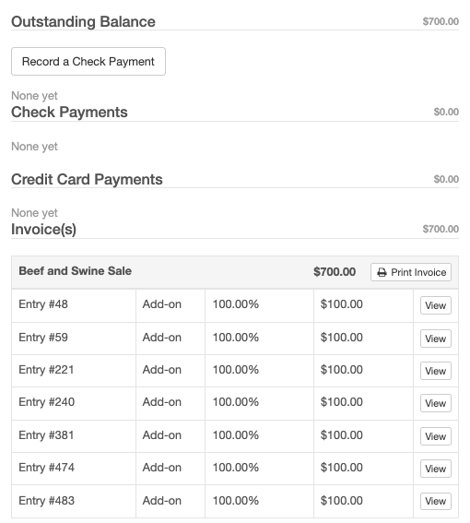
Tips
- Your buyers will need to have a login account in order to pay by credit card—there is not an option for managers to enter that information for them, for security reasons.
- Because of rounding, a customer’s credit card fee may occasionally be a penny more or less than the actual fees deducted by Stripe from the payment.

