Exhibitor Group (Family) Entry
Important Reminders
- Your fair probably has dates when entry is accepted into the fair. Be sure to complete your entries (including the final “Submit” step) prior to the cut-off date.
- Register all entries for each exhibitor in the family before proceeding to the Payment section.
- Be sure to click the “Submit” button when you have completed your entries. Entries are not final until they have been submitted.
- Check your email inbox for a confirmation email with a list of your entries and any related fees.
- You will receive a second email when your entries have been approved by your fair or show.

- You may access your Fair or Show from their direct link or go to http://www.fairentry.com and click “Find Your Fair”. | 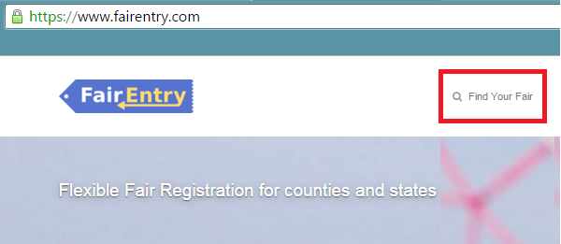
- Filter by your state, click Search, and then click on the correct fair. | 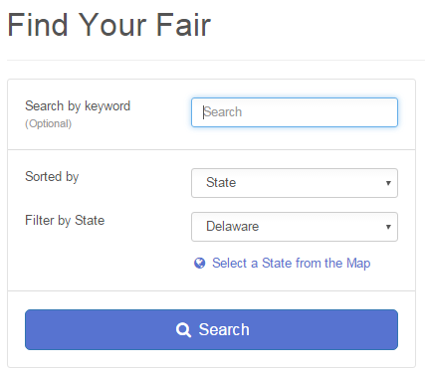
- If you have a 4HOnline family account, select to “Sign in with 4HOnline” and enter your login information.
NOTE: If you forgot your password for your 4HOnline account, you need to go to 4HOnline to set a new password. Then use the new password (not the temporary password) to log in to FairEntry.

- Click “Begin Registration” | 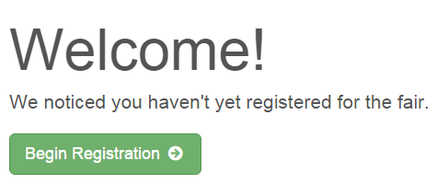
Step One – Entering Exhibitor Information
- Once you select to register an Individual, you will have the option of registering one or more of all the members with an active and up to date registration of that 4H Online account. | 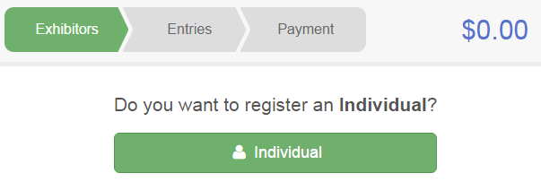
- If your fair or show requests a Social Security Number for 1099 purposes, that will be Step 4 on the progress bar. Those are fully encrypted and only the last 4 digits will be visible after the number has been saved.

- If your fair or show asks additional questions, those will be step 4 or 5 on the progress bar. Answer any questions, and click Continue.

- If your fair requires you to upload any files for the exhibitor, those will be step 5 or 6 on the progress bar. Upload requested files, and click Continue.

Step Two - Creating Entries for Exhibitors
Each exhibitor can have multiple entries. One entry must be made for each item, animal, class, etc. For example, if an exhibitor is bringing 2 photographs, two entries into the photography class must be created. If an exhibitor is showing one horse in 5 events, five class entries must be created. Once all entries have been created for the first exhibitor, you have the choice of creating another exhibitor in this exhibitor group (and entries) or proceeding to check-out (submitting the entries, whether or not fees are charged).

- Click Add an Entry beside the correct exhibitor (if more than one has been created). | 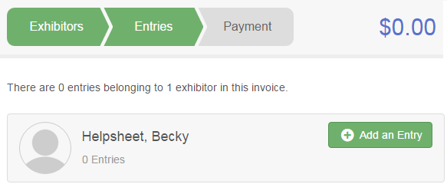
- Click Select beside the first department you wish to enter. Any departments that are not available for entry will be noted as “Not Available” with a short explanation.  - After you select a department, you will see a list of divisions to select from, and then a list of available classes. Also notice that there are blue “Change” links in case you mistakenly select an incorrect department, division, or class.  - After you have selected the class, click the green Choose button.  At this point, you will continue on with either the Multiple Entry process, or the Single Entry Process, depending on the option that your fair or show selected. The Multiple Entry process is described beginning on page 5, and single entries are described beginning on page 6. | 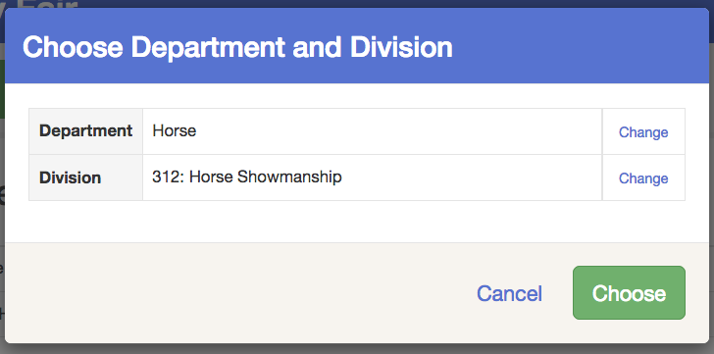

Creating Class Entries Using the Multiple Entry Process
If your fair or show has turned on the Multiple Entries option for this area, you will see a screen similar to the view at the right, below. If you do not see checkboxes next to each class, this area uses the single-entry process, and that process is described beginning on page 6.
- Click Change to select the Club to which these entries will be associated.  - If this is an Animal Entry, click Add Animal and enter the Animal’s details.  - If this is a pen or group entry, Add multiple animals and then select to Enter a pen of animals.  - Select which animals will be part of this entry (NOTE: these animals will be available for this exhibitor to use in other entries, if needed).  - Check the box next to each class this animal will enter. | 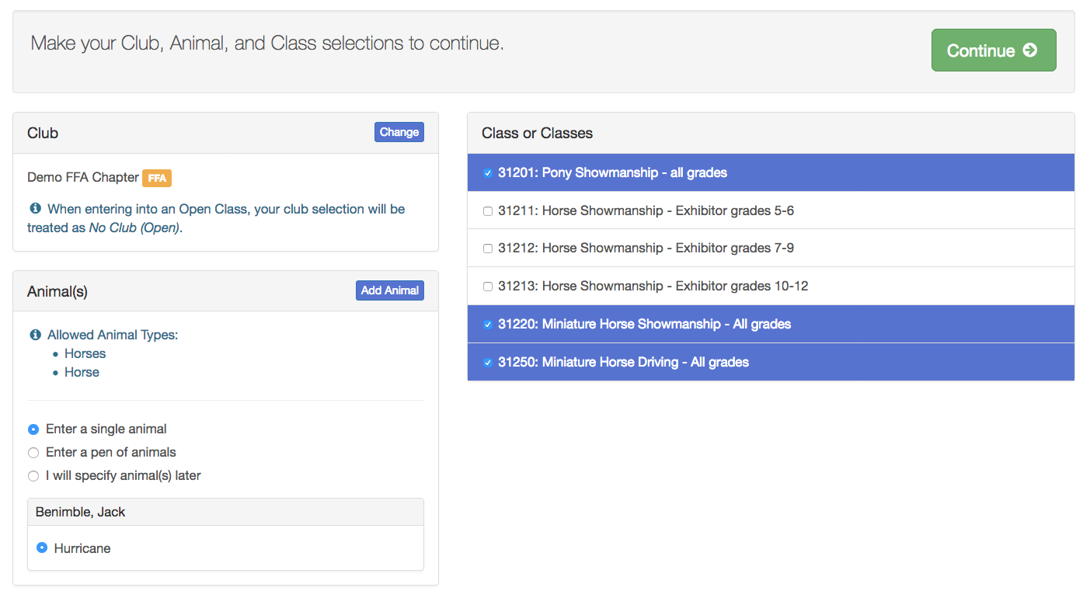
- If this is not an animal entry or if animals will be added at check-in, simply select the classes and number of entries in each class that you would like to create for this exhibitor. Click Continue. | 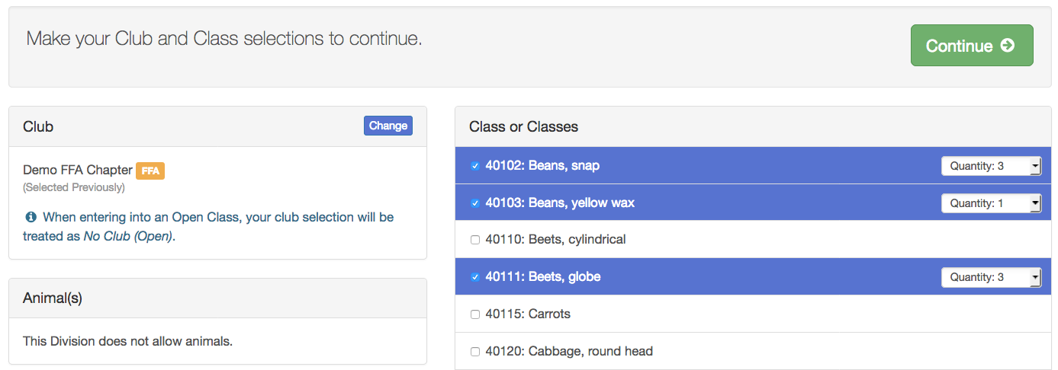
- Review the entries. If you need to make any changes, click Cancel. If everything is correct, click Create Entries. | 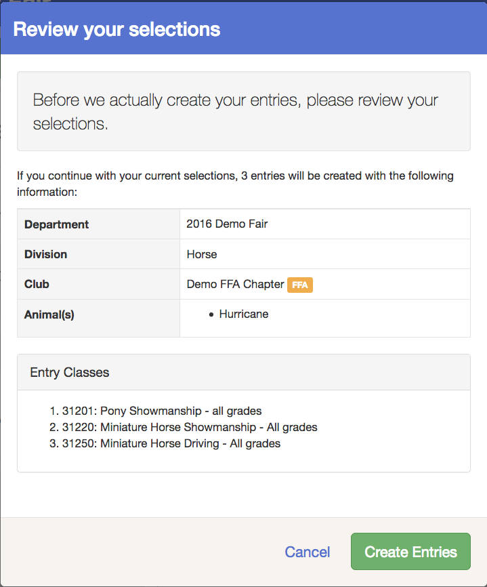
- If you need to add another exhibitor, click on the Exhibitors button at the top left and repeat the steps to create a new exhibitor.  - If all entries are complete, click Continue to Payment.  - If you need to add more entries for an existing exhibitor, click Add an Entry. | 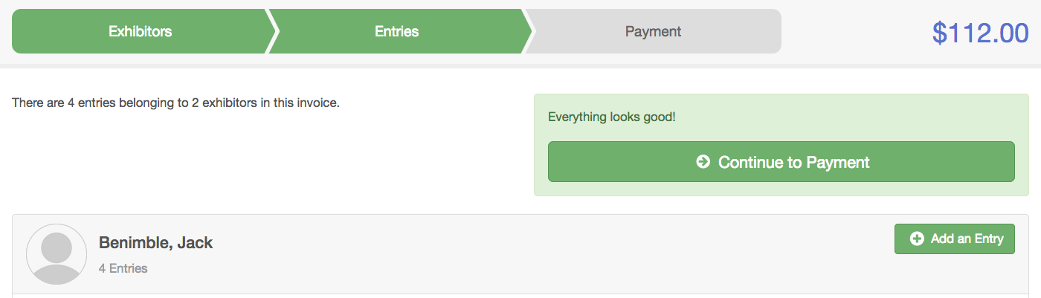  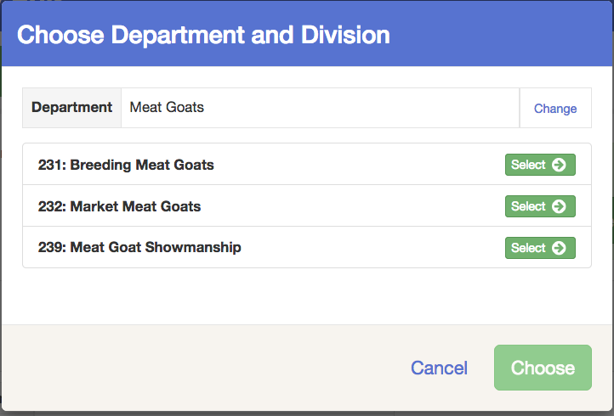
Creating Entries Using the Single Entry Process
If your screen does not resemble the picture on the right below, your fair may have used the multiple entry process in this area. See the section above, beginning on page 5.

- Select the appropriate class.  - Click Continue | 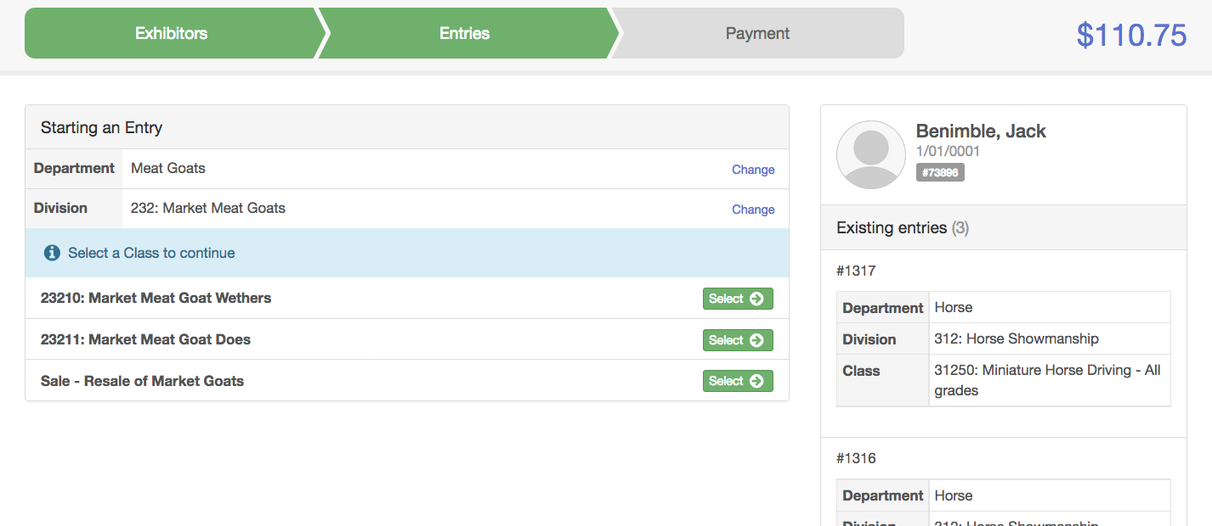
- Select a Club or Chapter for this entry. If this is an open class entry a Club or Chapter may not be required.  - If this is not an animal class entry, follow the instructions on-screen to enter any additional information such as Entry Description, Custom Questions or Custom Files associated with that entry. | 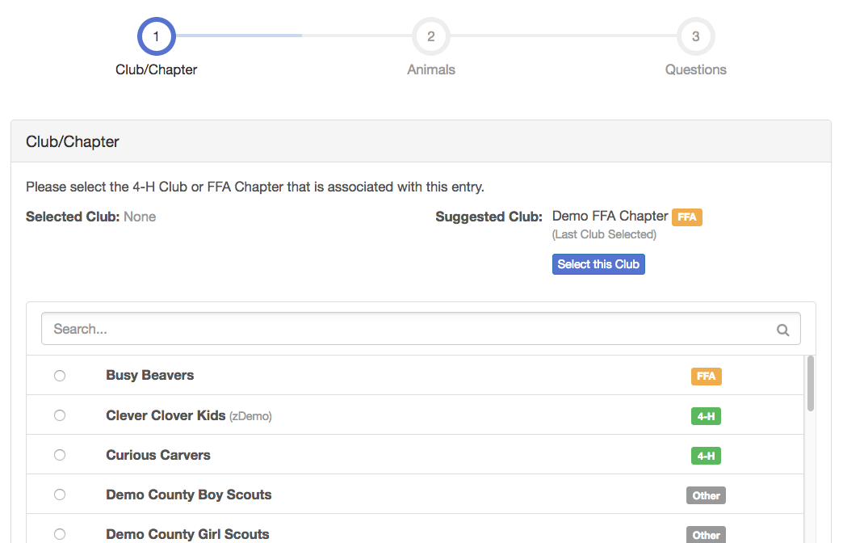
- If this is an animal class entry, you may be required to specify which animal will be exhibited in this class; that may be optional; or you may NOT be able to specify the animal at entry time. If you are able to do that, you will see the option to “Add an animal”.  - You will have two choices. Select “Choose an Existing Animal Record” to import and select animals from 4HOnline or animals already entered in FairEntry. Choose “Enter a New Animal Record” to enter new animal information.  - Fill in all of the fields with information about the animal you intend to exhibit. Click Create and Add Animal when finished. If the animal information was entered incorrectly, you have the option to either Remove From Entry (creating a new animal) or Edit Animal Details. When it’s correct, click Continue.  - Any questions or file uploads related to entry in this class will be next. Click Continue after answering those questions or uploading documents. | 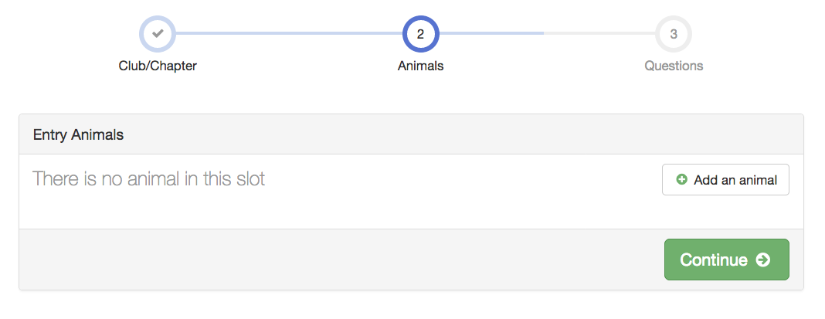  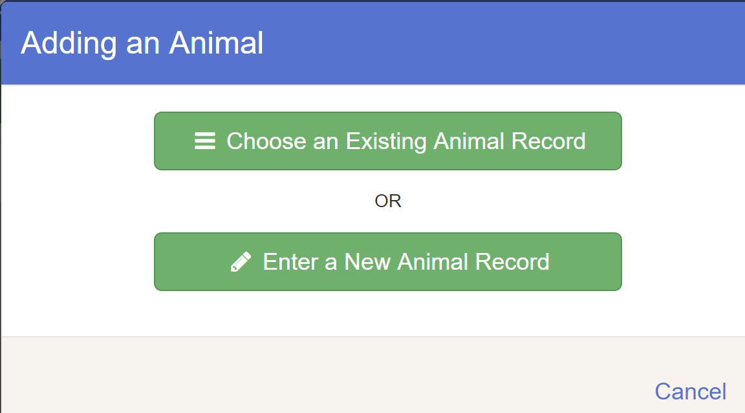  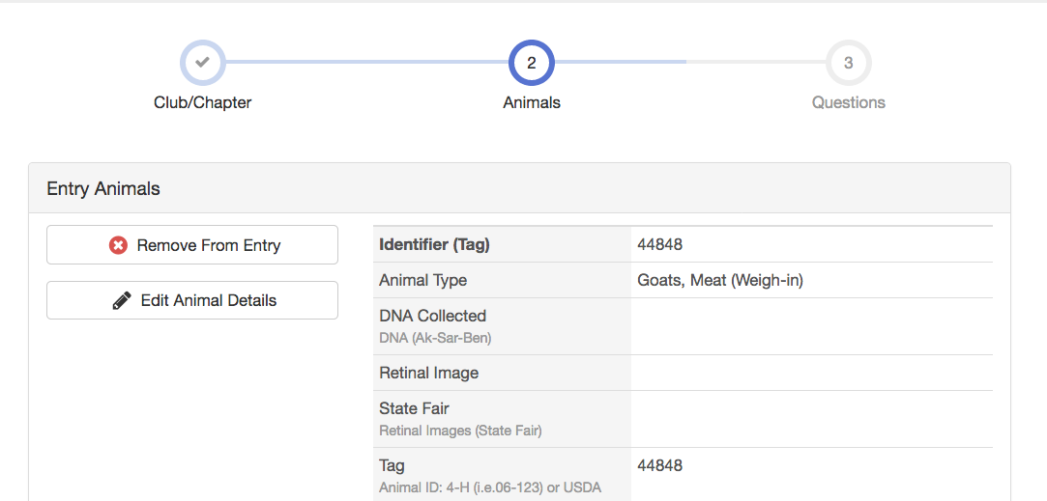
- When each class entry is complete, you have three choices for what to do next:  - If all class entries have been completed for one exhibitor, you can Register another Exhibitor in this exhibitor group.  - If this exhibitor has more class entries to make, you can Add another Entry for this Exhibitor. Do this until all entries for all exhibitors are complete, then Continue to Payment. | 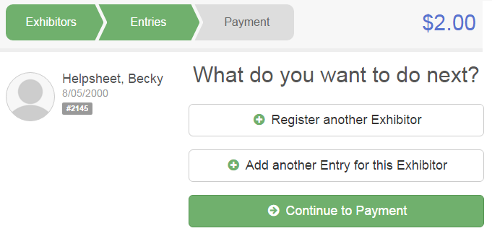

Submitting Entries
When all entries for all exhibitors in the exhibitor group have been completed, Continue to Payment to finalize and submit your entries. You must submit your entries even if there are no fees, so no payment is required.

- Review your entries for completeness and accuracy. Notice the Summary and Detail buttons at the top of the list on the right. If there are errors, click on the green Entries section at the top of the page. Click Continue when all information is correct.  - Once all entries have been entered for exhibitors in your family, submit the invoice for approval.  - You will receive an email message when the entries have been submitted for approval. You will receive a second email when the entries have been approved. | 