Online Auction – Manager Setup
After members have submitted their entries, they may edit their approved entries to add additional information for the auction including a video URL and an Auction narrative. These items will be visible to the buyers as part of the online auction. Entries should be checked in (if you need a weight) and marked for Auction (Sale Participation Status), the buyer list uploaded/added and the sale order should be created as per usual before following the steps below.

Preparing Buyer Accounts  At the top of the list of buyers, click the Allow Login button.  - When that button is activated, all buyers with the label "Login Allowed" beside their account will be able to login to the fair as a buyer.  - Accounts that do NOT show Login Allowed will not be able to log in until/unless their account is edited as in Step 5-8 below.  - If you click the Disable Login button at the top of the list, NO buyers will be allowed to login, regardless of the login status on their account. | 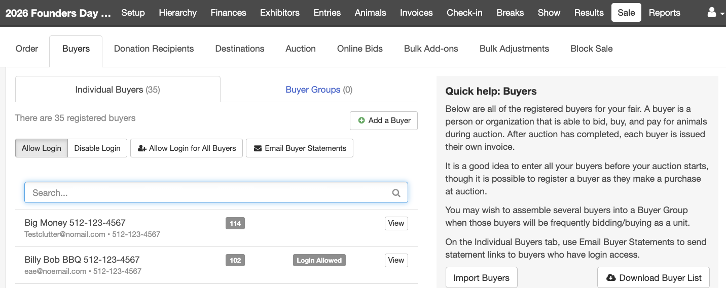
- Click to Edit the Online Account details.  - Select Yes for Allow Login  - Enter the buyer’s login email address.  - Click Save.  - The buyer will receive an email with their login information. | 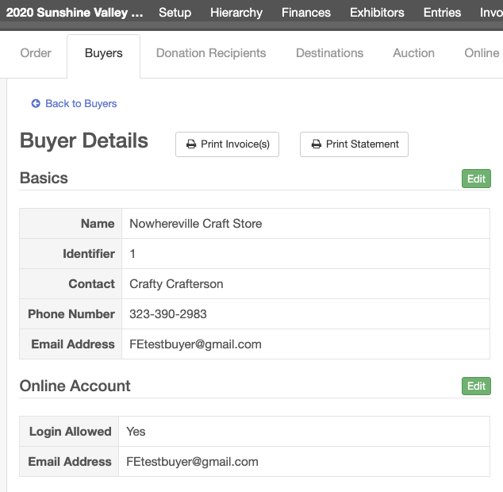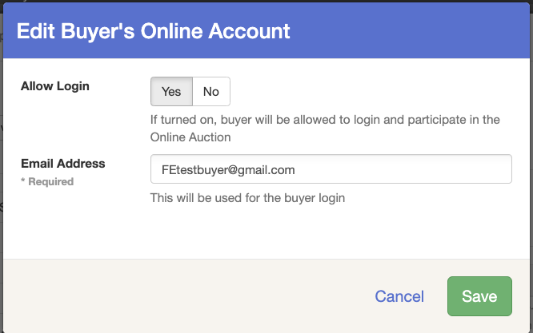
Preparing the Auction  - Click on the Sale tab and the Auction subtab.  - Select to View your Auction.  - Click Edit next to Online Auction is turned OFF.  - Select to Enable Online Auction (ON)  - Select to turn on Addons and or Bids (ON)  * you can leave both off if only for buyers to pay their invoice.  - Enter the Start Date and time, then End Date and time.  - Click Save. | 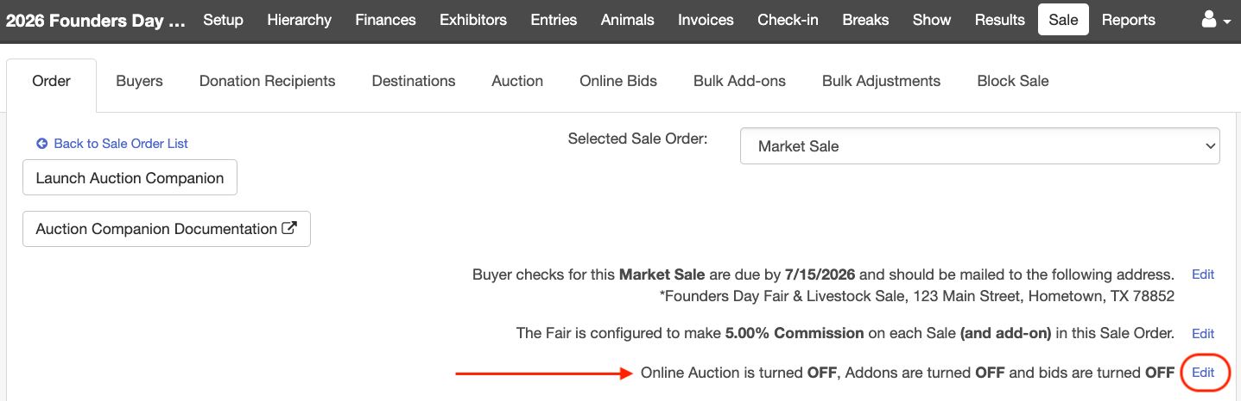  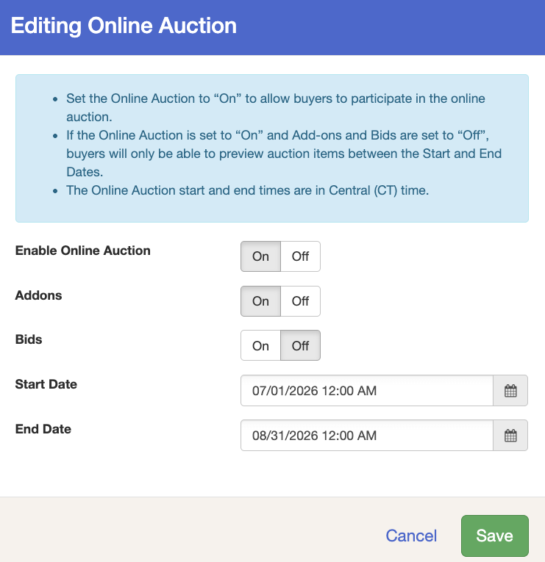

Entering Add-Ons in the Online Auction – Existing Buyers
Instructions for Buyers  - Go to your Fair’s FairEntry site.  - Enter the login information you received via email from FairEntry (sent when your fair set up your buyer account). Do not use the 4-H Online sign-in option, if available.  - Click Sign In.  NOTE: If you forgot or would like to reset your password, click Forgot Your Password. | 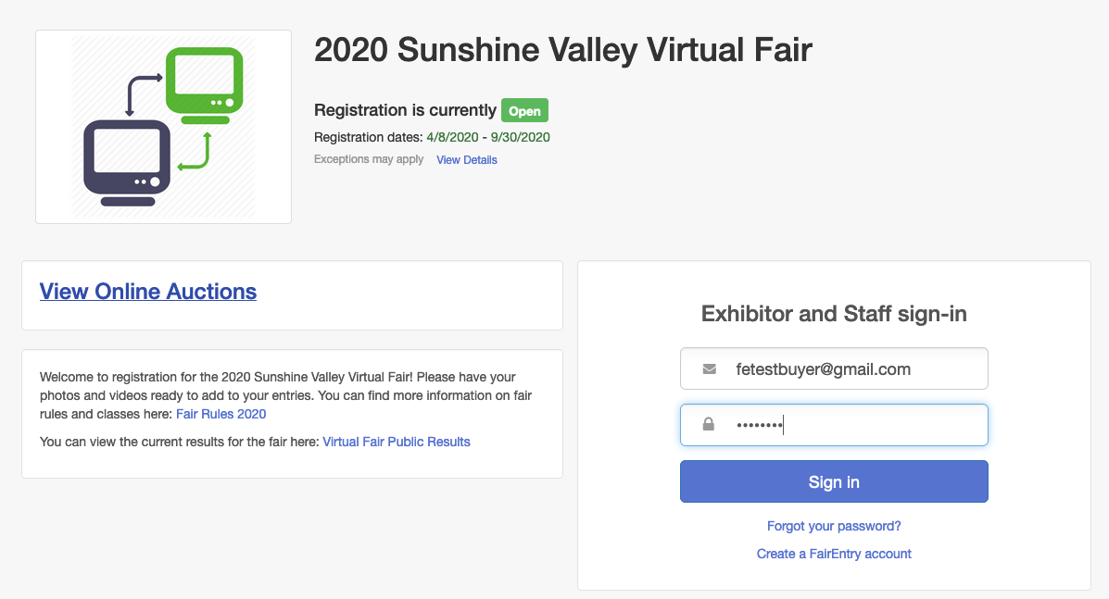
- Select the Auction you would like to view (if your fair has multiple auctions).  - Click View Details to add an add-on for an auction item. | 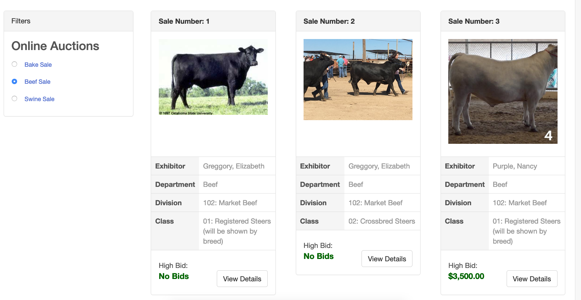
- You may view the exhibitor’s video, photos and introduction.  - Enter the amount of your add-ons in the box at the right.  - Click Back at the top of the screen to select another item. | 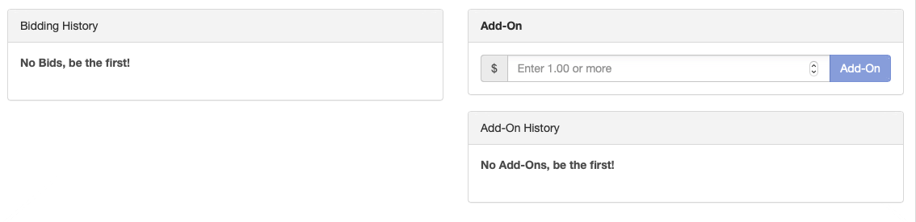  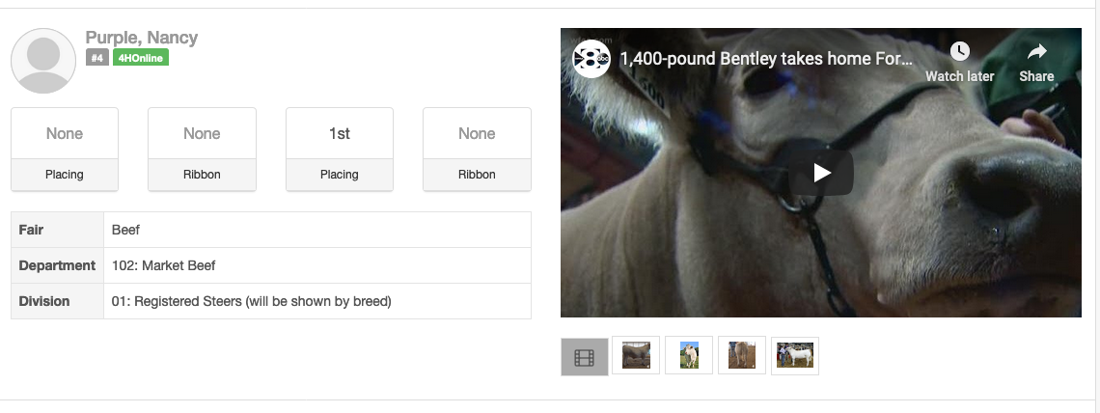

Bidding in the Online Auction – New Buyers
Instructions for Buyers
- Go to your Fair’s FairEntry site.
- Click View Online Auctions.

- Click Sign Up to Bid.  - Enter your Email Address, Account Name, Phone Number and create a Password.  - Click Create Account | 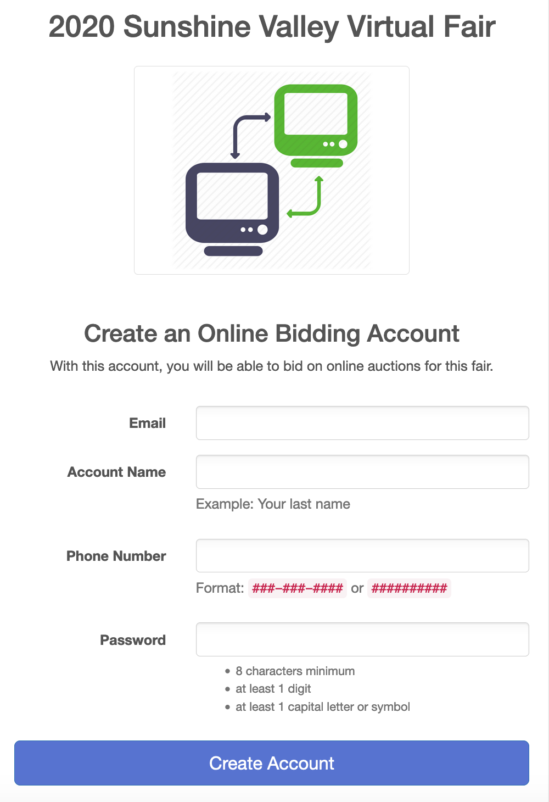  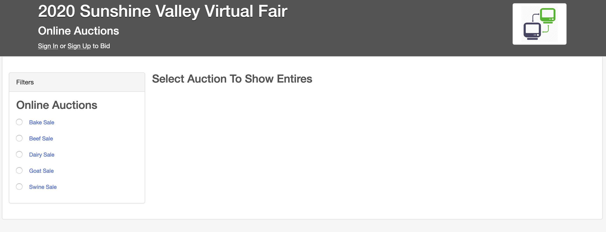
- You will be redirected to the login page for your fair.
- Enter your newly created buyer account information (Email Address and Password).
- Click Sign-In
- Select the Auction you would like to view (if your fair has multiple auctions).
- Click View Details to add an add-on for an auction item.
- You may view the exhibitor’s video, photos and introduction.  - Enter your add-on amount in the box at the right.  - Click Back at the top of the screen to select another item. | 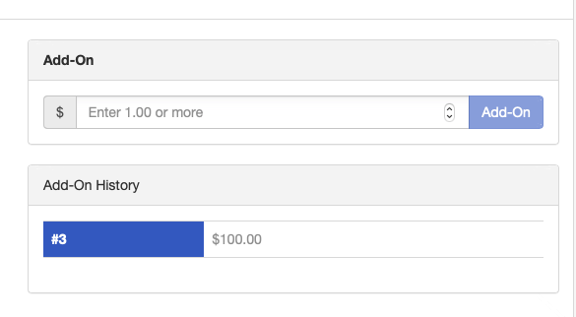

Paying for your Add-Ons
You can pay for your Add-ons at any time if your fair has chosen to accept Credit Card Payments.

- Go to your Fair’s FairEntry site.
- Enter the login information for your buyer account.
- Click the blue Sign-In button

NOTE: If you forgot or would like to reset your password, click Forgot Your Password.
Click the Make Payment button. | 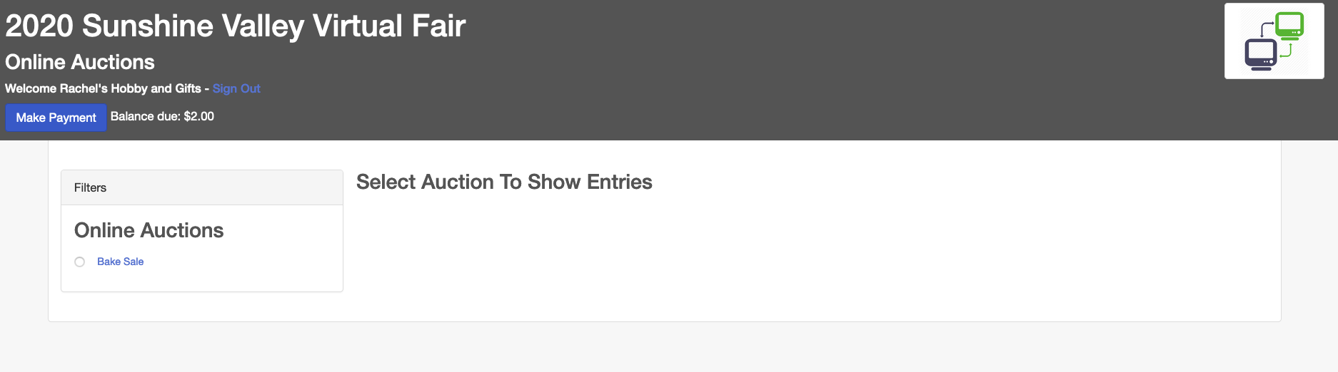
You will see Buyer Payment summary. Click Continue.  If you have any questions about this total amount, contact your Fair/Sale office. | 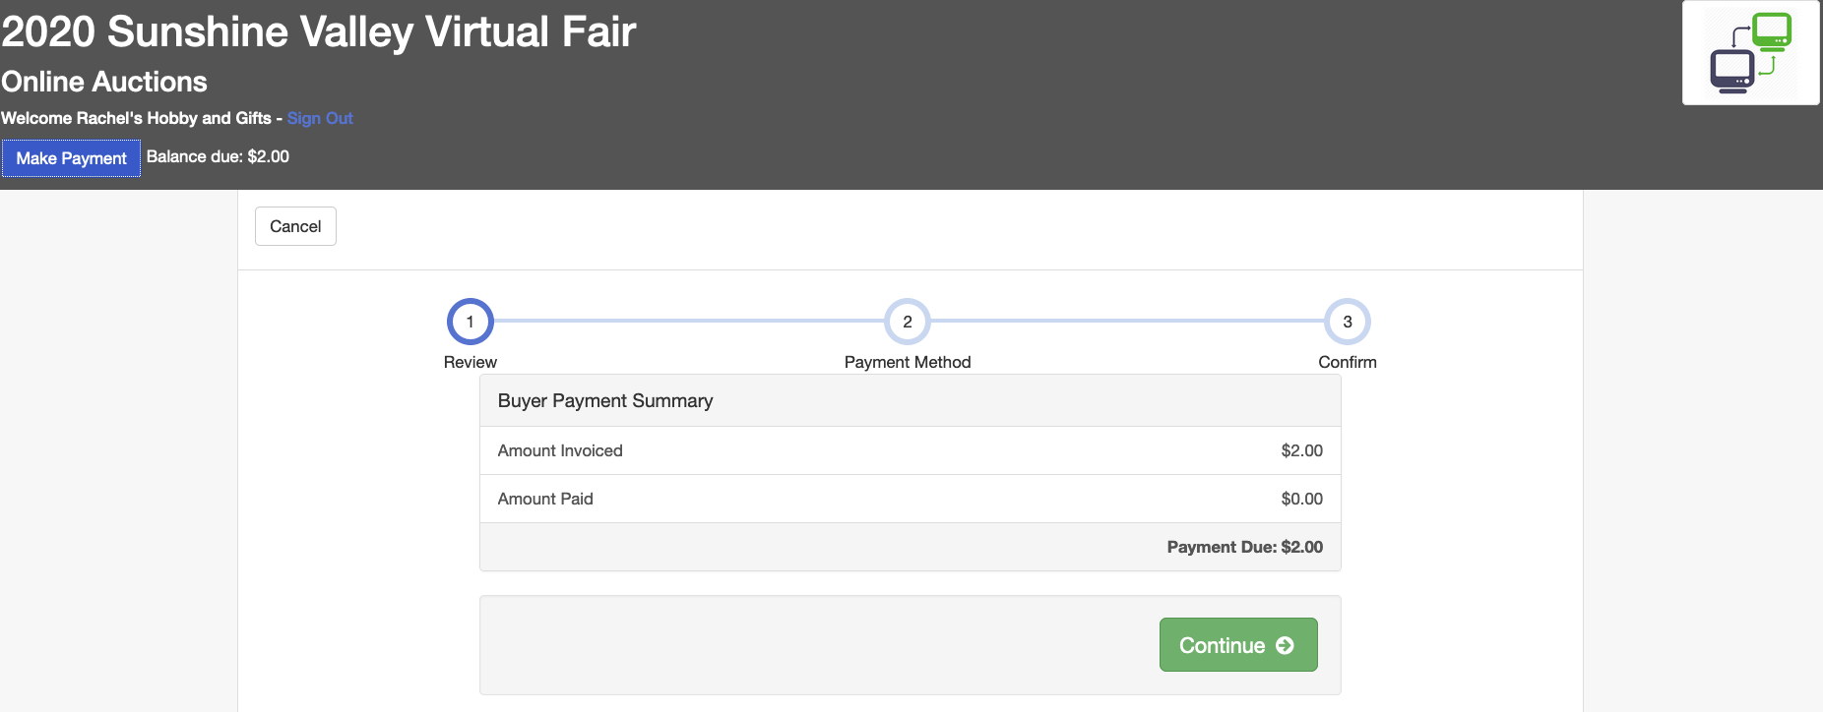
- Click the Add Credit Card button.  - Enter your credit card details.  Click Save. | 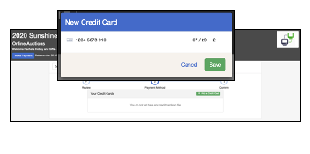
The credit card will be added to your list of payment methods.  Click Continue. | 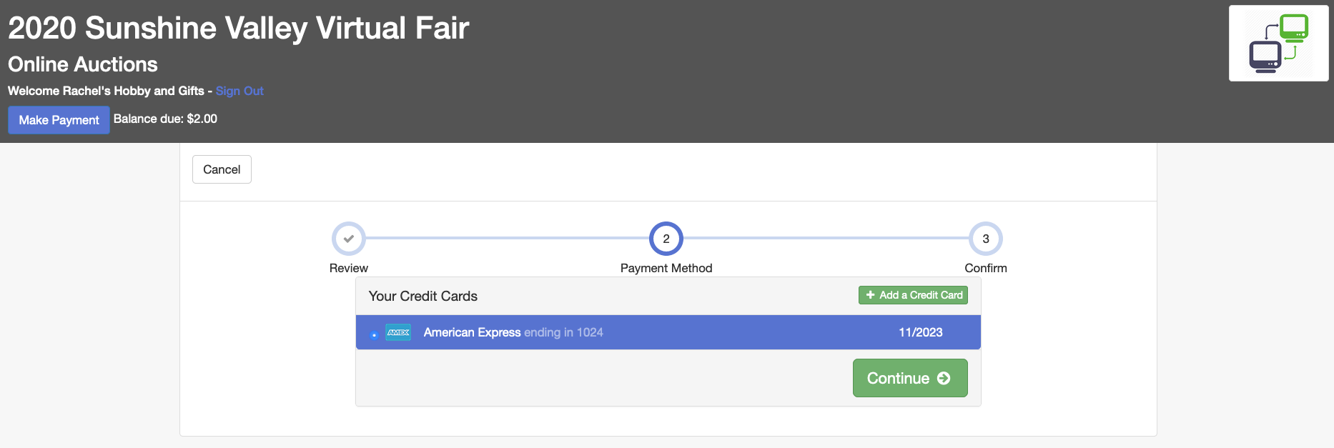
Click Submit. | 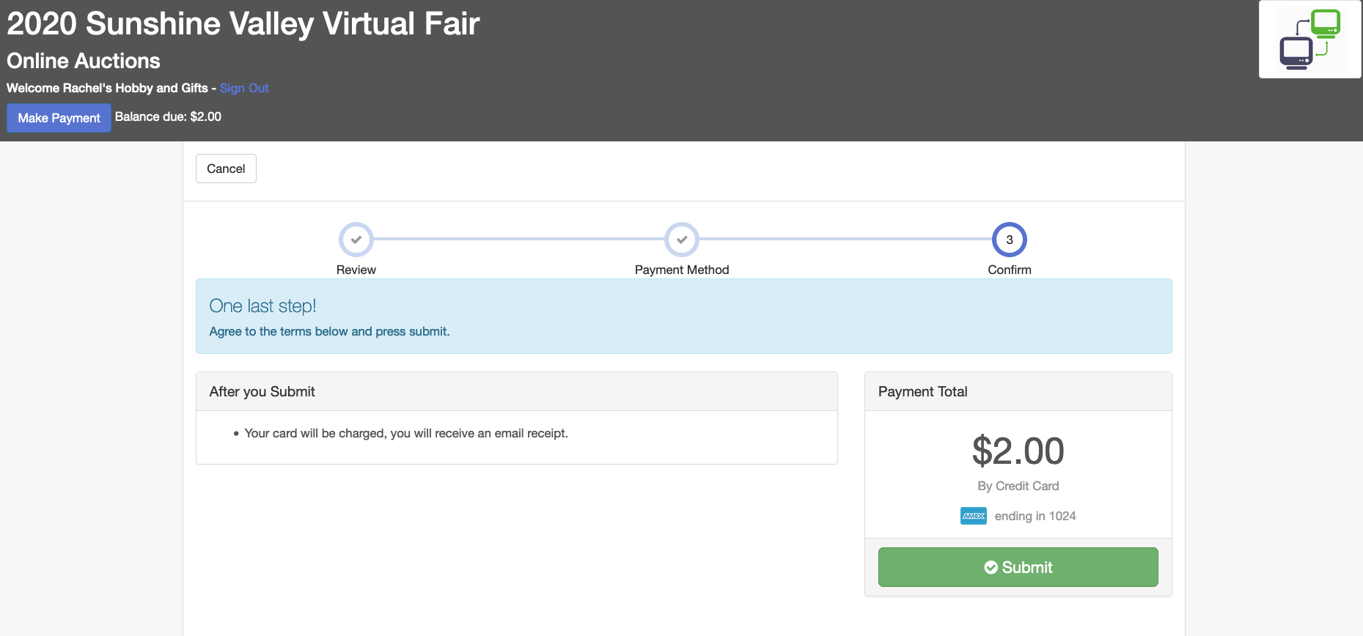
You will receive an email receipt confirming your payment.  For a detailed list of all the add-ons that you submitted/paid, contact your fair office. | 