Sale/Auction
Invoices, Checks, Payments, and Reports
After the auction is complete, you can print exhibitor checks (for show premiums, sale amounts, or combined totals), print reports (Buyer Invoices, Destination Packing Lists, Exhibitor Thank You Lists, etc.), and mark Buyer Invoices as Paid when funds are received.

Checks  - Click on the Finances menu, Checks tab to print Exhibitor Checks.  - Click Add Set of Checks, then name the check set.  - Select the Budgets, Auctions (including Add-ons, Floor, and/or Sale Price), and/or Block Sale to include on the set of checks, and click Save.  - Click View beside the Check Set. | 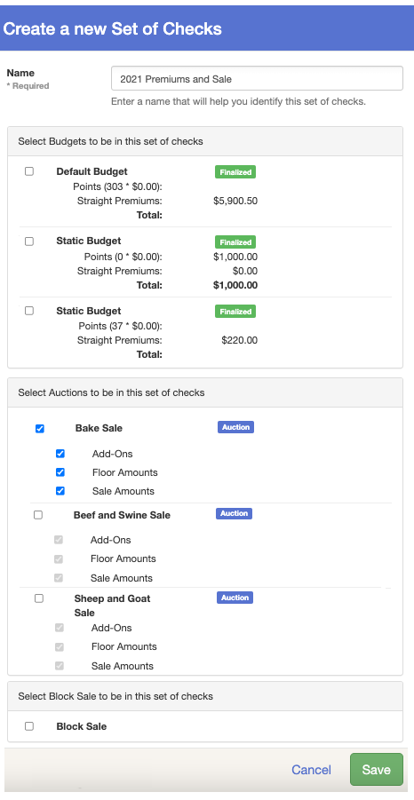
- Enter the starting check number, then Preview Checks or Generate Checks. | 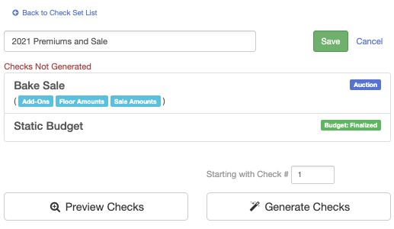
- Preview checks creates a PDF file of the line items that will be written on each check. You can make corrections/changes as necessary before printing checks.  - Generate Checks begins the printing process, generating a PDF file to be printed on check blanks.  - After Generating Checks, on the Check Set List, click View beside the Check Set that shows Generated. | 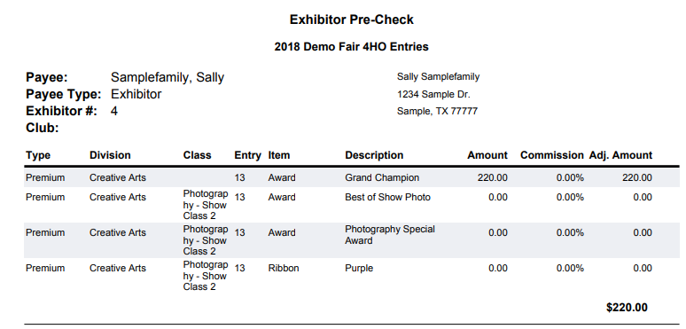
- This screen allows you to Print All, Print Labels (Avery 5160-size mailing labels), or download the file to Excel. There is also the option to Void the set of checks if necessary. | 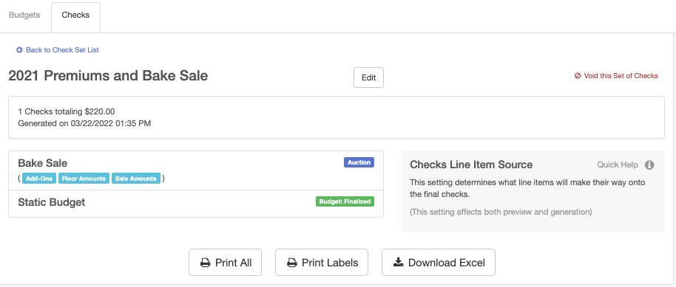
Buyer Payments  To record payments received from buyers:  - Click on the Sale menu, Buyers tab.  - Select to view a Buyer.  - Click Record a Check Payment.  - Enter payment information.  - Click Save. | 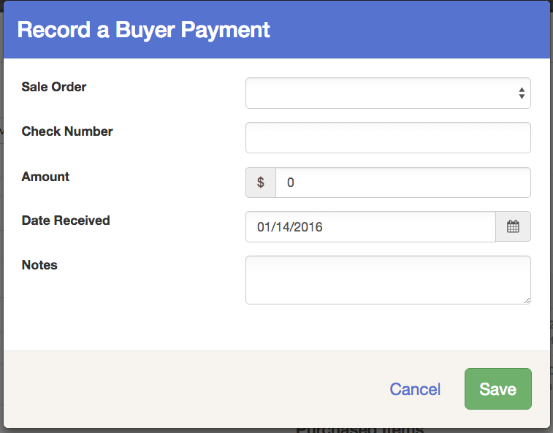  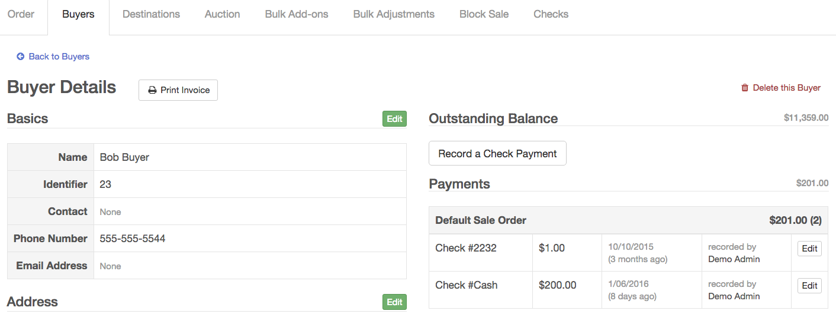
Reports:  Click on the Reports menu, Standard Reports tab and scroll down to the Sale reports to download and print standard reports for different areas of the Sale.  For more details on Standard Reports, see the Help Center section Standard Reports.  If you need a report that is not listed, you may create the report under Custom Reports (See the Help Center section Custom Reports for complete instructions). | 