FairEntry Custom Fields
Before You Start
Custom fields/questions can be created at any level of the hierarchy. The link to the hierarchy determines which exhibitors will see the question, and how many times. Custom fields are available in custom reports, based on selecting the portion of the hierarchy in which they appear.
Fair-level questions are only asked ONCE, the FIRST time an exhibitor record is created, for every exhibitor. Example: a fair opens communication entries in May, but other fair departments in July. The fair-level custom question will only be asked when the exhibitor does their first entry, in May.
A question set at the department level can be configured in one of two ways: it can be asked with each entry within that department, or it can be asked only one time when the exhibitor creates their first entry in that department.
If it is set to ‘one time per department,’ then once the custom field has been completed, the system will not prompt the exhibitor to answer it again for any additional entries in that same department.
For example, the question ‘How many beef stalls do you need?’ is set to be asked one time per department. The exhibitor will only answer this question with their first entry into the beef department.
A question set at the Department, Division, or Class level—when ‘Asked one time per department’ is not enabled—is asked once for each entry within that level of the hierarchy.
For example, if an exhibitor creates one entry in the Market Beef division, they will be prompted to answer the question one time. However, if the exhibitor creates six entries in the Market Beef division, they will be asked the same question six separate times—once for each entry.”

Custom Fields types and options
- True/False
  - Allows for Yes/No, True/False, Agree/Disagree and On/Off as options in radio buttons or select menu format.
  - Only one option can be selected.
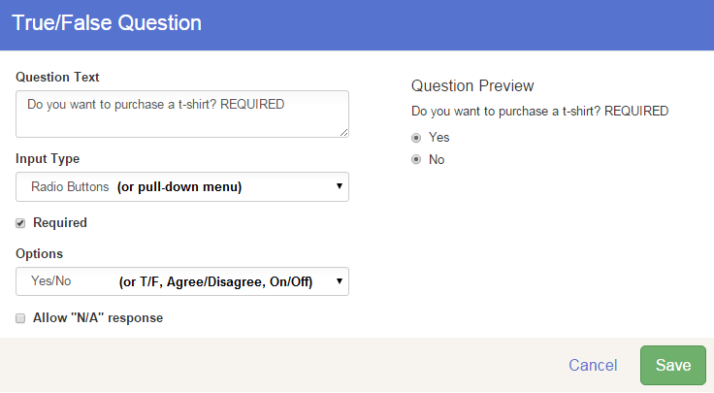
  - If required, consider whether you want or need the “Allow N/A response” turned on. That basically allows a required field to be left with no choice selected.

Preference Question
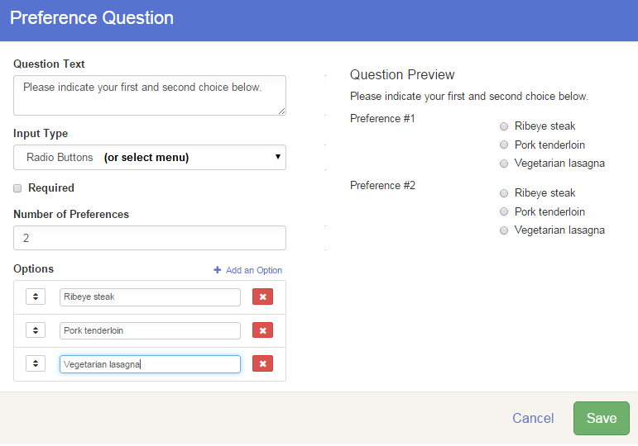
  - Allows for a number of choices (first choice, second, etc.)
  - Format can be radio button or select menu.
  - Only one option for each of the number of preferences can be selected.

- Timeslot Question
  - Checkboxes allow multiple responses
  - Radio buttons and select menu allow only one response
  - Once capacity has been reached (when family submits), that option will no longer be available.
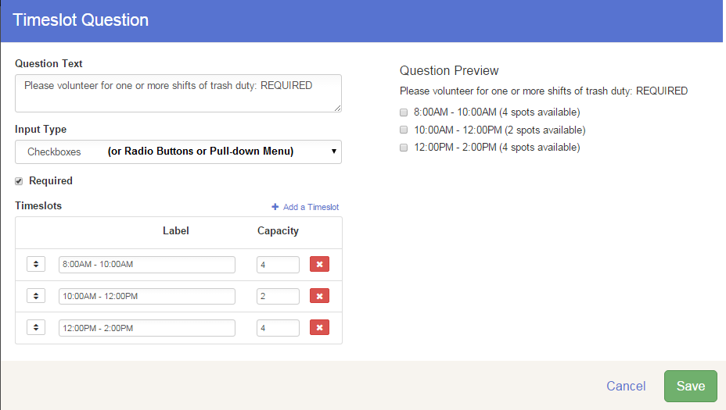
  - If a question is marked as “required” but all timeslots are filled, the question will not be required/available any more. However, you should consider what happens if everyone has to sign up for a time, but there aren’t enough slots available.
- Sign-up Question
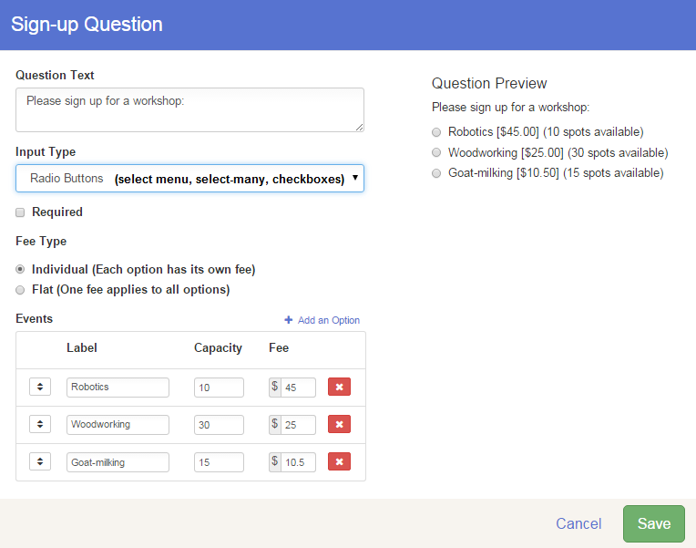
  - Radio button and Select menu allow only one choice
  - Select-many menu and Checkboxes allow multiple choices
  - Individual vs. flat fee options
  - Capacity—once reached (family submits), the option is no longer available for others.
  - Cannot combine a quantity with sign-up—Example: if T-shirt sizes are the options, you can’t ask how many of each size. If you need to know “how many” of any option, use the Quantity question.

- Matrix question
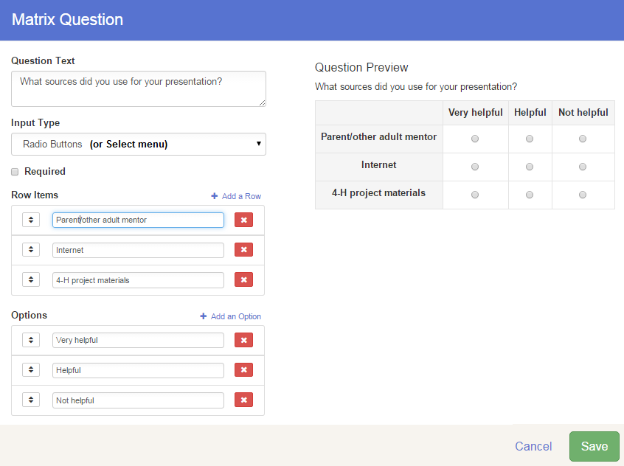
  - The data from this field can NOT be downloaded into a useful format. It will take a lot of editing in Excel to pull any useful information from answers to these types of questions. We would advise using multiple-choice question(s) to get survey answers rather than the matrix.
- Text question
  - Short text=one line, 64 characters will appear on screen, more can be entered
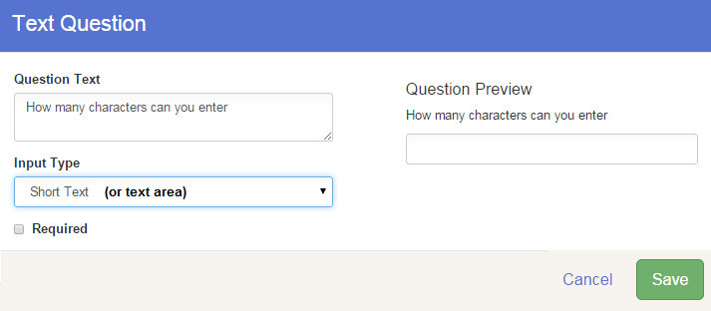
  - Text Area=larger box means more text is visible as they type.
  - Required only means they have to enter a minimum of one character
Multiple Choice Question
  - Radio button and Select menu allow only one choice
  - Select-many menu and Checkboxes allow multiple choices
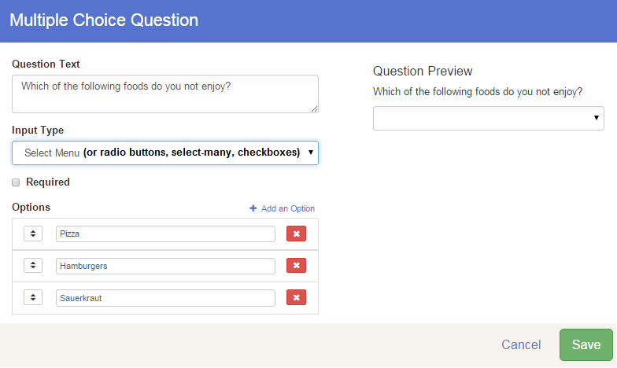

- Quantity Question
  - Can have a price attached
  - There is only one option—how many of this one thing
  - You can set a maximum per-entry (Transaction Limit) and a total number of items available (Limited Availability)—Example: how many shirts do you want (maximum 3 per exhibitor) and how many shirts can be sold to everyone (60 shirts are available for sale). You cannot list multiple items in a quantity question (like a list of T-shirt sizes). One item, one price.
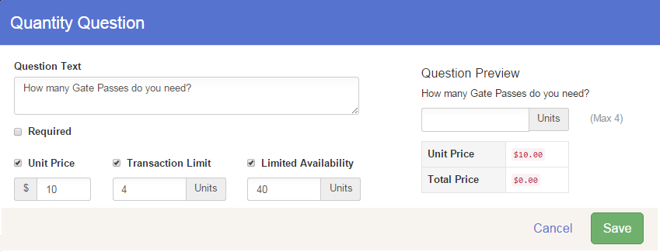
  - To gather both the T-shirt size and the number of items, you’ll need two questions. One might be a quantity question (how many T-shirts), and the other might be either Sign-up or Multiple Choice radio buttons (what size).
- Content Block
  - This is not a field for entrants to complete
  - Managers use this to add explanation etc. to their custom fields/entry forms.
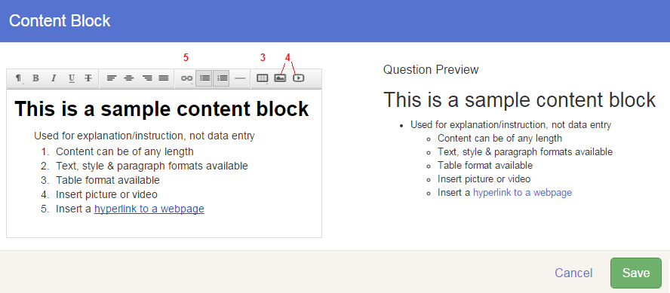
  - There are typical text format options: style, bold/italic etc., alignment, insert hyperlink, lists, tables, images.

