Buyer Payments
Tips for Communicating with Buyers  Buyers should receive an automated email when their online bid has been accepted. If you are hosting a traditional auction and would like to email your buyers -  As a Sale or Fair Manager or Administrator click "Email Buyer Statements" at the top of the Buyer list, an email will be sent to all buyers who have "Login Allowed" set to Yes.  Your fair’s Sale Order does not need to be turned on for your buyers to be able to log in and view their statements. | 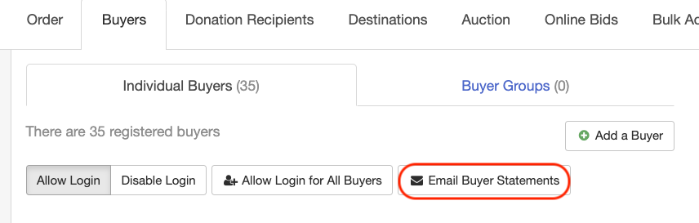  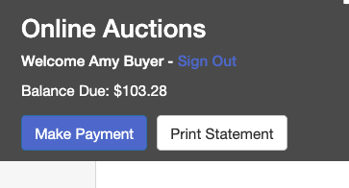
Entering Buyer Check Payments  - Click on the Buyers tab under the Sale tab.  - Select the Buyer that you have received a check from.  - Click “Record a Check Payment.”  - Enter the Payment Details.  Please see the FairEntry Help Center for more specific instructions and additional screenshots. | 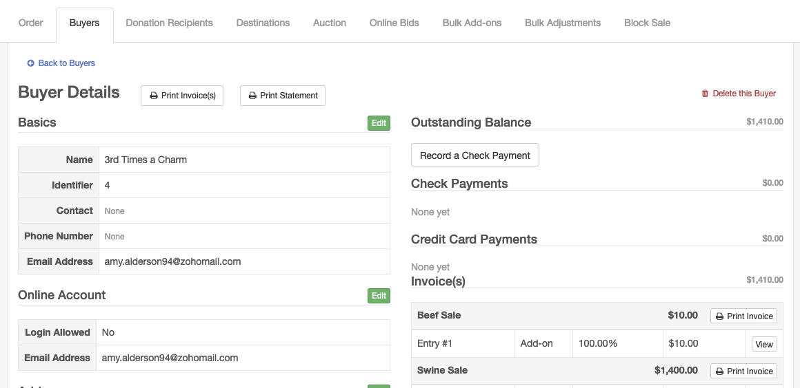
Allowing Buyer Credit Card Payments  Before a fair may accept credit card payments from buyers, they must integrate with Stripe.  - Click on the Set Up tab and select Payment Integration.  - Click “Connect with Stripe” and enter your Stripe login information.  - If you do not have a Stripe account yet, click “Create a Stripe account.” | 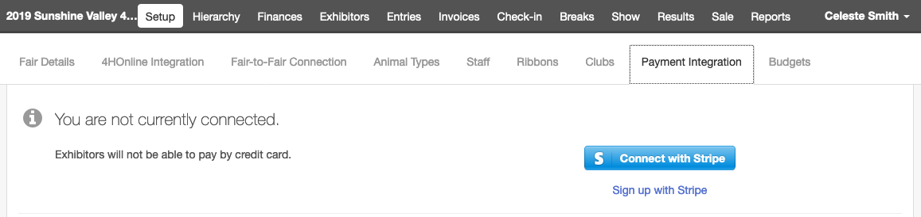  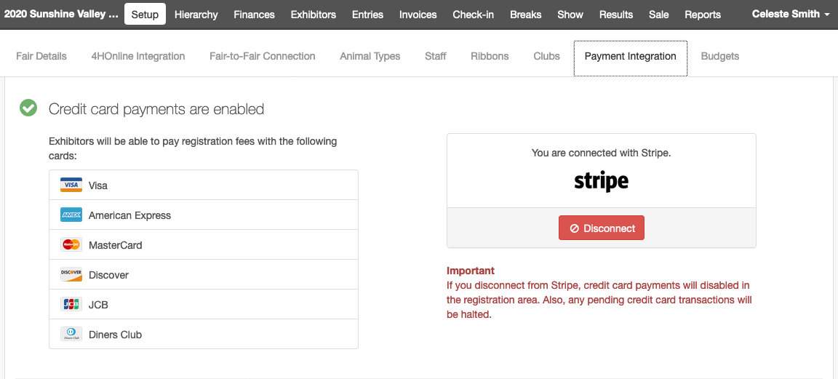
After you have completed the Stripe integration, you are all set to take credit card payments.  Buyers must be allowed to log in to their online account (even if you do not have an online auction) in order to pay for their bids online (see FairEntry Help Sheet with instructions for Setting Up the Online Auction). | Please see the “FairEntry Virtual Auction Buyer Instructions” Help Sheet to learn how buyers will log in to pay by credit card.
Buyer Credit card payments will appear in the Buyer Profile for each buyer.  Buyers are automatically notified if their credit card is declined during the payment process at the time that they click to Submit their payment. | 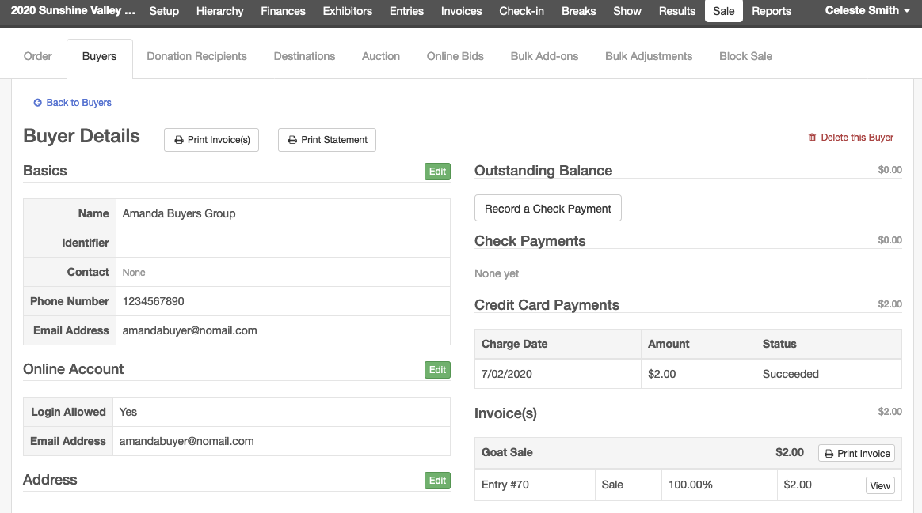
Individual Buyer Invoices & Statements
If a buyer requests an individual Statement (includes line items for payments for all auctions in your fair) or Invoice (separate invoice for each auction & payments are calculated in the invoice total rather than listed as line items), click on the Buyer’s Profile and click “Print Invoice” or “Print Statement.” This will open a PDF version of the Buyers Invoice or Statement that can be sent to them via email through your preferred email service.
TIPS  Buyer Invoices and Statements can be printed in bulk under the Reports tab, Standard Reports, Sale Reports section. An option is available to print only invoices with a balance greater than $0 to assist with following up with buyers who have not yet paid. | See the FairEntry Help Center for instructions regarding the following:  Printing Exhibitor Checks  Printing Standard Reports (Sale Reports included)  Creating Custom Reports (sale fields are available)

