Online Buyer Management
Before You Start
The online features of buyer management within your fair all depend upon your buyers having an email address as a part of their buyer account.

Allow Login/Disable Login  The Allow Login / Disable Login will turn on/off buyer access to the Online Sale Portal. This setting is for a buyer that already has their individual Online Account set to “YES”. | 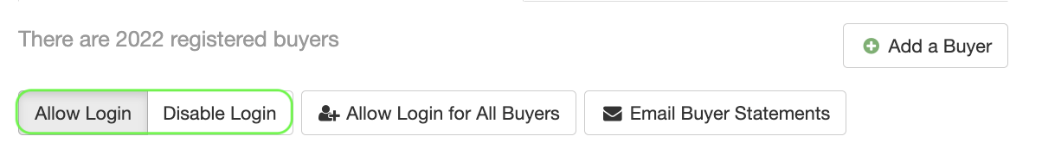
When “Allow Login” is set, and the buyer has an active Online account set to YES (see below) the “Login Allowed” icon will show for each buyer account on the main buyer page.  When “Disable Login” is set, or if an individual buyer does not have the Online account set to YES, their buyer account preview will not have the “Login Allowed” icon. | 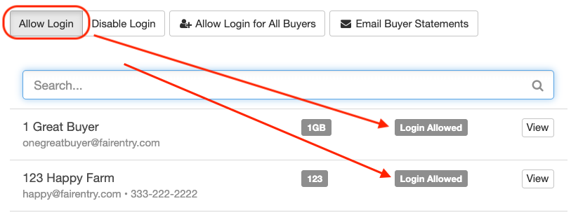  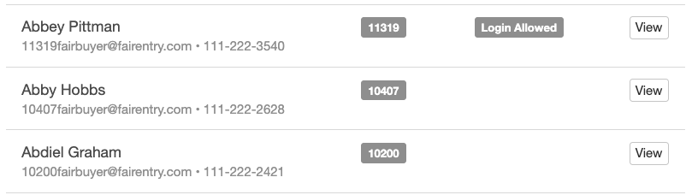
Allow Login for All Buyers  - The Allow Login for all Buyers button will turn on the Online Account for each individual buyer that has an email in place.  - When the Allow Login for All Buyers is clicked, it will automatically set the Online Account field to YES, pulling the buyer’s email address from their buyer basics. | 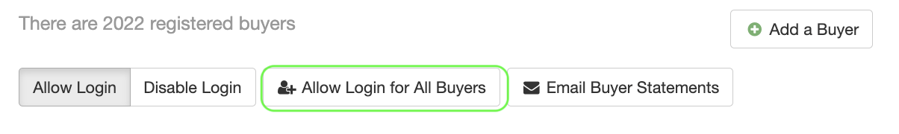  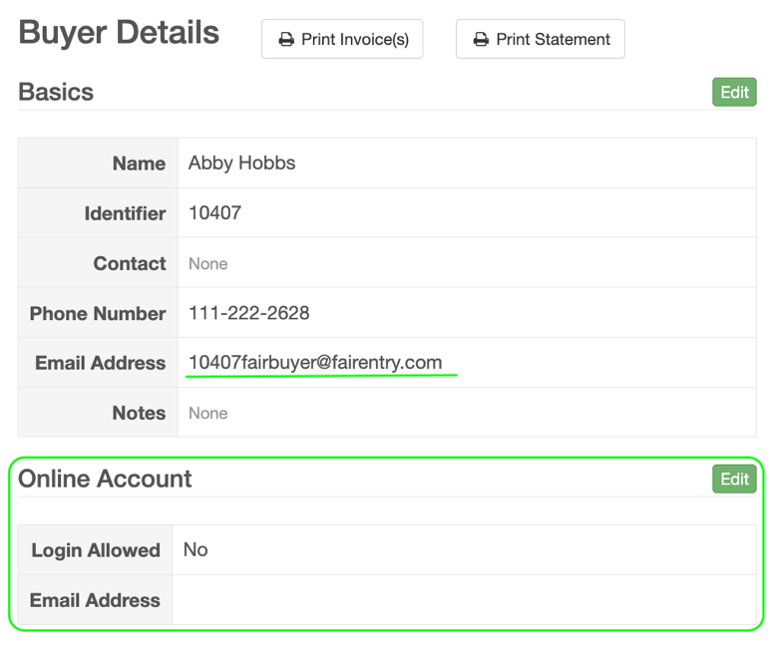
Email Buyer Statement  When a Sale or Fair Manager or Administrator clicks "Email Buyer Statements" at the top of the Buyer list, an email will be sent to all buyers who have "Login Allowed" set to Yes. | 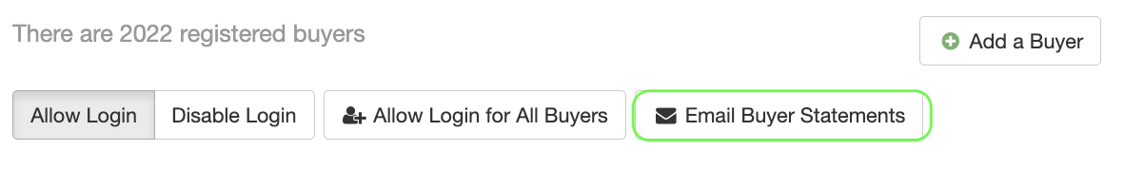
Your fair’s Sale Order does not need to be turned on for your buyers to be able to log in and view their statements.  - You can leave sale order off completely  OR -  - Turn on Sale – for viewing only  - Turn on Sale to receive Bids or Add-ons  - Turn on Sale to Receive only Bids or only Add-ons | 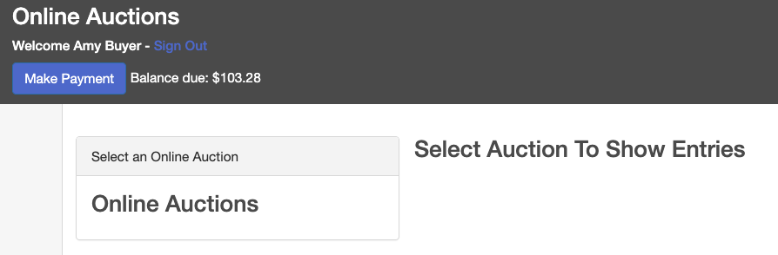  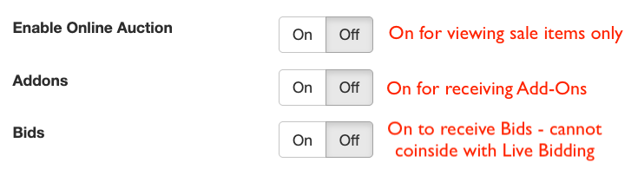
Tips
- If you would like to allow new buyers to create their own buyer account – please check out the article in the help center – Can Buyers Set up their own Accounts?
- Your buyers will only receive their login invite the FIRST time their buyer account is set to YES for their Online Account.
- For more information about setting up an Online Sale please check out the article in the help center - Online Auction Instructions

