Online Auction Set Up
After members have submitted their entries, they may edit their approved entries to add additional information for the auction including a video URL and an Auction narrative. These items will be visible to the buyers during the online auction. Entries should be checked in (if you need a weight) and marked for Auction (Sale Participation Status), the buyer list uploaded/added and the sale order should be created as per usual before following the steps below.

Preparing Existing Buyer Accounts  - Log in to the fair and click on Sale tab.  - Click the Buyers subtab.  - Click to View a buyer. | 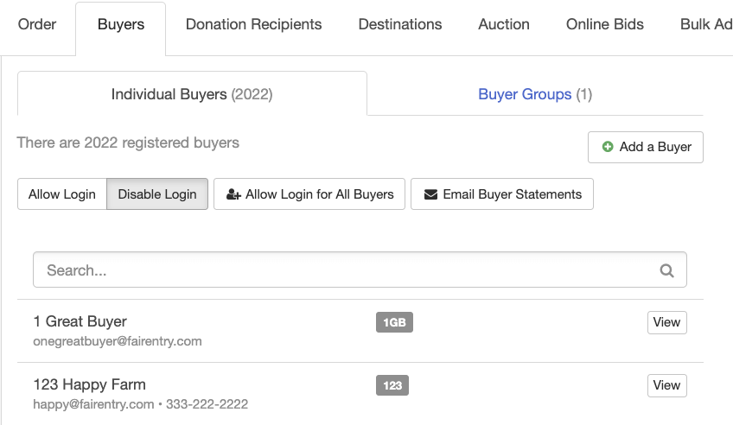
- Click to Edit the Online Account details.  - Select Yes for Allow Login  - Enter the buyer’s login email address.  - Click Save.  - The buyer will receive an email with their login information (if they do not have any other type of FairEntry account associated with the same email address). If a buyer has another FairEntry account with the same email address, they will log in using the same password that they have used for their other FairEntry account.  NOTE: If a buyer has any other type of FairEntry account with the same email address (buyer in another sale, staff member or exhibitor group), the manager will need to create the buyer account. | 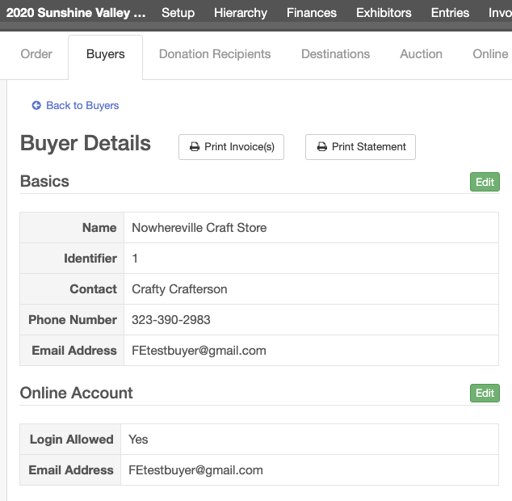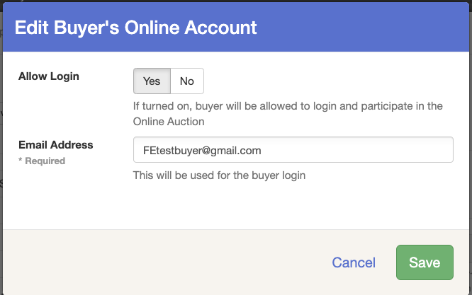
When “Allow Login” is set, and the buyer has an active Online account set to YES (see below) the “Login Allowed” icon will show for each buyer account on the main buyer page.  When “Disable Login” is set, or if an individual buyer does not have the Online account set to YES, their buyer account preview will not have the “Login Allowed” icon. | 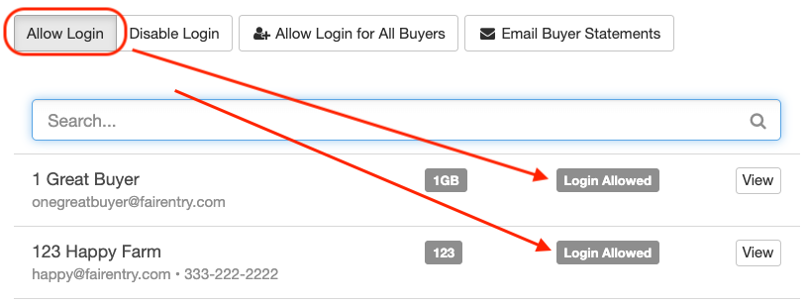  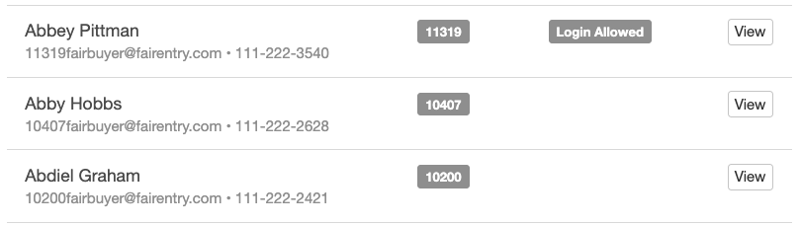
Preparing the Auction  - Click on the Sale tab and the Order subtab.  - Select to Edit your Sale Order.  - Click Edit next to Online Auction is turned OFF.  - Select to Enable Online Auction (ON)  - Select to Enable Add-ons and or Bids.  - Enter the Start Date and time and the End Date and time.  - Click Save. | 