Custom Shows
Before You Start
Although there are Show Programs available as Standard Reports, you may wish to customize the class order, sort within the class, and/or fields included on the program. You can do that by creating Custom Shows. Once the show is created (divisions/classes defined, ordering, etc.), you can create both show programs and judging sheets.

Note: You can copy your Custom Shows from one year to the next, but be sure to check them over in case the hierarchy has changed, and to pull in current entries by using the “Refresh Data” button.
- To set up your show, select the Show tab, and the Shows sub-tab.  - Select “Add a Show”. | 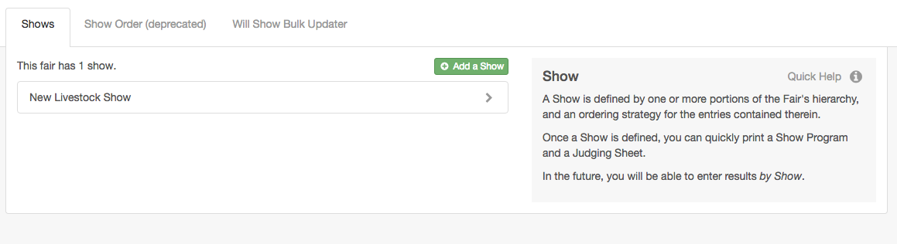
- Enter the name of the show—it will appear on the show programs and judging sheets.  - Note the available options for “Will Show” only, Virtual only, and In Person only. (When an entry is checked in, it is automatically marked as “Will Show” = Yes, unless it is manually changed to No. Entries that are NOT checked in will have “Will Show” = No, unless manually changed to Yes.)  - Select the departments, divisions and/or classes to be included in the show.  - Each area that has been added to the show can be re-ordered as needed, using the arrows and drag-and-drop. If you need to re-order classes that are in different divisions, be sure to use the “Select Children” button to add each of the classes individually so you can arrange them in the order you need.  Example: After highlighting a division, if you click Select, the entire division will be added to the list as one item; if you click Select Children, all the classes within the division will be added to the list as separate items. | 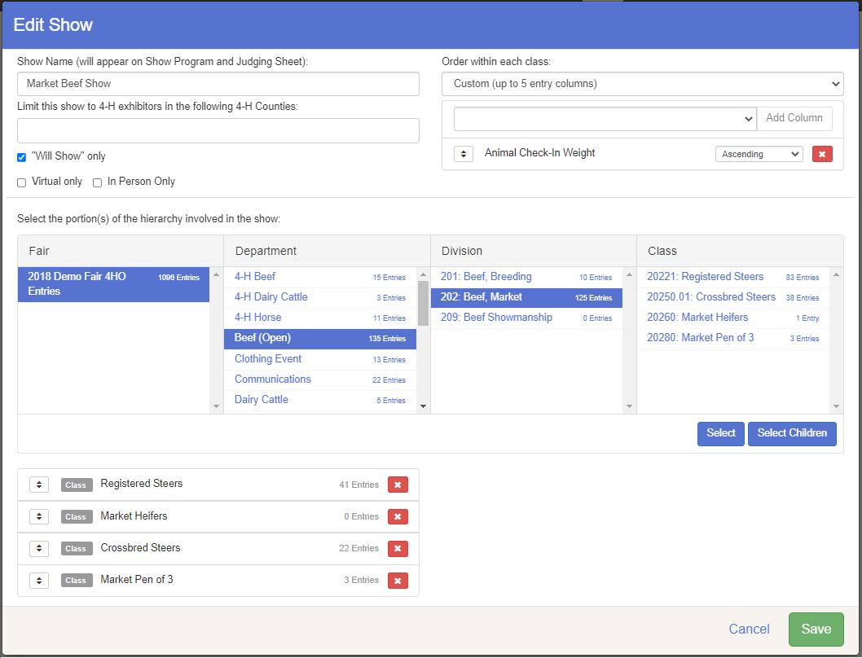
- Select how you would like the entries to be ordered within the classes.  - Class Breaks Order (then by exhibitor name) will put the entries in the order that you selected in Class Breaks. If two entries have the same criteria within the class (for instance, same weight), the two entries will be listed alpha by exhibitor name. If a class was NOT broken, it will be ordered alpha by exhibitor name.  - Random Order will randomize the entries in each class.  - Custom Sort will allow you to select up to 5 fields on which to sort. You may also select the direction you would like to sort (ascending/descending).  - Click Save to save this show. | 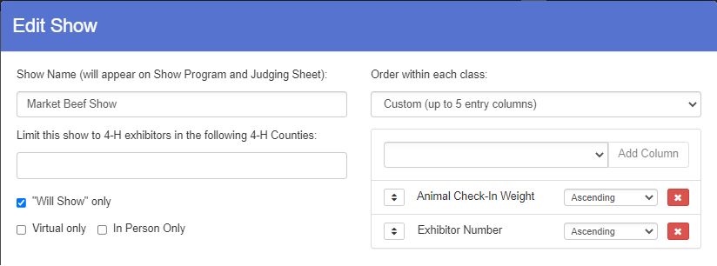
- IMPORTANT: When the Show is created, the sorting is saved to the database. If additional entries are added AFTER the show has been created, be sure to “Refresh Data” before printing the reports, or any new entries will be added to the end of the class and will not follow the sorting criteria. | 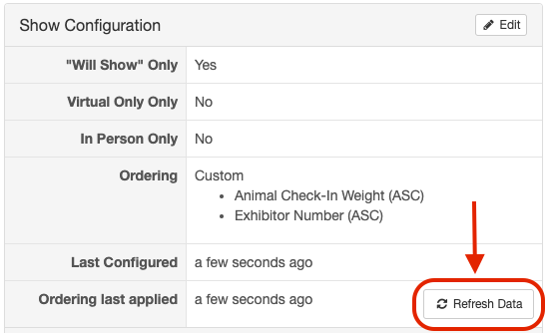
- Pre-formatted Judging Sheets and Show Programs are available for you to print. You can print a sample to see whether it’s right for your needs, or whether you need to Edit to add/change information for your show.  - Print Options -  - Show Fair Logo – in upper left-hand corner of first page of each report  - Page Break Between classes – prints one class per page  - Show Champion Lines – see Champion Lines Article in Help Center  - Show Grid Lines – lines to define each row & column  - Show Judging Signature Area – On Judging Sheet Only – at the end of each class | 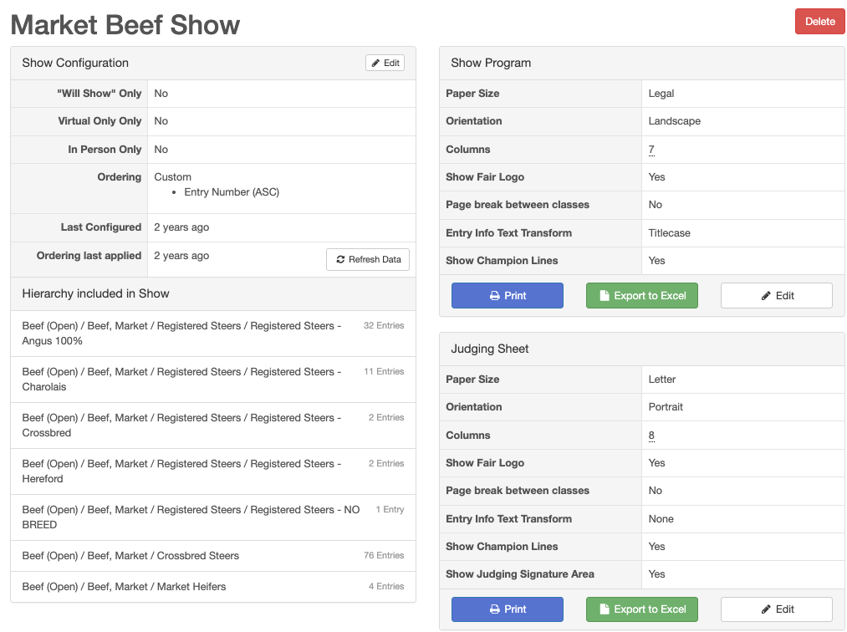

- If you edit the Show Program or Judging Sheet, click the Edit button and make your choices for paper size/orientation, print options, text case, and report columns to be included. Keep this information in mind as you make your choices:  - Columns will adjust to equal size based on the number of columns added to the report.  - Text in the columns will truncate (cut off) to fit in the width of the columns. Text will not wrap to a second line.  - The Show title and logos will only print on the first page of the report.  - If it is turned on, the Judges Signature area will print at the bottom of each page of the Judging Sheet.  - The Excel export option will export the raw data (clean export format) if further formatting/sorting is needed.  - To maximize space on the report, barcodes are placed very close together. You may need to use a blank sheet of paper to cover the barcodes below the one you wish to scan to ensure you are scanning the correct barcode. | 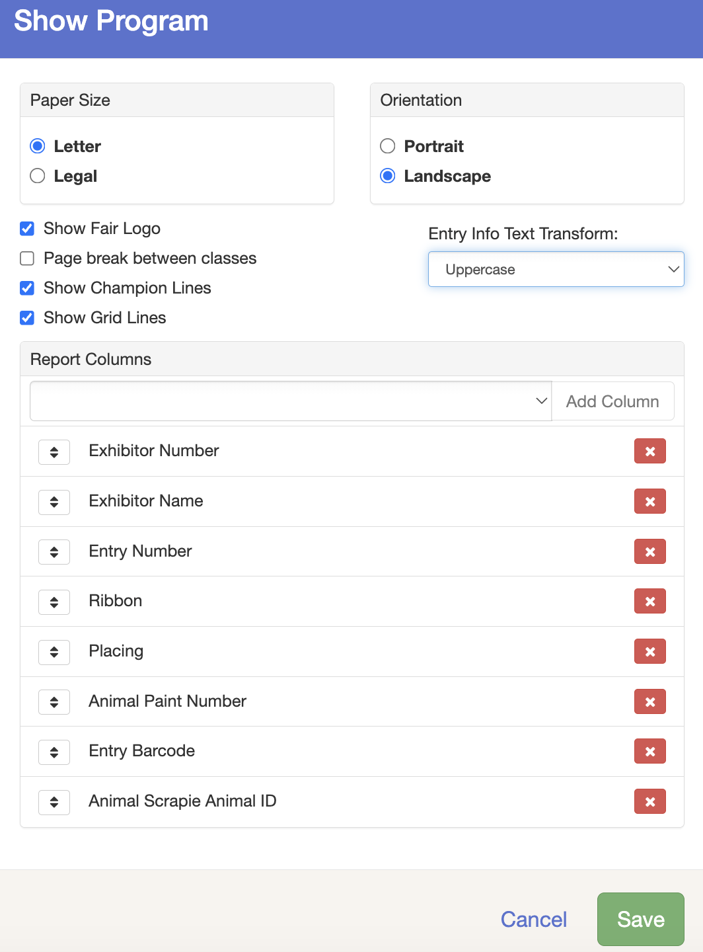  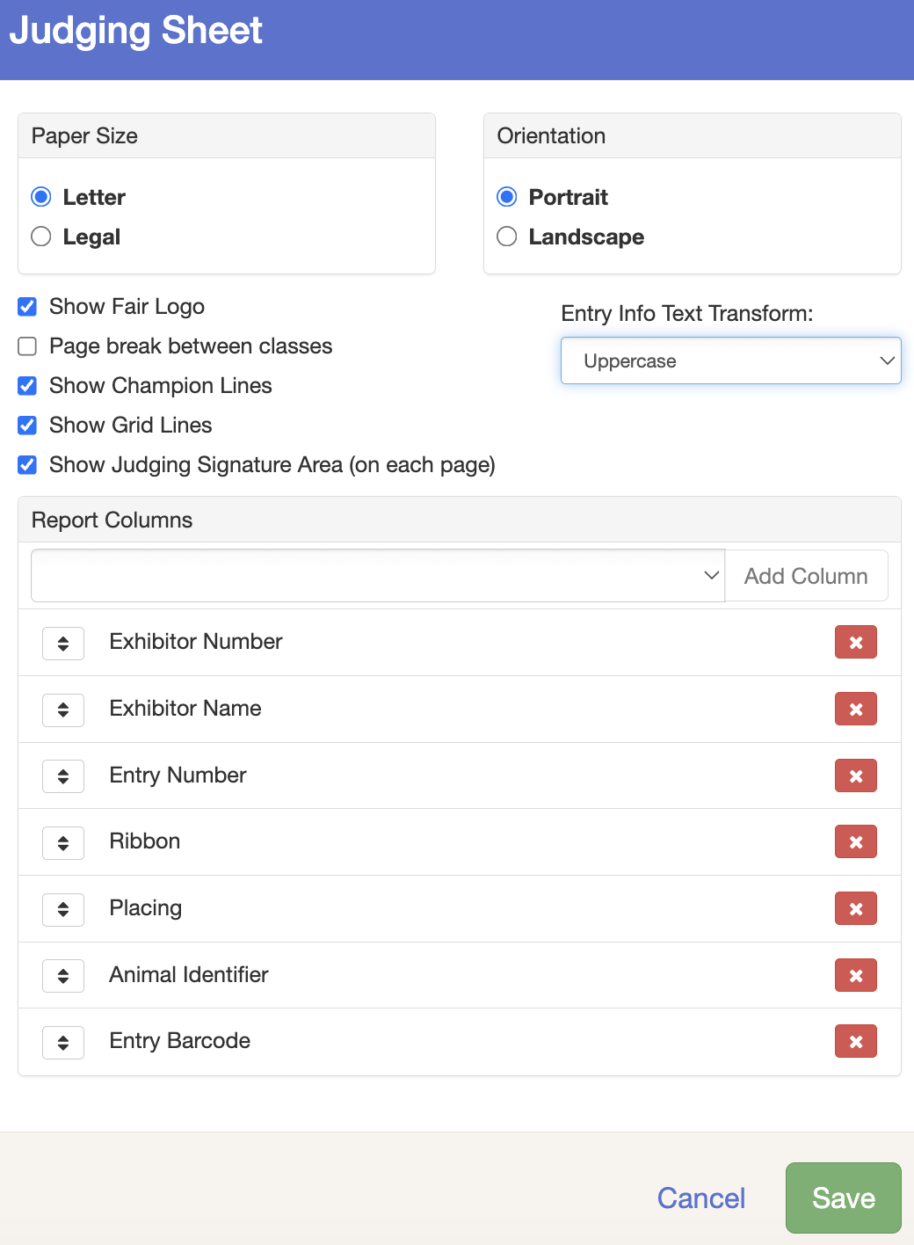
- Including the Ribbon and Placing fields on the reports leaves a blank space for placing, and an abbreviated list of available ribbons on the show program. If you reprint the report after results have been entered into FairEntry, the entered results will appear on the sheet. That report could then be used to post or proof results on paper.
