Setting Up Animal Identification
Before You Start
You can accept Animal Identification prior to your fair. It’s important to know that Animal Identification cannot happen concurrently with entries—it’s one or the other. Either your fair is open for Animal Identification, or it’s open for entries. If you inadvertently set the dates to overlap, Animal Identification “wins”, and your exhibitors/families will not be able to make entries until the Animal Identification process has closed.
If your fair has both 4-H, FFA, and Open exhibitors, the definition of the type of entry is important. An entry is designated as a 4-H entry when a 4-H Club is associated with that entry. If a 4-H Club is not selected (either another type of club is selected or an FFA club type is selected), then the entry is designated as “not 4-H”). An exhibitor could have both 4-H, non-4-H (FFA) and Open entries, depending on the club selection when they created each entry.

Steps  - The first step in accepting Animal Identification is simply to be sure that all your Animal Types are set up the way that you need them to be—all the correct fields, including whether they are required. For more information on setting up Animal Types, please see the Help Center article “Animals – Creating Animal Types in FairEntry”.  - Only the animal types linked in the hierarchy will be available for Animal ID – please see Help Center Article – “Linking Animal Types to Divisions”. If an animal type is linked for animal ID, then removed to “close” that species ID enrollment – the animals will not be able to be viewed by the exhibitor or manager until the animal type has been linked in the hierarchy again. | 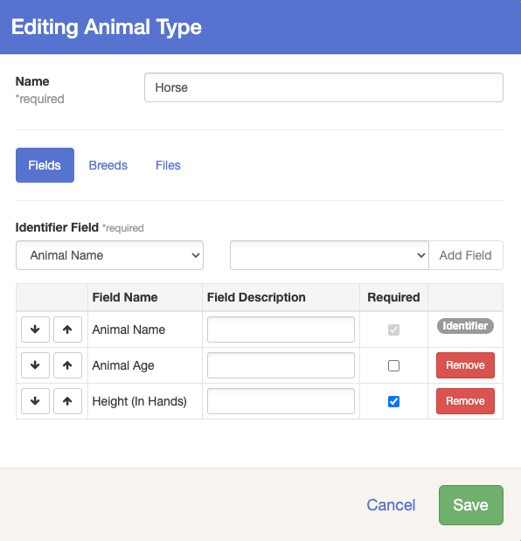
- To set your Animal Identification dates, go to the Setup menu, Fair Details sub-tab. Select “Yes” for Animal ID Registration, then enter the start and end dates for that process, remembering that entry registration cannot happen during those dates.  - Only the animal types that are linked in the hierarchy will be available during the dates set in the Animal ID Registration. The availability of each species (animal type) can be controlled by adding or removing the animal type from the Hierarchy.  - The Animals listed in the Animal Type dropdown list in the Animal Tab – are the ones that are currently linked in the hierarchy and available for Animal ID & adding animals to an entry during registration.  - To control what animals can be added during Animal ID, you can remove an animal type from the hierarchy. For example, if your Market Beef are only open until January 31st, but Market Lambs & Goats opens on February 1^{st,} you can remove the Market Beef Animal type in the hierarchy link and add in the lamb & goat animal type. If you do this, it will hide any animals added to the Market beef animal type from the manager/exhibitor view but will re-populate once the animal type has been added back to the hierarchy. | 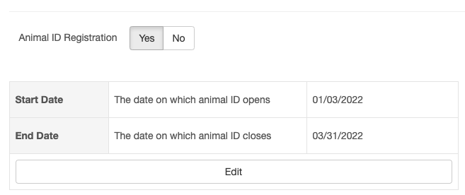  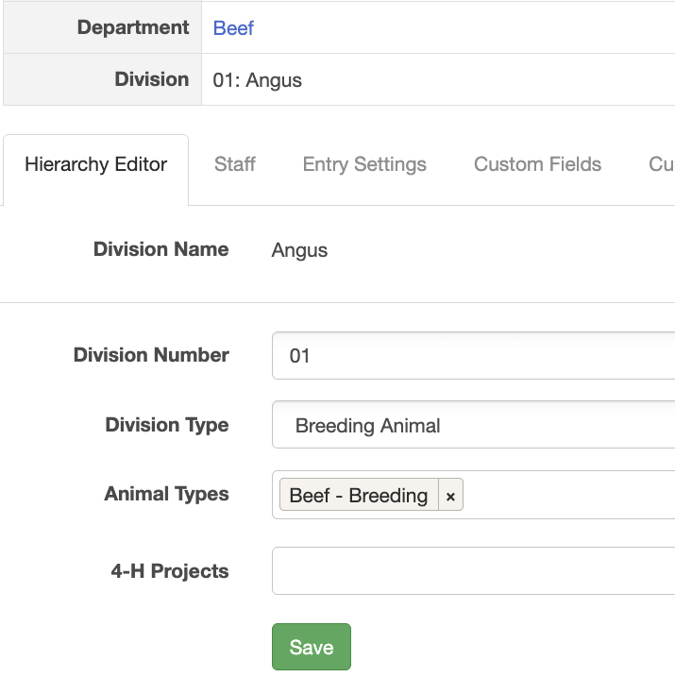  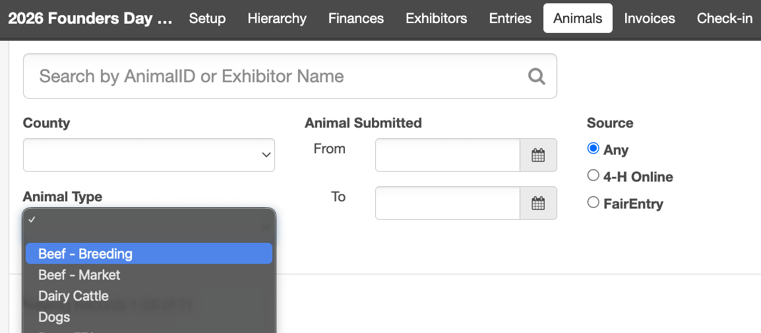
- Check your Registration Open/Close Dates using the Hierarchy menu, then Entry Settings. | 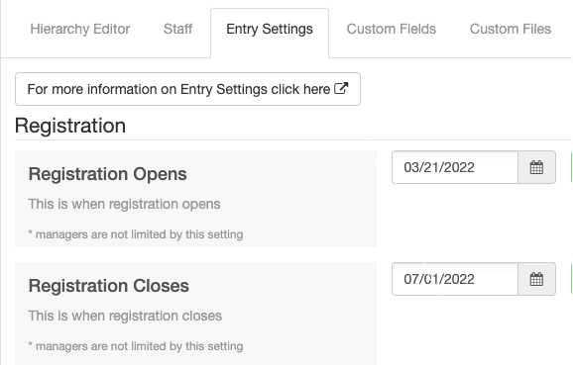
- Your Fair’s home page will reflect the Animal ID and Registration dates. When the exhibitor/family signs in, they will be able to register their animals, but not make entries. This screen is correct—the Animal ID is closed before Entry Registration opens. | 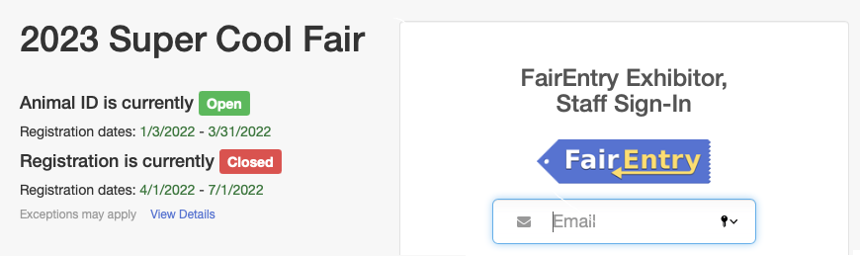
- This screen can be misleading for families, because the Animal ID and Entry dates overlap. Exhibitors will only be able to identify animals if they log in at this time. They will not have the option to go on and add entries. | 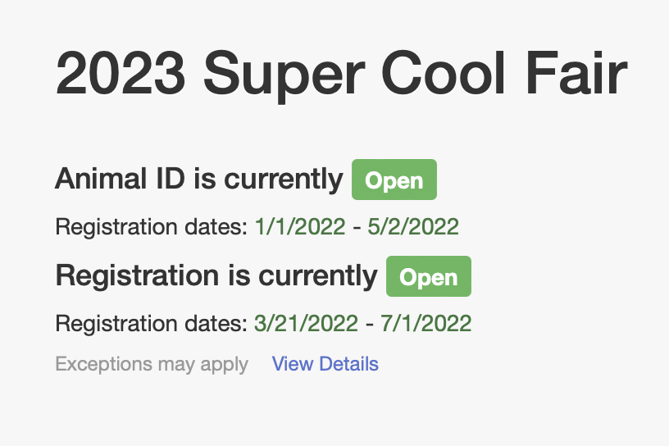
- You can use Entry settings (at any level of the hierarchy) to determine whether your exhibitors can ONLY use animals that were identified during the pre-fair Animal ID period, or they can add new animal information as they make their entries.  - An entry is determined to be “4-H” or “Non 4-H” at the time the exhibitor selects the club for the entry.  - The default on both settings is “Yes”, and it can be changed at the Fair level, or any lower level as necessary.  - Yes = the exhibitor will be able to create a new animal for an entry at the time they are making the entry, or they can select an existing animal.  - No = the exhibitor will only be able to select from animals that have been previously identified in either 4-H Online or FairEntry. | 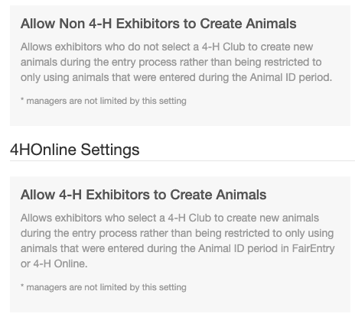

Animal Search and Reporting Options for Managers
Once exhibitors have entered their animal information, managers can search, view and download an Excel file of the animals, whether there are entries tied to the animals yet.

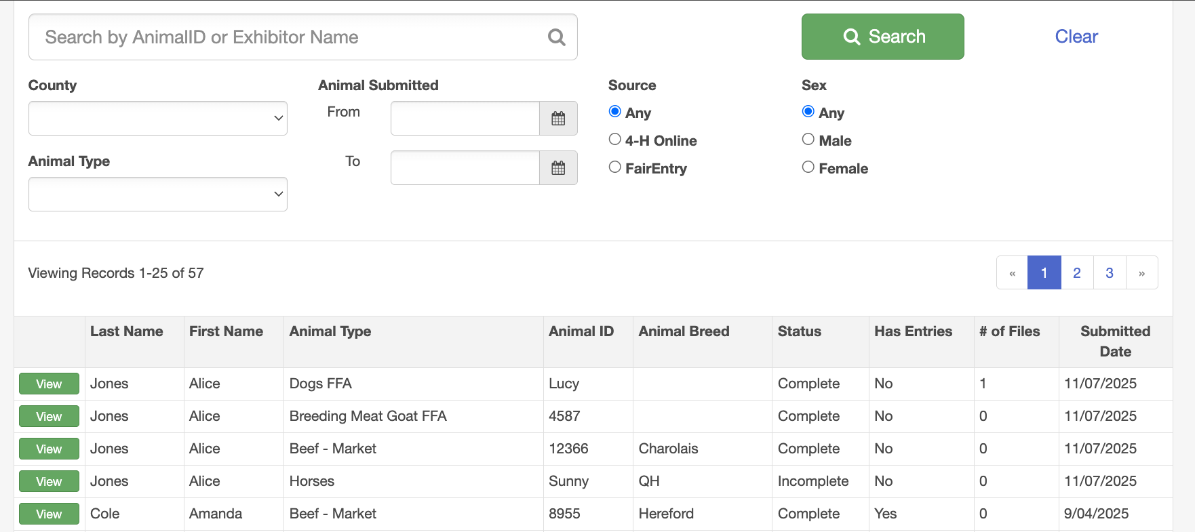
Animal Search Screen

In the top Menu, there is an Animals option after the Entries menu.
The fields included on the screen are Exhibitor Last/First Name, Animal Type, Animal ID (Tag, Tattoo, or Animal Name, as set up in Animal Types), Animal Breed, Status, Has Entries, Files, and Submitted Date. (The Submitted Date field only shows up for records created in FairEntry, not the ones created in 4-H Online.)

You can filter (Search) by:
- Animal ID (Tag, Tattoo, or Animal Name, as set up in Animal Types)
- Exhibitor Name
- Exhibitor County (if the exhibitor logged in through 4-H Online)
- Animal Type
- Identification Submission Date
- Source (where was the animal identified—4-H Online or FairEntry) The 4-H Online animals will only appear after 4-H Online integration has been approved, member records have been imported, and the exhibitor has created entries using their 4-H Online animals.
- Sex (of the animal, if that field was used in the Animal Type).
After you select your search criteria, click the Search button. Use the Clear option to remove any search criteria and view the entire list.

*Animals showing as Incomplete on the Status column, will not be available for entry selection until the required animal type information has been completed. A manager will be able to update/edit any incomplete animal information if Animal ID has closed and Exhibitor no longer has access.
*Animals added during the Animal ID process will show as Incomplete until all required animal information has been completed. Once the required information has been provided, the animal will show as Complete and be available for selecting during the registration/entry process.
*Animals added during the entry process will show as Incomplete until the entry the animal is associated with has been approved.

Clicking the View button beside an animal record brings up the complete information about the animal, as well as entry information, if the animal is part of an entry.  - The green 4HOnline logo below the exhibitor’s name indicates that the exhibitor logged in through 4-H Online.  - The green 4HOnline logo on the Animal record indicates the animal was identified in 4-H Online.  - If there were files uploaded as part of the animal identification in 4-H Online, there is a link that opens the file in a separate browser tab. (The files that were uploaded with the animal ID in FairEntry are visible on screen.)  - Managers can edit animal information by clicking the green Edit button.  - If entries have been made using the animal, they show up in a list below the animal information. There is a View button that would take you to the details of the entry.  - To return to the Search screen, click the Animals tab in the menu bar. | 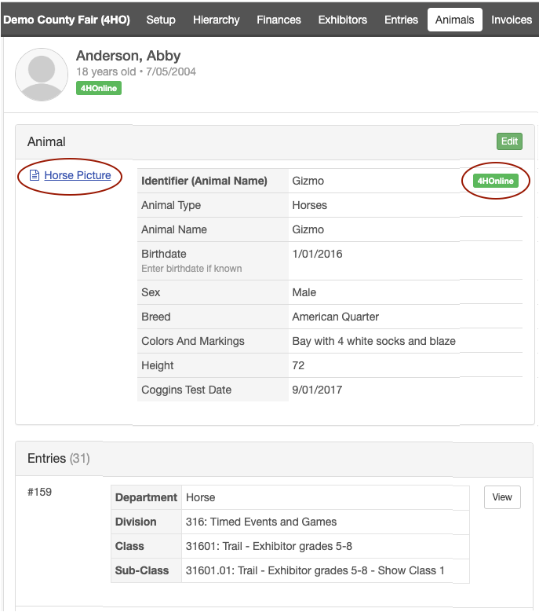
DELETE ANIMAL - To be able to delete an animal it must NOT be associated with an entry. The delete button will be inactive if the animal is a part of an entry. To view delete button you must click View button for animal detail. The Delete Button is only available through the Animals Tab. | 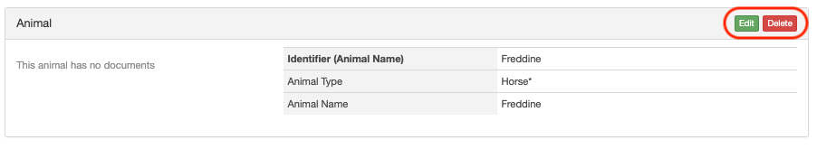
To create an Excel file of the identified animals, click on the Reports tab on the menu bar, Standard Reports, Animals, Animals by Animal Type.  Select the Animal Type from the drop-down list, then click Download Report. | 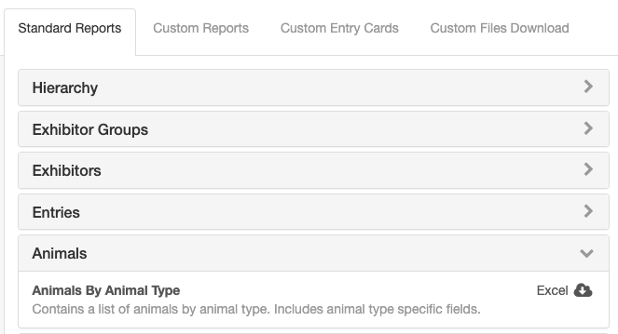
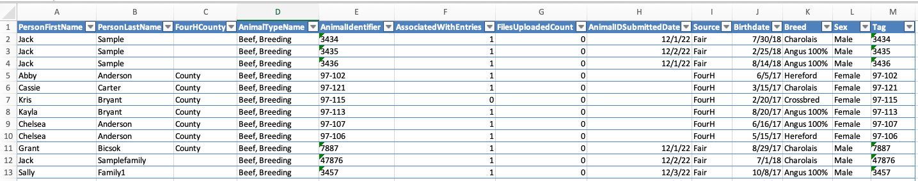
The fields from the Animal Search screen are included, followed by any other fields that were used for that animal type.

Animal ID Process for Exhibitors
These are the screens/steps that families and exhibitors will see when they log in to identify animals.

Steps  - After logging in, the exhibitor will click on the Register an animal button. There is no option to make fair entries. | 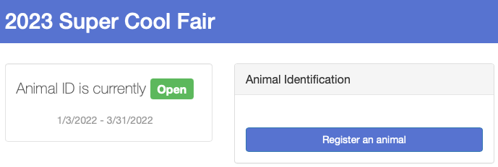
- The first step is to register the exhibitor. There are 3 screens to complete:  - First Name, Last Name, Birthdate, Grade – Names are required, Birthdate and Grade are controlled by your entry settings.  - Contact Info – Phone is required, email, cell phones are optional.  - Address (required)  - When those 3 screens are complete, there is a Continue to Animals button on the Review screen. | 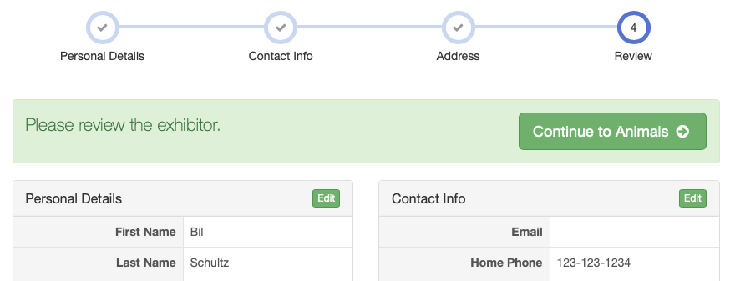  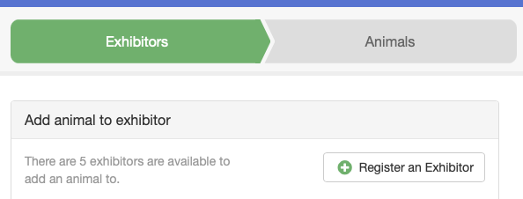
- The first step is to select the Animal Type to be identified. Only the animal types linked in the hierarchy will be available for Animal ID. | 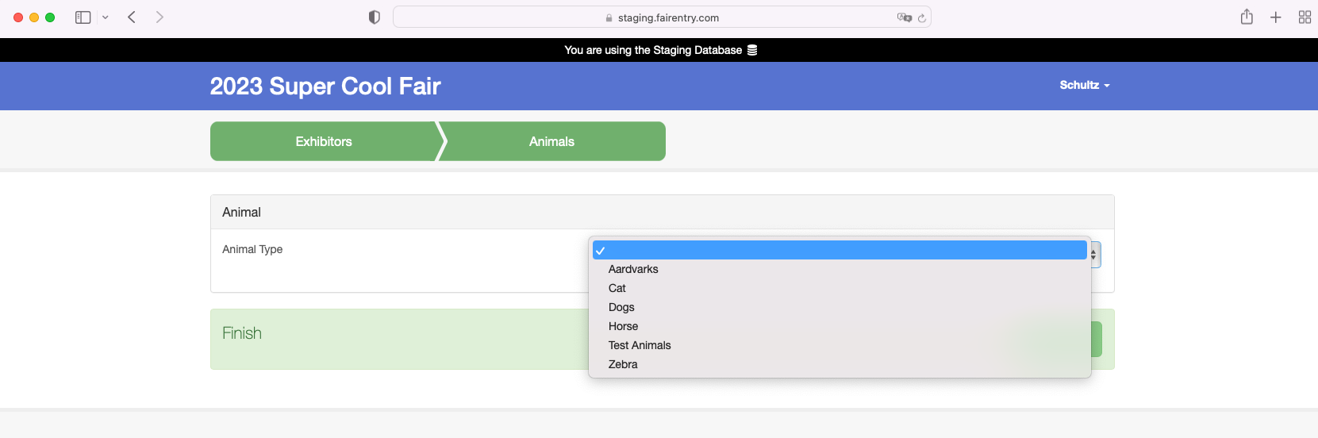
- After all fields are complete, the exhibitor will either see a Continue to Upload Files option (if you have set up Files for this Animal Type) or a Finish button. Files uploaded must be either PDF or an image file (GIF, JPG, PNG, TIFF). | 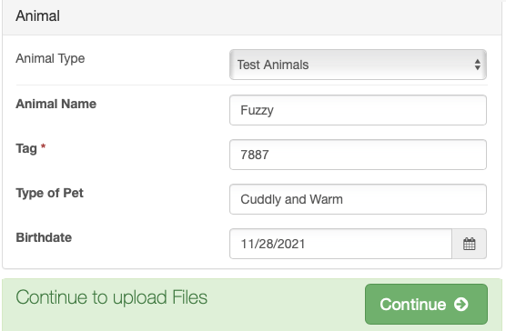
- After clicking Finish, the exhibitor is taken to a list of all exhibitors/animals for this family. There is an option beside each to Add an Animal for that exhibitor. There is also an option to Edit existing animals. To add a new exhibitor to the family, click on the green Exhibitors tab at the top of the screen. | 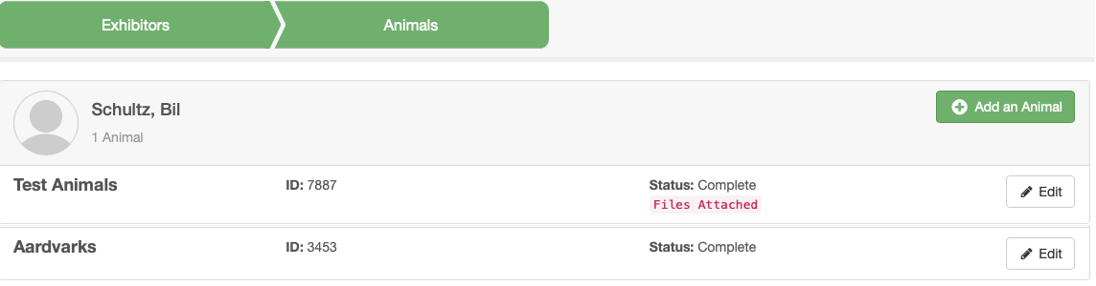
Note: Exhibitors can edit/update their animals adding during Animal ID if Animal ID is open. Once Animal ID has closed, the exhibitor no longer can edit their animals. Managers will be able to edit/update animals once they have been added to the exhibitor’s account.

