Assigning Credit Card Fees to Exhibitors
Before You Start
For Fairs that charge exhibitor or entry fees ( or custom field fees), credit card fees can be a burdensome expense item, but often exhibitors prefer using credit cards instead of checks or cash. Transferring the credit card fees to the exhibitor group allows the Fair to offer that convenience, without incurring additional expense. Only exhibitors who choose to use credit cards will be charged the fee.
Steps  - Select the Setup menu, then the Fair Details tab. There are 4 options below the Start and End date of the fair. Select Yes on “Recover Exhibitor Fees” to have credit card processing fees added to the exhibitor’s invoice.  - If you have not previously accepted credit card payments at your fair, go to the Setup/Payment Integration tab, click Connect with Stripe, and enter your information for the account. | 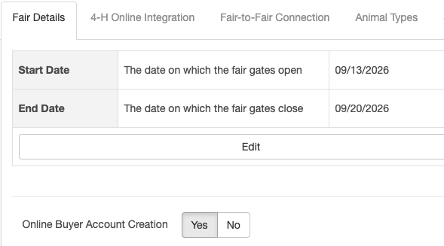      
- Exhibitor logs in and creates entries for registration during the payment process they will select to pay online by credit card. | 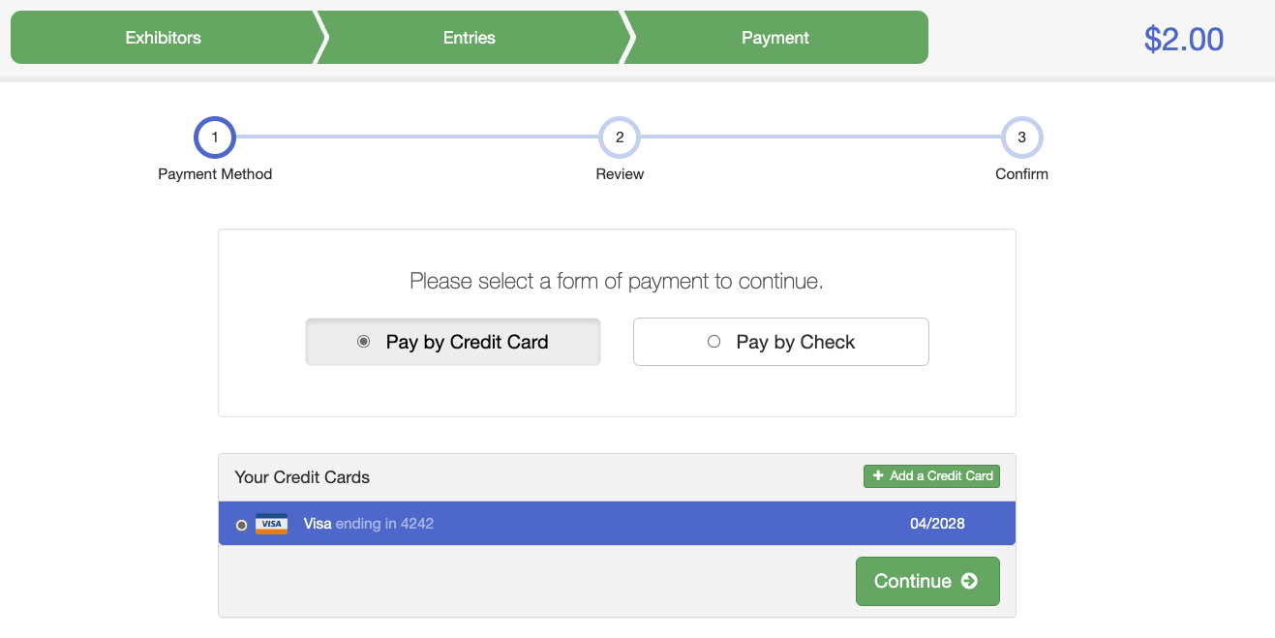

- After selecting credit card as payment method and adding their card information, the final screen displays the total payment, including the processing fee.  - Once the exhibitor clicks Submit, their card will be charged that amount upon entry approval, and they will receive an email receipt at the email address they used to log in. | 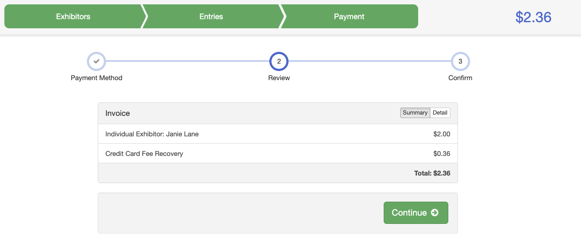  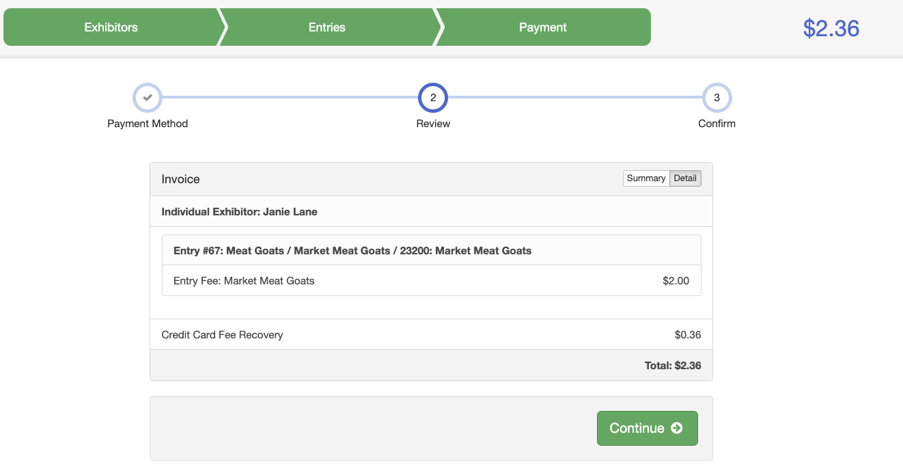  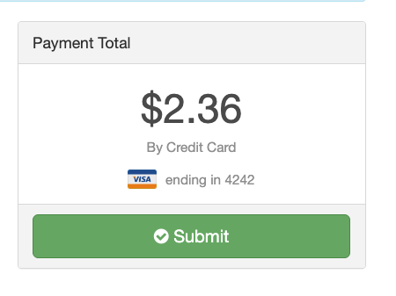
- Submitted Entries can be viewed and approved on the Invoices – Awaiting Approval tab. The total shown in the preview will include the credit card fee to be charged to exhibitor upon approval.  - If Bypass Invoice Approval is set to Yes (under Setup – Payment Integration) the registration is automatically approved upon submittal and credit card fees are assessed at that time. | 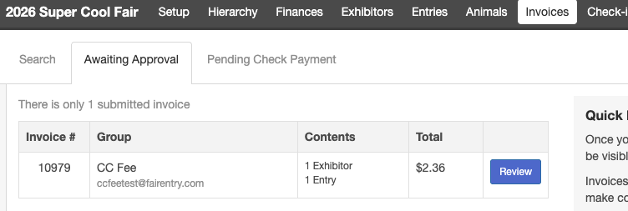
- Printed Invoices: These do reflect the credit card processing fee if the exhibitor has chosen to pay by credit card. | 
Tips
- Your exhibitors will need to login to their exhibitor account to pay by credit card—there is not an option for managers to enter that information for them, for security reasons.
- Due to rounding, a customer’s credit card fee may occasionally be a penny more or less than the actual fees deducted by Stripe from the payment.

