Using the Resale Feature
Before You Start
This help sheet will guide you through the process of creating Donation recipients and using the Resale feature. A sale entry may be resold as many times as needed. The proceeds of the sold item may be distributed to the owner/seller, the exhibitor, or a donation recipient or any combination thereof.

The first time an item is sold, the owner/seller is the exhibitor. Each time it is re-sold, the owner/seller is the person or entity that purchased the item the previous time. The exhibitor is no longer the seller after the first sale.

Please note: It is important that a sale item does not have a destination and/or flooring information entered until the final time it is sold.

Adding a Donation Recipient
- In the Sale area, click on the Donation Recipients tab.  - Click the +Add a Donation Recipient button.  - Note: Do not add the exhibitor as a donation recipient—there is an option to select the exhibitor when you designate the recipient. | 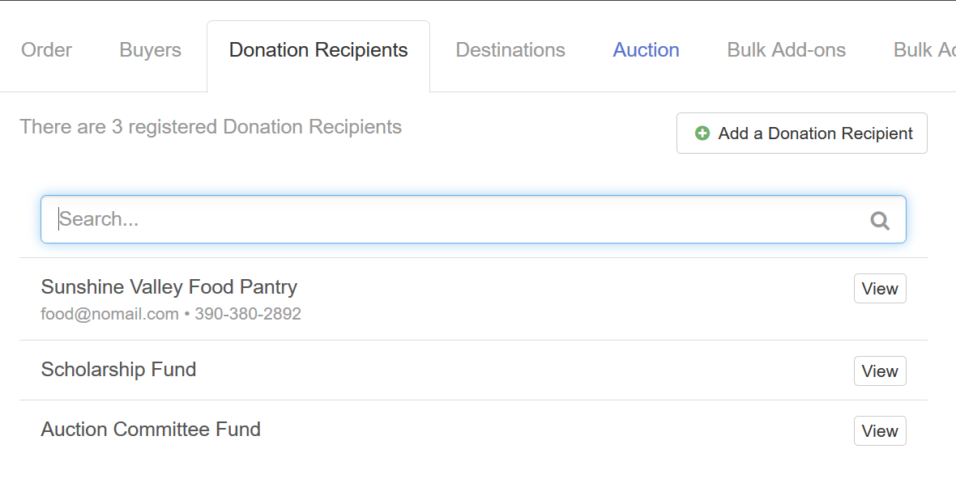
- Name is the only required field for donation recipients. However, if proceeds are to be mailed to this recipient, you will also need to complete the Address fields.  - Phone Number, Email address, and a Contact Name are available if that info is necessary.  - Click Save to save the donation recipient record.  - Repeat Steps 2 – 5 for each Donation Recipient that you need to add. | 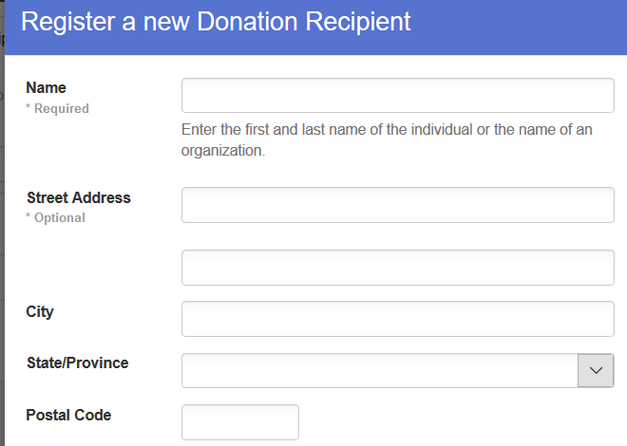

Reselling an Entry
Steps  - After selling the entry, record the total bid amount, and record the buyer contributions and click Save.  NOTE: Do not assign the entry to a destination or add flooring information until the item is sold for the last time.  - Click the red ‘Sell It Again’ button to create the new sale entry for the item to be sold again. | 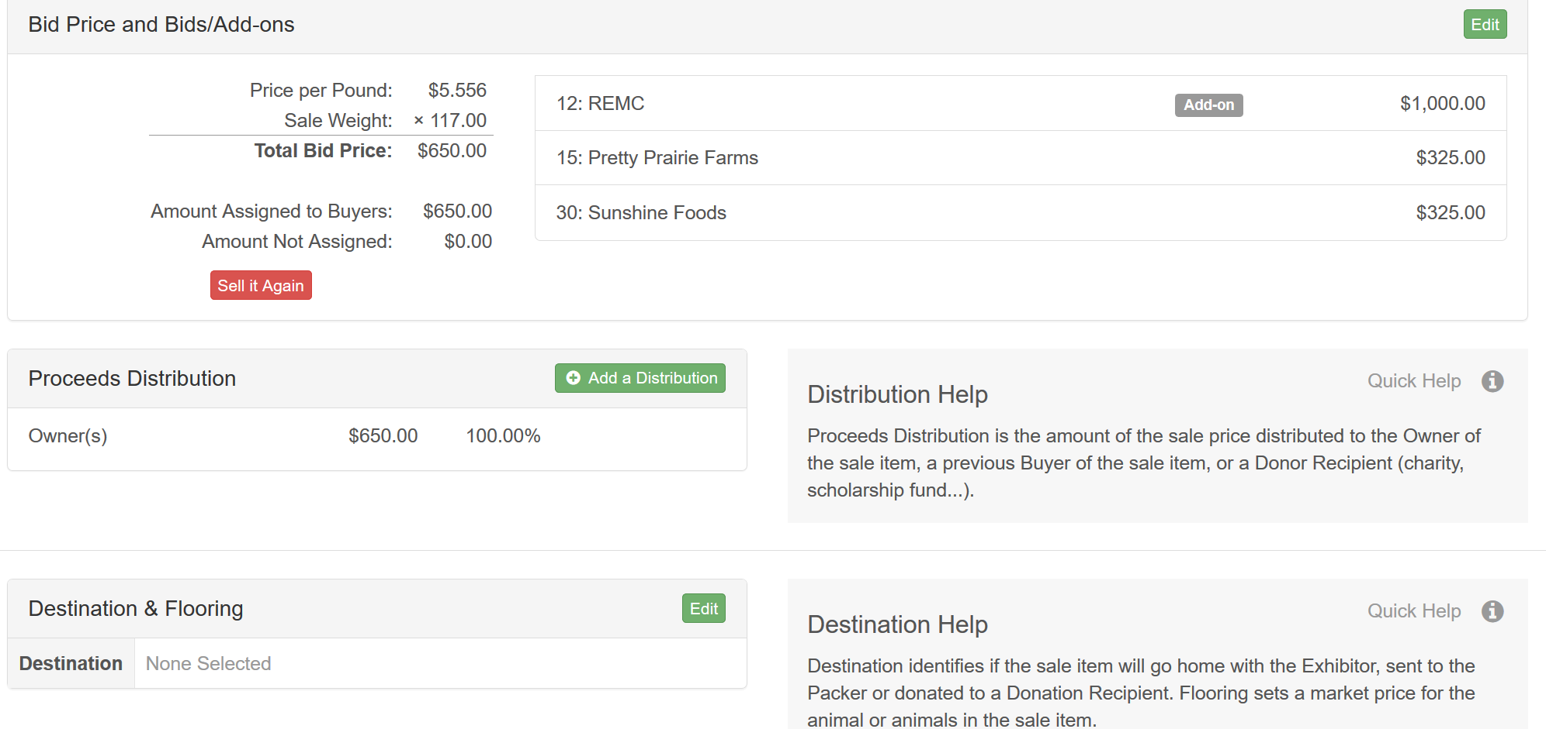
- After clicking ‘Sell It Again’ a popup window will appear.  - Click Save to lock the record (Bid and Buyer information) and create the resale item (it will have a new sale order # similar to 14.1, where 14 is the original sale order #) or click Cancel to return to the item to make any corrections to the sale information. | 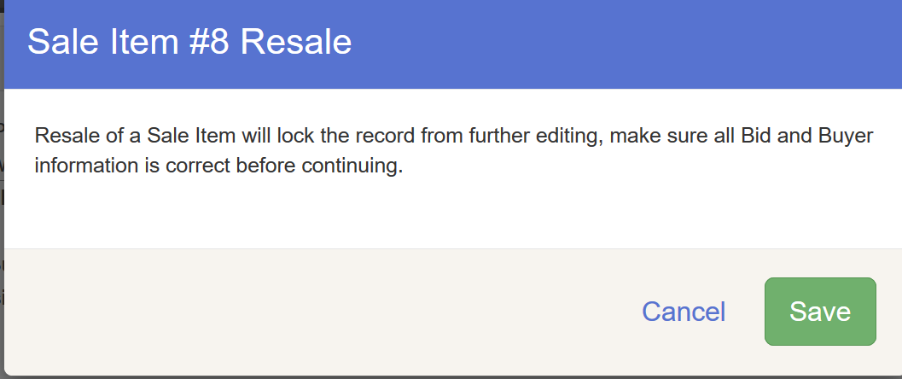
- If the bid amount will be donated to a recipient other than the owner(s) listed at the top left of the screen, click the green Add a Distribution button to select the recipient and amount. | 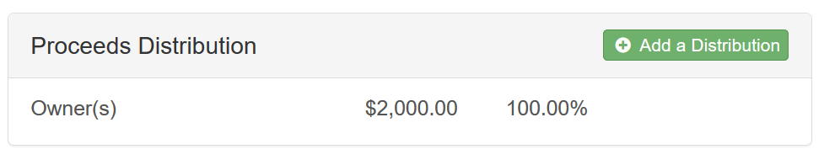
- Use the drop-down menus to select the Recipient (Exhibitor or Donation Recipient).  - Select the name of the Donation Recipient.  - Enter the amount or percentage to be distributed to the Donation Recipient.  - Click Save.  - Repeat steps 4 – 8 to add additional donation recipients until the total bid price has been distributed among owners (if applicable) and other donation recipients. | 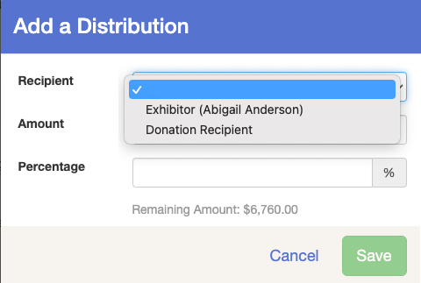
- Verify the amounts in the Proceeds Distribution. | 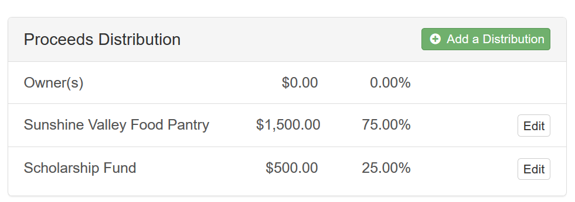
- After the item has been sold for the final time, you may assign the item to a destination using the drop down menu.  - If the animal is being floored, click on Yes for Floored and make any adjustments to the floor price. | 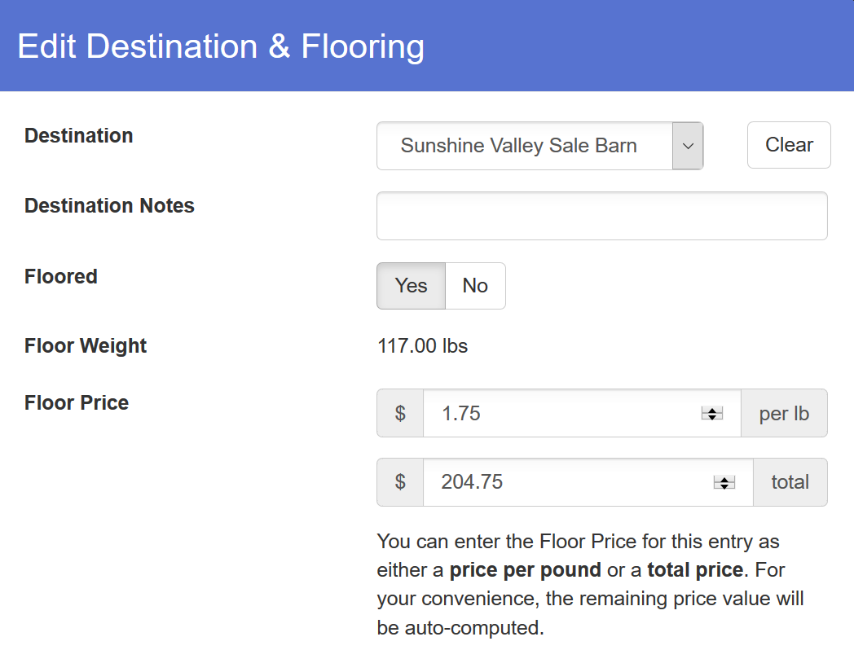
- Check the correct option for how the floor value of the animal is being assigned. If you select Donation Recipient, a drop-down menu will appear for you to select a single Donation Recipient to receive the floor value of the animal. Even if there are multiple Donation Recipients, only one can be selected to receive the Floor Value.  - Click Save. | 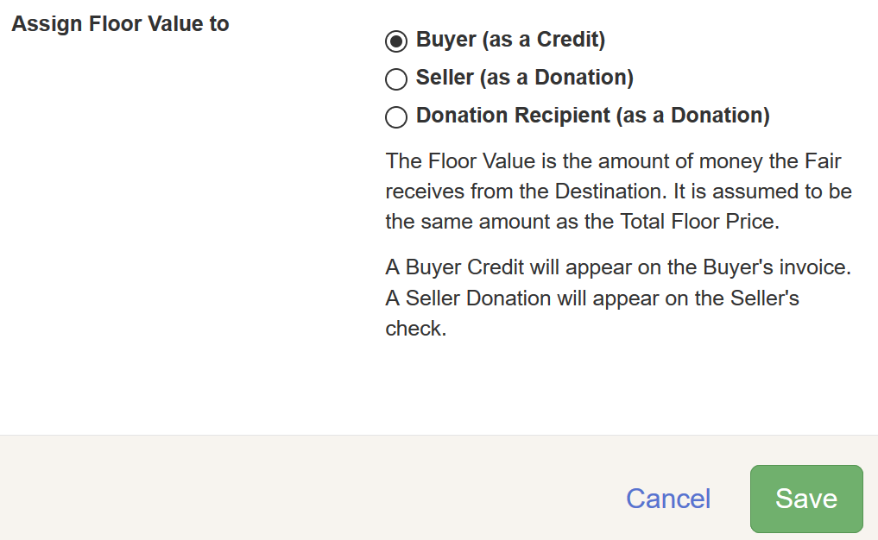
Tips
Sale items with a destination may not be sold again. If you have entered Destination and Flooring information for an item, you must remove that in order to be able to resell the entry. The Destination and Flooring information should only be added to the sale item for the final time it is sold.

