Recording Sale Information
At the sale, you can enter the bid/buyer information for each sale item, including any add-ons, adjustments (discounts or credits), destination, and flooring information.

Enter Auction bids:  - Select the Auction tab.  - Click View next to the correct Sale Order.  - Click View next to the entry you wish to edit. | 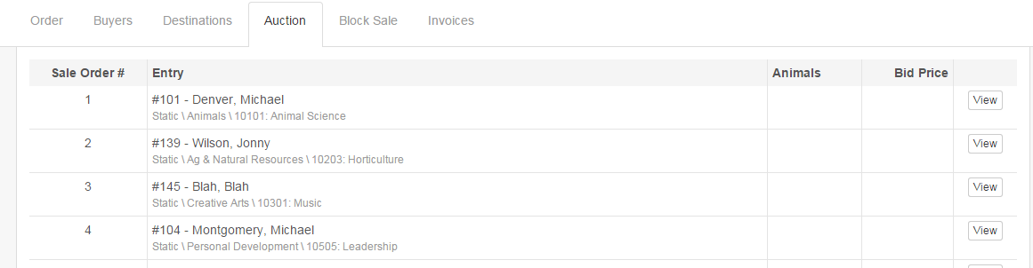
- Click Edit to open the bid and buyer window. | 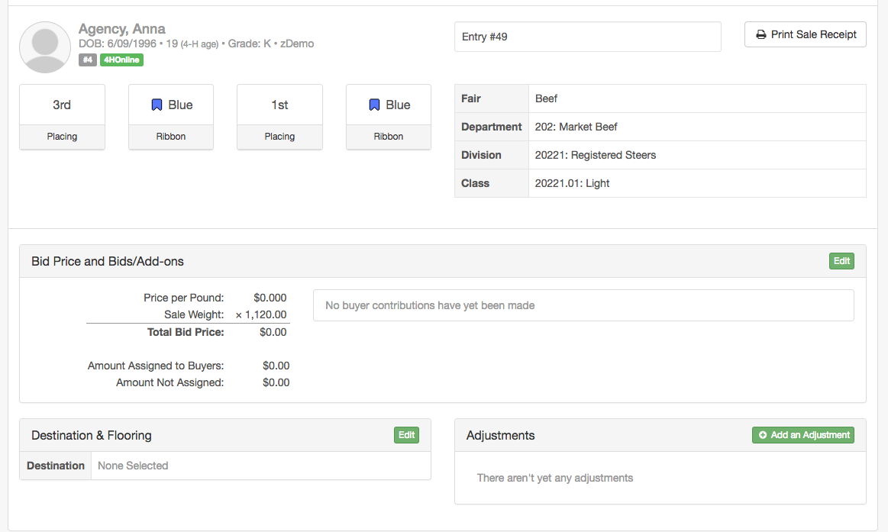
- Enter either a Price per Pound or Total Bid Price (entering one will calculate the other)  - Click in the Buyer drop-down or use the tab key to navigate to the Buyer drop-down list.  - Select the buyer from the pull-down, or type in the Buyer’s number. The green “plus sign” at the upper right of the Buyer section adds another line for a buyer, if you need one.  - If you would like to add a group of buyers to the list of buyers, first select the Group from the drop-down at the bottom. Click Add Group.  - Tab or click in the Amount or % of total for each of the buyers. As you add amounts, the program calculates the remaining amount to be assigned on the left side of the Buyer section.  - When set to Auto, the system will give a warning/explanation, and then automatically enter the bid amount for the Buyer Contribution and split the bid equally among multiple buyers. If multiple buyers are paying different proportions of the bid price, use the Manual button to enter the Bid Contribution Amounts manually. | 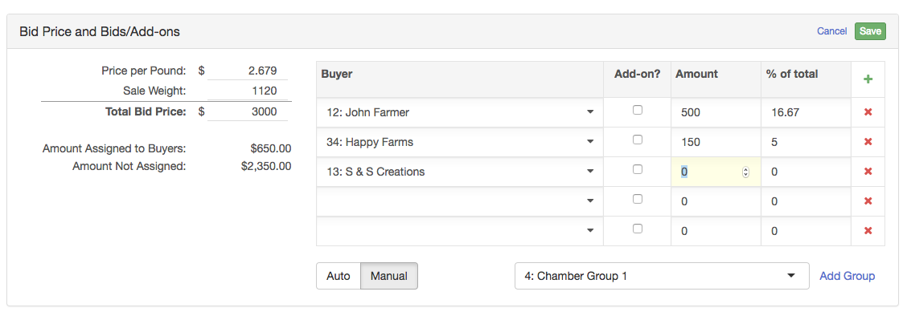
- If the amount is an Add-on, check the Add-on checkbox.  - After all buyers and bids have been added, be sure to click “Save” at the top right of the window. | 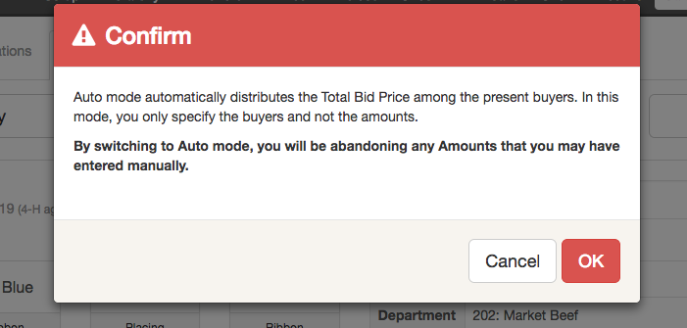  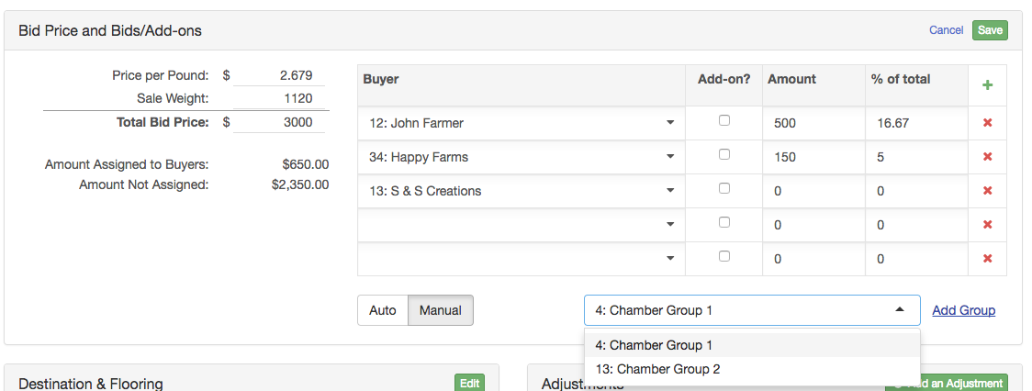
- If the buyer(s) choose to send the item through the auction ring a second time, click “Sell it again.”  - After clicking “Sell it Again,” the bids, buyer contributions and add-ons will be locked on the original sale item. The buyers associated with the initial sale of the item become the new owners. Click “Save” to go on to re-sell.  - Enter the re-sale information (bid, buyer, etc.) and be sure to click Save before going on to add a distribution or sell again. You may re-sell an item as many times as you would like. | 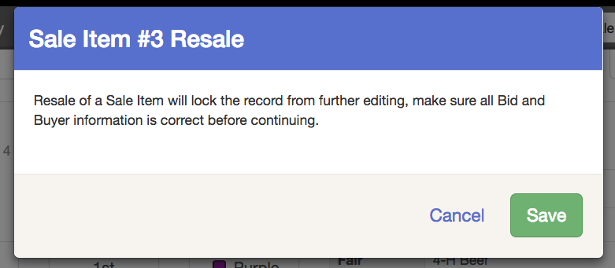  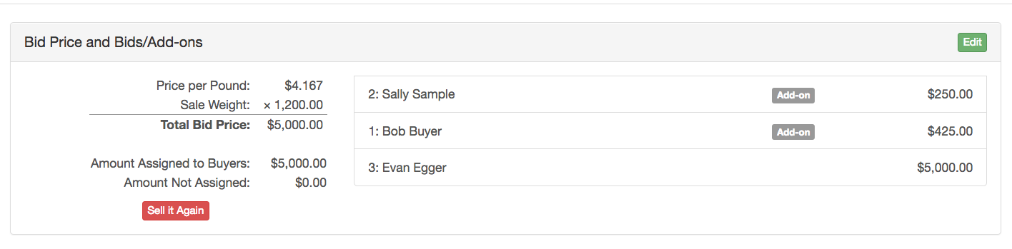
- By default, the funds from the sale of an item will go to the new owners. In the case of an item that has been resold, the new owners are the buyers who last purchased the item.  - If the funds from the sale (or resale) of the item should not go to that previous buyer (new owner), click “Add a Distribution.”  - Select the Donation Recipient (or Exhibitor).  - Enter the amount that should go to the selected entity. Any remaining amount will be assigned to the Owner(s) – the previous buyer. | 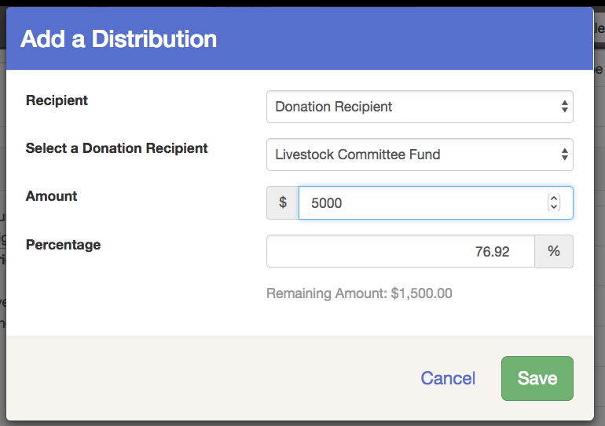  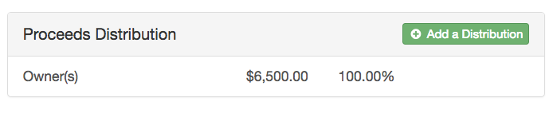
- After the item has sold for the final time, you can enter the item’s Destination (where the animal is going) and Flooring information (how much the processor is going to pay for the animal).  - Click Edit in the Destination & Floor section to add details about the entry’s destination and flooring (packing). If the item is marked as Floored, you may designate whether the floor value is to be assigned to the buyer as a credit or to the seller as a donation. If the Buyer is selected, the amount will be reflected as a credit on the Buyer Invoice. If the Seller is selected, the amount will be reflected on the Seller’s check.  If a Donation Recipient is selected, the amount will be reflected on the Donation Recipient’s check. | 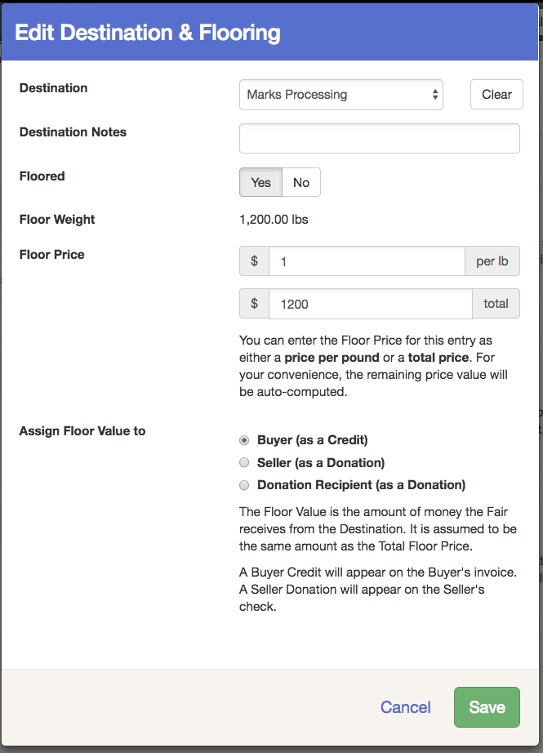
- Click Add an Adjustment in the Adjustments section to add adjustments (seller or buyer fees).  NOTE: You can add adjustments in bulk using the Bulk Adjustments tab. | 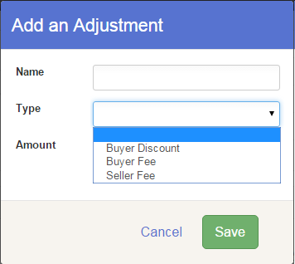
- Click “Print Sale Receipt” if you wish to print a receipt for the sale of this entry.  - Click Next Entry at the top to right to navigate to the next entry in the Sale Order. To return to a list of all entries, click the Auction tab at the top. | 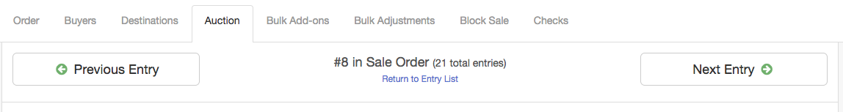  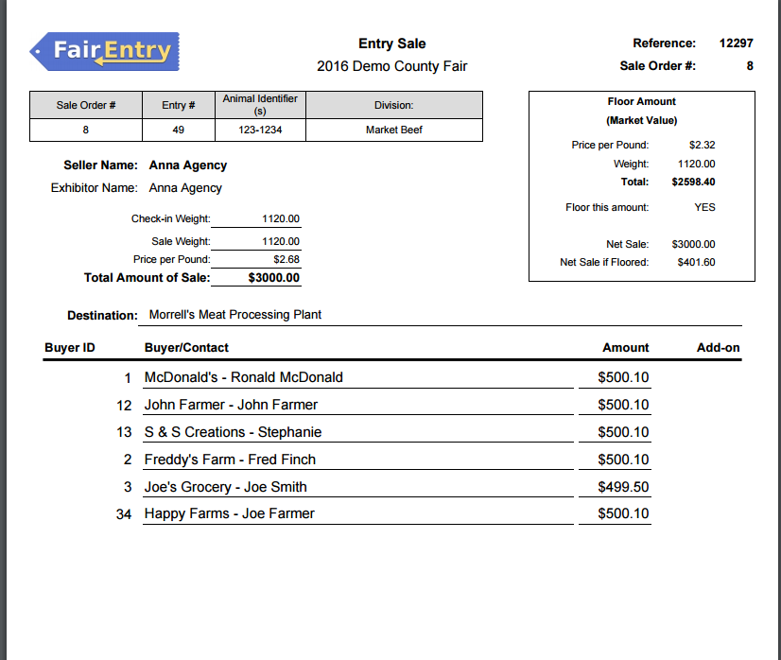
Bulk Add-ons:  Instead of entering Add-ons for each individual sale entry, you can enter them in bulk for several entries at once:  - Click on the Bulk Add-ons tab.  - Select the correct Sale Order.  - Select a Buyer.  - Enter the Add-on Amount.  - Select entries for which the add-on will be applied (notice the Division Filter and Select All option).  - Click Action “Create” (or Delete to remove incorrect Add-ons).  - Click the green Continue button. | 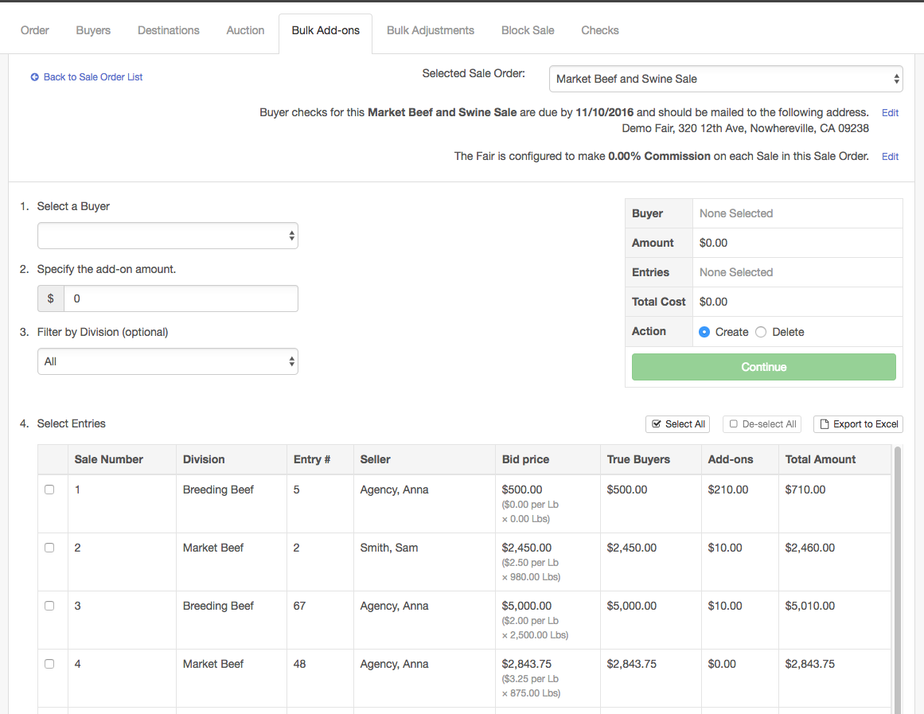
Bulk Adjustments:  Instead of entering adjustments for each individual sale entry, you can enter them in bulk for a several items at once:  - Click on the Bulk Adjustments tab.  - Select Sale Order.  - Select Adjustment Type (Buyer Discount, Buyer Fee, Seller Fee)  - Select Calculation method (Flat Amount, Percent of Sale Price, Percent of Add-ons, Percent of Total Amount)  - Enter Description/Name of Adjustment.  - Select Entries for which the add-on will be applied (notice the Division Filter and Select All option).  - Click the green Make Bulk Adjustment button. | 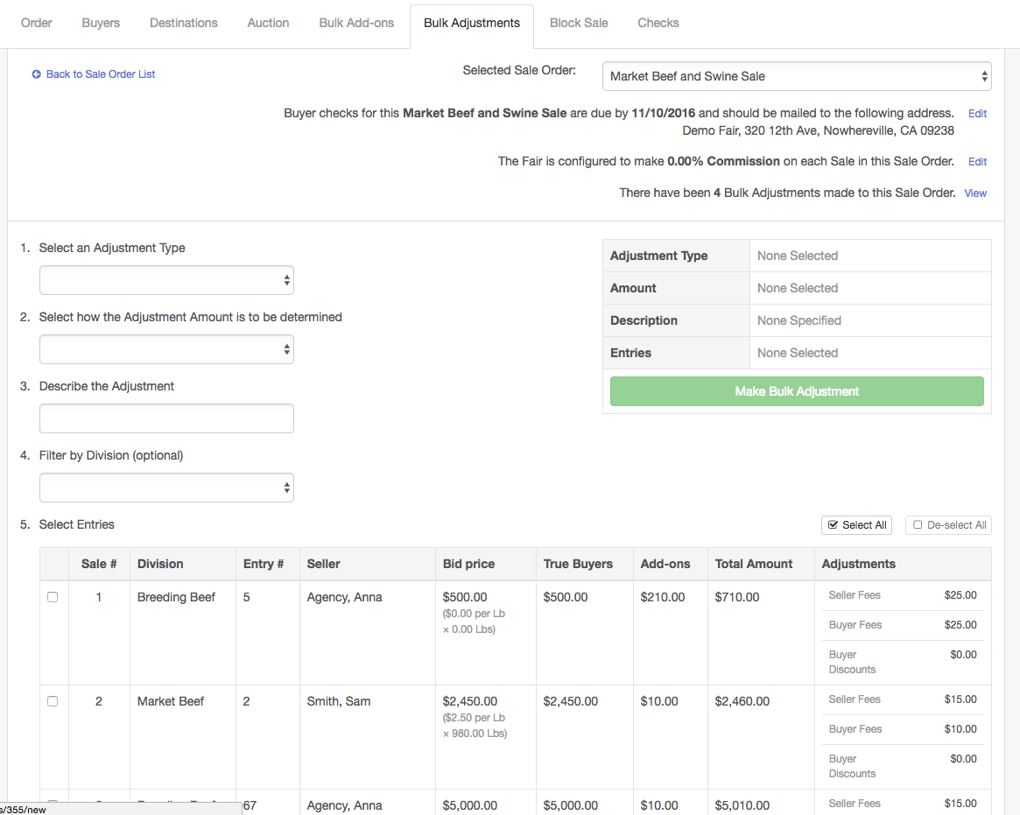
Block Sale  - Click on Block Sale to enter Block sale information.  - Block Sale information is managed at the division level. Select a division to edit the block sale information.  - All entries that were marked “Block Sale” on Sale Participation (for this division) will be listed.  - Click Edit beside the entry to add/change information about the floor price, Destination, and any Destination notes. | 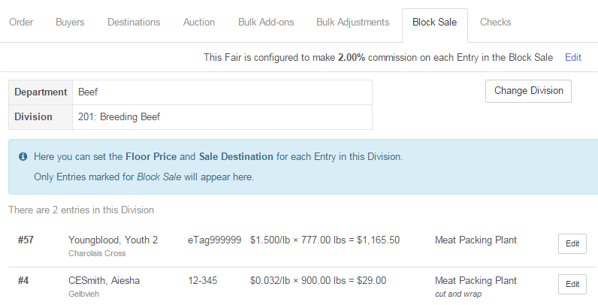  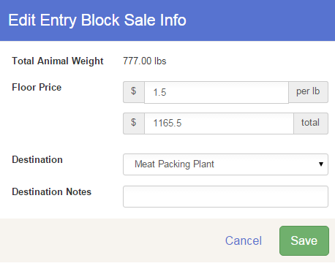
Auction Companion  - If you would like to project the Auction items on a screen during the auction, click the “Launch Auction Companion” button.  - This will open the Auction Companion in a new tab to project on a screen during the auction.  - Auction results will refresh every 10 seconds.  - Use the left and right arrow keys on the keyboard to navigate to the previous and next items.  TIP: If you would like to see the current and previous items on the screen at one time, simply open the Auction Companion in two different browsers (DO NOT open in multiple tabs within the same browser) and adjust the screen sizes to your preference. | 