QuickBooks Export
Before You Start
If you already have accounts set up in QuickBooks, or if you are using an older version of QuickBooks, you may need to edit the FairEntry file before you can import it into QuickBooks.

Steps  - The QuickBooks Export option is located on the Reports menu, Standard Reports tab, Finances section. | 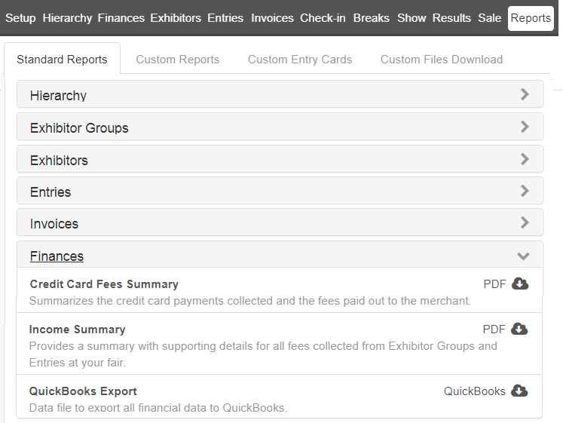
- After the file is downloaded, locate the download on your computer. RIGHT click on the QuickBooksExport file, and select Properties.*  * On a Mac, right click and select “Open With…” | 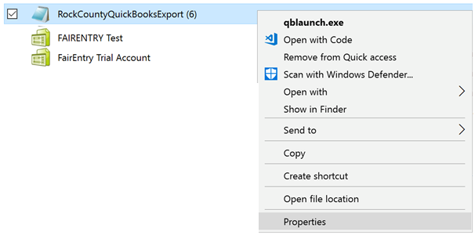
- Change the type of program to open the (.iif) file with—select Notepad.*  * On a Mac, use TextEdit. | 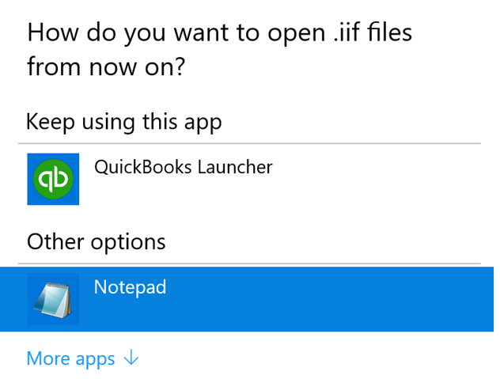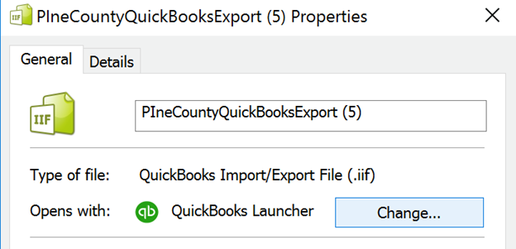
- Now you can open the iif file as a text-only file to view the text.  - Select the top portion of the file that includes the account names and delete. The only reason you need these lines imported is if you are starting with a new program/file in QuickBooks. | 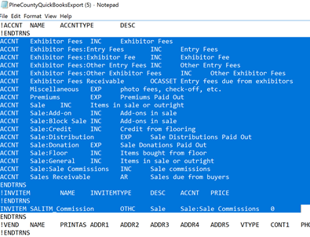
- When you’ve deleted the top section, your file will look like this. When you close the file, it will ask if you want to save changes - SAVE.  * Mac - TextEdit will save automatically. | 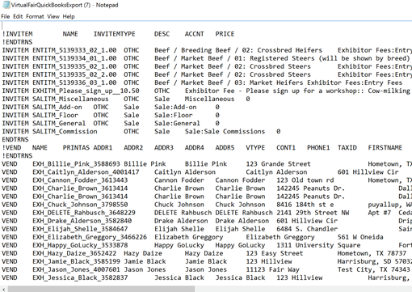
- You will need to edit how the computer opens the file again. Using the process in Steps 2 and 3, change this back to QuickBooks. | 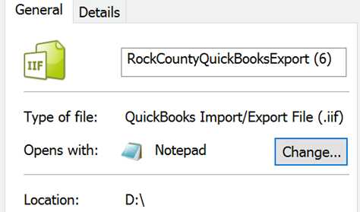
- Log in to your QuickBooks program and upload the iif file. | 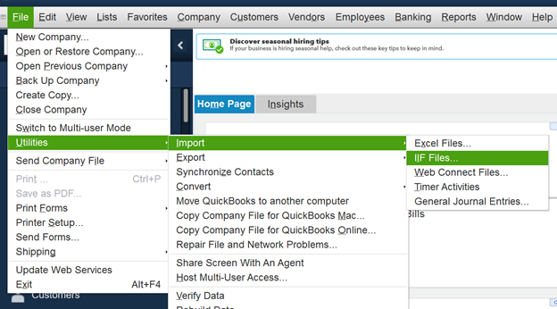
- If importing into an older version of QuickBooks, you may see this import screen instead.  - Be sure to select the “Import it for me. I’ll fix it later” option. It doesn't mean you'll have something to fix, but if there are issues with the import, you'll be able to make changes later. | 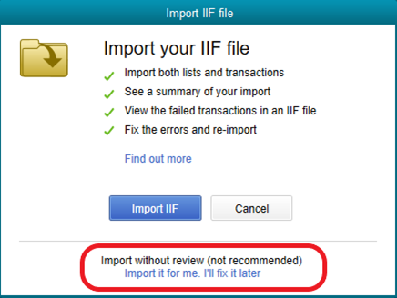
Tips
Different versions of QuickBooks may require slightly different formats for importing data. Once you know what format and data that your version requires, you can adjust the FairEntry export file to match the requirements of your QuickBooks program.

