Managing Uploaded Files
If you have set up Custom Files for your exhibitors to upload, follow the steps below to retrieve those files in bulk from FairEntry or view a list of files that have been uploaded on a report.
Download Files  - After entries have been approved, click on the Reports tab.  - Select the Custom Files Download subtab.  - Click the “Download Files” button next to the files you would like to download.  - The system will process your request and send you an email when the files have been retrieved.  - The email will contain a link to download a .zip file of all of the items. If there are more than 500 files, you will receive a separate email for each group of 500 files.  NOTE: The email will be sent to the email address associated with the account you used to log in to the fair. Please be sure this is a valid email address that you can access. | 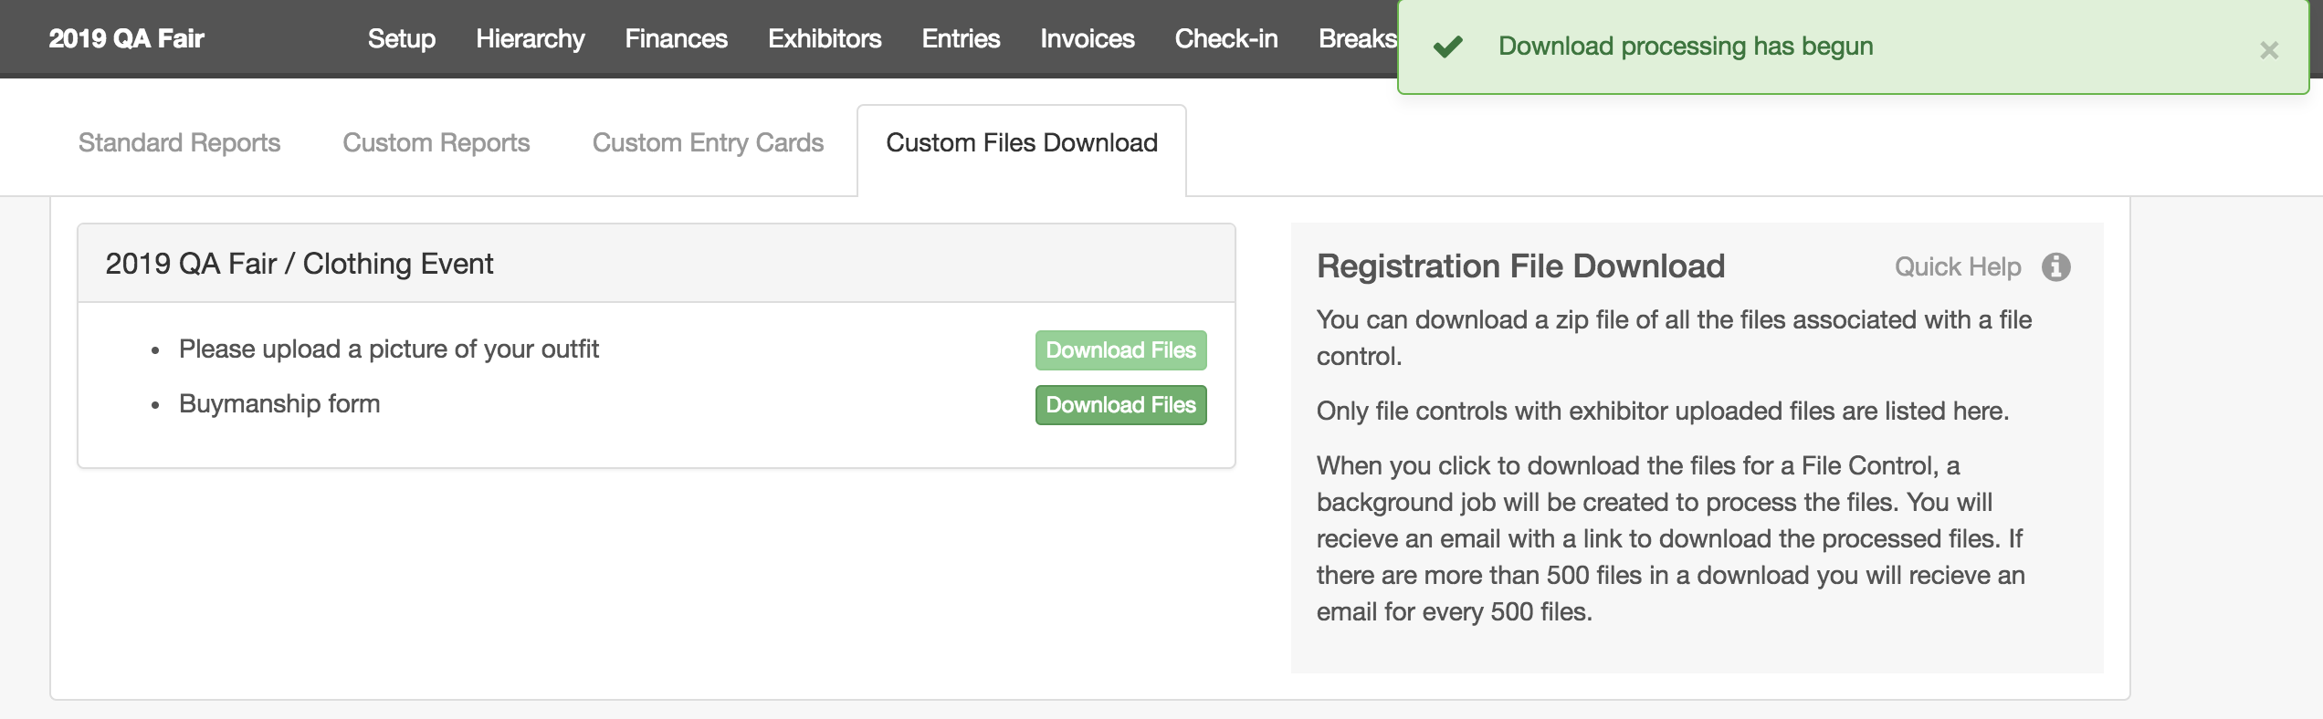  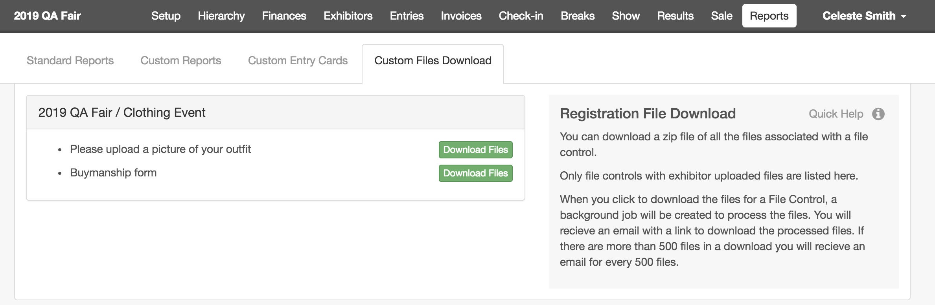  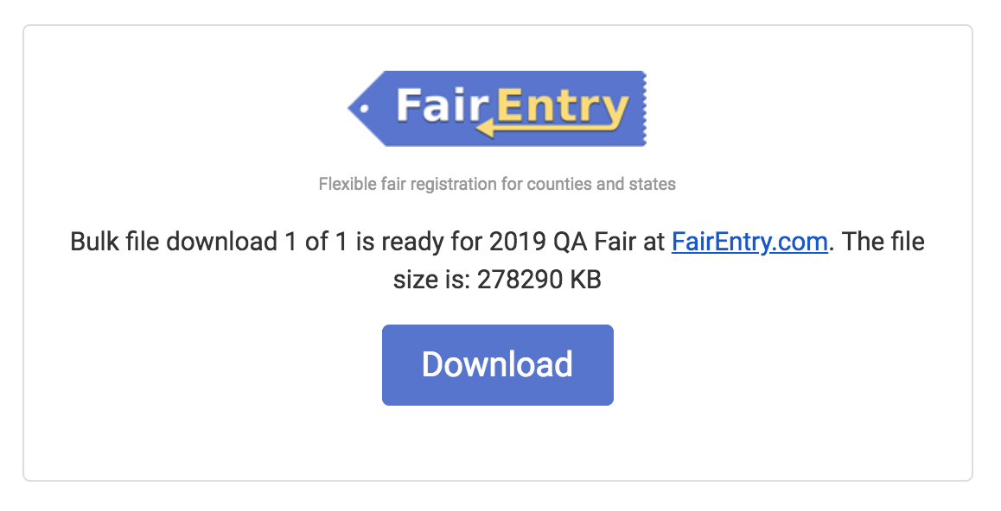
Reports for Uploaded Files  If you only need to verify that a form has been uploaded, you can create a custom report that includes either the “Entry: File Uploaded” or “Exhibitor: File Uploaded” field.  - If a custom file upload was created at the Fair level, it will appear in the Exhibitor: File Uploaded field.  - If a custom file upload was created at the Department, Division, or Class level, it will appear in the Entry: File Uploaded field. | 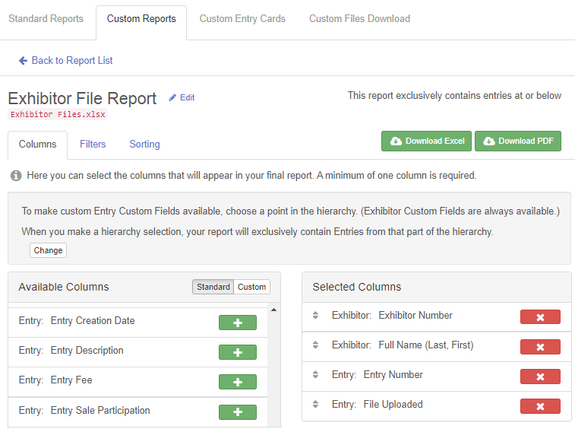

IMPORTANT: You cannot include both of those fields in your custom report if you want to download to Excel. That will cause an error on the Excel download. Although it will not cause an error on the PDF download, the fair-level file will be listed on each entry by that exhibitor, which may not be useful. It’s better to create two different reports if you need both fair-level uploads and entry-level uploads.  The Report will show the name of the custom file control for any files that were uploaded with that specific entry, not the name of the actual document that they uploaded. For example, if an exhibitor uploaded a photo that they had saved as “RedLilyPhotoInParis”, the download would not include that name, instead using the name you specified when setting up the file upload.  If an entry did NOT have custom files uploaded, the File Uploaded field will be blank. | 