Creating Custom Reports
Before You Start
Custom reports can be exported to Excel or they can be printed as a PDF, with more formatting included. In Excel, you have all the functionality to customize the look, order, etc. any way that you wish. Reports are dynamic, meaning they return the most current data whenever they are run/exported.

The two most common questions that arise about custom reports are about custom fields and listing all entries.

Custom fields—you can include those on your report, if you use the “Select Hierarchy” button on the Columns tab, and select the same part of the hierarchy as where the field was created.

All Entries—remember that if you are listing entries, the most unique piece of info is going to return data. If you select only Department, and an exhibitor has 2 entries in that department, only one row will be created, because there’s nothing to differentiate one entry from the other. If you always include the Entry: Entry Number field, you’ll get a row for each entry, as the number is different on each entry.

Steps  - On the top black menu bar, click Reports, and then click the “Create a Report” button.  - The first step is to name the report and to name the Excel file that will result from the report. These can be the same, or not.  - The Report Title is what will help you identify the report on the list when you need to run it again. Keep in mind that they will alphabetize by this field, so have a naming scheme ready.  - Don’t use symbols in Excel Worksheet Title, or more than 31 characters.  - The rest of the report creation process is basically a 3-step wizard: Columns, Filters, Sorting—what information (fields) do you need, which records are included, how are the results sorted. | 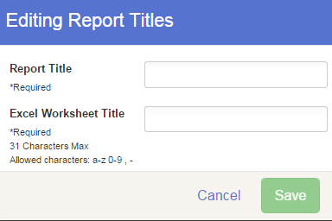
Columns:  - Click on the green “plus sign” beside each field to select it for the report. Use the red “x” to remove one if necessary.  - Order the columns by using the up/down arrows in the selected columns list.  - When you are finished, click “Save Columns”.  “Back to Report List” - stop at this point and come back later to finish or edit.  “Edit” to change the report name or Excel file name.  Download Excel or PDF if you are done—don’t need to filter or sort.  Quickly change the portion of the hierarchy to be included on the report.  - If your report is about entries, be sure to include the Entry: Entry Number field. | 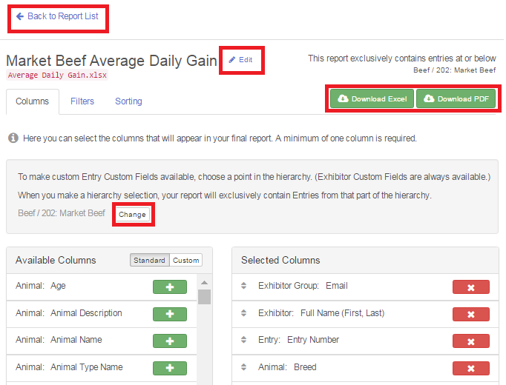
Custom Fields:  If you have set up custom fields for your fair, you can add them to a report, but you must click on the button to select the portion of the hierarchy that contains those questions. Click on the Custom tab at the top of the list of columns to switch to those from Standard.  - All “Exhibitor” custom fields (the ones that were added at the Fair level of the hierarchy) are available to print regardless of what portion of the hierarchy that you select.  - “Entry” questions are those that were added at the department, division, or class level of the hierarchy. They are only available when you have selected a portion of the hierarchy that would contain them.  - Hierarchy selection automatically filters the report to only entries within that portion of the hierarchy. If you select the Beef department, you will not see entries in the Swine department on the report. | 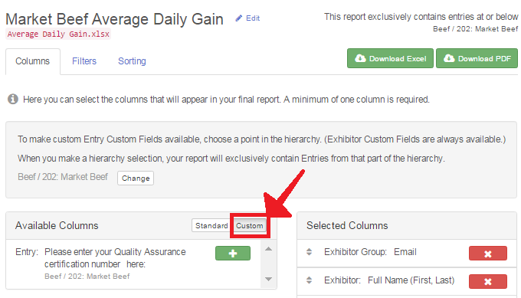
Filters:  - Click on the “Filters” tab at the top.  - You have a choice of “Any” or “All”, which correspond to “or” and “and” in logic.  - All: if you list 3 conditions, the only records that will be listed are the ones that meet all 3 of them.  - Any: same 3 conditions, but the records listed will be those that meet any one (or more) of the conditions.  - “Add a Group” allows you to customize your filters even further.  - Example: Group 1 is “Any”—Grade = 7, Grade = 8. Group 2 is “All”—Gender = female, Department = Beef. The resulting list would be 7-8 grade girls who are showing beef.  - Save Filters when finished. | 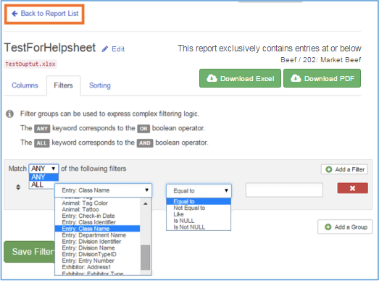
Sorting:  - Click on the “Sorting” tab at the top.  - This is pretty straight-forward. Select any field(s) to use for sorting, ascending or descending, in the order you want.  - If you select a field that has not been included on your report (on the Columns screen), it will be added to your report, at the end of the other columns.  - Example: Sort order is County, Club, Last Name. Results =  1Kid 1Club 1County  2Kid 1Club 1County…  1Kid 2Club 1County  2Kid 2Club 1County…  1Kid 1Club 2County  - Save Sorting, then Download Excel. | 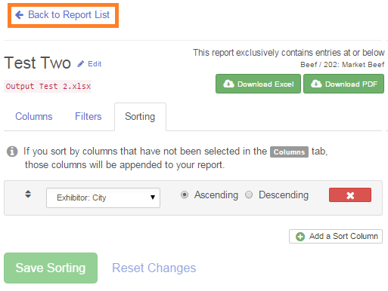
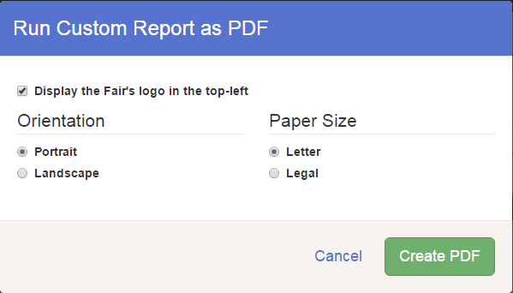
Tips
The Excel format allows you to customize your report with text formatting, new sort order, blank lines between rows, deleting individual rows/columns/cells, etc. If you have very specific needs for data output, this is your best option.

The PDF format gives you a more “finished” report, with alternating gray highlighting, and options for adding your fair’s logo to the report, portrait/landscape orientation, as well as letter/legal size paper.

Although the barcode field is available on custom reports, it will not print correctly (PDF). If you have a barcode font configured on your computer, you may be able to download the report to Excel and change the font. Due to the variables involved with installing a font and converting the barcode field in Excel, the FairEntry support team is not able to troubleshoot issues with entry barcodes exported to Excel.

Excel Download
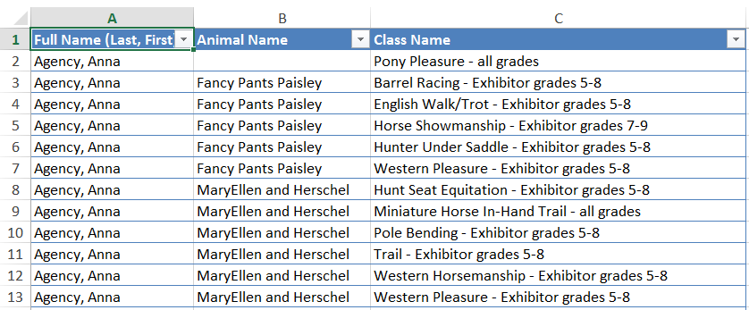

PDF Download
