Bulk Check-In for Non-Animal Entries
NOTE: Bulk Check-in is only available for non-animal entries.
- Click on the Check-In tab.  - Enter the Exhibitor’s first OR last name in the search (or scan the Exhibitor barcode from the Entries by exhibitor report).  - Click to View the entries for the correct exhibitor. | 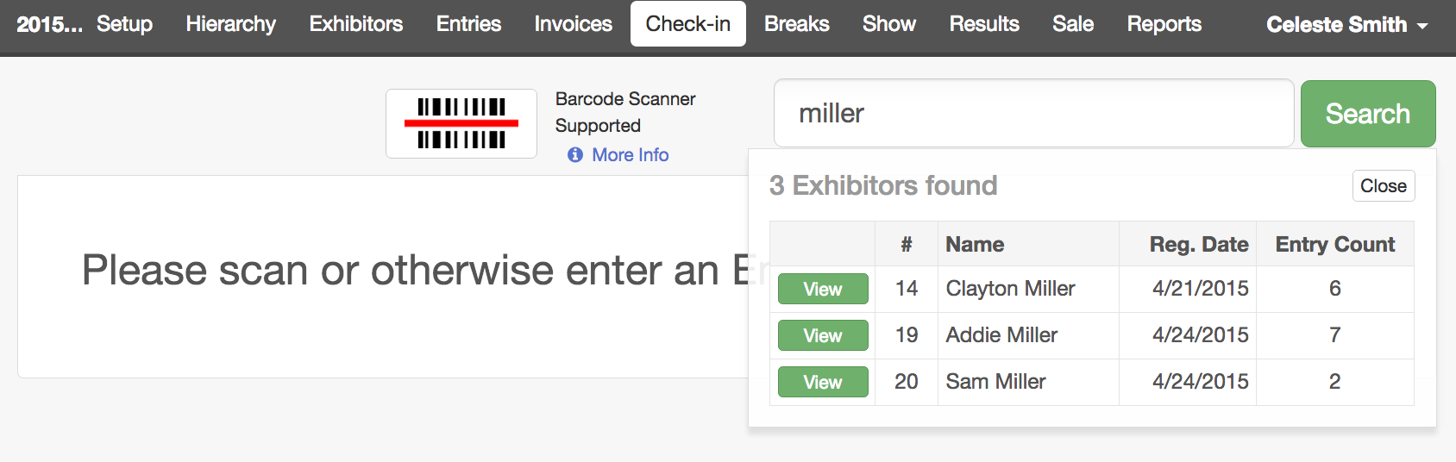
NOTE: Entries made into Animal divisions/classes cannot be checked in here, except by clicking the View button beside the entry—that takes you to the “normal” Check-in screen for that entry.

- Once the appropriate non-animal entries are selected, click the “Check-in Selected” button. If you have selected entries that are not eligible for this process (animal entries), a red error message will appear at the top right of your screen. Other selected entries will be marked as “Checked-in”.

- If you have not previously printed entry cards or tags, you can print those for the selected entries by using the Print Selected pull-down options.

- If an entry should be moved to a different class, select to view the individual entry and then select to Change Class.

- NOTE: The current date will be the default check-in date. This can be adjusted if needed. | 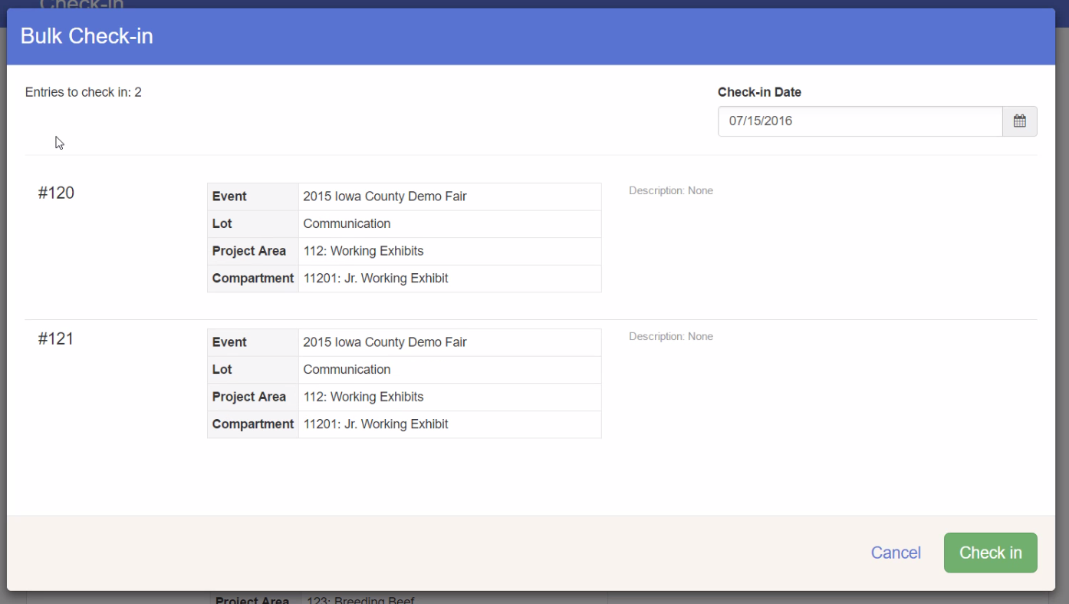

You can use the “regular” check-in method to check in static exhibits one at a time, as opposed to all of them from one exhibitor.  - Click on the Check-In tab.  - If you are using a scanner, click in the search box first, then scan the entry barcode.  - If you are not using a barcode scanner, enter the Entry Number or Exhibitor Name in the search box.  - If no additional check-in information is needed, click check-in, then repeat the process for the next entry. | 