Finalize the Online Auction
After the Online Auction has closed (or when you choose to close the auction by changing the online auction dates, follow these steps to finalize bids and collect payments from buyers).

Finalize Bids  - Log in to the fair and click on Sale tab.  - Click the Online Bids Subtab.  - Click to View the auction. | 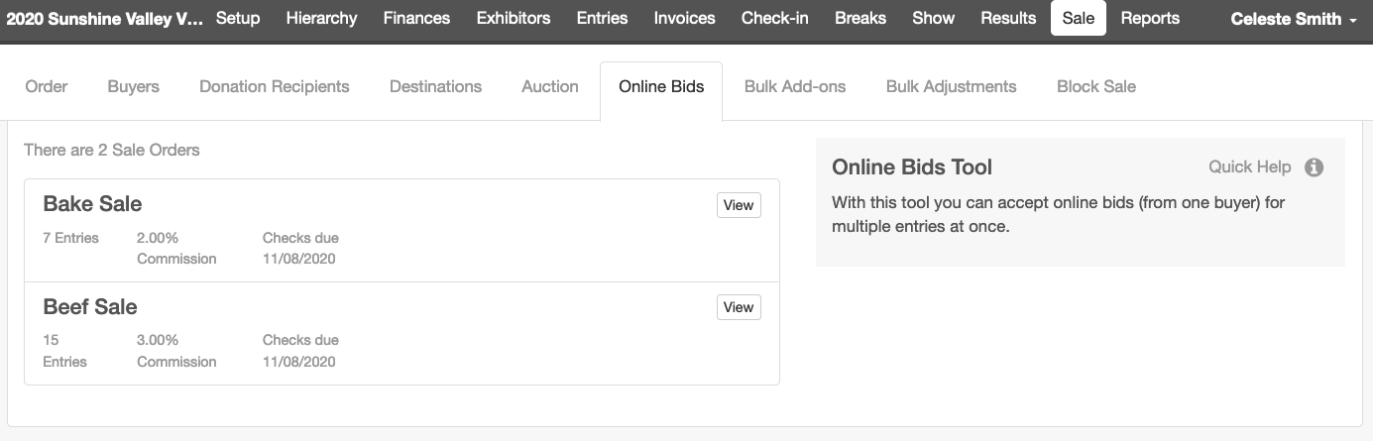
- Select the Online bids that you would like to accept.  - Click “Accept Bids.”  - When a bid is accepted, that bid is entered on the item under the Auction tab.  NOTE: If a manager has entered any bids for these items under the Auction tab, before the Online bids are accepted, you will receive an error message that you are unable to accept the bid. To resolve this, remove the existing bids from the items under the Auction tab. | 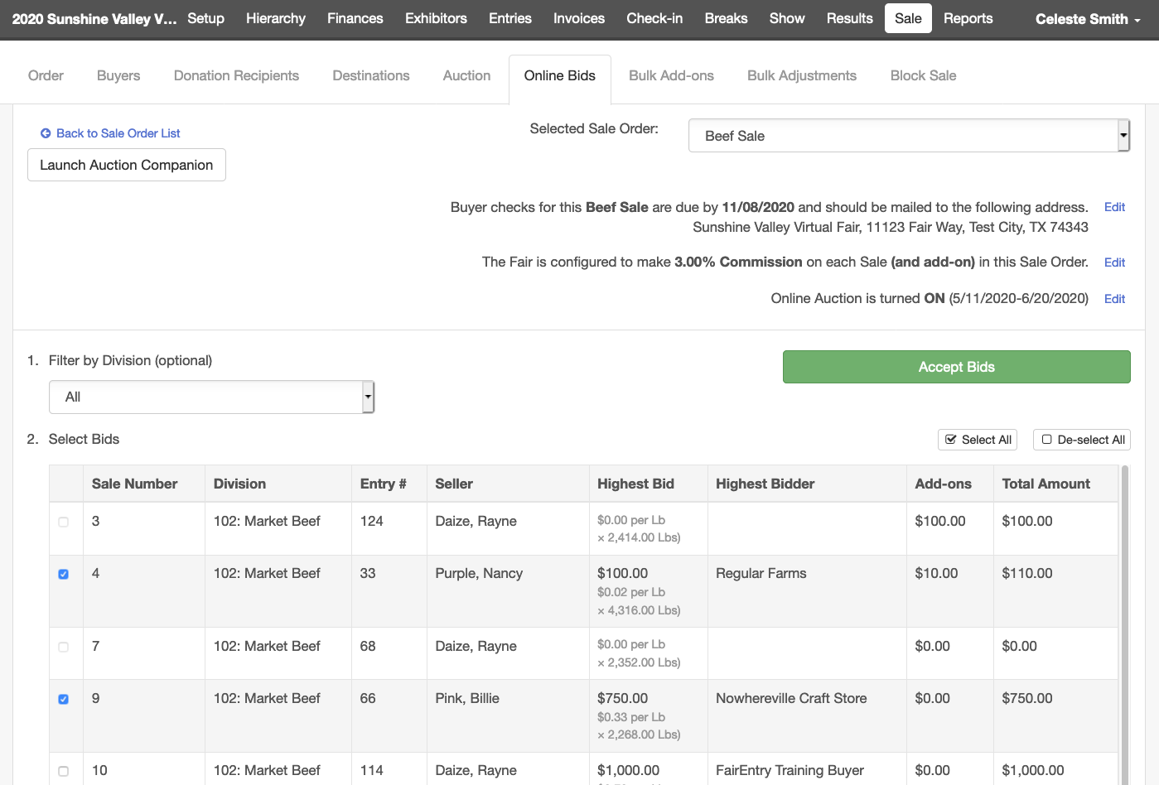
Enter any Additional Information that would affect Buyer Amounts Due  After a bid has been accepted and it is transferred to the item under the Auction tab, the Fair or Sale manager may proceed with any necessary adjustments including:  - Splitting the bid between multiple buyers  - Adding additional add-ons or bids  - Selecting Destination and Flooring Details  - Bulk Add-ons  - Individual or Bulk Adjustments  - Entering Donation Recipients  Please see the Sale Resources section in the Help Center for instructions on how to complete the above items as these processes are the same for traditional Auctions.  See Managing Buyer Payments for details on collecting payments. | 