Agent Exhibitor Group Entry
FairEntry Manager Reminders
- A Club Agent account logs in to an exhibitor group account, very similar to a family account.
- Club Agents may add any exhibitors to the exhibitor group.
- All entries and exhibitors within the exhibitor group are included on the Club Agent’s invoice.
- If multiple Club Agents have permission for this Club, they will be logging in to and working on the same invoice.
- If families will also create entries for the Exhibitors included in the Club Agent Exhibitor Group account, it is likely there will be duplicate exhibitor accounts in the fair.
- You can use the information and screen shots below to create a help sheet for your Club Agents.

Club Agent Reminders
- Your fair probably has dates when entry is accepted into the fair. Be sure to complete your entries (including the final “Submit” step) prior to the cut-off date.
- Register all entries for each exhibitor in the Club/Chapter before proceeding to the Payment section.
- Be sure to click the “Submit” button when you have completed your entries. Entries are not final until they have been submitted.
- Check your email inbox for a confirmation email with a list of your entries and any related fees.
- You will receive a second email when your entries have been approved by your fair or show.

- If you have been invited as an Agent to submit entries for your Club or Chapter, you will receive an email invitation with a temporary password from FairEntry.  - Click the Sign-In link or go to www.fairentry.com and select Staff Sign-In. |  | 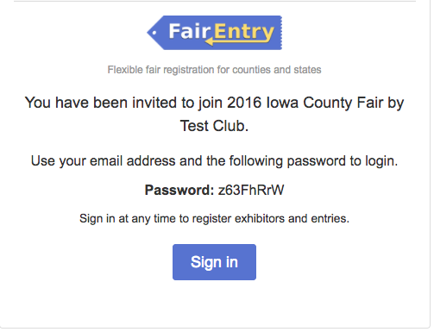
- If you are unable to find the email invitation, but know you have an account, go to www.fairentry.com, select Staff Sign-In, enter your email address and select the Forgot Password option to receive a new temporary password via email.  - Enter the temporary password on the login screen.  - After you enter the temporary password, you will be prompted to enter a new password. |  | 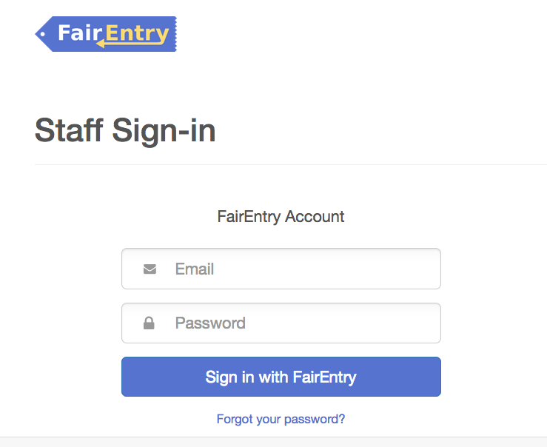
- You may also access your Fair or Show from their direct website link or go to http://www.fairentry.com and click “Find Your Fair”. |  | 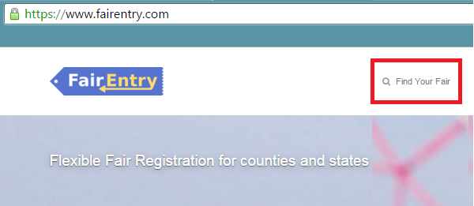
- Filter by your state, click Search, and then click on the correct fair. |  | 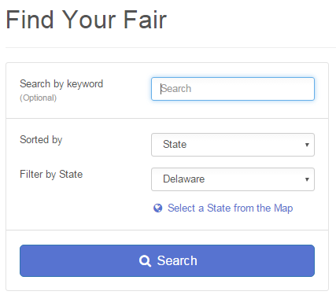
- Click “Begin Registration”

Enter Exhibitor Information  If your fair is configured to accept both individual and team entries, click on the appropriate choice for your entry. Some fairs may only be configured for individual entries. |  | 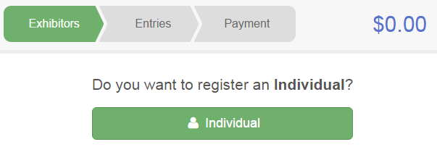
- Enter the exhibitor information into the required fields. Some forms may require different information depending on the Fair or Show. |  | 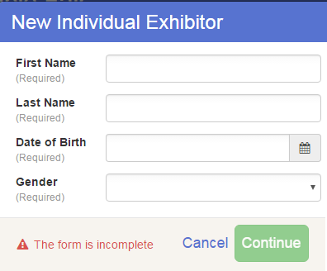
- Enter the information on the Contact Info screen—the only required field is the top Home Phone Number. You can use the same email address that you used to create the account, or an alternate one unique to the exhibitor. If they wish to receive text messages, enter the cell phone number and carrier. That number can be the same as the Home Phone Number entered above, or different. Click Continue when you are finished entering data. |  | 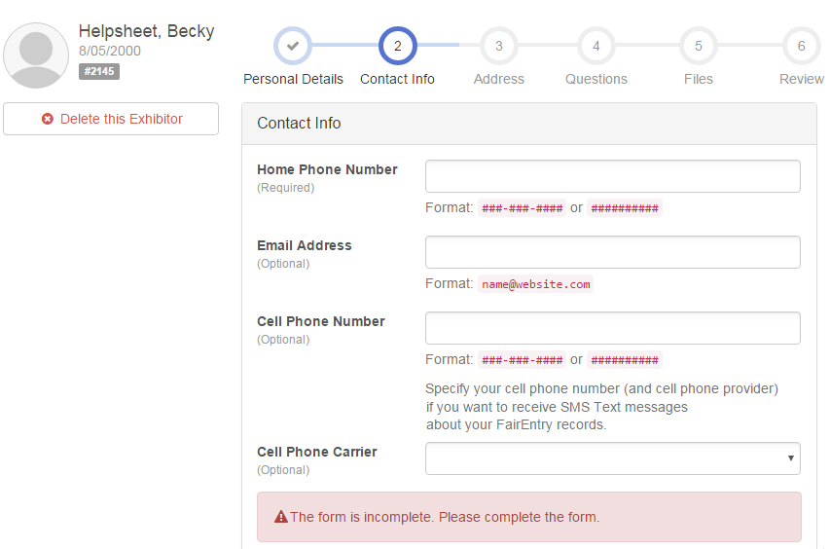
- Enter the mailing address. All fields, except Address continued, are required. If the exhibitor has the same address as another exhibitor in the Exhibitor Group, simply click “Copy” to add the address to the current Exhibitor record. Click Continue when all information is entered correctly.  - If your fair or show requests a Social Security Number for 1099 purposes, that will be Step 4 on the progress bar. Social Security Numbers are fully encrypted and only the last 4 digits will be visible after the number has been saved.  - If your fair or show asks additional questions, those will be step 4 or 5 on the progress bar at the top. Answer any questions, and click Continue.  - If your fair requires you to upload any files for the exhibitor, those will be step 5 or 6 on the progress bar. Upload requested files, and click Continue. |  | 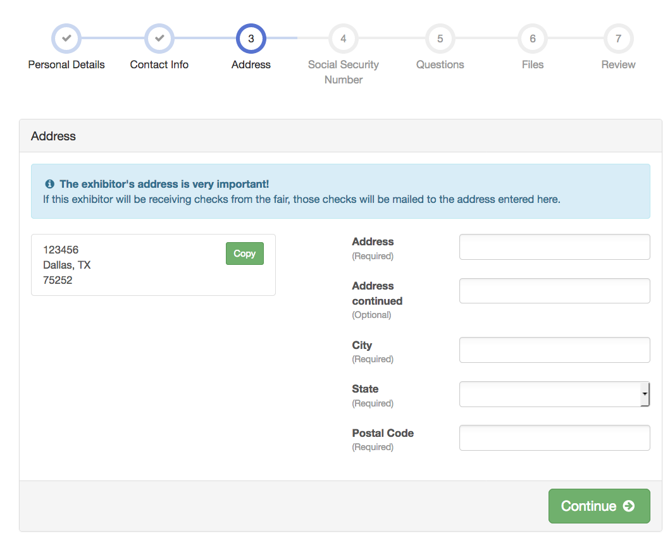
- Review the exhibitor information. If any information is incorrect, click the green Edit button in the appropriate group to change it. When all information is correct, click Continue to Entries. |  | 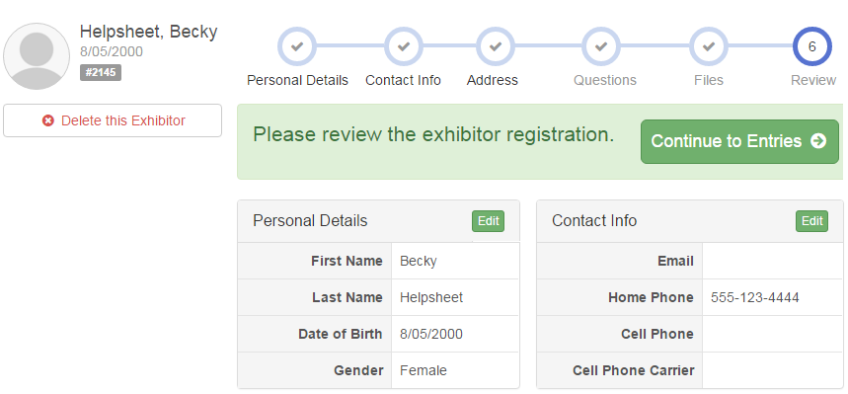
Creating Entries for Exhibitors
Each exhibitor can have multiple entries. One entry must be made for each item, animal, class, etc. For example, if an exhibitor is bringing 2 photographs, two entries into the photography class must be created. If an exhibitor is showing one horse in 5 events, five class entries must be created. Once all entries have been created for the first exhibitor, you have the choice of creating another exhibitor in this exhibitor group (and entries) or proceeding to check-out (submitting the entries, whether or not fees are charged).

- Click Add an Entry beside the correct exhibitor (if more than one has been created). | 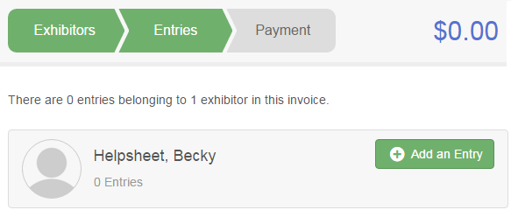
- Click Select beside the first department you wish to enter. Any departments that are not available for entry will be noted as “Not Available” with a short explanation.  - After you select a department, you will see a list of divisions to select from, and then a list of available classes. There are blue “Change” links in case you mistakenly select an incorrect department or division.  - After you have selected the division, click the green Choose button. | 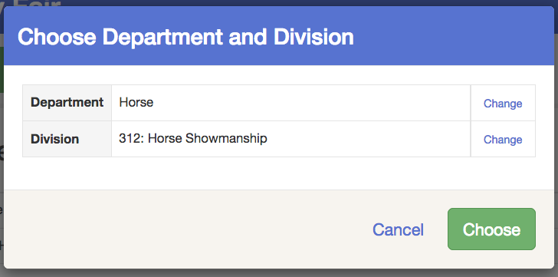

Add Entries - Multiple Entry Process  - If your fair or show has turned on the Multiple Entries option for this area, you will see a screen similar to the view at the right. If there are not checkboxes next to each class, this area uses the single-entry process (see step 16).  - Click Change to select the Club to which these entries will be associated.  - If this is an Animal Entry, click Add Animal and enter the Animal’s details.  - If this is a pen or group entry, Add multiple animals and then select to Enter a pen of animals.  - Select which animals will be part of this entry (NOTE: these animals will be available for this exhibitor to use in other entries, if needed).  - Check the box next to each class this animal will enter. | 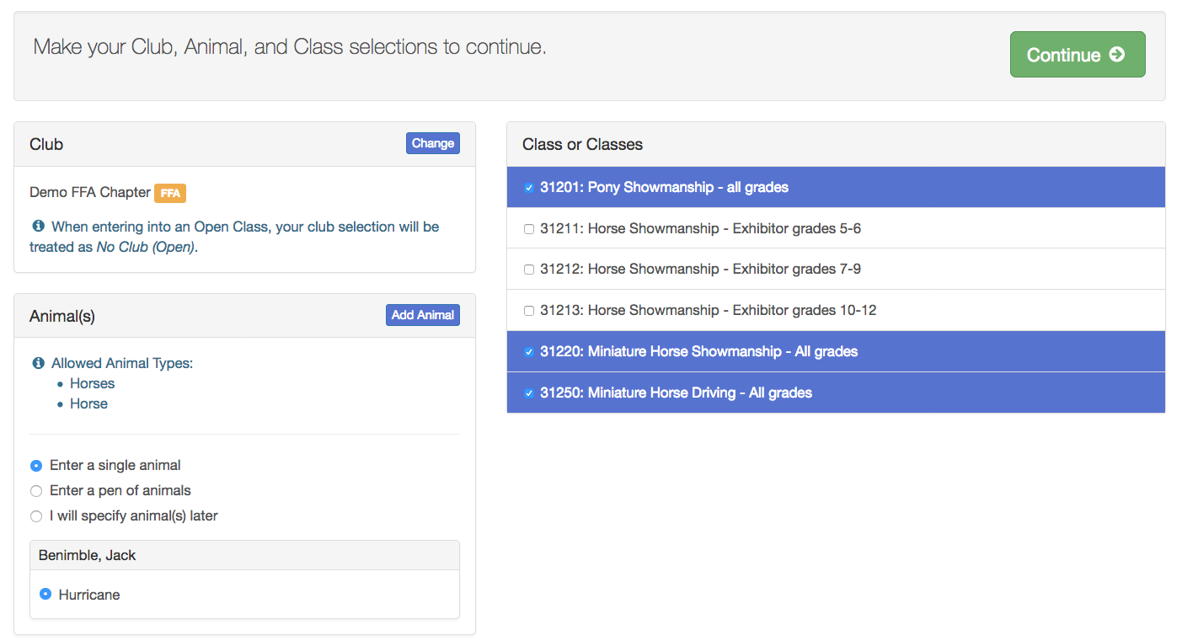
- If this is not an animal entry or if animals will be added at check-in, simply select the classes and number of entries in each class that you would like to create for this exhibitor. Click Continue. | 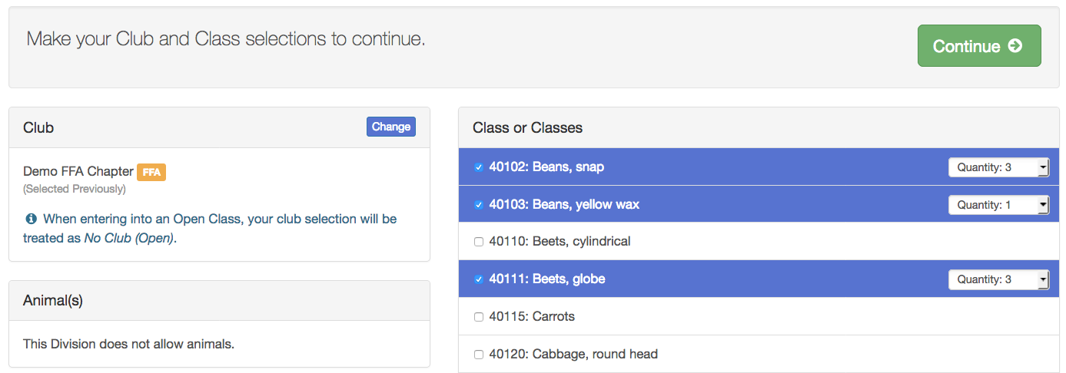
- Review the entries. If you need to make any changes, click Cancel. If everything is correct, click Create Entries. | 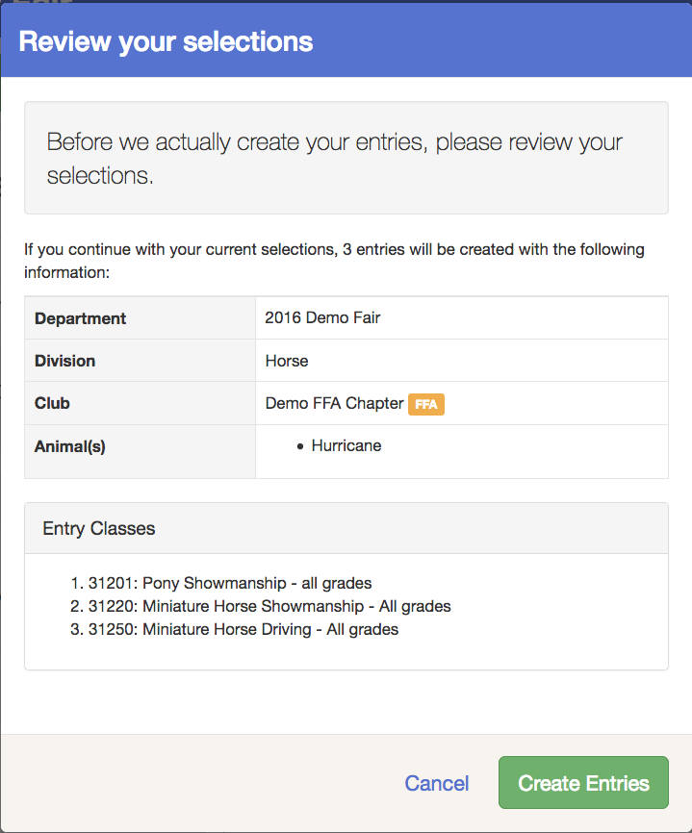
- To add another exhibitor, click on the Exhibitors button at the top left and repeat the steps to create a new exhibitor.  - If you need to add more entries for an existing exhibitor, click Add an Entry. | 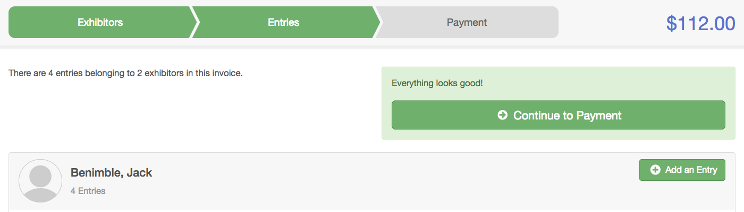
Creating Entries – Single Entry Process  If your screen does not resemble the picture on the right, your fair may have used the multiple entry process in this area. Repeat steps 5-11 above.  - After you have selected the department and division, click Choose.  - Select the class and click Continue. | 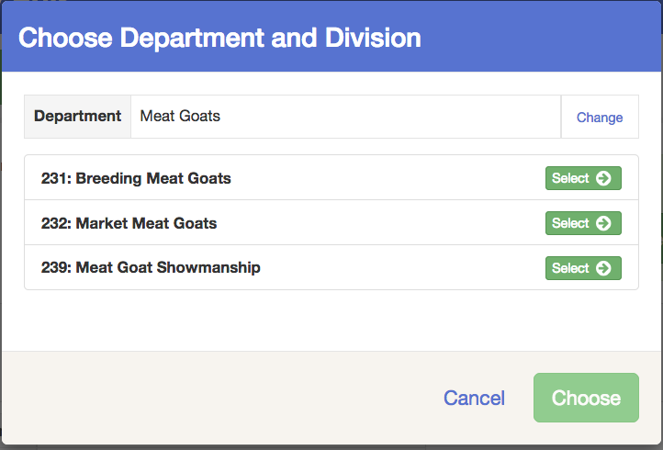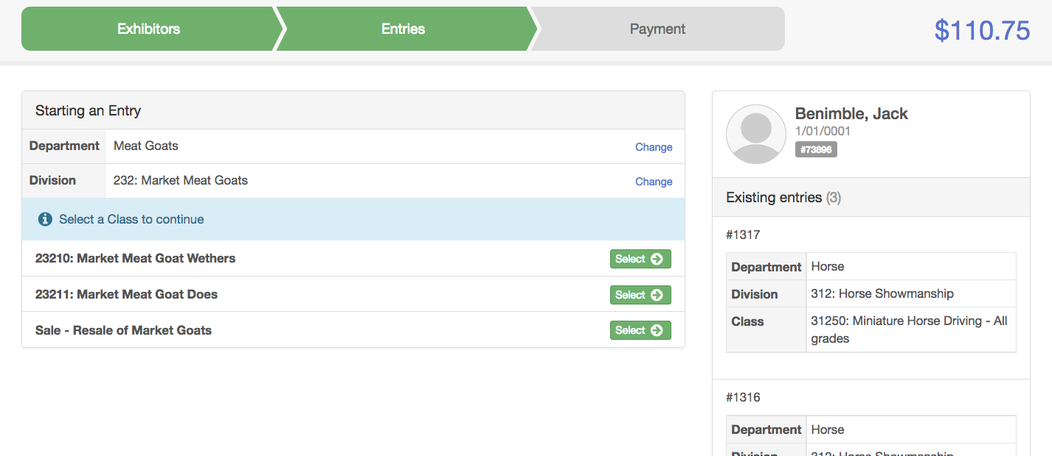
- Select a Club or Chapter for this entry. If this is an open class entry, a Club or Chapter may not be required.  - If this is not an animal class entry, follow the instructions on-screen to enter any additional information such as Entry Description, Custom Questions or Custom Files associated with that entry. | 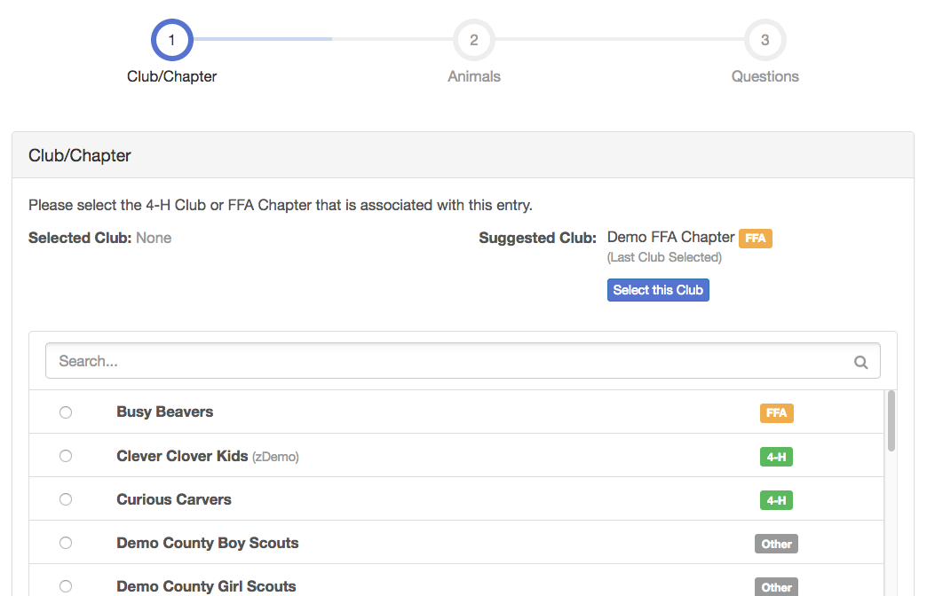
- If this is an animal class entry, you may or may not be required to specify which animal will be exhibited in this class. If you are able to specify an animal, you will see the option to “Add an animal”.  - Fill in all of the fields with information about the animal attached to this class entry. Click Create and Add Animal when finished.  - If the animal information was entered incorrectly, you have the option to either Remove From Entry (creating/adding a new animal) or Edit Animal Details. When it’s correct, click Continue. | 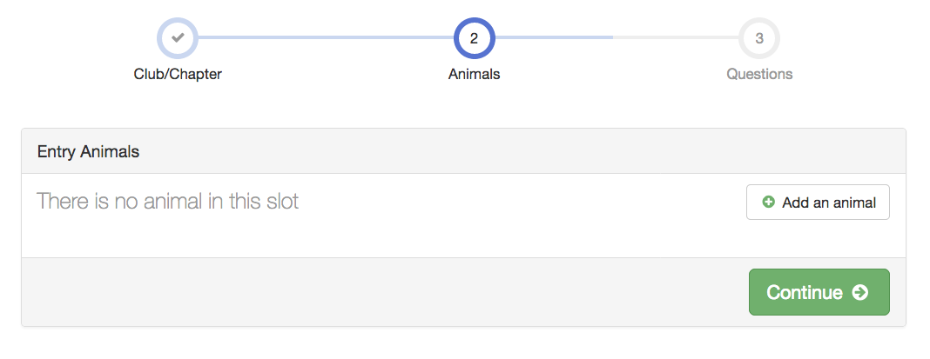  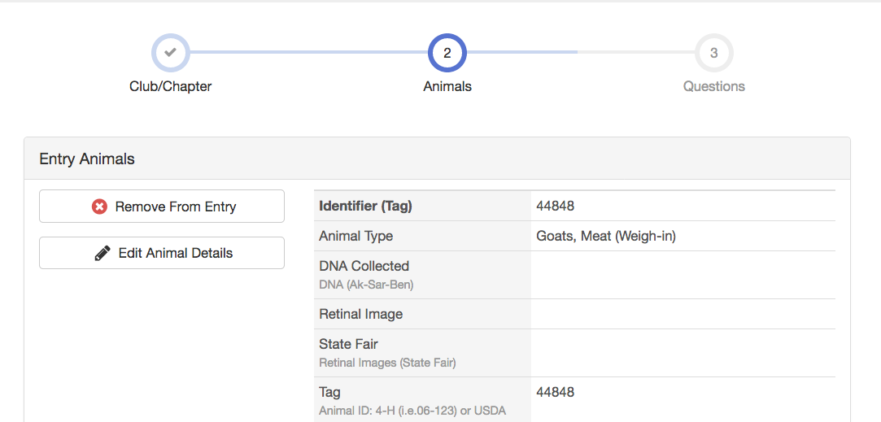
- Any questions or file uploads related to entry in this class will be next. Click Continue after answering those questions or uploading documents.
- When each class entry is complete, you have three choices for what to do next:  - If all class entries have been completed for one exhibitor, you can Register another Exhibitor in this exhibitor group.  - If this exhibitor has more class entries to make, you can Add another Entry for this Exhibitor. | 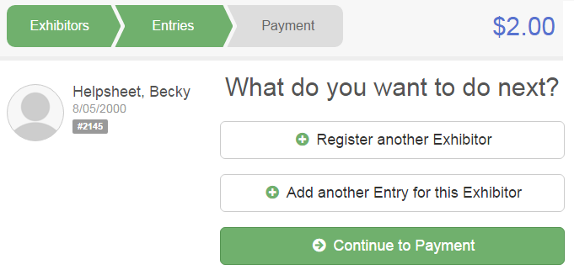

Finalize and Submit Entries

- When all entries for all exhibitors in the exhibitor group have been completed, Continue to Payment to finalize and submit your entries.
- If your screen displays a blue “Incomplete entries” button instead of green Continue to Payment, you have made some entries that require additional information to be entered, and you will need to do that before proceeding.
- Review your entries for completeness and accuracy. Notice the Summary and Detail buttons at the top of the list on the right. If there are errors, click on the green Entries section at the top of the page. Click Continue when all information is correct.  NOTE: DO NOT Submit the entries until all Agents in your Club or Chapter have completed the entry process for all exhibitors. All exhibitors and entries must be added before you click Submit. | 