Multiple Entries Feature
Before You Start
There may be some parts of your hierarchy that lend themselves to multiple entries—where exhibitors can enter several classes with the same animal, or enter several classes at one time (with no animal). The primary examples of those would probably be horses (the same horse showing in several classes) and static exhibits (the exhibitor entering 2 or more exhibits into the same class, or into lots of classes).

The biggest thing to remember is that multiple entries is only available for classes in the same division. So, in order to make the best use of this feature, you may need to switch up your hierarchy to put more classes into the same division. An example would be for the Horse department—if you want to use multiple entries, you may want to have just one Horse division so that all classes are in the same division.

Setting your hierarchy to allow multiple entries is a one-step task. It’s more important, however, to be aware of how that changes the entry process for your exhibitors.

Set the Option

In Entry Settings, you’ll find the option: Entry Registration Process. It’s available at all levels of the hierarchy, and it defaults to “SingleEntry”. Select the portion of the hierarchy where you wish to have multiple entries available, and change the setting to “MultiEntry”. If you select this option for a department (Horse department, for example), all divisions within that department will allow multiple entries.

Remember, however, that multiple entries can only be made (at one time) for classes that exist within the same division. So, if you have a Performance division and a Halter division within your Horse department, an exhibitor will be able to select all the classes they wish to enter in the Performance division, but then would need to begin a new entry and select the Halter division for entries into that division. This may affect how you set up your hierarchy for departments/divisions that traditionally have multiple entries for one exhibitor or for one animal.
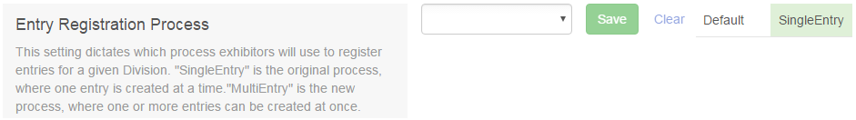

MultiEntry Process for Exhibitors (Livestock Example)  - With either SingleEntry or MultiEntry, the first two steps for an exhibitor are to select the department and division. When an exhibitor selects a division that has been designated as MultiEntry, the entry process looks a bit different for them. | 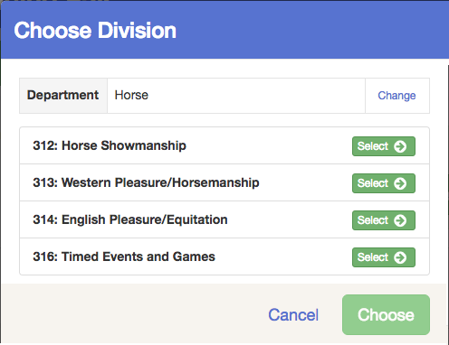  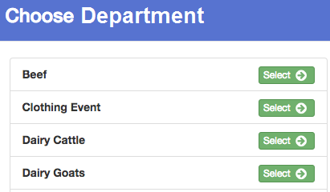
- The next screen lists classes in that division, but also asks for the exhibitor to select (or change) the club, and to select (or add) an animal (for animal divisions only).  - Notice the options for animals: Enter a single animal into multiple classes, enter multiple animals into a pen class, and “…specify animal(s) later”.  - In the Add Animal process, it doesn’t matter which of the top two options is selected. | 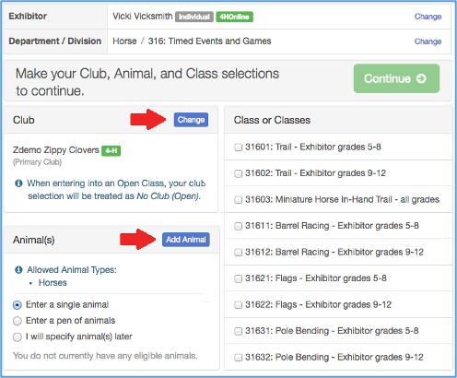
- After the “Add Animal” process is completed (either by selecting or creating an animal record), the animals are listed at the bottom left, and animals/classes can be selected. (Click Continue). | 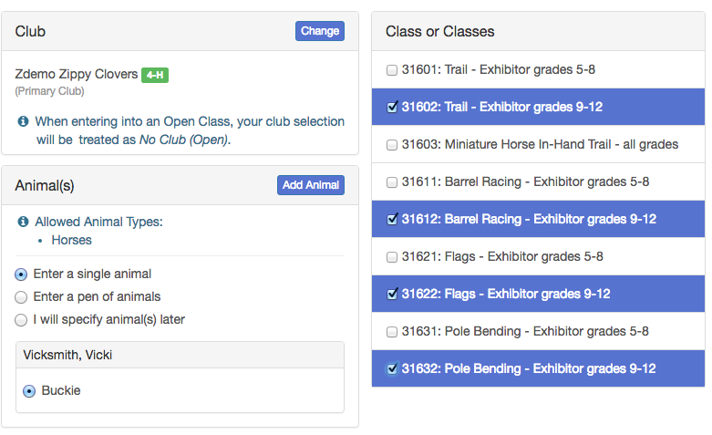
- The three options available for the selected animal(s) are important to use when assigning animal record(s) to class entries:
- Enter a single animal into multiple classes
- Enter multiple animals into a pen class
- Specify animal(s) later - The last choice is not available if your entry settings are set to allow animals to be added at registration.
- “Enter a single animal” creates a radio button beside the animal identifier. One animal can be selected to enter into multiple classes (the classes have checkboxes, so that more than one class can be selected). | 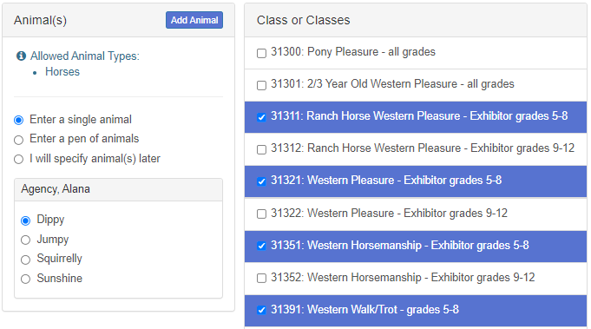
- The “pen” method creates checkboxes beside the animal identifiers, so that the exhibitor can select which animals will be entered into the class selected. *Note: a class must be designated as a “pen” class in the entry settings before this option can be used. | 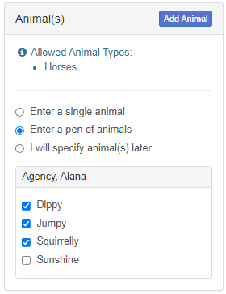
- The exhibitor will be asked to confirm that the information entered on the previous screen was correct. They can click Cancel to begin the process again, or Create Entries. | 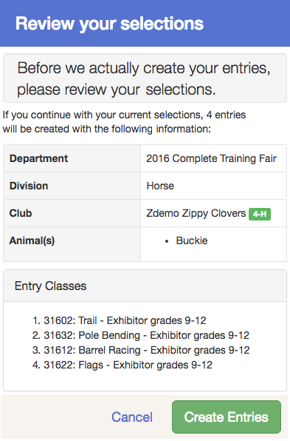
- After confirming the multiple entries, the exhibitor has the option of continuing to payment (if they’re done with entries) or adding another entry. They can also edit individual entries on this screen at this time. | 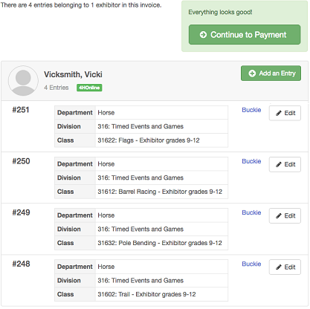
- If there is incomplete information on the entry (for example, custom fields), and the exhibitor chooses “Continue to Payment” on the previously-displayed screen, they have the family options to add another entry (for this exhibitor), register another exhibitor, and Review/Complete Outstanding Records. That must be done before the exhibitor can submit their entries. | 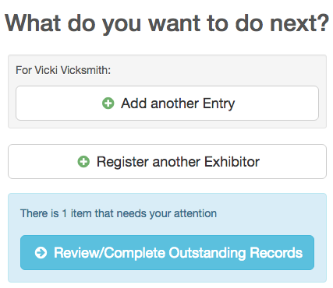

Single Entry Process for Exhibitors (Livestock Example)  - By comparison, the single entry process presents slightly different screens and options. The first two steps of selecting a department and division are similar. However, once those selections are made, the exhibitor is asked to first select a class. | 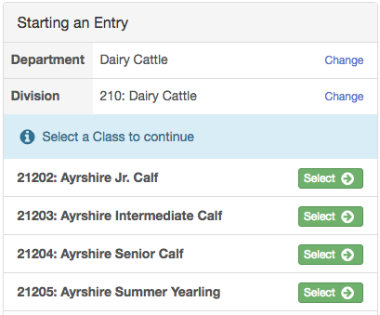
- After the exhibitor selects a class, they are asked to select the club/chapter associated with the entry (Click Continue). | 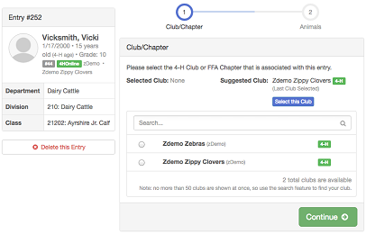
- The next step is to identify the animal for that class entry. | 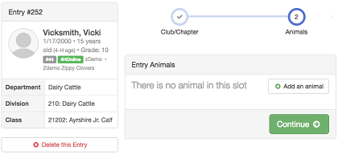
- The animal info can be reviewed, and edited. When the exhibitor clicks Continue, they will see custom fields, then will have the options to add another entry, register another exhibitor, or proceed to payment/check-out. | 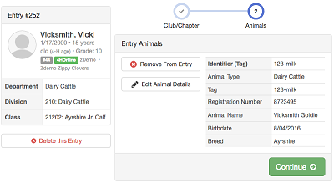

Single Entry Process for Exhibitors (Livestock Example)
- By comparison, the single entry process presents slightly different screens and options. The first two steps of selecting a department and division are similar. However, once those selections are made, the exhibitor is asked to first select a class.
- After the exhibitor selects a class, they are asked to select the club/chapter associated with the entry (Click Continue).
- The next step is to identify the animal for that class entry.
- The animal info can be reviewed, and edited. When the exhibitor clicks Continue, they will see custom fields, then will have the options to add another entry, register another exhibitor, or proceed to payment/check-out.

MultiEntry Process for Exhibitors  (Static Example)  - The non-animal MultiEntry process also includes the option to select how many entries they wish to make into a specific class. After selecting the department and division, the exhibitor will see a list of classes with a checkbox and a quantity pull-down. | 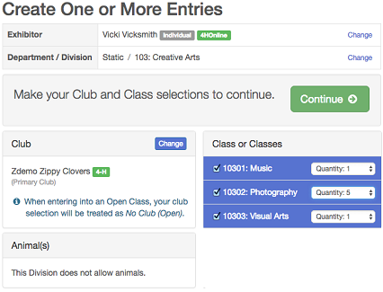
- The exhibitor can review the entries before confirming. They can Cancel if they are not right, Create Entries if they are. | 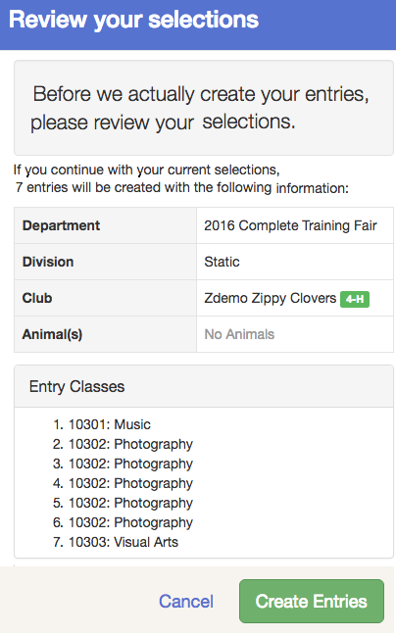
- Because an entry description was required on all static exhibits, the list of entries shows them as “Incomplete” with a button to complete the outstanding records. They can also add an entry or edit the existing list from this screen. | 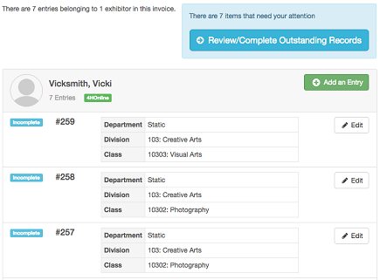
- For the first entry, they are taken to a screen where they can enter the description and can click Continue. | 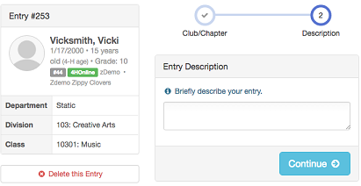
- They will loop back to the Review/Complete options until all of the issues are resolved and the entries are complete. If there are 3 issues with the same entry, they will resolve each issue separately. Each time they return to this option, the count of outstanding issues decreases by one, until there are none left. | 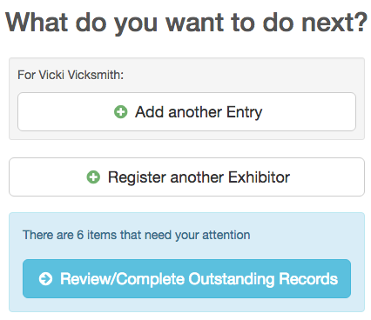
- When all issues are resolved, and the entries are complete, the exhibitors will have the options to add another entry, register another exhibitor, or proceed to payment.
Tips
Allowing the multi-entry option can save your exhibitors time and “clicks” in the entry process. However, if you have custom fields associated with the entries, or require an entry description, the exhibitors will have to complete that information for each entry before they can submit their registration.

The most valuable use of this function will be when the classes in question exist within few divisions, and when there are few additional pieces of information required after the class selection is made.

