Premiums Setup
Before You Start
Paper planning can be your friend. Sketch out your premiums, finding the most efficient way to enter them. You could set them all at the class level, but it’s much more efficient to enter the most common settings at the highest level, and then just enter the exceptions at lower levels.

Your premium settings will “carry over” after the first year, only requiring changes if your structure changes at some point.

Setting up premium values  - Setup >> Ribbons – Make sure that you have selected all the ribbons available in your fair, AND make sure they are listed in highest-to-lowest order. (Use the up/down arrow button on the left side of the ribbon name and drag to correct order.) | 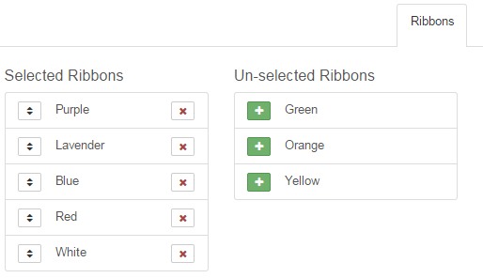
- Setup >> Budgets – Each fair has a Default Budget (Unlimited) configured. That is the type of budget you need for straight-dollar premiums. The only reason to add another budget is if you print your premiums in two (or more) separate batches—one for livestock premiums, and one for static, for example. You will assign a budget to each part of the hierarchy where you enter premium values—it can all be from the same budget, or from different ones. | 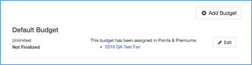
- Hierarchy >> Select Level – Start at the highest level at which there is consistency in your points/premiums setup. Example: If all livestock exhibits get the same amount of money for PBRW, start at the fair level. THEN if all your static exhibits get different premiums, override the fair premiums at the static department level. | 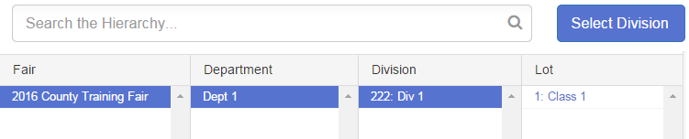
- Click on the Points & Premiums tab. It starts out with a screen as at right, “Ribbons have not been configured”.  - Scroll down and you will see configuration options for both classes and divisions.  NOTE: Division setup is only used when you assign additional premiums to an exhibit that is judged at the class (first premium) and then again at the division level (division champion gets another premium).  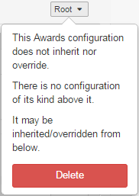  - If you have a premium setup and you need to start over, you will see a small pull-down menu at the upper right of the section name (Ribbons, Placings, Awards). Click on that and at the bottom you will see a red “Delete” option. Selecting that requires a confirmation popup and will remove all of the setup for that section at the selected level of the hierarchy.  DO NOT use the Delete option if you just need to set an exception for (override) a premium setup at a lower level, or if you want to make a small adjustment—then use the Edit option at the lower right. Only use Delete when you want to start over. | 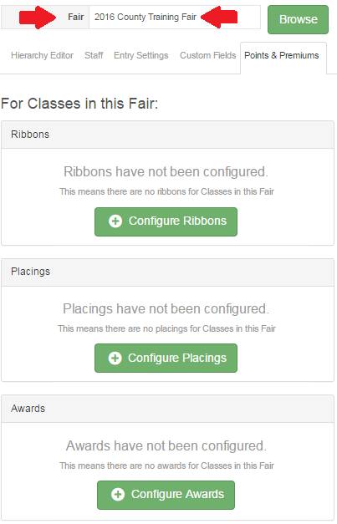
Ribbons  - Click the “Configure” button at the Ribbon level.  The dialog box reminds you that you are setting ribbons at the CLASS level for the entire fair.  Select Premiums, which means each ribbon color is worth a specific amount of money. Points are selected when each ribbon color is assigned a point value, which is divided into a total “pool” of money—see Points helpsheet. | 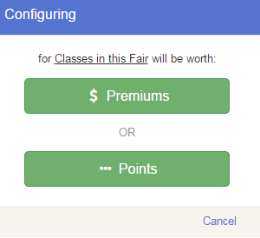
The top bar is a reminder of the level that you are setting (Class premiums, Fair).  The ribbons appear in the order in which you set them back in step 1. If that is not correct, go back and re-order them before going on.  The upper right pull-down will say “Root” at the highest level at which you enter points/premiums—the only option on the root menu is Delete. Levels below that will show “Inherited”, meaning the structure is the same as the level above it, and will have a “Override” option to set exceptions. Those exceptions will then show up as “Overridden” in that box.  - Click the Edit button at the lower right. | 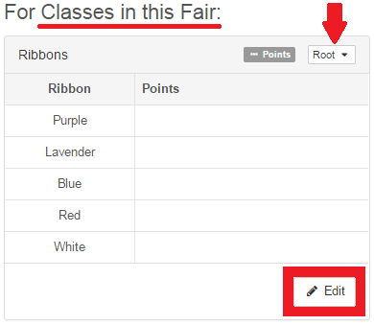
- The Premiums boxes are editable—type in your values.  If you give different values for ribbons based on the size of the class (Example: if there are 1-10 entries, a blue gets $5.00, but if there are 11 or more entries, a blue gets $6.00) you can “Add a Range”. Clicking on the title bar that lists the range allows you to customize the beginning/ending values of each range.  - SAVE when your setup is correct. | 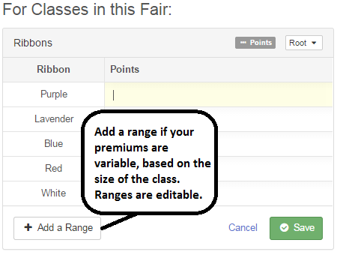
Placings

Even if you do not assign money for placings (1st, 2nd, etc.) this is where you set up which placings will be available to select in results.

You can choose to set up the largest number of placing values (1-10, etc.) at the FAIR level, with the result of the entire list showing up as options for all class entries; or selectively set up placing lists for departments etc. –1-10 for Horticulture, 1-5 for Swine, etc. Either way, you can customize the premiums assigned to the placings at all levels.

- Click the “Configure” button at the Placing level, and select Premiums (although the selection doesn’t matter, if you’re not going to assign values).  - Click Edit to add premiums OR to add more places than 1-2-3.  - Add a Placing to have more than 1-2-3 available. Delete if you want fewer (only 1-2 for example). Save when complete.  NOTE: If you have an auction, and the sale order is determined in part by placing order, you must set up and assign those placings. | 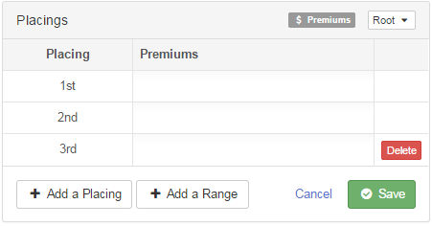
Awards  Even if you do not assign money for awards (Champion etc.) this is where you set up which awards will be available to select in results.  Most awards will need to be added at the level where you want to see them on the result screen.  Examples: Grand Champion Market Steer and Grand Champion Breeding Heifer would be configured at the Division level (Beef Department, Market (or Breeding) Beef Division). Best Opposite Sex of Breed would be configured at the Rabbit department level.  - Click the “Configure” button at the Awards level, and select Premiums (although the selection doesn’t matter, if you’re not going to assign values).  - Click Edit to add premiums OR to add custom awards.  - Add an Award to enter your awards. Delete if you add something in error. Save when complete. | 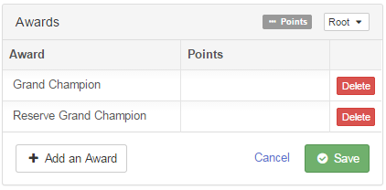

Exceptions (Override)  Example: All fair entries get premiums of $5-$4-$3-$2 for P-B-R-W with the following exceptions:  (1) all market beef ribbons are worth $7-$6-$3-$2  - After the points values of $5-$4-$3-$2 are entered at the Fair level, go to the hierarchy and select Fair>>Beef Department>>Market Beef Division.  - Choose the Points & Premiums tab.  - Notice in the upper right, the drop-down indicator says “Inherited”—meaning the premiums here were entered at a higher level. Pull it down and select “Override”.  - Click Edit, select Premiums, and enter the $7-$6-$3-$2, Save. Now the drop-down shows “Overriden” | 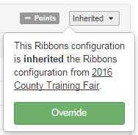
(2) aged dairy cow ribbons are worth $10-$8-$6-$4

- After the points values of $5-$4-$3-$2 are entered at the Fair level, go to the hierarchy and select Fair>>Dairy Cattle Department>>Dairy Cattle Division>>Aged Cows Class.
- Choose the Points & Premiums tab.
- Notice in the upper right, the drop-down indicator says “Inherited”—meaning the premiums here were entered at a higher level. Pull it down and select “Override”.
- Click Edit, select Premiums, and enter the $10-$8-$6-$4, Save. Now the drop-down shows “Overriden”.
- If you have more than one aged cow class (like Holstein aged cows and Jersey aged cows), repeat the process for the next class.

(3) static exhibits get $4 for P, $3.50 for L, $3 for B, $2 for R and $1 for W.

- After the points values of $5-$4-$3-$2 are entered at the Fair level, go to the hierarchy and select Fair>>Static Department.
- Choose the Points & Premiums tab.
- Notice in the upper right, the drop-down indicator says “Inherited”—meaning the premiums here were entered at a higher level. Pull it down and select “Override”.
- Click Edit, select Premiums, and enter the monetary values for the ribbons, Save. Now the drop-down shows “Overriden”.
- If you give NO premiums for a specific static class, after setting the premiums at the static department level, you would locate that class in the hierarchy, and repeat the process, entering zeroes for premiums.

Note: Values that are not “whole dollars” have to be entered as 3.50, not as 3.5. “Whole dollar” values can be entered as either 5 or 5.00.

