Creating Clubs and Club Agent Accounts
Before You Start
Follow the steps below to import non 4-H Online Club and Chapter information and set up Exhibitor Group Accounts for Club Agents who should be able to add entries for non 4-H Online exhibitors.
- The import can only be completed ONE time.
- This must be completed before 4-H Online clubs are imported via the 4-H Online Integration tab.

Fair Administrators may add non 4-H Online clubs to the Club tab either individually or via a Club import. This import can only be completed one time.  - Click on the Clubs tab under Set Up.  - Select to Download Data Template.  NOTE: There are two worksheets in the template. | 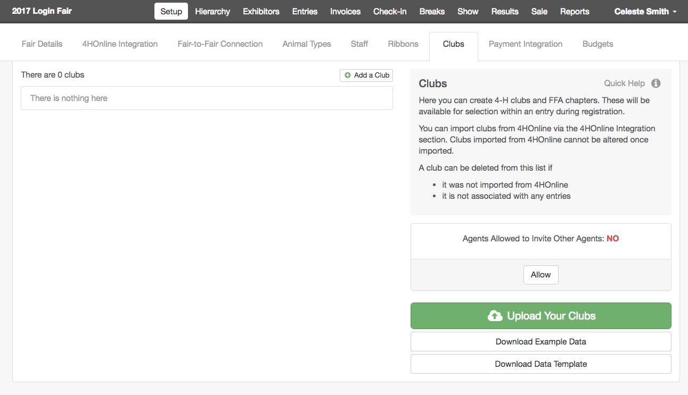
- Club Import Worksheet: Enter the Club Data for any non 4-H Online Clubs that you would like to import. Remember, do not change any headings.  - Club ID: Required – assign a unique number to be used in the database to identify the Club. This will not be visible on screen. Duplicate Club ID’s are not allowed. Each Club must have a unique ID.  - Club Name: Required - Name of the Club will appear on screen and on entry tags/cards and reports  - Club Type: Required – identifies if the Club is 4-H, FFA or Other  - Club Leader: Optional – Primary Contact person for the Club, information only  - Club Address, City, State, Zip: Optional – Address for the Club, information only  - Club Email: Optional – Primary Email address for Club, information only  - Club Phone: Optional – Primary phone number for the Club, information only | 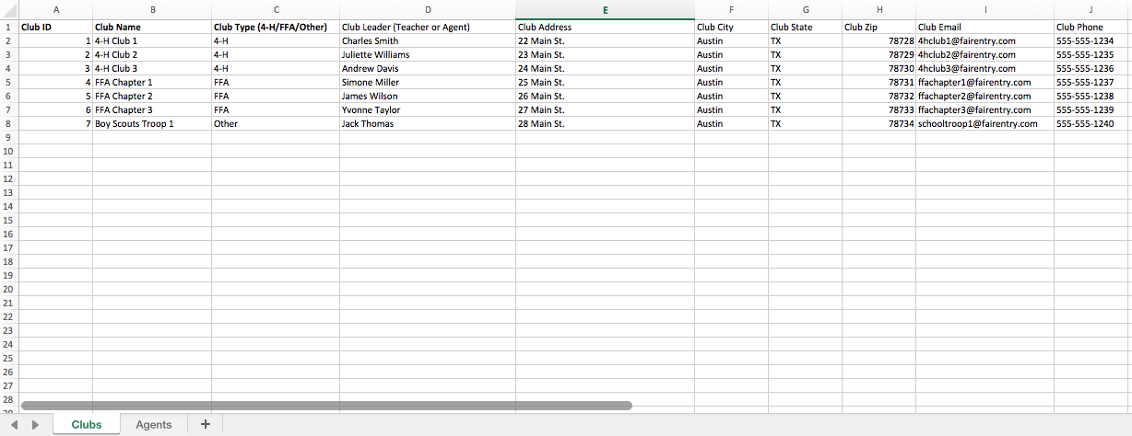

- Agent Import Worksheet – OPTIONAL  If you would like to import Club Leaders/Agents who can log in as an Exhibitor Group to create entries for exhibitors in their Club/Chapter/Class, you may create these manager accounts using this import. Do not enter the same Agent information twice on this sheet. Each Agent can only be assigned to one club.  - Club ID – Required – This must match the Club ID on the Club Import Worksheet for the Club in which this Agent will create entries.  - Club Name – Required – This must match the Club Name on the Club Import worksheet for the Club in which this Agent will create entries.  - Email – Required - Email address that the Agent will use to log in to the Club Exhibitor Group Account (does not have to match the Club Email on the first sheet).  - First Name – Required  - Last Name – Required | 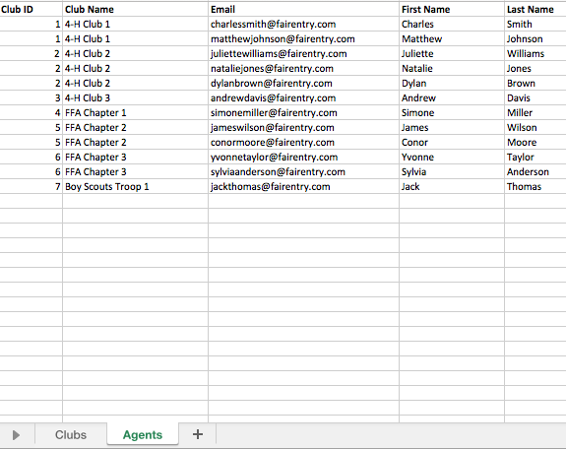
- When the file has been prepared, select Upload Your Clubs and select the appropriate file from your device.  - If you want the Agents (Agent Import Worksheet) to be able to invite other Agents to add entries to their Exhibitor Group, click on the Allow button. | 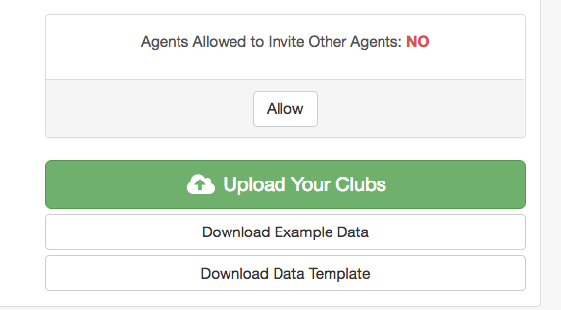
- To Add or Remove additional Club Agents after the import, Edit the Club.  - Click the Red “X” to remove an Agent, or Click Invite a New Agent to add an Agent.  NOTE: The first agent added to a club (and the one imported through the spreadsheet) is designated as the Primary Agent. Primary Agent accounts may not be removed. To edit a Primary Agent account, please contact support@fairentry.com with the details of your request.  NOTE: An agent may only be designated as the Primary agent for one club/chapter. | 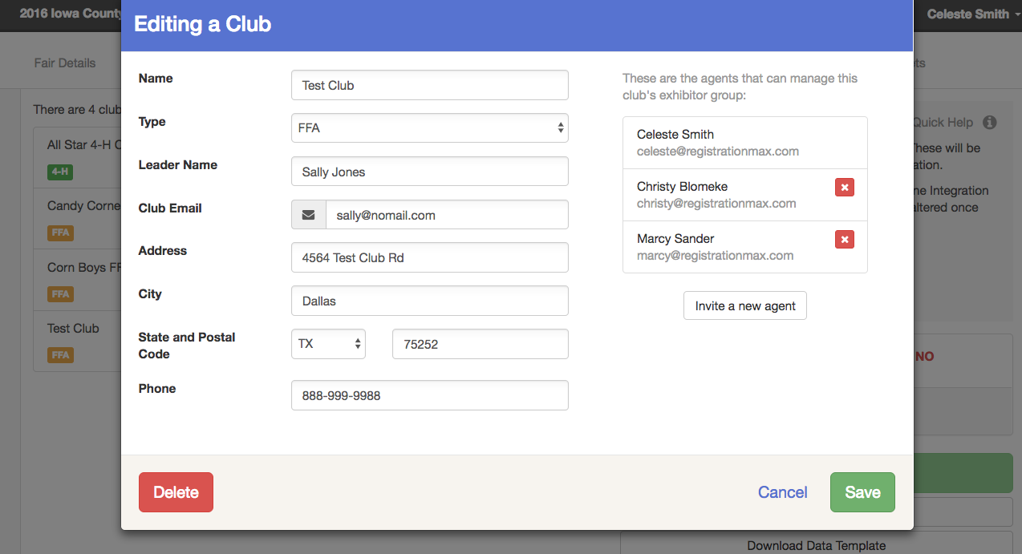
Agent-Only Entries: If there are some areas in which only Agents and Managers are allowed to register exhibitors, the Fair Administrator can adjust those settings:  - Select those Departments/Divisions from the Hierarchy tab.  - Select Entry Settings.  - Select Yes for Agent-only Exhibitor Group. Agents will have access to all areas of the hierarchy that are open for entries.  NOTE: Non-Agent Exhibitor Groups (Family groups) will not see any areas of the hierarchy that are marked for Agent-Only registration during the entry process. | 