FairEntry Budgets
Budgets are linked to points & premiums and checks/reports.
Setting Up Budgets
- Select the Setup tab.
- Select Budgets
- A default unlimited budget is automatically configured for each fair. You may need to Add and/edit the budget:  - Limited Budget: You know how much money is allotted for premiums each year. Entries are awarded points, then all points are divided into the total amount of premium money to determine the value of the premium for each entry.  - Unlimited Budget: You know how much money you want to award for a ribbon (for instance, $5 for a blue ribbon). The total amount spent will vary, depending on how many blue ribbons are awarded.  - Unlimited Budget: You know how much money each POINT is given (for instance, $0.25 per point), and different ribbons are assigned different point values. The total amount spent will vary, depending on how many ribbons are awarded.  - Click Edit to edit the default budget or Add Budget to add an additional budget.  - If you would like to print checks for one area of the fair at a different time from another area of the fair, you will need to set up a budget for each print run. | 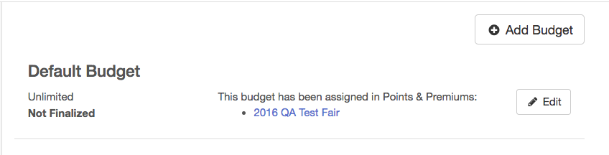
- Enter the name of the budget.  - Select if the budget will be Limited or Unlimited.  - If the budget is Limited, enter the amount, if this amount is known at this time. | 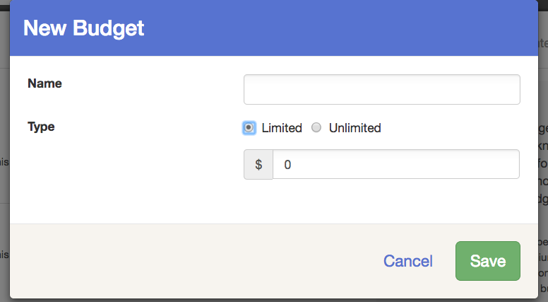
- To assign a budget to an area of the fair, select the Hierarchy tab, then select the area of the hierarchy to which you would like to apply the budget. | 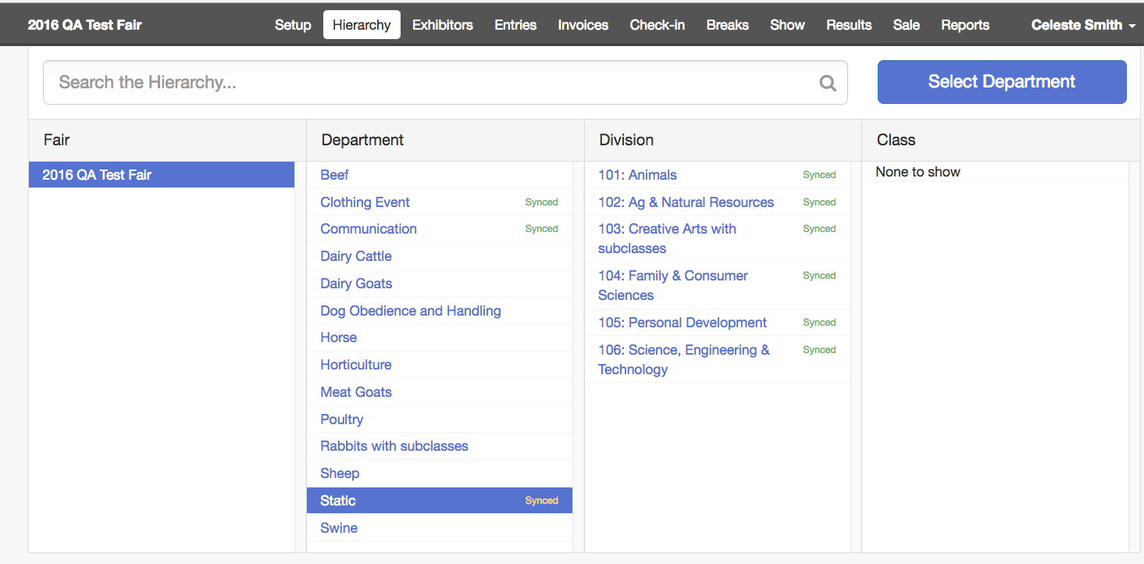
- Select the Points and Premiums subtab.  - By default, the Default Budget has been applied to the entire fair. To override this setting, select to override the setting from the button at the top right. | 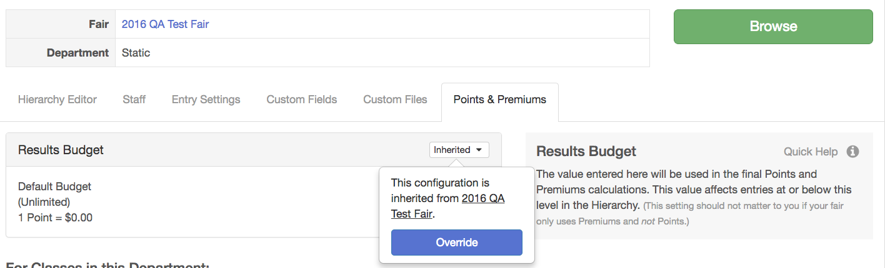
- Select the budget to apply to this area & click Save.  - If you need to edit the budget or add a new budget to use in the area, you may select to do so from this screen as well. | 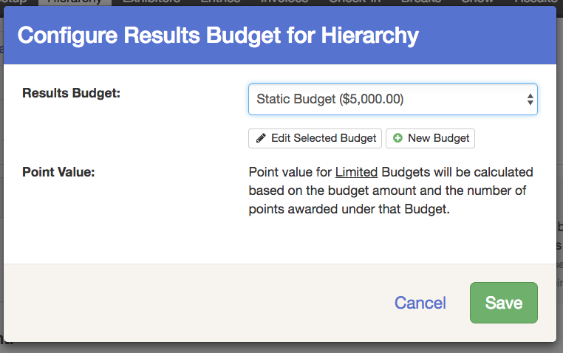
Using Budgets After the Fair
- After results have been entered and you are ready to review premium reports or print premiums checks, select the Finances tab and click on Budgets.  - Select if you would like entries marked as Will Show to be counted in the premium calculations.  - Click “Finalize”. All budgets will finalize at the same time.  - If the finalization for your fair takes longer than a minute, you will see a pop-up message that the finalization process has been moved to a background task and to check back.  - The following areas are locked when Budgets have been finalized:  - Premium Set Up  - Results and resulting premiums (the results can be edited, but the resulting change in premiums will not apply)  - Check-In & Will-Show Status  - Class Breaks  If changes need to be made to these areas after Budgets have been finalized, the Budgets must be reset. | 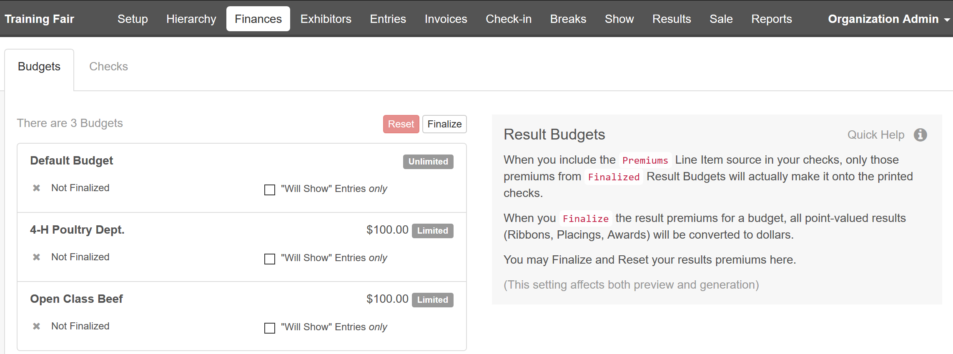  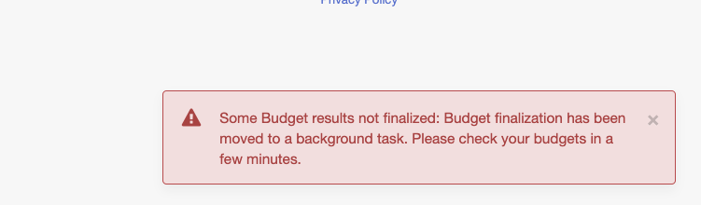
- Once a budget has been finalized, an overview of the funds will be listed.  - If changes are made to results that are part of a budget that has been finalized, the budget must be Reset and finalized again to pull in those changes.  - Class Breaks in a Finalized budget may not be reset and/or broken. If changes to classes are needed, the budget must be reset.  - Click Preview and/or Generate Checks.  NOTE: only Finalized Budgets will be included in checks. | 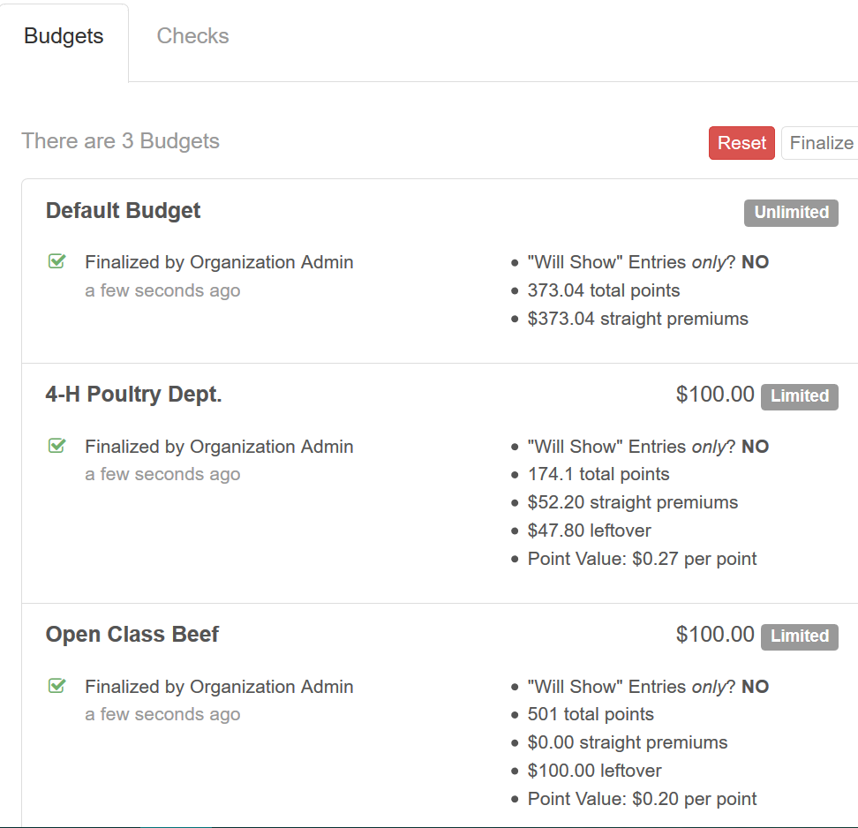
NOTE: Budgets may be applied only the Fair or Department level. Each level can only have one budget assigned. All divisions and classes within the department(s) will be paid out of the budget that is associated with the Department.

