Using Excel PivotTables for Premium or Fee Totals
Before You Start
Using PivotTables in Excel can help you get quick summaries (counts and totals) of various fields on reports, listed by whatever criteria you need—ribbon color, exhibitor, department, etc. Although the term “PivotTable” is not terribly user-friendly, these are not difficult to create, once you have exported a report containing the correct data to Excel.
The menu bars and options vary slightly between versions of Excel. The screenshots in this document are from Excel for Windows®
**NOTE: If you are summarizing Results data, and using a custom report, you must have finalized your budget(s) before the results fields (ribbon, placing, points, premiums, etc.) will appear on custom reports.
Steps  - Begin by creating a Custom Report that includes (at least) these fields:  - Entry: Entry Number  That field is necessary in order to get a full list of all entries.  - The field that you need to group by  For example, if you need the total fees paid per department, the field is Entry: Department Name; per Division, it’s Entry: Division Name; per exhibitor is Exhibitor: Exhibitor Number AND Exhibitor: Full Name (Last, First)  - The field that you wish to total  Examples: Entry: Entry Fee or Entry: Premium Points.  **If you have not finalized your Budgets, the premium field will be blank.  **The Entry Fee field will contain the actual fee paid on the invoice. Manager entries created with no invoice will not show a fee.  - If you want to limit your summary to a specific portion(s) of the hierarchy, use the Specify Hierachy button.  - Save and Download the Excel file. | 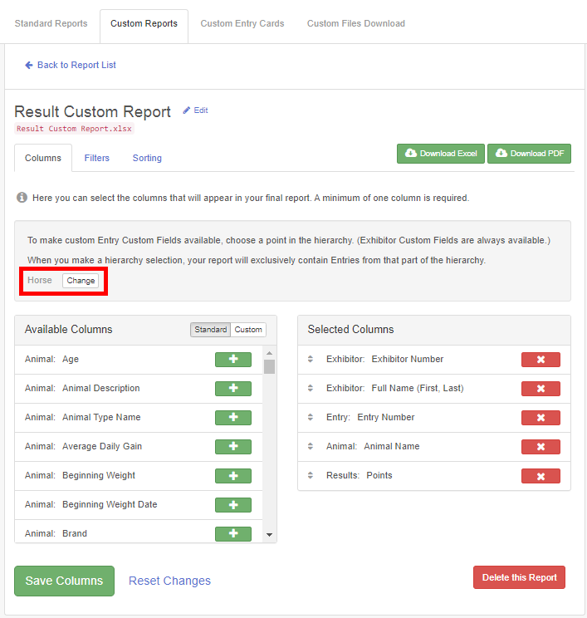
- When you open the workbook in Excel, Fees and Premiums fields will be in a text format. Select the column containing those fields then use the Data tab, Text to Columns option (Next, Next, *General-Finish). If it’s not a long list, you can also highlight the first number through the last number in the column, then click on the yellow diamond-shaped icon beside the top entry and “Convert to Number”.  - Notice that the rows in the spreadsheet represent the information for each exhibit. | 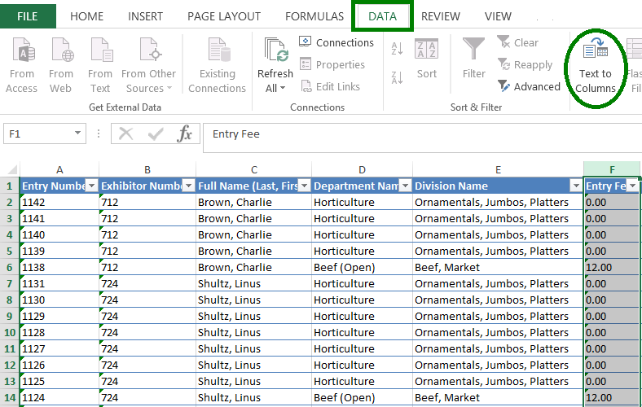
- Use either the Insert tab or the Data tab (depending on the version of Excel that you are using) to find and click on PivotTable. Be sure you do not accidentally choose the PivotChart option instead of PivotTable. | 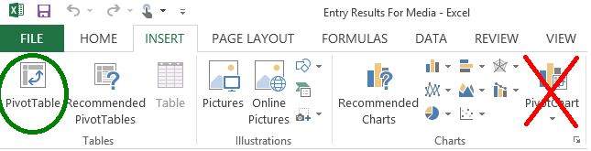
- On the dialog box, be sure that Table1 and New Worksheet are selected as the default options, and click OK. Since you have clicked into the worksheet to change the points to numbers, you may have to enter the Table/Range. You can do that by typing in Table1 (no spaces) or you can click the button at the right of the input box and highlight the cells in the table. | 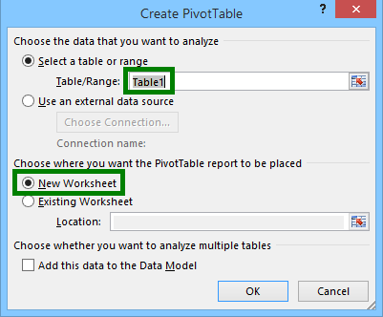
- In the PivotTable builder, scroll through the field list and drag the field you used in Step 1b to the Row box (bottom left).  - Drag the field(s) from 1c to the Values box (bottom right).  - In the Values box, click on the drop-down arrow beside each field and choose Value Field Settings, then Sum.  Excel Hint: If your PivotTable builder box goes missing, look on your menu bar for PivotTable Tools>>Analyze, and click Field List. | 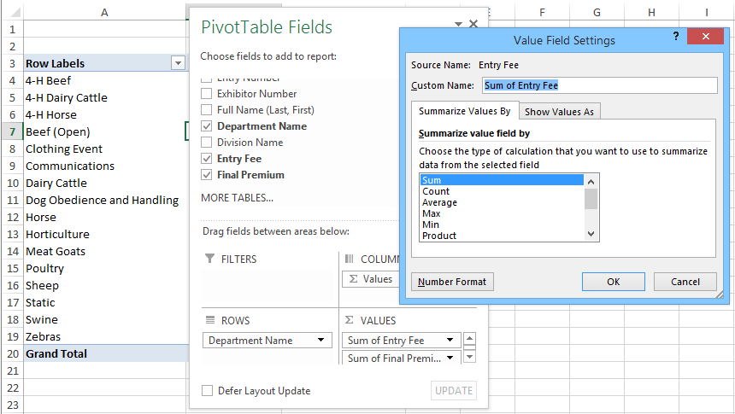
- A Little Fancier—you can compare entry fees paid with premiums paid by including both of those fields in your report and PivotTable. Change the format of the numbers from General to $ to make the report easier to understand. | 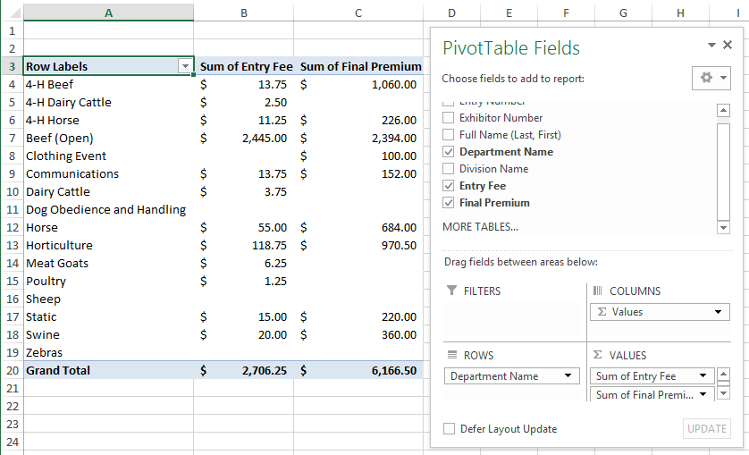
Tips
Exporting reports to Excel, then creating PivotTables can be a great tool for answering the “How many…” questions that typically come after a fair. Remember that if you plan to use a Custom Report to summarize (count or total) Results or Premiums fields, you can only do that after Budgets are finalized. Those fields will be blank on Custom Reports until then.

