FairEntry Budgets
Budgets are linked to points & premiums and checks/reports.
Setting Up Budgets
- Select the Setup tab.
- Select Budgets
- A default unlimited budget is automatically configured for each fair. You may need to Add and/edit the budget:  - If you have a Limited budget (entries are assigned points, and premiums are prorated and paid based on points)  - If you would like to print checks for one area of the fair at a different time from another area of the fair.  - Click Edit to edit the default budget or Add Budget to add an additional budget. | 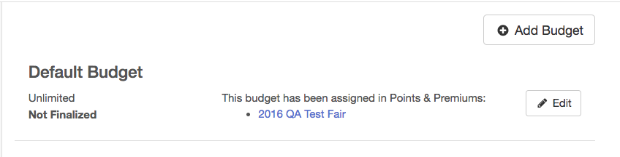
- Enter the name of the budget.  - Select if the budget will be Limited or Unlimited.  - If the budget is Limited, enter the amount, if this amount is known at this time. | 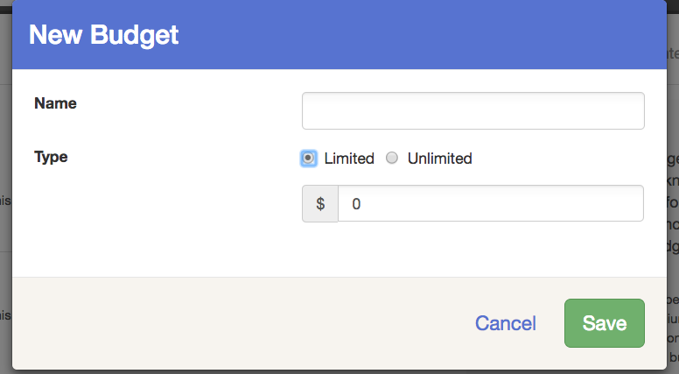
- To assign a budget to an area of the fair, select the Hierarchy tab, then select the area of the hierarchy to which you would like to apply the budget. | 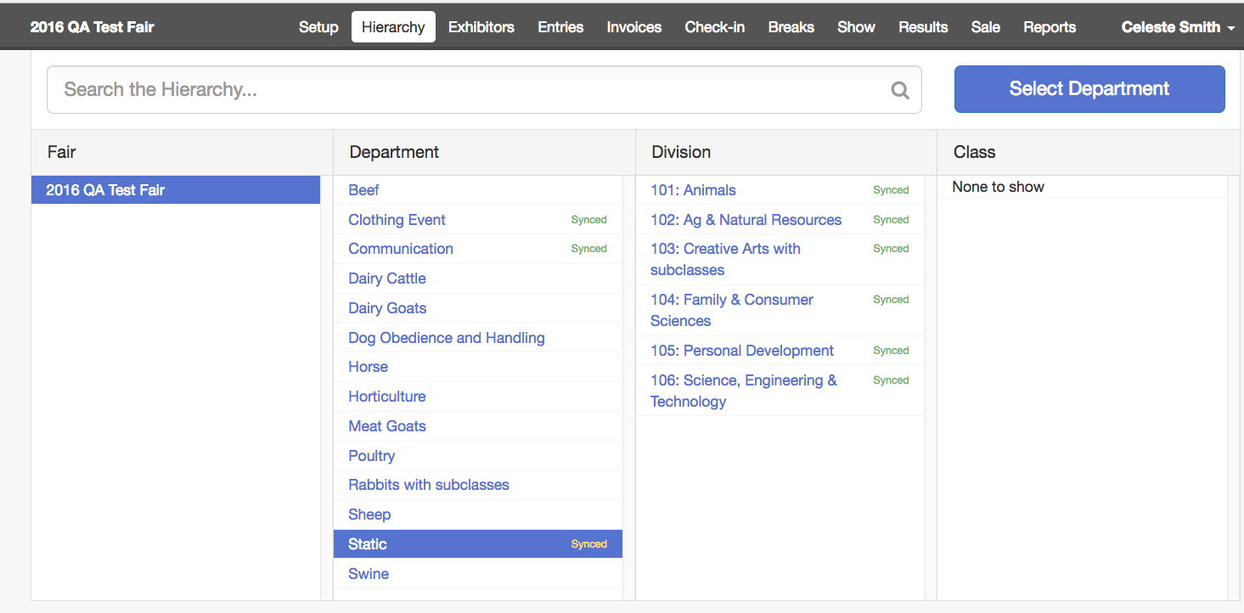
- Select the Points and Premiums subtab.  - By default, the Default Budget has been applied to the entire fair. To override this setting, select to override the setting from the button at the top right. | 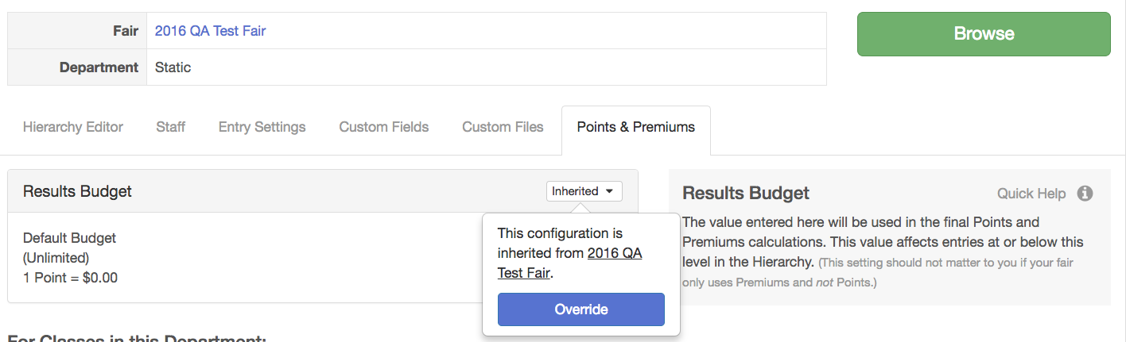
- Select the budget to apply to this area & click Save.  - If you need to edit the budget or add a new budget to use in the area, you may select to do so from this screen as well. | 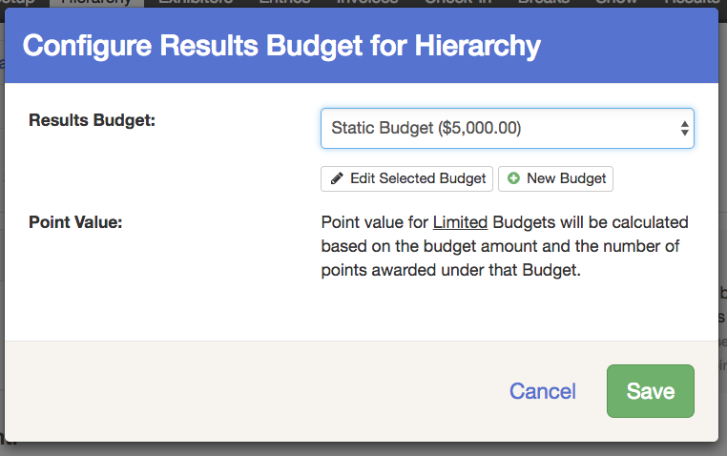
Using Budgets After the Fair
- After results have been entered and you are ready to review premium reports or print premiums checks, select the Finances tab and click on Budgets.  - Select if you would like entries marked as Will Show to be counted in the premium calculations.  - Click “Finalize”. All budgets will finalize at the same time.  - The following areas are locked when Budgets have been finalized:  - Premium Set Up  - Results and resulting premiums (the results can be edited, but the resulting change in premiums will not apply)  - Check-In & Will-Show Status  - Class Breaks  If changes need to be made to these areas after Budgets have been finalized, the Budgets must be reset. | 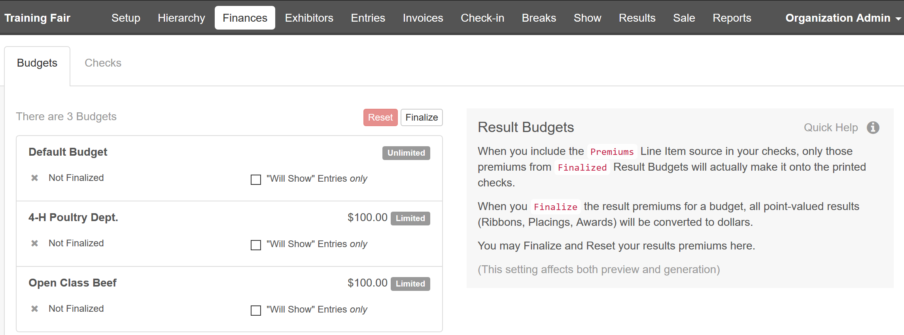
- Once a budget has been finalized, an overview of the funds will be listed.  - If changes are made to results that are part of a budget that has been finalized, the budget must be Reset and finalized again to pull in those changes.  - Class Breaks in a Finalized budget may not be reset and/or broken. If changes to classes are needed, the budget must be reset.  - Click Preview and/or Generate Checks.  NOTE: only Finalized Budgets will be included in checks. | 