Fair to Fair Connection (counties)
Before You Start
IMPORTANT: When you create your hierarchy, it must NOT include any departments that include “state fair classes”—those come from the synchronization process, which is done AFTER the hierarchy upload process. The order MUST BE:
- Create a spreadsheet hierarchy of county-only departments and upload that.
- Synchronize to add the departments for which entries are promoted from the county fair to the state fair.
- Use the Hierarchy Editor to add county-only classes that exist within State Fair departments—an example would be a Pride of the County baking class that is county-only—the winners do not advance to the State Fair, although other Food & Nutrition class winners do advance. You can also delete State Fair classes that are not offered at your county fair.

The state fair must set their fair to Receive Connections before counties can request connection, and the state fair hierarchy must be uploaded before counties can synchronize that portion of the hierarchy.

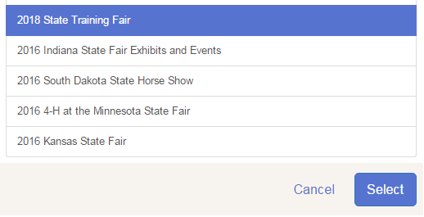
Request the Connection

- Setup>>Fair-to-Fair Connection: “Connect to another fair”.
- From the list of available fairs, select the correct year and fair. Scroll to the bottom and click Select.
- The Fair-to-Fair Connection tab shows that there is a Pending connection. Once it’s been approved by the state fair admin, it will show Approved status.

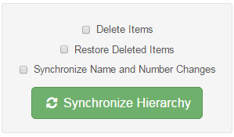
Synchronize State Fair Departments

- After the connection is approved, and after your own county departments have been uploaded, synchronize to add the state fair departments to your hierarchy. The first time, it will bring over all the synchronized departments/classes from the state fair. They will be noted as “synced” in your Hierarchy. You can re-synchronize if changes are made to the state fair hierarchy:
  - Delete Items—if classes were removed by the state fair, they will be removed from your fair.
  - Restore Deleted Items—if you deleted a state fair class from your hierarchy because it’s not available at your county fair, this will restore that deleted class if it still exists at the state fair.
  - Synchronize Name & Number Changes (highly recommended)—if the state fair changes a class name or number, your county fair would be updated to the same new name & number. Skipping a year using that option will mean that the next year will not include the changes from the year you skipped.

