Sale/Auction
Getting Ready for Sale
For the most part, the sale will go more smoothly if most of the information about buyers, groups, and destinations is entered before the sale. However, information can be entered before or during the fair, and updated/ edited during or after the fair if a new buyer registers, address information changes, etc.

Buyers and destinations from one year’s fair can be copied over to the new year fair, if the buyer list is substantially the same from year to year. All Online Accounts need to be re-authorized each year, though.
Adding Buyers (manual entry):  - Click on the Buyers tab, then Individual Buyers.  - Click Add a Buyer.  - Enter the Buyer’s information. Note that you can enter a business name in the Name field, and (optional) a Contact name as well.  - Identifier is required - The buyer Identifier can be a number (1234), or letters/characters (AB&C) – it must be 3-5 characters long, so you can’t use “1” for the first buyer, for example. It would have to be “001” or begin at 100. This "number" will be used as the "buyer number" if you print buyer bid cards.  - Email address – if you plan to utilize the Online sale option, you need to add an email address.  - Click Save. | 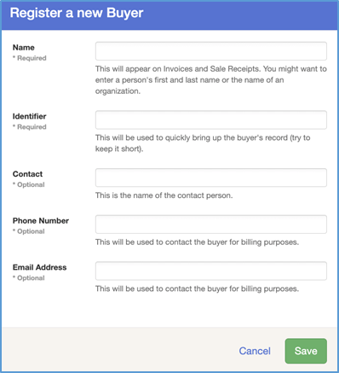
Adding Buyer Groups:  Note: Buyers must exist as individual records before they can be added to a Group.  - Click on the Buyers tab, then Buyer Groups.  - Click Create a Group.  - Enter a Name (required) for the group, and an optional Identifier. Both of these are searchable.  - Click View beside the Buyer Group and then Add Buyers to add existing Buyers to the Group. | 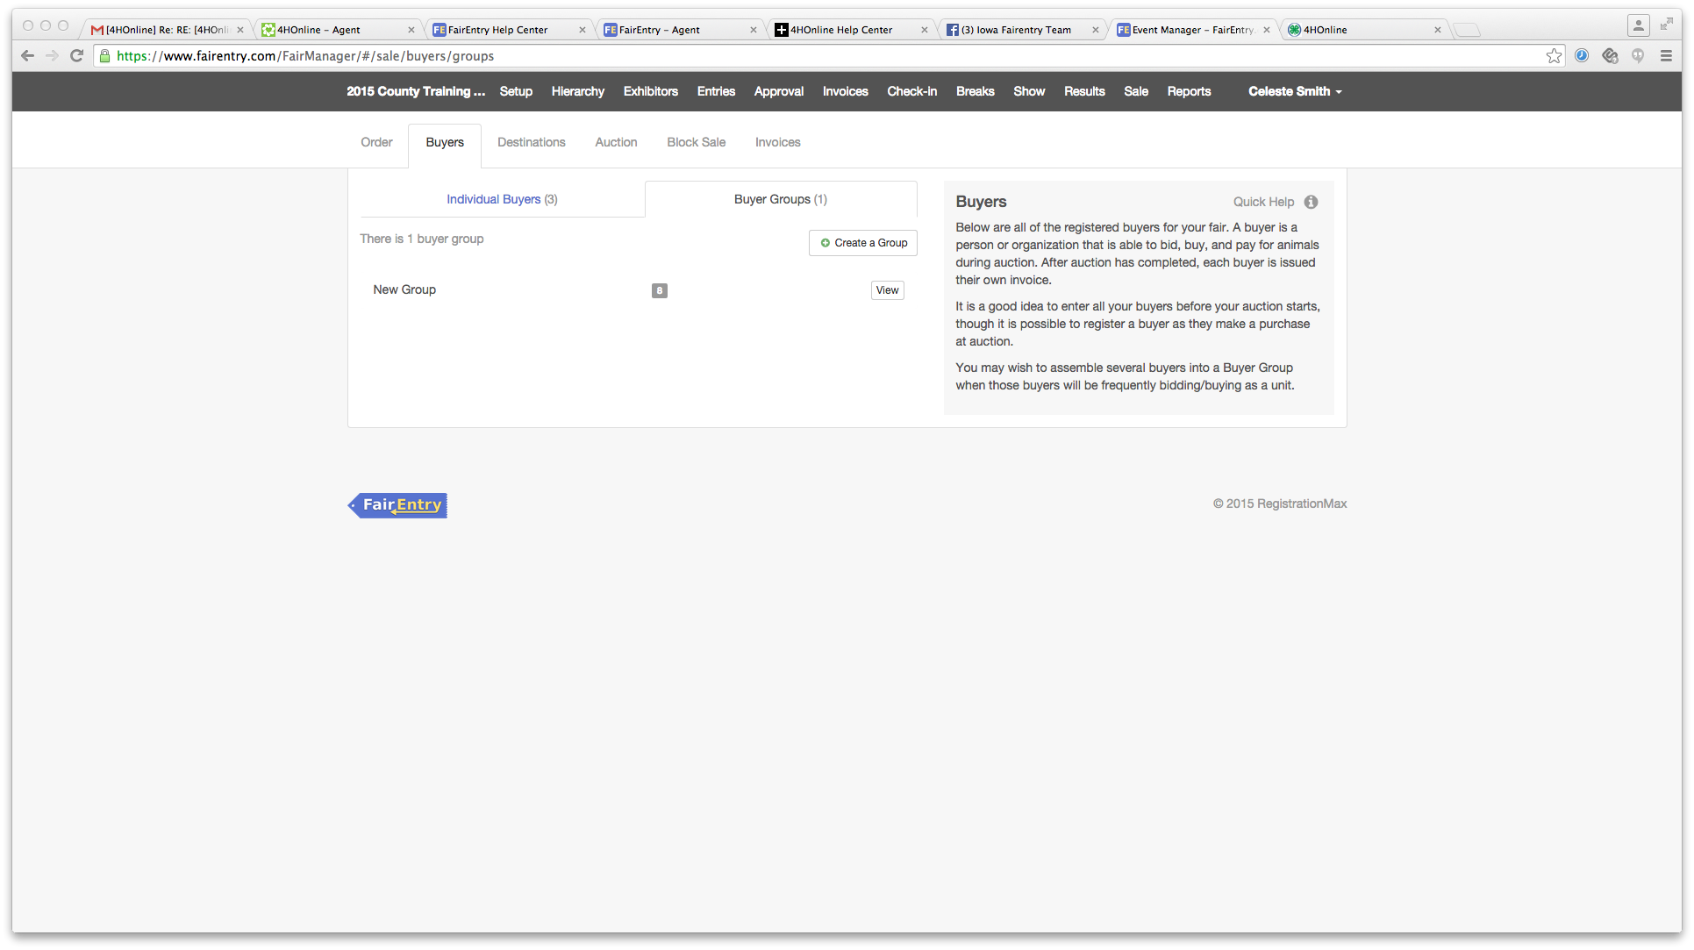  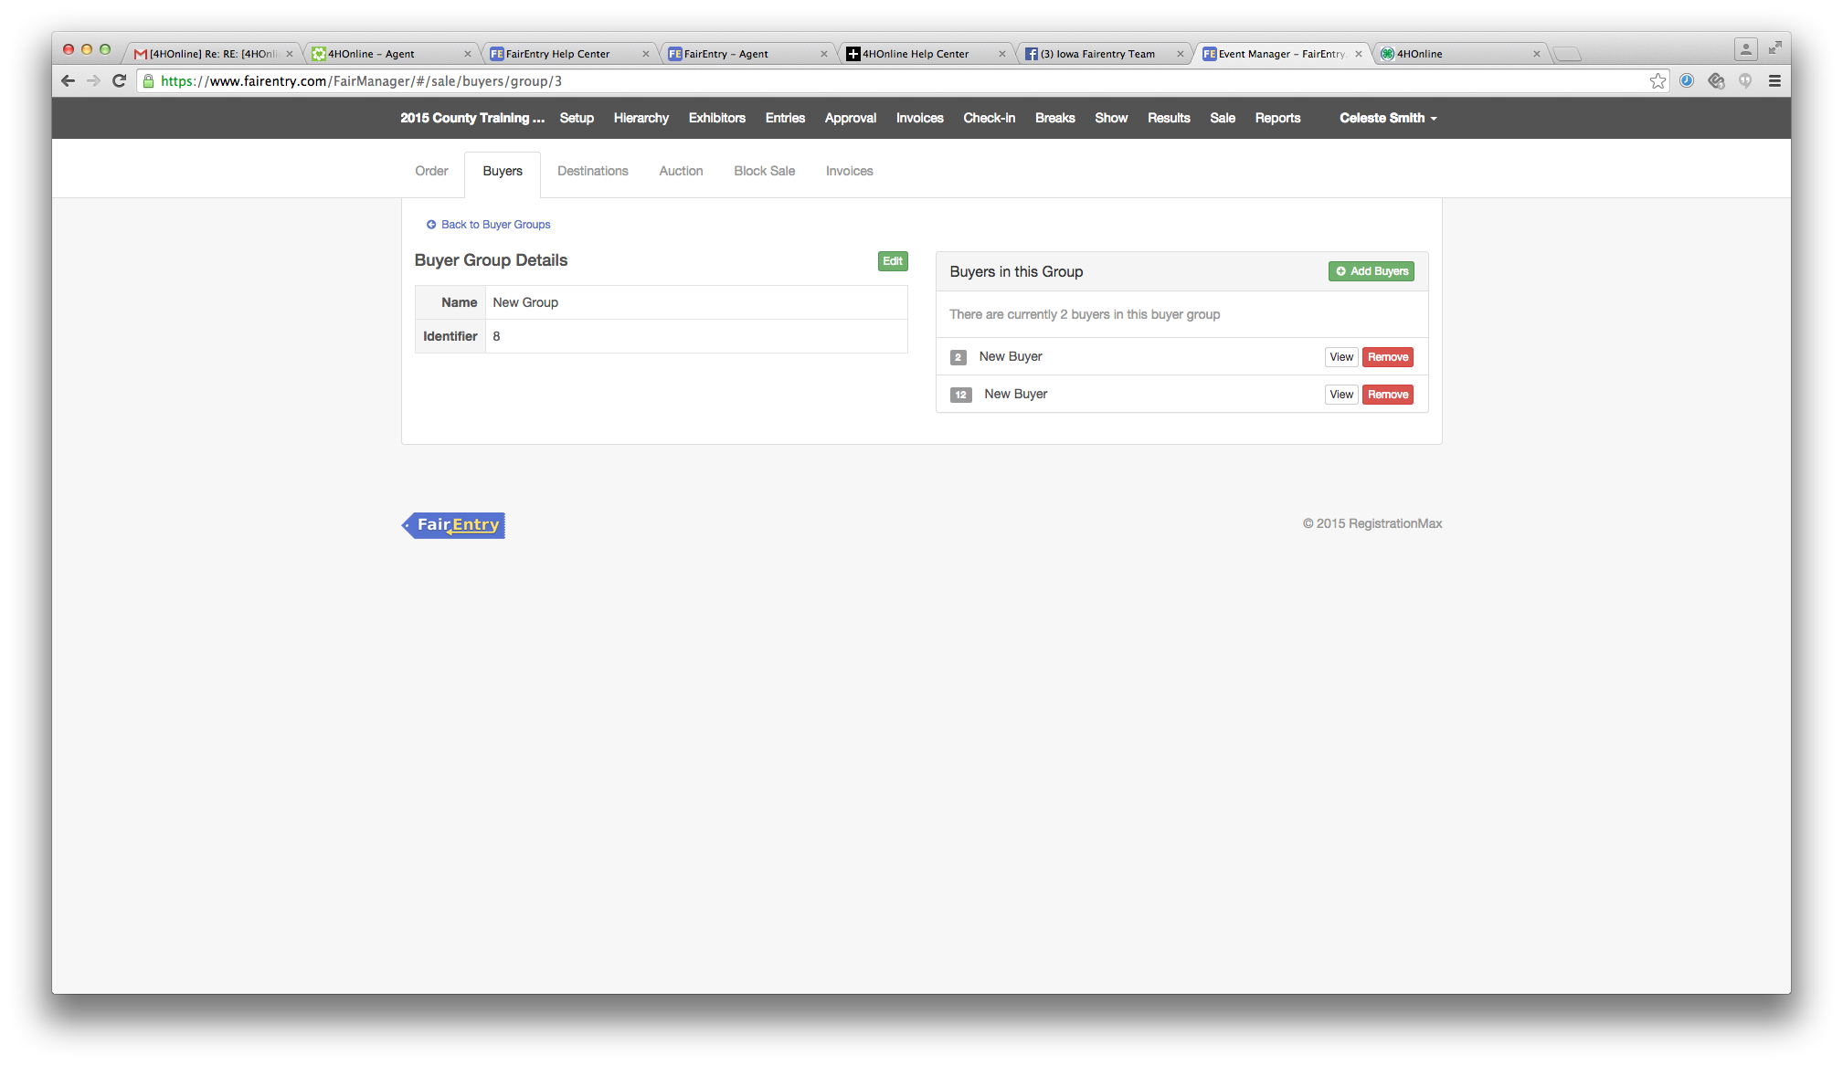  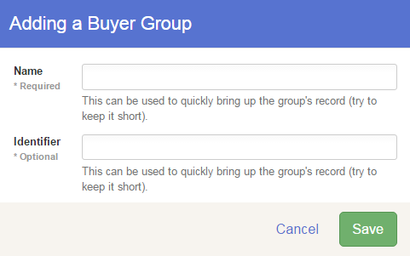
Adding Buyers and Groups (spreadsheet upload):  - Click on the Buyers tab, then Individual Buyers.  - Click on Import Buyers on the right in Quick Help.  - The popup box contains information about the format of the XLSX spreadsheet that can be uploaded. There are two small links at the bottom of the information to download either a blank Template (formatted with correct column headings) or Example Data.  - Required fields: the 8 fields listed in the Quick Help are required—if left blank, the file will not upload. If you do not have complete information for a buyer, either add the buyer manually when the information is available, or enter a place-holder in the cell in the spreadsheet, which can be edited later as more information is available.  - When the spreadsheet is completed in the correct format, click Select File to locate and upload the buyer information.  - Additional Buyers: This upload can be repeated as many times as necessary, adding new buyers as additional information comes in. Additional buyers/groups may also be added manually during the sale if necessary. | 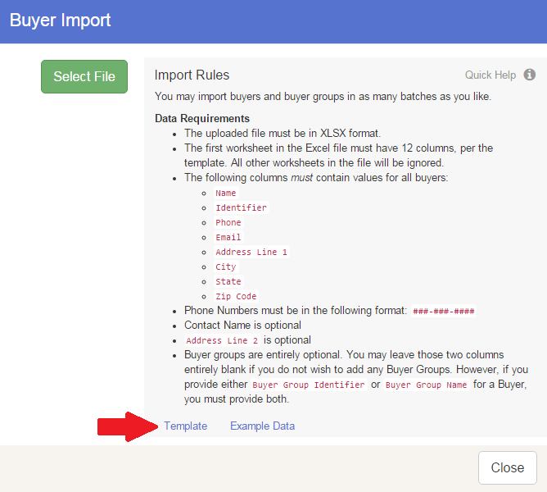
Adding Destinations:  - Click on Destinations.  - Click Add a Destination for the animals.  Packing Lists can be printed for each destination. | 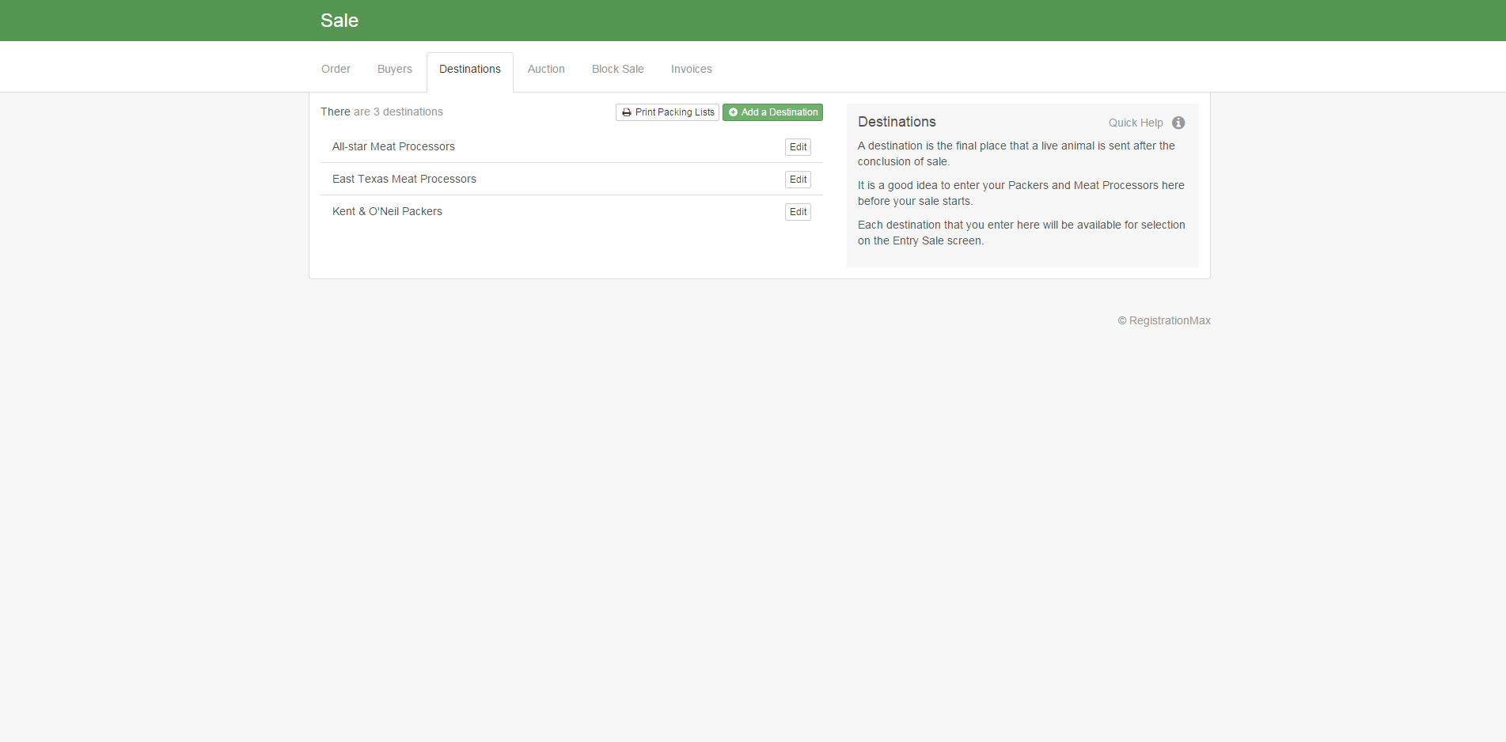
Tips

If you have online buyers, their record will copy over as Online Account Login Allowed = (Yes or No), whatever it was set to in the previous year. This can be problematic if the same email address is used for an exhibitor group account (entries) and a buyer account. Before entries begin, you will need to set that to “No” so that exhibitor groups are able to make entries. When an email address is used for both functions, the Buyer account “trumps” the Exhibitor group account as the login default.

