Setting Up your First Fair in FairEntry

Congratulations and thank you for choosing FairEntry, the online fair management solution! We are delighted that you have selected FairEntry to assist you with managing your fair.

Please use this document as a guide to getting your fair set up for this year and beyond. Most of the set up in the program will happen this first year. You will need to set up your Fair’s hierarchy (your Fairbook), custom fields (your Registration form), points and premiums and entry settings (your Rules). In the second year and beyond, you will be able to copy over all the settings from this year, and just make any changes that you need. Here is a basic checklist of the items that need to be completed before you are ready to start accepting entries in your fair. Each item on the list is either explained in this document (the items marked “see below”) or has a Help document with detailed information (the items with links to the Help Center). Each of the topics below are covered in the training series.

**Organization Admin**

* Select a custom URL if desired (see below)

**Set Up Menu – Covered in Training 1, 2, and 3**

* Fair Details Tab (see below)
* *4-H Integration, if your fair is integrated with your county 4HOnline data (see* *below**)*
* *Fair-To-Fair Connection, if your county fair is connecting to a state fair (see* *below**)*
* Animal Types (see the [Help](https://fairentry.zendesk.com/hc/en-us/categories/6905313662100-Setting-Up-Your-Fair) Center for 4-H Online and FairEntry Animal Types)
* Staff - Logins and Permissions (see the [Help](https://fairentry.zendesk.com/hc/en-us/categories/6905313662100-Setting-Up-Your-Fair) Center)
* Ribbons (see below)
* Clubs (see below)
* Payment Integration, whether or not you charge fees or accept Credit Cards (see below)
* Hierarchy Setup and Upload (see the [Help](https://fairentry.zendesk.com/hc/en-us/categories/6905313662100-Setting-Up-Your-Fair) Center)
* *Synchronize Hierarchy, if your county fair is connected to a state fair (see* *below**)*

**Hierarchy Menu – Covered in Training 2 and 3**

* Hierarchy Editor tab options (see below)
* Staff can be added/viewed from Setup or Hierarchy (see the [Help](https://fairentry.zendesk.com/hc/en-us/categories/6905313662100-Setting-Up-Your-Fair) Center)
* Entry Settings – rules, limits, fees governing entries into your fair (see the [Help](https://fairentry.zendesk.com/hc/en-us/categories/6905313662100-Setting-Up-Your-Fair) Center)
* Custom Fields for your entry process (see the [Help](https://fairentry.zendesk.com/hc/en-us/categories/6905313662100-Setting-Up-Your-Fair) Center)
* Custom Files, for uploads during entry process (see below)
* Points & Premiums (see the [Help](https://fairentry.zendesk.com/hc/en-us/categories/6905313662100-Setting-Up-Your-Fair) Center)
* Division Settings – assigning Animal Types and Project Affiliation (see below)

# Helpful Hints

Paper planning can be your friend. Sketch out your points/premiums and entry rules, finding the most efficient way to enter them. You could set them all at the class level, but it’s much more efficient to enter the most common settings at the highest level, and then just enter the exceptions at lower levels.

As you are getting things set up, you may lose track of what you have already set up and what needs to be done next. Click on Reports, then choose Entered (or Applied) Hierarchy Settings for a spreadsheet export that will give you a full picture of all of your settings and help you quickly pick up where you left off.

Organization Admin

## Custom URL

Click the edit button next to the Organization title to set your Fair’s custom URL. This is the URL that exhibitors will use to register for your fair. The URL is not tied to the year and will be the same for each year, so don’t add the year into the URL.

Set Up Menu

Fair Details

* If your fair’s start/end dates are not correct, you can edit the month and day, but not the year.
* Allow Online Buyers allows buyers to create and sign in to online auction accounts, paying with credit card if you allow that.
* Animal ID Registration allows exhibitors to enter animal information BEFORE fair entries are open. Animal ID Registration dates must end before entry dates begin.
* Recover Buyer Fees—if you Allow Online Buyers, and Credit Card payments, you can select to have the credit card fees charged to the buyer rather than the fair.
* There is the first-step option to allow Result Publishing to a public URL. If you allow that, then at the division level, you will share those as they are complete. This can also be selected/setup at the fair.
* Upload a custom logo for your fair’s homepage, and enter a Welcome message for exhibitors who are entering the fair. The message should be short and basic—people don’t read lots of text on webpages.
* FairEntry uses the terms Department, Division and Class to describe the levels of the hierarchy. If you call these something else (i.e. Lot instead of Class), you can change Department, Division and Class to terms with which you and your exhibitors are most familiar.

At the bottom of the page is the option to upload an Excel file with your Hierarchy structure. (see Hierarchy).

4-H Integration

If you would like to import records from 4-H Online into FairEntry (members, clubs, projects, animals), select the appropriate **Year**, State and County. *This will need to be re-established each year.* After integrating, be sure to import the clubs, projects, and animal types from 4-H Online right away. Import members just before opening for entries.

Fair-to-Fair Connection

If your fair is connected to another fair that is using FairEntry (i.e. County and State Fairs), it is necessary to establish the connection between the two fairs in order to promote selected exhibits from one fair to another. Follow the on-screen instructions to find and request a connection to the fair. *This will need to be re-established each year.*

Synchronize Hierarchy

If you are connecting to another fair, after the fair-to-fair connection has been set up and approved, AND AFTER your own (non-synchronized) hierarchy has been uploaded, click Synchronize (be sure to click Synchronize Name and Number) under the Fair-to-Fair Connection tab to import the hierarchy from that fair. This option is available for county fairs that connect to a state fair and use the same hierarchy (or partial hierarchy).  
**NOTE: It is absolutely critical that this step is done AFTER the classes that are not connected are set up. If you are a county fair that will be synchronizing part of your hierarchy with a connected state fair, do not include those state fair classes in your upload file (that would include them in the hierarchy twice). Upload your county classes, THEN synchronize with state fair classes.**

Ribbons

Select all the ribbon colors that you will be using and arrange them in order of their value.

**NOTE: This must be done before setting up Points & Premiums.**

## Clubs

Click on Clubs to see which Clubs were imported from 4-H Online (after integration is approved) and/or add additional 4-H Clubs, FFA Chapters, or Other clubs that exhibitors may select when they register for the Fair. If you have a long list of clubs to be added, you can do that with an upload spreadsheet. There is a sample of that posted for you to view.

Payment Integration

**Even if you do not accept credit card payments or charge entry fees, this is also where you MUST enable check payments in order for families to be able to proceed to “check out” and finalize their registration.** If your Fair charges entry fees and accepts credit card payments, click on Payment Integration to set up a new Stripe account or to link an existing Stripe account. You also have the option to Bypass Invoice Approval, which means credit card payments are processed immediately, and once the payment is approved, all entries will be made active without an additional manager approval. This only affects credit card payments. Be sure to enter a Terms Message on this page.

Hierarchy Menu

The following areas can be set up at each level in the hierarchy. Click on the Hierarchy tab, select the Fair, Department, Division or Class and select the set up you would like to complete for that area.

Hierarchy Editor

Click here to add or edit Departments, Divisions and Classes, as well as (at the division level only) link Animal Types and/or 4HOnline projects to divisions of your fair. (See Division Settings for more information)

Staff

Click on Staff to see who has permissions to access this level of the hierarchy. You may add additional staff directly to this level here as well. Implicit staff have been given permissions at a higher level and thus have access to this level. Explicit staff have been given permission specifically at this level.

Custom Files

If there are files that exhibitors need to upload during registration, set those up here. Uploads set up at the Fair level will be asked of each exhibitor one time, regardless of how many classes they enter, or how many separate invoices they create. Those created at lower levels will be asked as part of each entry in those respective areas. File uploads flow down the hierarchy just like Custom Fields. For example, if you have a Digital Photography division and all entries in that division, regardless of the class, need to upload a digital photo, the question should be set up at the Division level. If it’s only required for one class, it should be set up at the class level.

Once you have a strategy, go to **Hierarchy** (select a level) **>> Custom Files** and “Add a Control”.

Division Settings

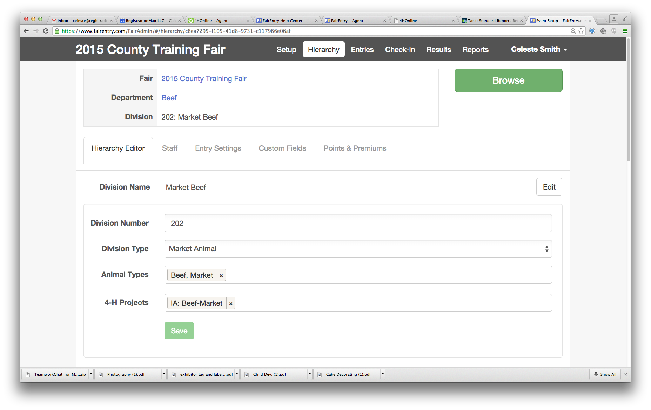

Select a Division from the Hierarchy and click on the Hierarchy Editor tab to set the following restrictions for Divisions:

### Animal Types

If an animal’s information (i.e. tag, breed, birthdate) needs to be added to an entry in an animal division, select the animal type(s) (from 4-H Online or set up in FairEntry in the Setup area) that will be associated with that division. *The Animal Type designation for each division has to be re-established each year—it is not copied over from a previous year’s fair.*  
**NOTE: Animal Type designations become permanent for a fair once the entry process begins. Be sure to consider how all the animals may have been identified and add all applicable animal types.**

### Project Affiliation

If a member from 4-H Online is required to be enrolled in a specific 4-H Online project in order to submit entries in a specific division, select the required project(s) under 4-H Projects. When a member registers for Fair, the system will check the 4-H Online projects and will only allow the member to submit entries in Divisions for which they have enrolled in the corresponding 4-H Online project. Exhibitors who are not 4-H members (logging in with their 4-H Online account credentials) are not affected by this setting.