Point of Sale Buyer Payments
Before You Start
- Point of Sale buyer payments allow buyers to pay in-person via an m2 card reader connected to the FairEntry Payments App.
- The FairEntry Payments app is currently available for IOS mobile devices with IOS 16.0 or greater.
- Payment options include credit card, debit card, Apple Pay and Google Pay (swipe, insert or tap)
- Login to your Stripe account to order your m2 reader(s).
- *Prior to taking the first payment, the m2 reader will need to be charged for two hours. Please plan ahead.*
- ONLY Fair Managers and Sale Agents have permission to accept point of sale payments. If you are an Organization Administrator or a Fair Administrator, please log in to your FairEntry account and add a Staff Account (Setup tab, Staff subtab) with Fair Manager or Sale Agent permissions to use for taking payments.
- The FairEntry Payments app requires a physical location. As an Organization Administrator, before the sale begins, login to the Organization Administrator homepage (where all the fairs are listed) and select to enter the Primary Contact information for your Organization. Please use a STREET address for the Sale’s location - using a PO Box will result in processing errors. NOTE: This address will also print on the Buyer Statements.
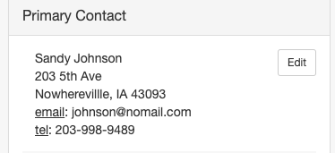
- If you would like the buyers to pay the processing fee for credit cards, as an Organization or Fair Administrator, be sure to set “Recover Buyer Fees” to “Yes” (Setup tab, Fair Details subtab) in your FairEntry account.
Steps  - *Prior to taking the first payment, be sure the m2 reader has been charged for at least two hours.  - *Download the FairEntry Payments app to the device(s) from the Apple App Store that will be used to connect to the reader. | 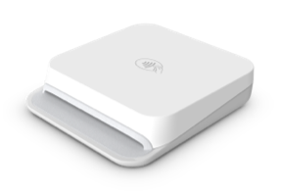  

- Open the FairEntry Payments app on the device.  - Select the top FairEntry logo.  - Enter the Fair Manager or Sale Agent login credentials.  **NOTE: Organization Administrators, Fair Administrators and 4-H Online Staff members will need to use a Fair Manager or Sale Agent account for this login.**.  - Tap “Sign in with FairEntry.”  **NOTE: If you have forgotten your password, please go to www.fairentry.com, select “Staff Sign-In” and “Forgot your password?” Use the new password (not the temporary password) to sign in to  FairEntry Payments. | 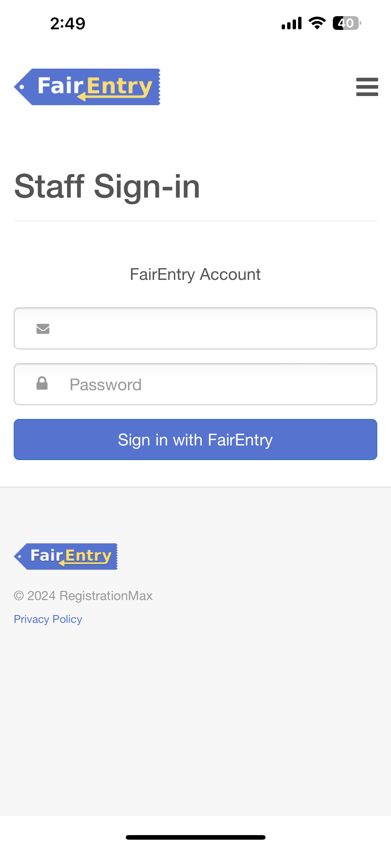
- Select the Fair Manager or Sale Agent account for the Fair/Event for which to take payments (if the login credentials are used in multiple fairs). | 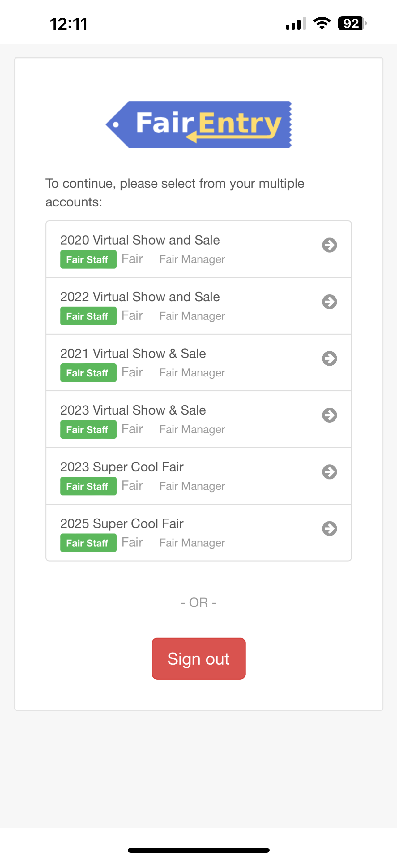
- *If this is the first time connecting the m2 reader, you will be prompted to allow access to Bluetooth and location. These are both required in order to take payments. Please be sure to enable the Bluetooth and Location features on the device.  - Turn on the m2 Reader. The reader will pair with the device automatically. | 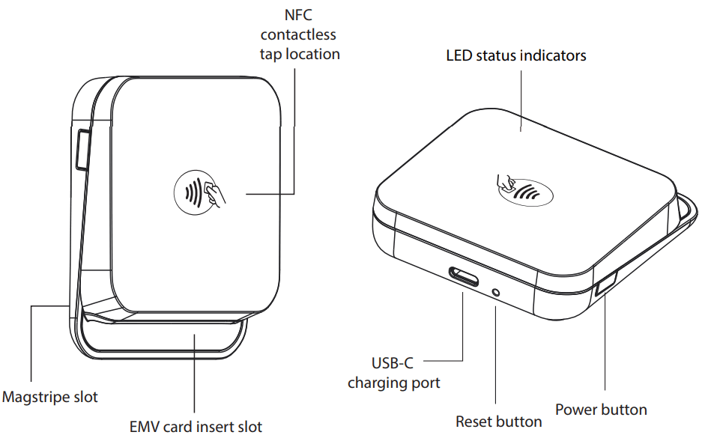  Icons indicate the status of the  m2 reader connection, location  and Bluetooth connection  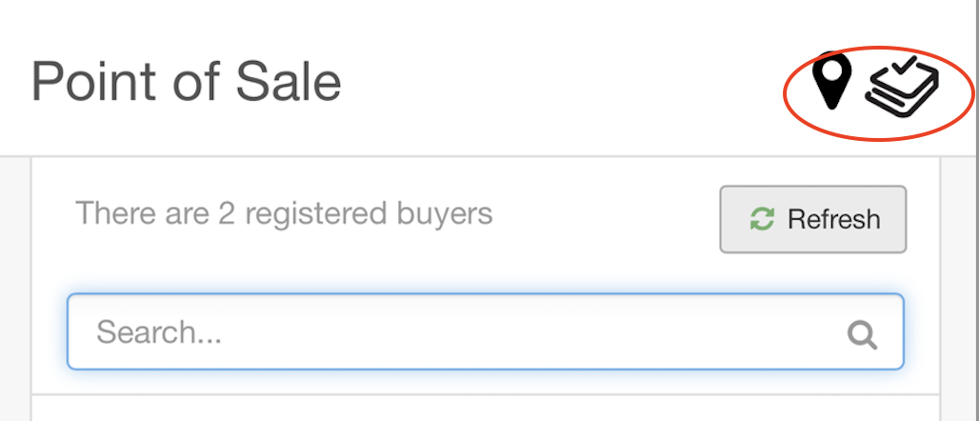

- *Once the device is connected successfully, if this is the first time connecting, the device may need to install a firmware update. This process will begin automatically and may take several minutes. After this initial update, the device will connect right away. | 
- Search for the buyer using the Buyer Name or ID. Click View.  - Click “Refresh” to pull in newly added buyers while logged into the App. | 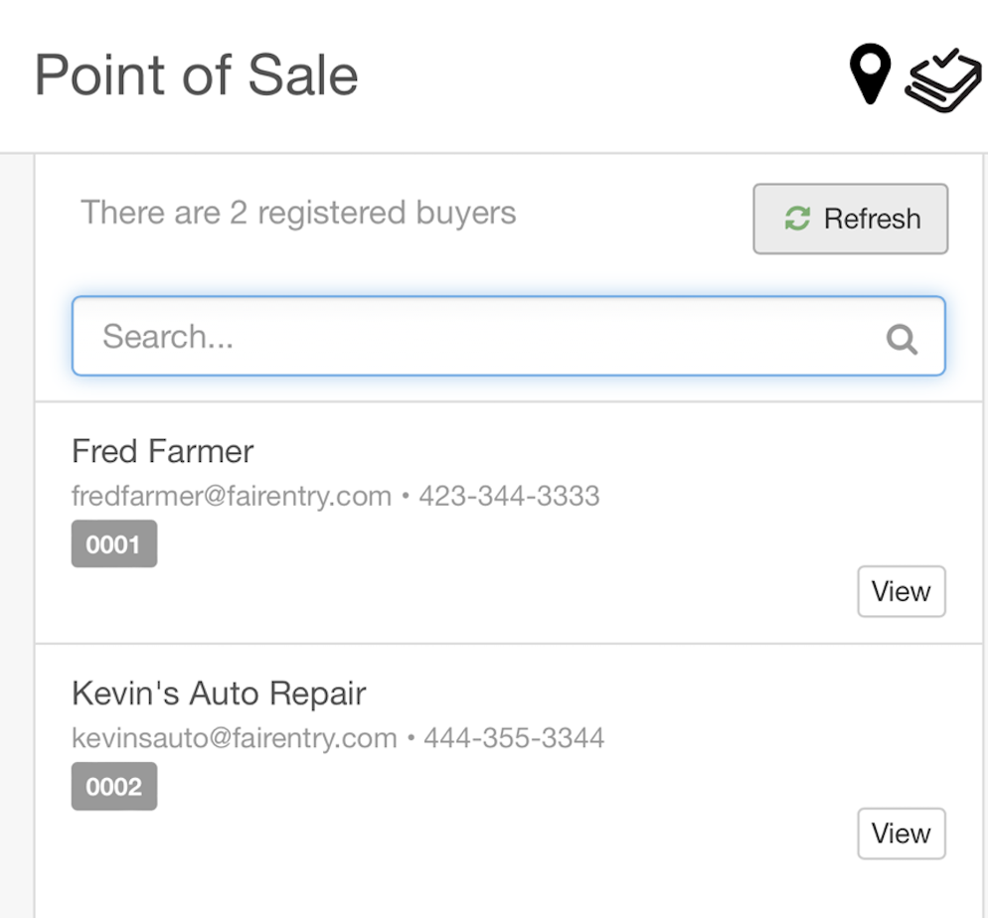
- Scroll to the bottom of the buyer page and tap “Pay Now” | 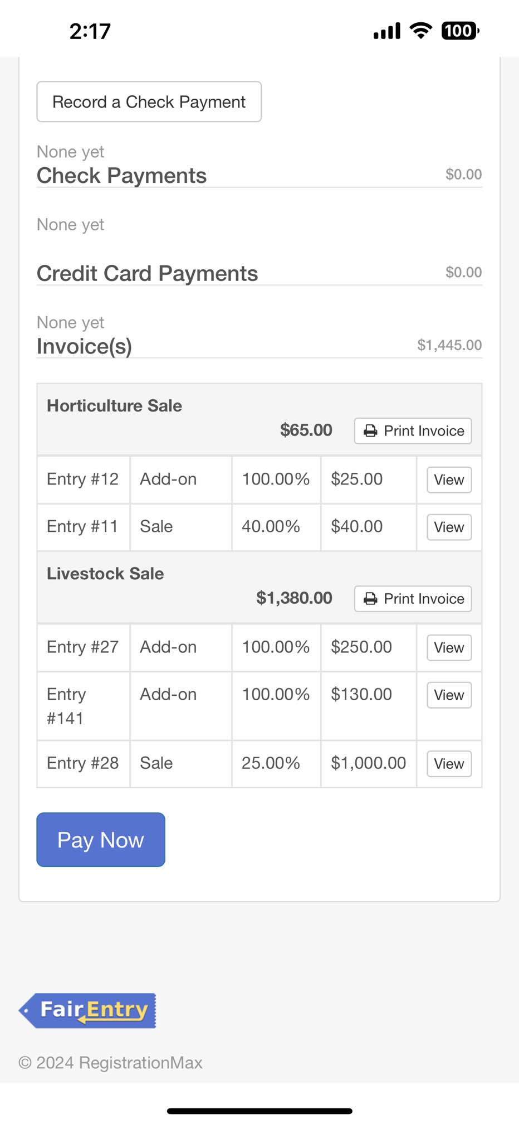
- Enter the payment amount if it is different from the full payment amount. Tap “Pay”  - If “Recover Buyer Fees” is set to yes, the processing fee will be calculated on the entered Payment Amount and the new amount will appear on the screen so you may inform the buyer of the new total prior to processing payment. | 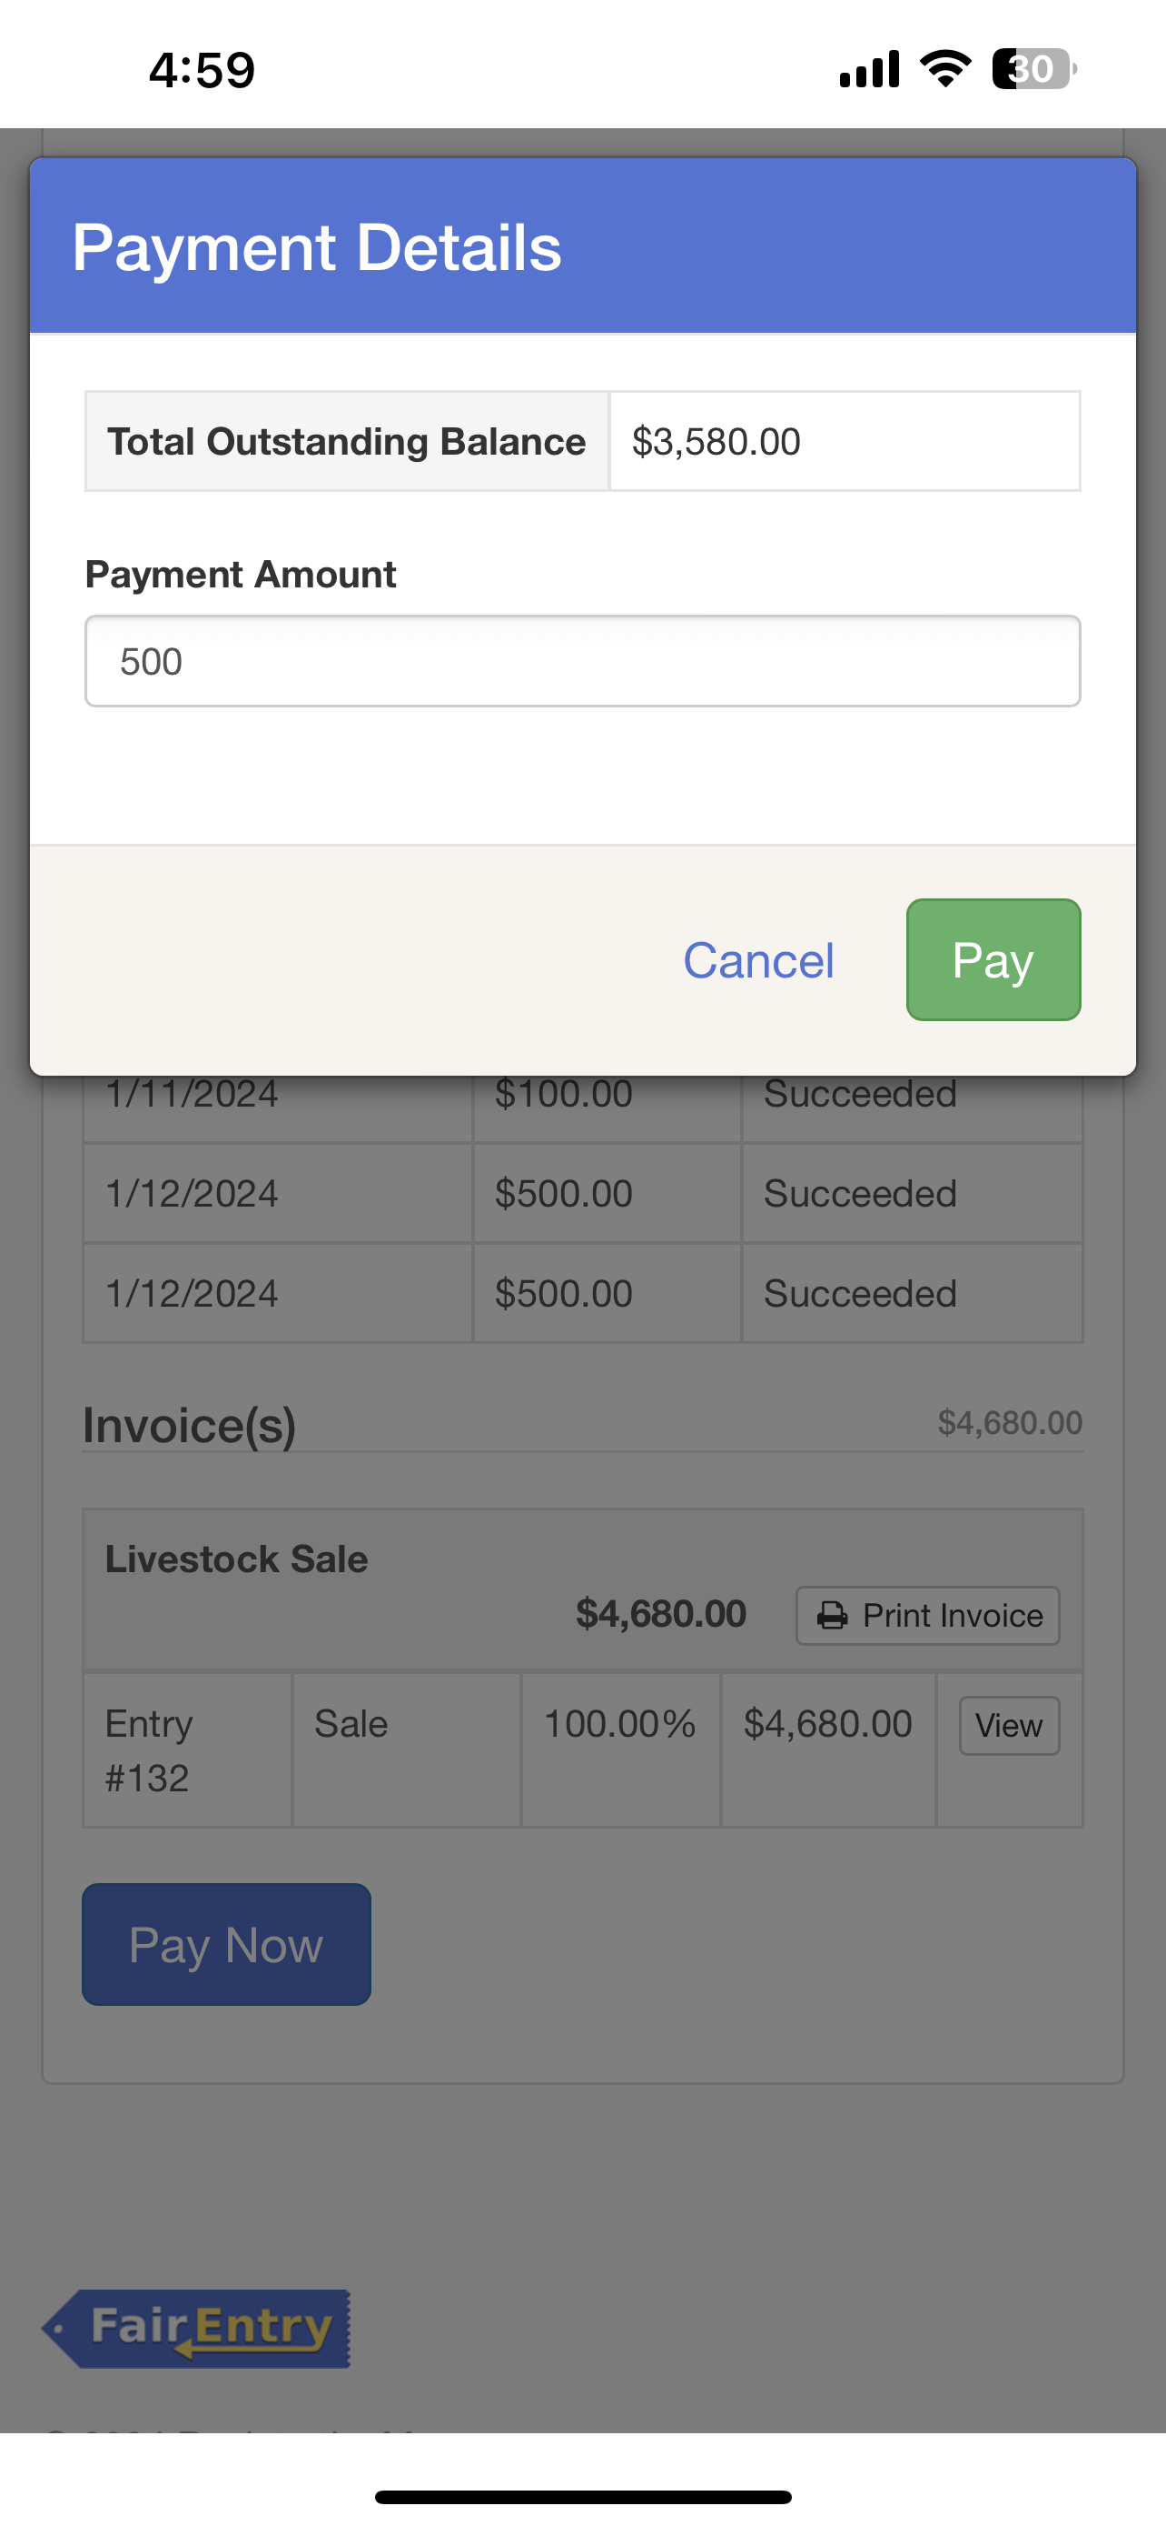
- Follow the prompts to tap, insert or swipe the payment card.  - After the receiving the prompt that the payment is successful, remove the card. | 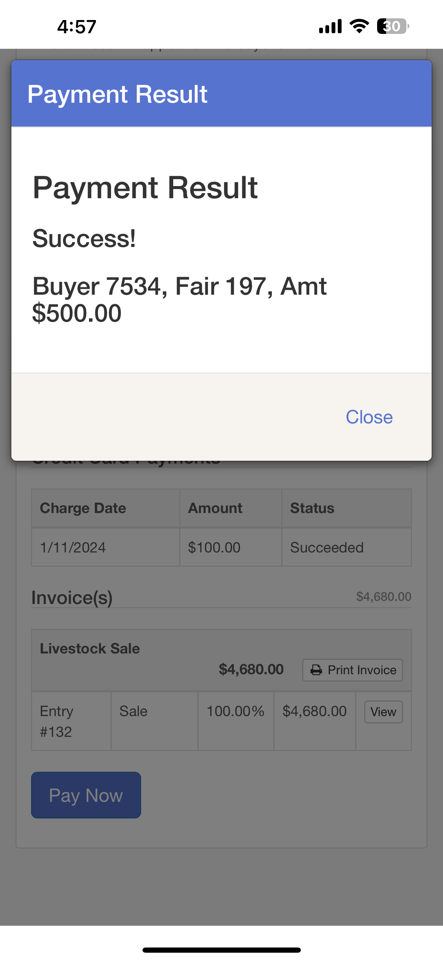  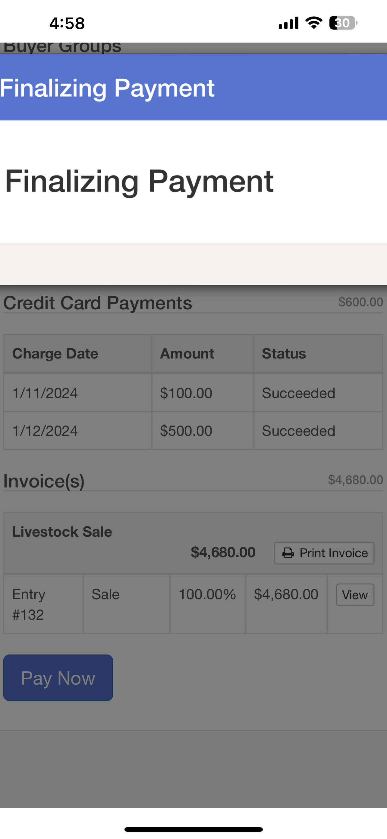  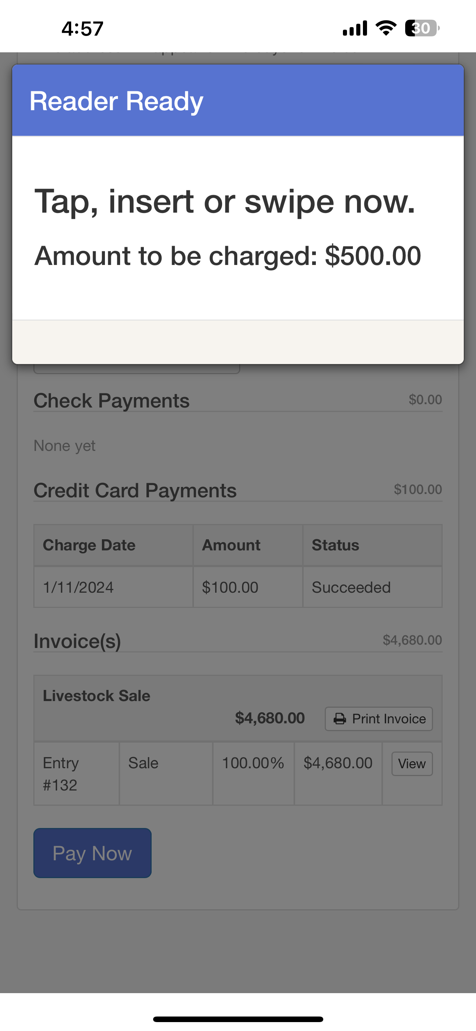
- The payment will be recorded on the Buyer’s page both in the app and in FairEntry. | 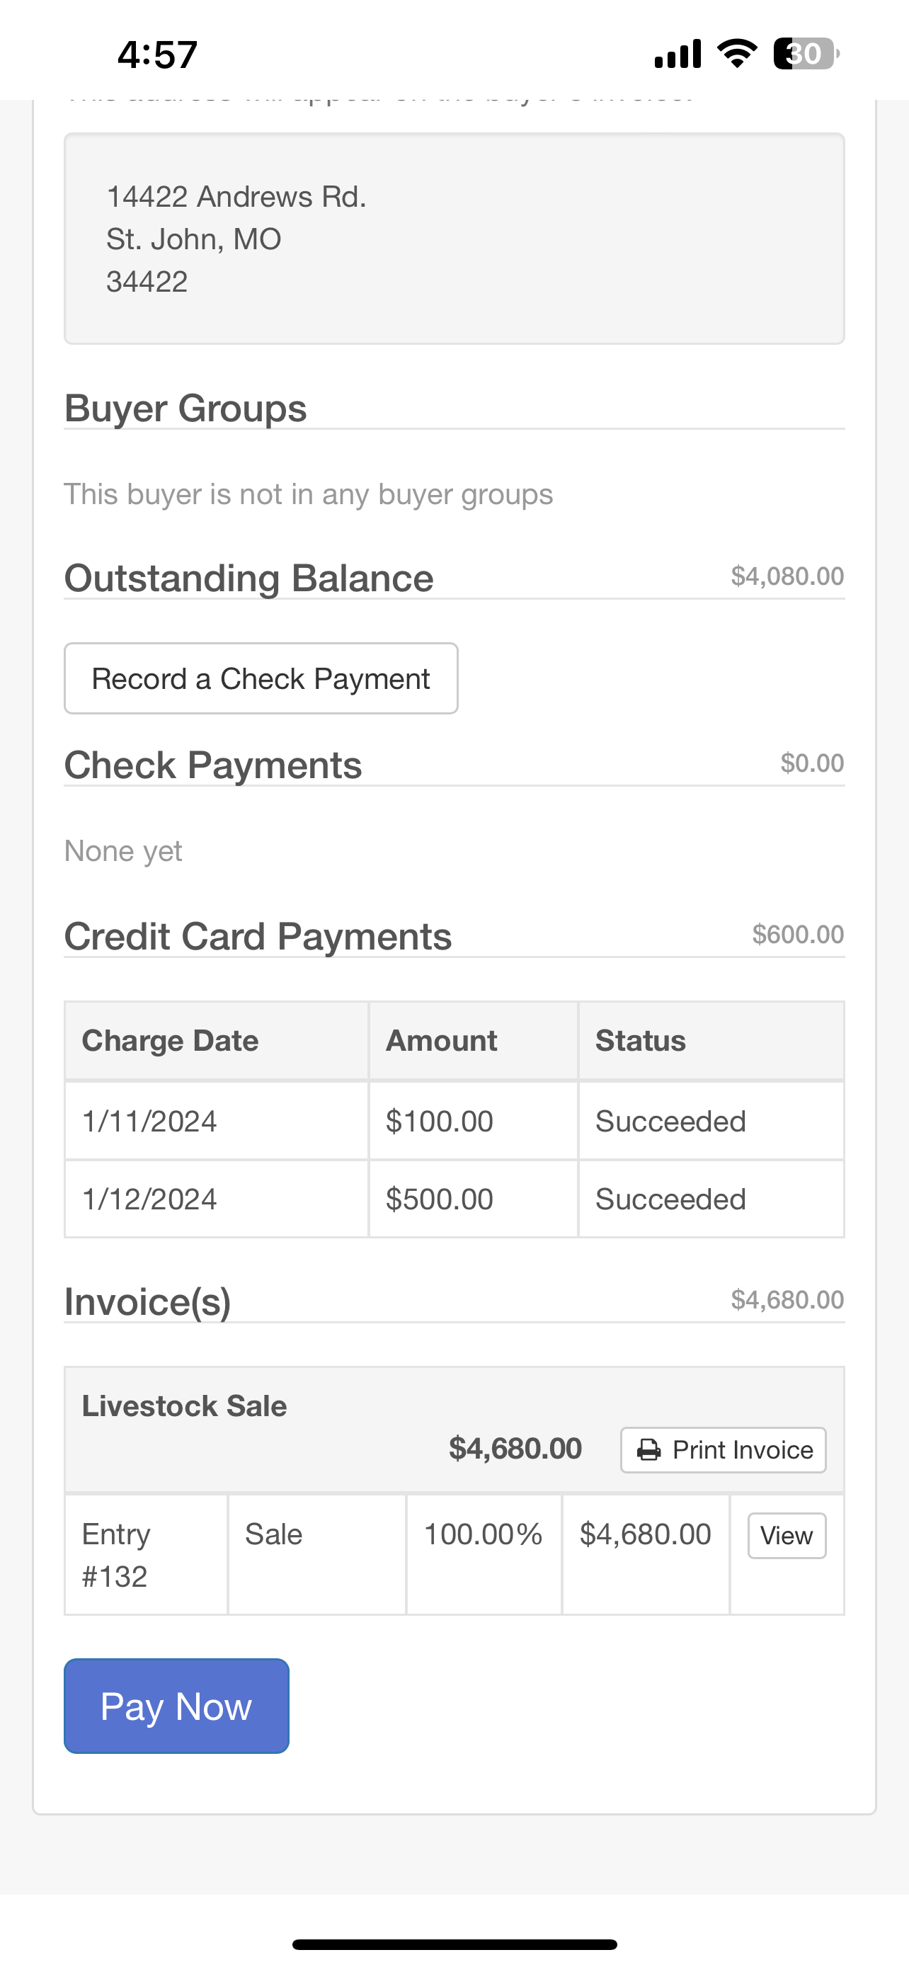
- If the Buyer’s email address has been entered in the Buyer’s contact details in FairEntry, they will receive an email with a receipt.  - Congratulations! Wasn’t that easy? | 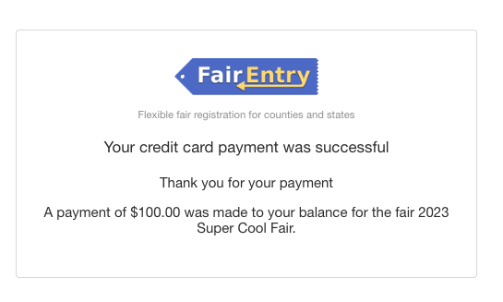
- Use Search bar at the top of the page and repeat steps 11-17 to process the next payment. | 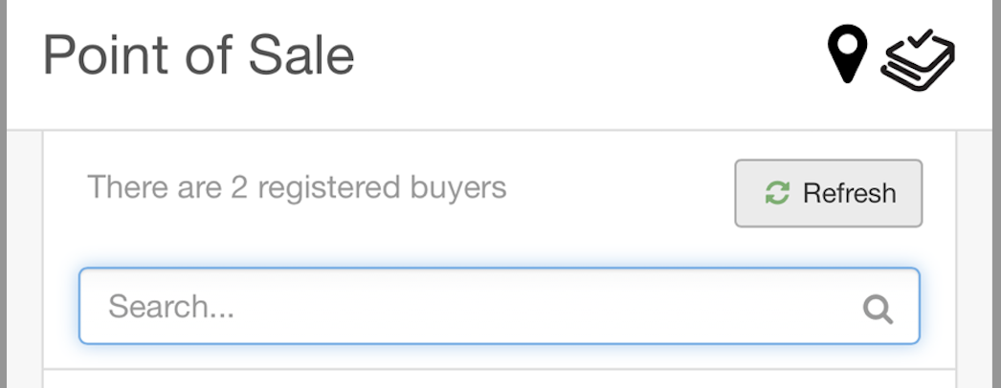
Tips
*These steps only apply the first time that the m2 reader is connected to the device and can be skipped with subsequent connections. These steps can take several minutes. Please be sure to complete the initial connection process prior to the day of the sale/auction to avoid a highly stressful situation. J
**If your fair is using more than one m2 reader, it is recommended to color-code or mark which reader is paired with which device. If the devices get switched around, and two people are processing payments at the same time, there is a risk that buyers may end up paying for the wrong invoice.
***After buyers have paid and the m2 reader is no longer going to be used on a device, it is recommended to select the Device’s Bluetooth settings and “Forget” the m2 reader in order to prevent accidentally connecting to the reader in the future.

