Are You Ready to Begin Accepting Entries?

Below is a basic checklist reminder of the items that need to be completed before families begin making entry to your fair. Each item on the list is either explained in this document (the items marked “see below”) or has a Helpsheet with detailed information (the items with links to the Help Center). Items with an asterisk are required of all fairs.

**Set Up Menu**

* *Hierarchy Setup and Upload (see [Helpsheets](https://fairentry.zendesk.com/hc/en-us/sections/200677380-Training-Documents-Set-up-your-fair))
* *Ribbons (see below)
* *Clubs (see below)
* *Create Animal Types (see [Helpsheets](https://fairentry.zendesk.com/hc/en-us/sections/200677380-Training-Documents-Set-up-your-fair) for 4HOnline and FairEntry Animal Types)
* *Payment Integration, whether or not you charge fees or accept Credit Cards (see below)
* Fair homepage—logo and welcome message (see below)
* *4-H Integration, if your fair is integrated with your county 4-H Online data (see* *below**)*
* *Fair-To-Fair Connection, if your county fair is connecting to a state fair (see* *below**)*
* *Synchronize Hierarchy, if your county fair is connected to a state fair (see* *below**)*

**Hierarchy Menu**

* *Assign Animal Types to each animal division (see below)
* *Entry Settings – rules, limits, fees governing entries into your fair (see [Help sheet](https://fairentry.zendesk.com/hc/en-us/sections/200677380-Training-Documents-Set-up-your-fair)) *You must AT LEAST set Open and Close Registration dates.*
* *Open and Closing Registration Dates* (see below & [Help sheet](https://fairentry.zendesk.com/hc/en-us/articles/9730891403668-Setting-Entry-Registration-Dates))
* Assign Projects to divisions if you are integrated with 4-H Online and require project enrollment (see below)
* Custom Fields for your entry process (see [Helpsheet](https://fairentry.zendesk.com/hc/en-us/sections/200677380-Training-Documents-Set-up-your-fair))
* Custom Files, for uploads during entry process (see below)
* Points & Premiums (see [Helpsheet](https://fairentry.zendesk.com/hc/en-us/sections/200677380-Training-Documents-Set-up-your-fair))

Set Up Menu

Fair Details

* Your hierarchy must be uploaded. (see [Helpsheets](https://fairentry.zendesk.com/hc/en-us/sections/200677380-Training-Documents-Set-up-your-fair)).
* If your fair’s start/end dates are not correct, you can edit them.
* Allow Online Buyers – set this to No during exhibitor registration. If you want your buyers to be able to login online, turn on after registration is closed.
* Upload a custom logo for your fair’s homepage, and enter a Welcome message for exhibitors who will enter your fair.

4-H Integration

If you would like to import records from 4-H Online into FairEntry (members, clubs, projects, animals), select the appropriate Year, State and County. *This may have been done for you in the initial account setup, but will need to be re-established each year.*

Fair-to-Fair Connection

If your fair is connected to another fair that is using FairEntry (i.e. County and State Fairs), it is necessary to establish the connection between the two fairs in order to promote selected exhibits from one fair to another. Follow the on-screen instructions to find and request a connection to the fair. *This may have been done for you in the initial account setup, but will need to be re-established each year.*

Synchronize Hierarchy

If you are connecting to another fair, after the fair-to-fair connection has been set up and approved, AND AFTER your own (non-synchronized) hierarchy has been uploaded, click Synchronize under the Fair-to-Fair Connection tab to import the hierarchy from that fair. This option is available for county fairs that connect to a state fair and use the same hierarchy (or partial hierarchy).  
  
**NOTE: It is absolutely critical that this step is done AFTER the classes that are not connected are set up. If you are a county fair that will be synchronizing part of your hierarchy with a connected state fair, do not include those state fair classes in your upload file (that would include them in the hierarchy twice). Upload your county classes, THEN synchronize with state fair classes.**

Ribbons

Select all the ribbon colors that you will be using and arrange them in order of their value.

**NOTE: This must be done before setting up Points & Premiums.**

## Clubs

Click on Clubs to see which Clubs were imported from 4-H Online (after integration is approved) and/or add additional 4-H Clubs, FFA Chapters, or Other clubs that exhibitors may select when they register for the Fair.

Payment Integration

**Even if you do not accept credit card payments or charge entry fees, this is also where you MUST enable check payments in order for families to be able to proceed to “check out” and finalize their registration.** If your Fair charges entry fees and accepts credit card payments, click on Payment Integration to set up a new Stripe account or to link an existing Stripe account.

Hierarchy Menu

The Hierarchy menu is used for defining your Entry Settings, adding Custom Fields/Files to the entry process, and defining Points & Premiums, as well as assigning animal types and project requirements through the Hierarchy Editor tab. \****If you do not assign an animal type to each animal division, members will not be able to successfully complete their registration into those divisions.***

Open & Closing Registration Dates

FairEntry is very literal when it copies the fair, it copies everything including the previous year's open & closing registration dates.Before you can take entries to your fair, you must designate the dates for the entry registration period. To enter those, start on the Hierarchy menu, and select the Fair. Then on the Entry Settings tab, the first options are Registration Opens and Registration Closes. Update BOTH of those to be the current year. Save after each. (Opening dates begin at midnight CST at the BEGINNING of the date entered, and Closing dates end at midnight CST at the END of the date entered.)

Division Settings

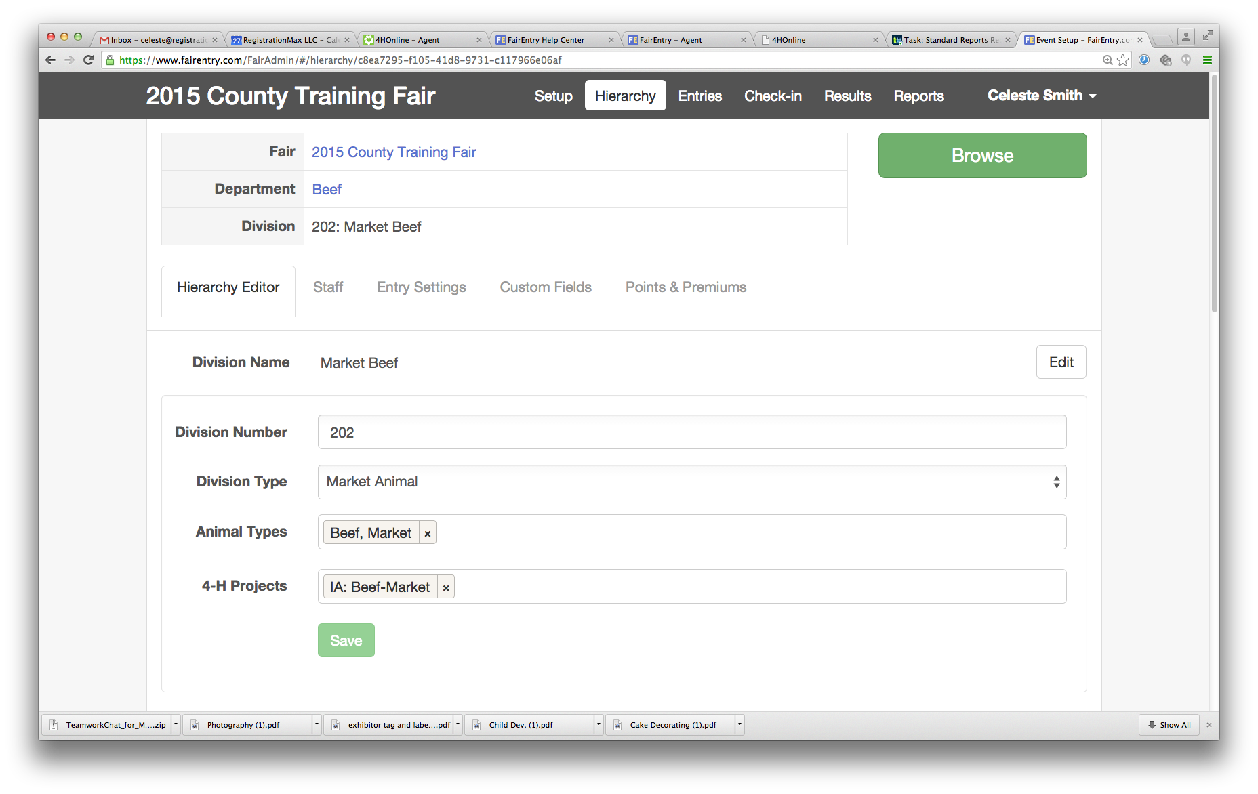

Select a Division from the Hierarchy and click on the Hierarchy Editor tab:

### Animal Types

For **each** animal division, use the pop-up menu beside Animal Types to assign the correct animal type (the ones you created earlier) to the division. That creates the animal information piece of the entry process—a member makes entry into a class, and based on which division it belongs to, animal information fields are then available for him/her to fill out. If you do NOT assign an animal type to a division, no one will be able to make entry into any class in that division.  
**NOTE: Animal Type designations become permanent once the entry process begins. Be sure to consider how all the animals may have been identified and add all applicable animal types.**

### Project Affiliation

If a member from 4-H Online is required to be enrolled in a specific 4-H Online project in order to submit entries in a specific division, select the required project(s) under 4-H Projects. When a member registers for Fair, the system will check the 4-H Online projects and will only allow the member to submit entries in Divisions for which they have enrolled in the corresponding 4-H Online project.

Custom Files

If there are files that exhibitors need to upload during registration, set those up here. Uploads set up at the Fair level will be asked of each exhibitor one time, regardless of how many classes they enter, or how many separate invoices they create. Those created at the Department, Division or Class levels will be asked as part of **each** entry in those respective areas. File uploads flow down the hierarchy just like Custom Fields. For example, if you have a Digital Photography division and all entries in that division, regardless of the class, need to upload a digital photo, the question should be set up at the Division level. If it’s only required for one class, it should be set up at the class level.

Once you have a strategy, go to **Hierarchy** (select a level) **>> Custom Files** and “Add a Control”.