Team Entries
Before You Start
- Team entries are limited to manager entry.
- Teams are not included on invoicing and will not be charged entry fees.
Premium Considerations:
- If a Team consists of more than one named member, any premiums earned by the entry will be paid to EACH member of the team. If a blue ribbon is worth $5, each team member would receive $5.
- If you wish to have the premium paid to the team (not duplicated for each member), then you must make sure that there is exactly one team member listed. That member will receive the total premium.

Create a Team  - Select the Exhibitors tab.  - Click “+Team”. | 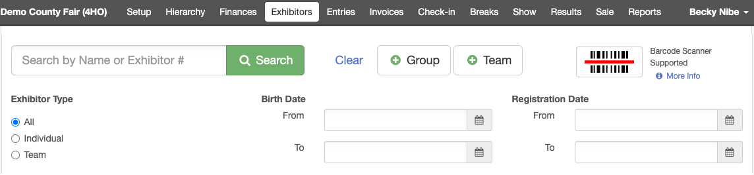
- Enter the team name and click Continue. | 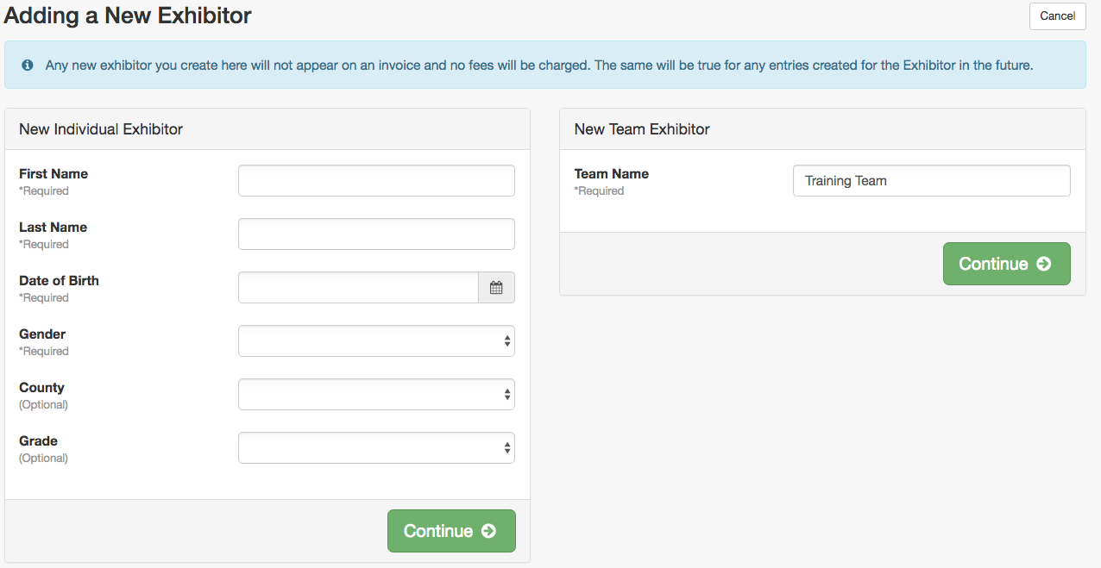
- Answer any questions that may be required for the team.  - Click Edit in the Team Members section to add members.  NOTE: Team Exhibitor Numbers increment with Individual Exhibitor Numbers. | 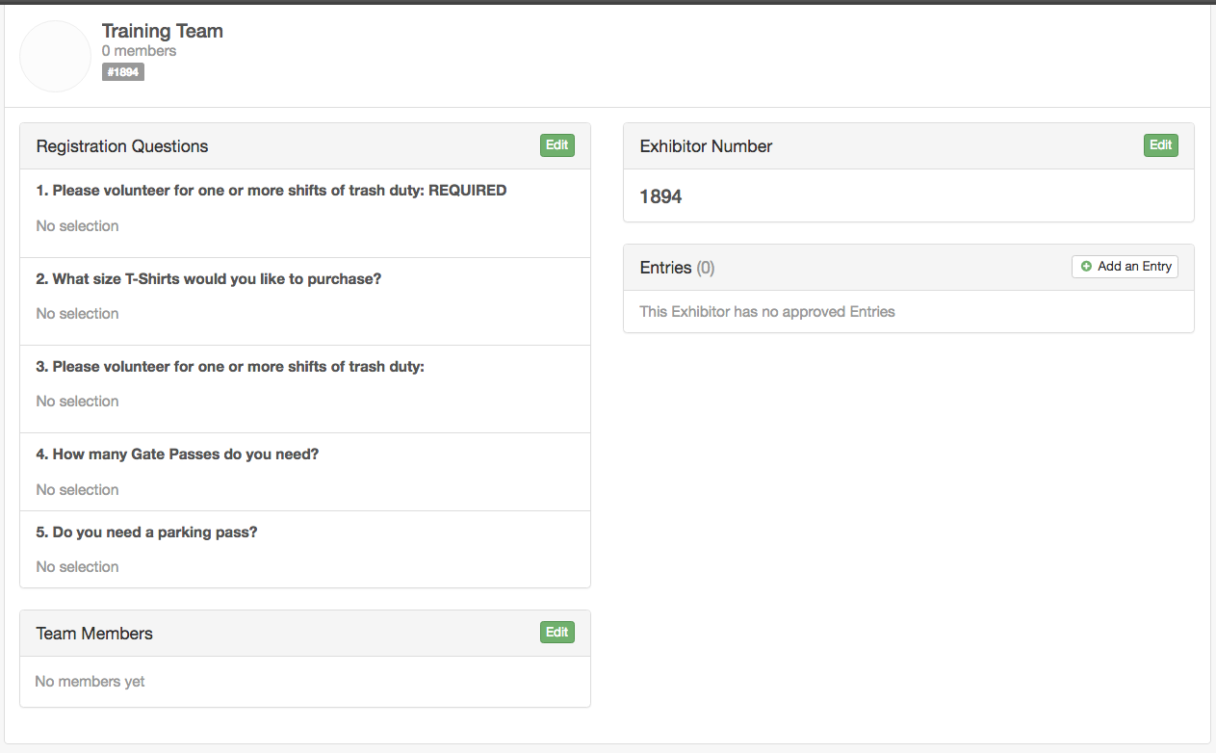
- Enter the first name, last name or birthdate of an existing exhibitor to find the exhibitor. (Don’t create a new exhibitor record for an existing exhibitor.)  - Click Add Member to add the exhibitor to the team.  - If the exhibitor does not exist yet, click Continue as new member.  - Click Search again to find the next member.  - Once all of the members have been added to the team, click OK. | 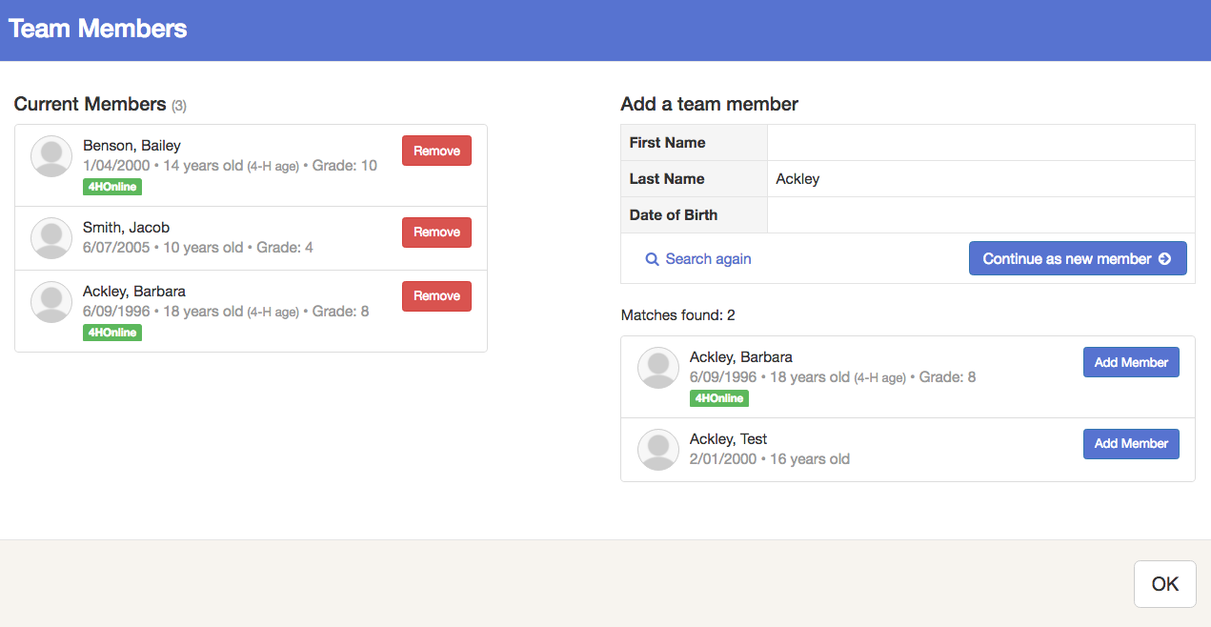
Create Team Entries  - From the Exhibitor Search, select to view Teams. Click View next to any of the team members to access the Team information. | 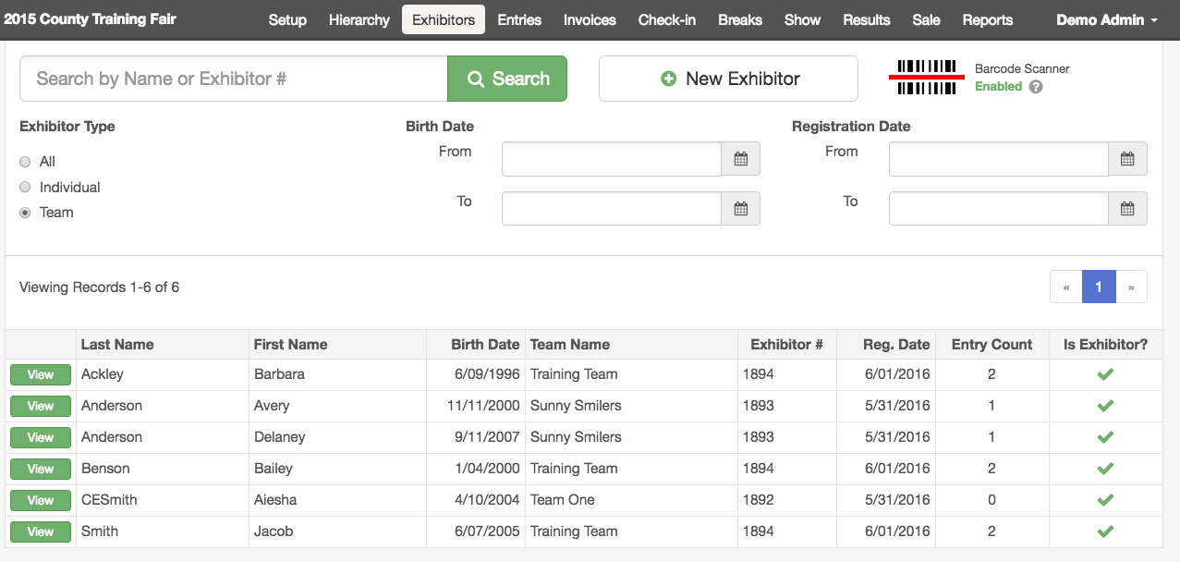
- Click Add an Entry (small white button at the top of the Entries section). | 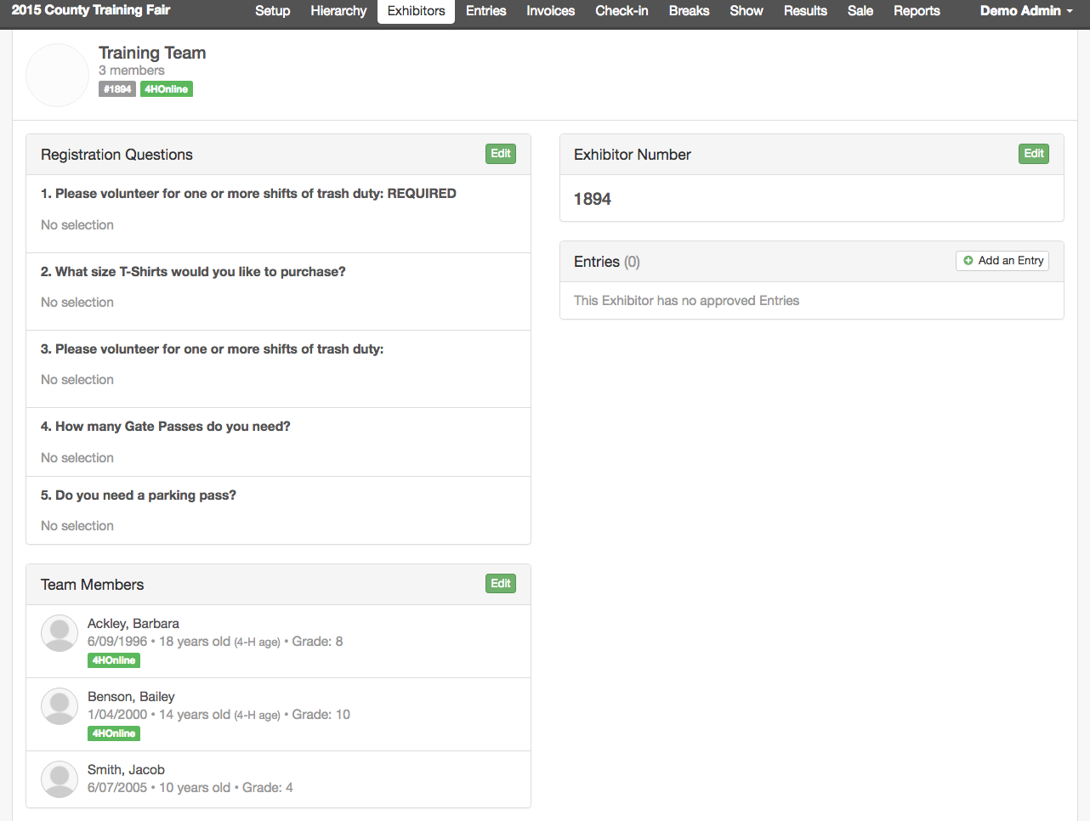
- Select the Department, Division and Class for the entry.  Click Continue. | 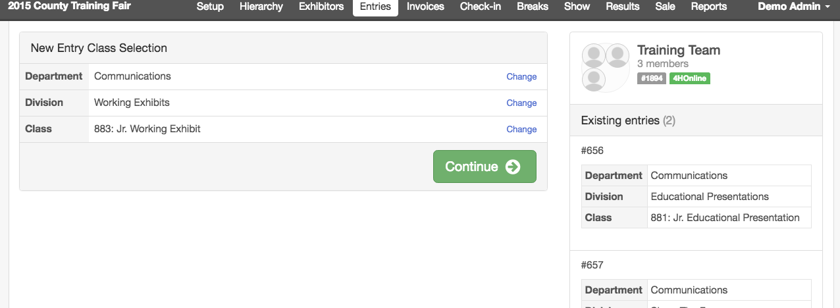
- Select the Club, answer any custom questions, upload any files, complete any other necessary entry information. | 