Animal Identification for Exhibitors
Before You Start

Animal ID does NOT register you or create entries into your fair.

Adding animals using the Animal ID process makes those animals available to be selected during the registration and entry process for the fair. Animal ID dates end before the entry dates begin.

Steps  - Login to your fair using your 4-H Online or FairEntry account.  - NOTE: in order to use the 4-H Online login account, you must be a fully approved active member in 4-H Online for the current year.  - If you are a member of both 4-H and FFA, or are unsure about whether to use the 4-H Online login, contact your fair office for instructions.  - If you have made entries through FairEntry in a fair in a previous year, you have an account. You can use the “Forgot your password?” link if you have forgotten the password you used on your account.  - If you do not already have an account in FairEntry, create a new account using the “Not in 4-H Online and need to create a FairEntry exhibitor account?” link. | 
- When you have logged in, you will see the dates that Animal ID is open.  - Click on the blue “Register an animal” button. | 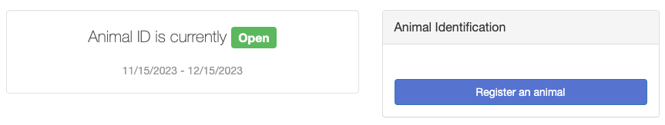

- Select “Register an Exhibitor” to add information about the person who will be exhibiting the animal.  - If you have a FairEntry account, have logged in through 4-H Online, or if you have previously identified animals in this fair, you may see the option to select an existing exhibitor. Otherwise, use the “Create an Exhibitor from Scratch” option.  - Note: Please do not create two separate exhibitor accounts for the same person, even if you are enrolled in both 4-H and FFA. There should only be one exhibitor account for each person.  - Enter all exhibitor information. This may vary by fair, but be sure all required fields are completed as directed by your fair office. Click Continue when finished. | 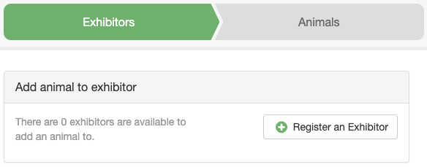
- At this point, you can add another exhibitor record, or you can “Review and add animal” for the existing exhibitor.  - You can enter information either by creating all the exhibitors in the family first, then identifying the animals for each one; or by identifying animals for the first exhibitor, then adding the second exhibitor and their animals, etc. | 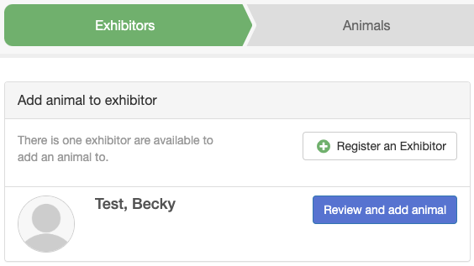
- Use the green “Continue” button to review, add, or edit exhibitor information. The information on the screens will vary by fair, by 4-H Online info, and also whether this is a new or returning exhibitor. | 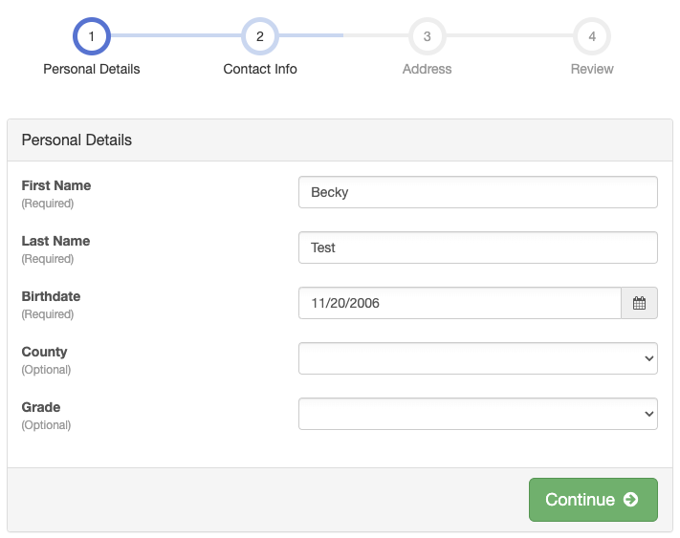
- When you reach Step 4 (Review), and all information is correct, click Continue to Animals. | 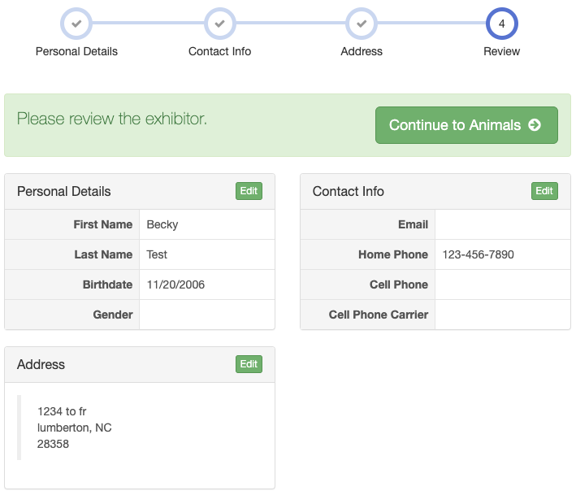
- Select the Animal Type from the drop-down menu, then fill out all fields as requested. Fields marked with an asterisk are required. Click Finish.  - If there are file uploads requested or required for this animal, that screen will appear next. | 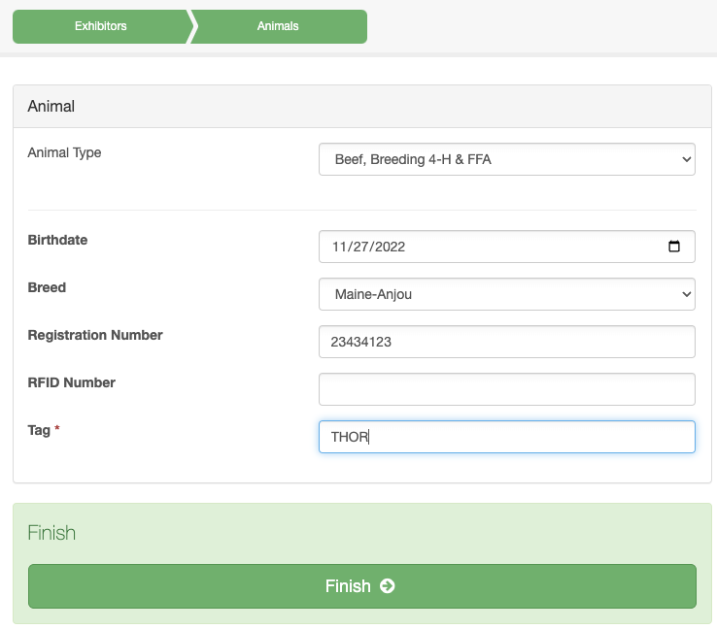
- Continue to add animals for this exhibitor by using the Add an Animal button. Notice that you can delete or edit animal information if you need to do that.  - When you are done with all the animals for this exhibitor, click on the green Exhibitors tab at the top of the screen to add another exhibitor and their animals.  - When you are done with all animals for all exhibitors in this family, use the green Finished button to exit the process and return to the original screen. | 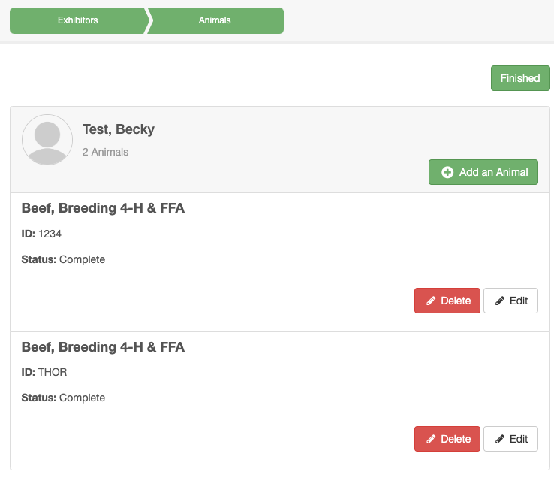
Tips
- Be sure to use the same login for Animal ID as you use for creating entries for your fair. The animals identified will only be available to exhibitors using this same login.

- If your fair allows animal sharing within families, you can add an animal through one exhibitor, and it will be available to be selected for an entry for any exhibitor that is a part of the same exhibitor group. Check with your fair office to see if this is available so that you do not have to identify the same animal multiple times for multiple exhibitors in your family.

- While Animal ID is “Open” for your fair in FairEntry, you can login again to add more animals to your account, if you have more that need added after you log out the first time. (Note: Animal ID dates and entry dates cannot overlap, so when you log in, you will EITHER be able to identify animals, OR make entries into the fair.)

