Bulk Check-In for Non-Animal Entries
NOTE: Bulk Check-in is only available for non-animal entries

- Click on the Check-In tab.  - Enter the Exhibitor’s first OR last name in the search. (or scan the Exhibitor barcode from the Entries by exhibitor report).  - Click to View the entries for that exhibitor. | 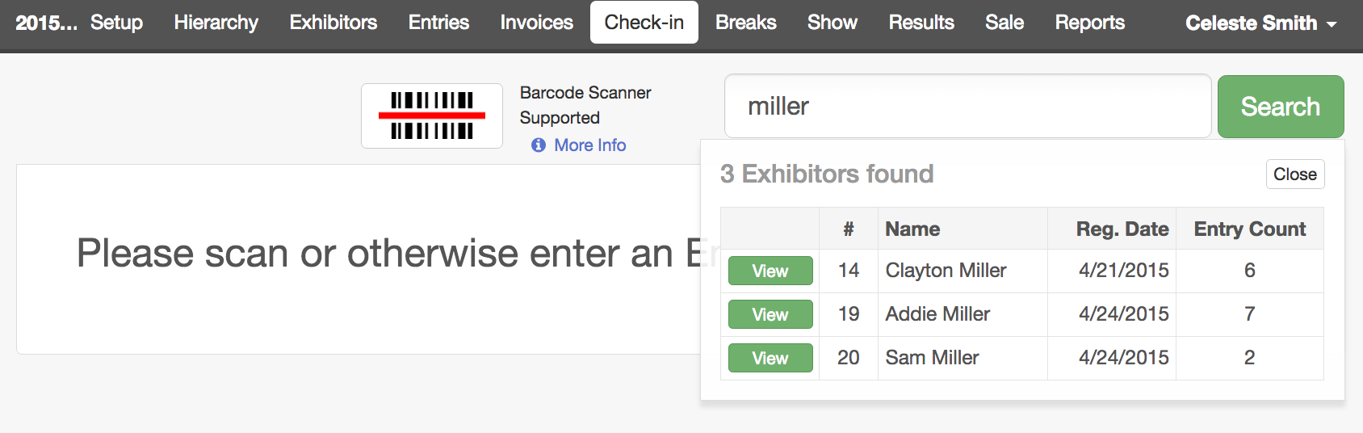
- Select the entries you would like to check in.  REMINDER: Animal entries cannot be checked in using bulk check-in. | 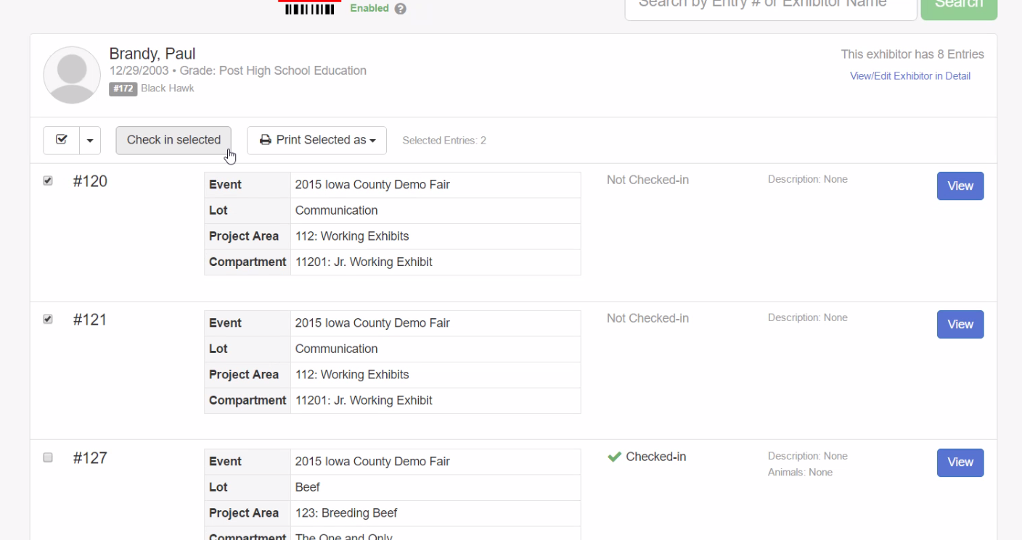
- Click Check-In  NOTE: The current date will be the default check-in date. This can be adjusted as needed. | 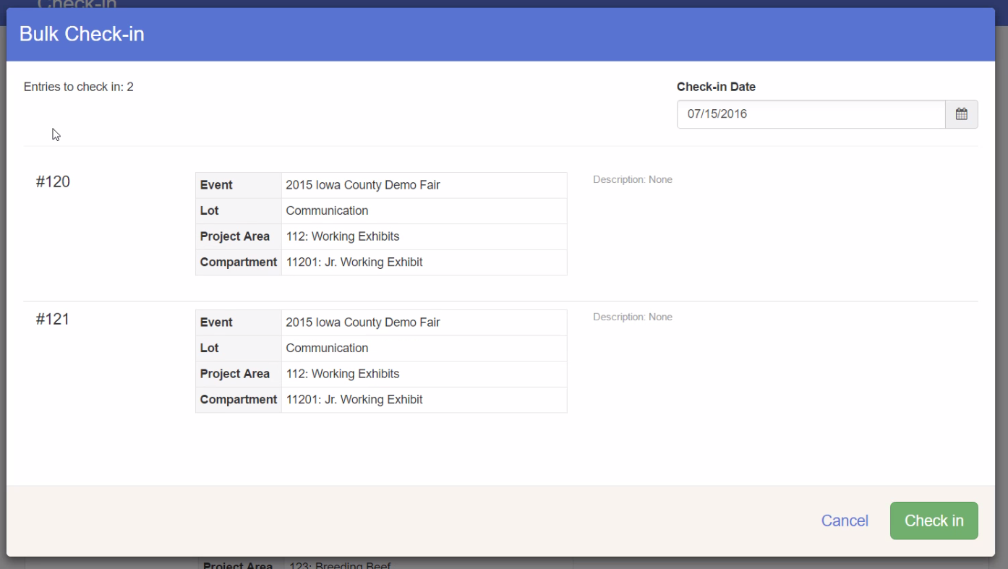
If you wish to print entry tags or entry cards for the exhibitor’s entries, select Print Selected As from the top and select the desired tags or cards.

If an entry should be moved to a different class, select to view the individual entry and then select to Change Class.

