Creating Staff Login Accounts

Approved logins and permissions can be created for each person who will be working in FairEntry. Permissions can be as broad, or narrowly constrained, as necessary.

The following “rules” are very important to remember as you set up staff, so that they will be able to successfully login to the fair(s) with the correct permission level.

* Each person needs to only have ONE login account (email address). Don’t set any individual up with two different email account logins.
* The 3 roles of Organizational Admin, Fair Admin, and Fair Manager should always be the ONLY role for one email address within one fair. Don’t ever set up an account that is both the Organizational Admin and the Fair Admin, or Fair Admin and Check-in Clerk, for example.
* The staff roles of Check-in Agent, Results Agent, Class Breaks Agent and Sale Agent can be added to the same email address, but not in combination with any of the higher roles.

Creating Staff Accounts - *This can only be done by Organizational or Fair Administratorss.*

* Select the Setup Menu, Staff tab.
* Click “Add a Staff Member”
* Select “Invite by Email”
* Enter an email address, then click Continue.
* Enter the First and Last name of the staff being added and click “Create Account and Add Staff Member”.
* Back on the Staff screen, click on the down-arrow beside the name, and select “Add Permission”, selecting the permission set (and the part of the hierarchy, if necessary) that you wish to assign to that person, using the definitions on the following page. The example below would result in the staff member having permissions to enter results in the 4-H Dairy Cattle department only.
* 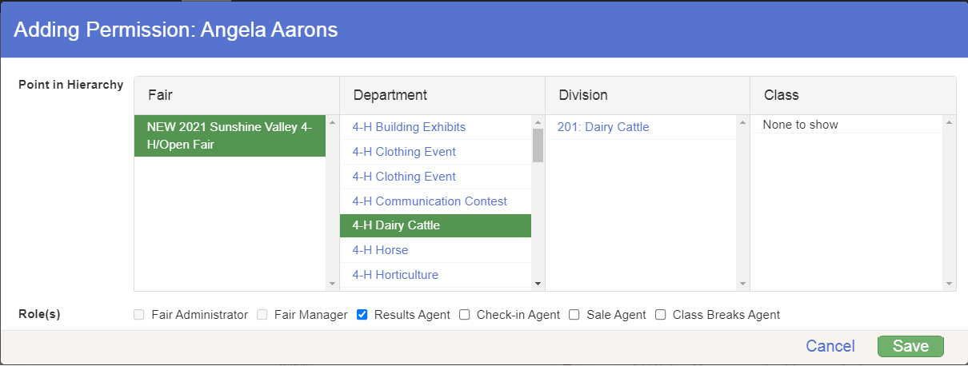An email message with login instructions is mailed to the newly created staff person within a few minutes.

Account Types/Permissions

**Organizational Administrator**

* Set up at initial subscription. This account represents the “owner” of the license for the program.
* Complete permissions to the program, setup, and data, including creating a new fair, deleting a fair, and setting the custom URL for the fair’s public login page.
* DO NOT combine this role with any other(s).
* All other account types are created by either the Organizational Admin or the Fair Admin.

**Fair Administrator** (Cannot be combined with any other permission level)

* Complete permissions to the program, setup, and data
* Cannot create a new fair, delete a fair or set the custom URL for the fair’s public login page.
* DO NOT combine this role with any other(s).

**Fair Manager (Cannot be combined with any other permission level)**

* Complete permissions to entry data in all departments, no Setup, Hierarchy or Finance menus/functions.
* DO NOT combine this role with any other(s).

**Check-in Agent**

* Permission only to check in entries at the fair
* Can change an entry to a different class before the entry is checked-in
* Only menu available is Check-in
* Can be configured to only specific department(s), division(s), class(es) if desired
* Can be combined with Class Breaks Agent, Results Agent and/or Sale Agent permissions

**Class Breaks Agent**

* Permission only to break classes
* Cannot change entry data
* Only menu available is Breaks
* Can be configured to only specific department(s), divisions, class(es) if desired
* Can be combined with Check-in Agent, Results Agent, and/or Sale Agent permissions

**Results Agent**

* Permission only to enter results
* No permission to change entry data
* Only menu available is Results
* Can be configured to only specific department(s), division(s), class(es) if desired
* Can be combined with Check-in Agent, Class Breaks Agent, and/or Sale Agent permissions

**Sale Agent**

* Permission only to configure the Sale Order, upload buyers, setup destinations and donation recipients, record bids and add-ons, apply adjustments and record buyer payments
* No permission to mark entries for sale, generate or print sale checks or print reports (includes invoices and statements)
* Can be combined with Check-in Agent, Class Breaks Agent, and/or Results Agent permissions

Login Options

**(Preferred)** Staff Login Method 1 – all accounts, **including** Organizational Admin

* 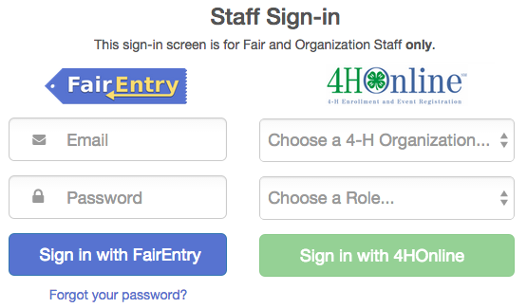Go to <http://www.fairentry.com> and click on the “Staff Sign In” link in the upper right corner.
* **Sign in with FairEntry:** accounts **not** linked to 4-H Online (including Organizational Admin). Enter Email and Password. If staff member is linked to multiple fairs, they will be asked to select which fair on the following screen.
* **Sign in with 4-H Online:** accounts linked to 4-H Online manager accounts (NOT for Organizational Admin) Select 4-H Organization (state) and Role (State, District, County), then click the green Sign in with 4HOnline button.

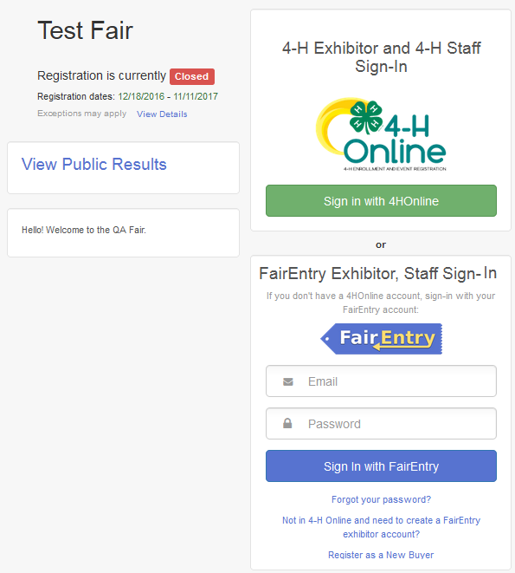Staff Login Method 2 – only for staff levels **below** Organizational Admin

* Go to your fair’s custom URL and select to Sign in with 4-H Online (for 4-H Online managers only) or Sign in with FairEntry (non 4-H Online staff).