Requesting and Approving 4-H Online Integration
Before You Start
Integrating with your county/state 4-H Online data allows you to import Members, Clubs, Projects, and Animal Types from 4-H Online.

Members: The entry process for families will be much faster/smoother if you integrate with your county/state 4-H Online data, saving them from re-entering data that is already entered in 4-H Online.

Projects: Importing the Project list from 4-H Online is the only way to connect project enrollment with exhibit entry in the fair (if you require that an exhibitor be enrolled in the Food & Nutrition project in 4-H Online in order to make an entry into the Baked Goods class at the fair, for example).

Clubs: Importing the Club list from 4-H Online saves setup time in creating that list of clubs for exhibitors to link to their entries. (Once imported, the clubs from 4-H Online cannot be deleted or edited in the current fair year).

Animal Types: (If your state uses Animal ID in 4-H Online) Importing these Animal Types saves a great deal of setup time in configuring the fields necessary to collect animal information as they are added to entries.
Requesting 4-H Online Integration  - In FairEntry, use the Setup menu, 4-H Online Integration tab.  - Select the appropriate 4-H year and state from the drop-down lists at the top of the screen.  - The lists at the bottom default to the County tab, but if you need to integrate with a different unit (State/Region/District), select the appropriate tab.  - The list is checkboxes, meaning that if you are a multi-county fair, you can select multiple counties to integrate.  - You can type in a custom explanatory message, which will be sent to the 4-H Online manager(s) in the unit(s) you selected.  - Click “Continue with Integration”. The integration status will show Pending until the 4-H Online manager approves the request. When it’s approved, you can import. | 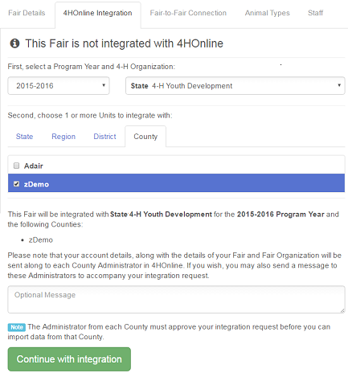

Approving 4-H Online Integration (4-H Online Primary Hierarchy Managers)

- When you log in to 4-H Online, you will see the FairEntry integration request on the Home page. Click Review to approve requests as needed.

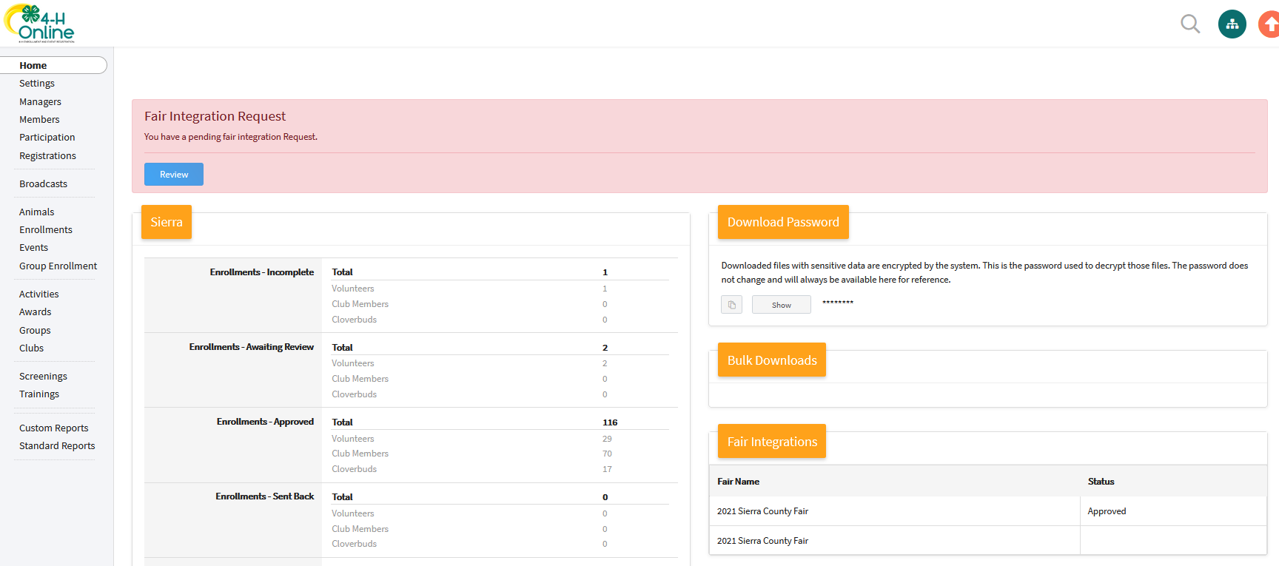
- You will see an informational screen. Click the blue button to Approve data integration. | 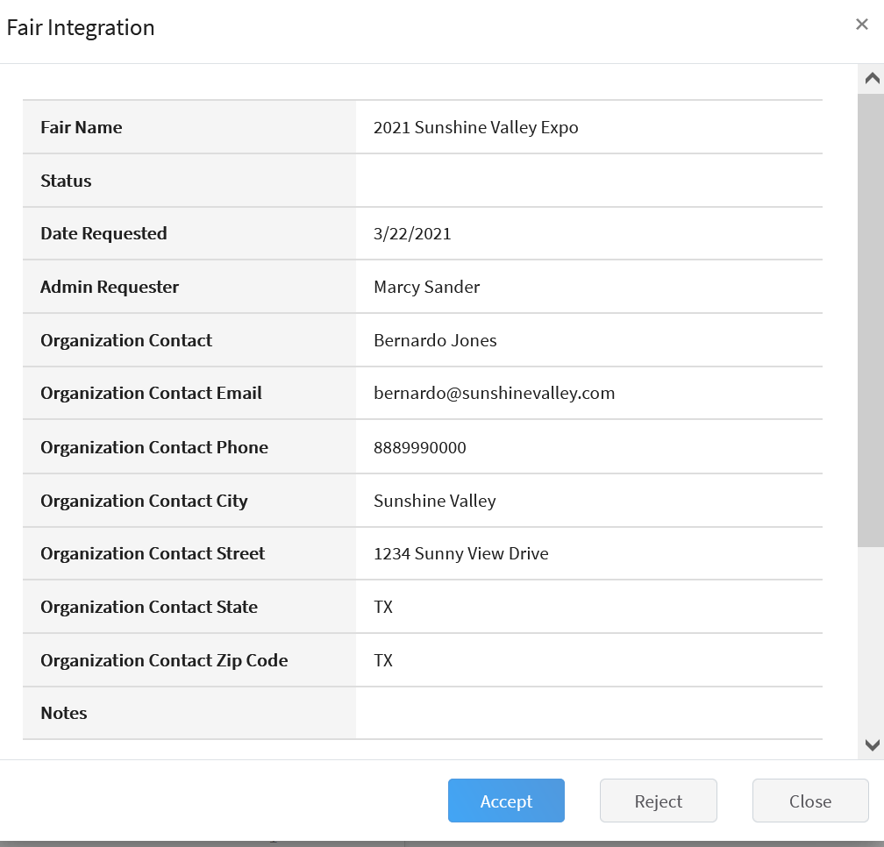
- In the lower right is a section “Fair Integrations” that lists the fair(s) that are integrated with your county’s 4HOnline data. | 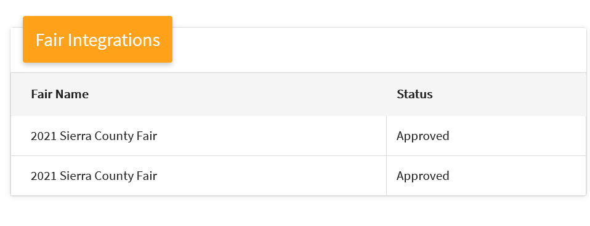
Tips
Each year, when the fair manager begins setting up the new year’s fair, 4-H Online integration will need to be requested and approved.

