Customizing Championship Lines
Before You Start
Customized Championship Lines* can be configured to print on custom show programs at the division level (after all classes are listed within the division), and at the class level (after all show classes, created by class breaks. are listed within the class). Both division-level and class-level Championship Lines can be used on the same custom show program. There is a standard report (Hierarchy>Championship Lines) which lists where the Championship Lines have been configured, and the text on those lines.

*Championship Lines are pieces of text that can be printed in your Custom Show Program. They are not fields, don’t contain data, are not available on custom reports, and are not linked to results or points and premiums.
Division Champions  - On the Hierarchy menu, select the division that needs to have Championship Lines configured. | 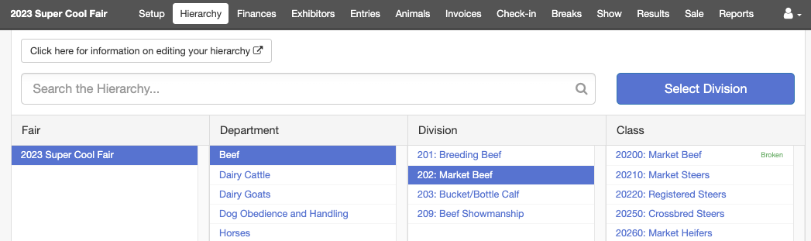
- Click on the Championship Lines tab.  - Enter up to ten Championship Lines to be printed at the end of all the classes within this division.  - Be sure to click Save when complete. | 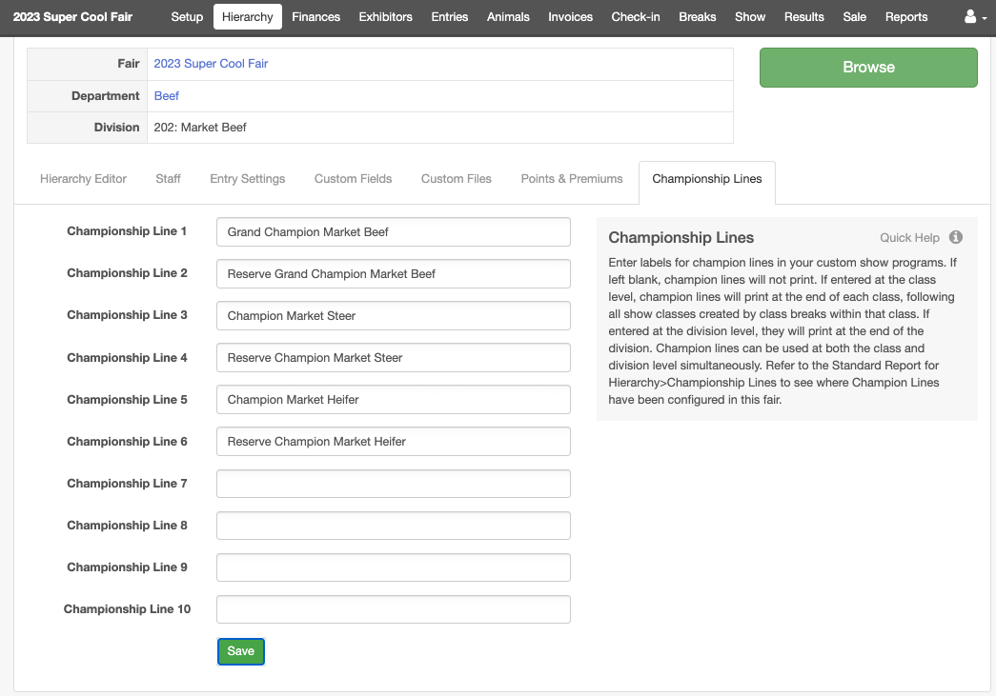

Class Champions  - On the Hierarchy menu, select the class that needs to have Championship Lines configured. (In this example, the class has been broken by breed.) | 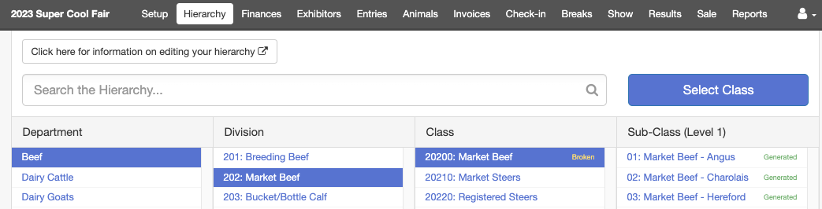
- Click on the Championship Lines tab.  - Enter up to ten Championship Lines to be printed at the end of all the show classes within this class.  - If there are no show classes, the lines will print after the class.  - Be sure to click Save when complete.  Note: If you are using defined sub-classes (part of the hierarchy), you must enter the Championship lines at the lowest level of entered sub-classes. | 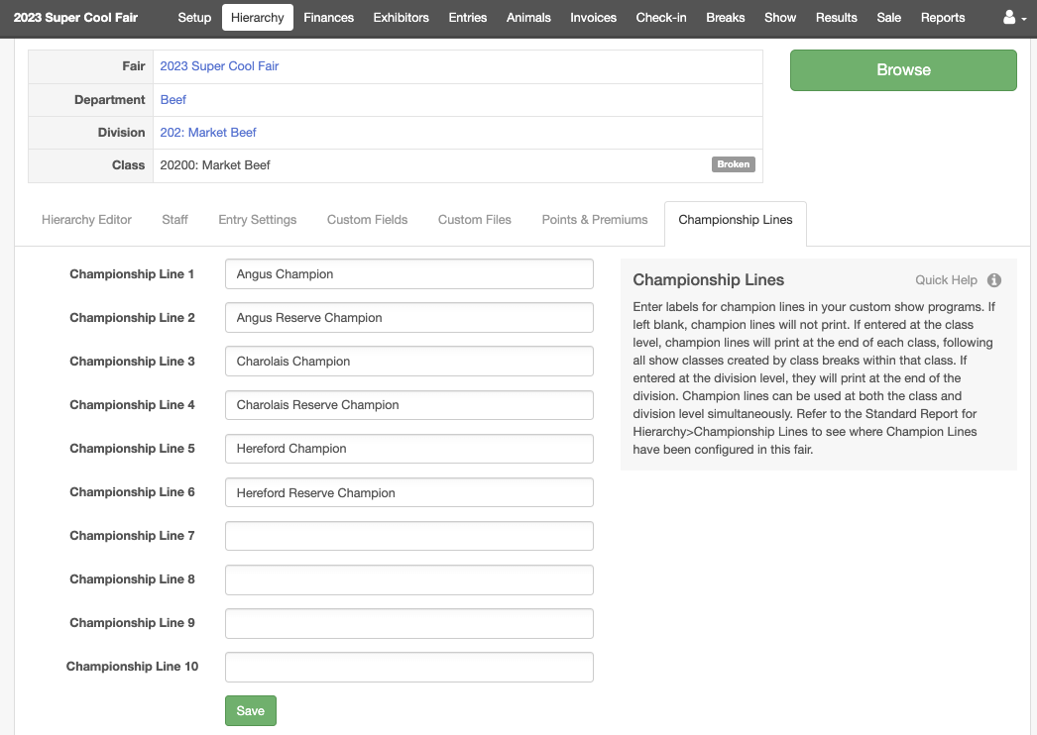
Custom Show Programs  NOTE: Championship lines do not print on the Standard Show Programs. To print the Championship Lines, configure a custom show program.  - The setting that triggers the Championship lines is “Show Champion Lines”. Set that to “Yes” to display/print the text you entered.  - If the Championship Lines were left blank in the Hierarchy>>Championship Lines tab, no extra lines will print.  - If “Show Champion Lines” is set to “No”, no extra lines will print. | 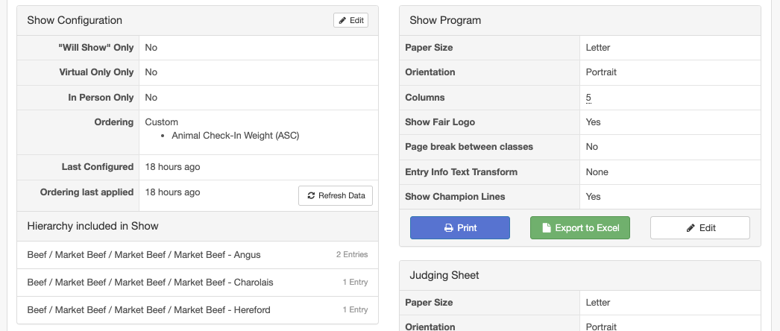

Classes with no Breaks or Sub-Classes  This is the easiest setup.  Championship lines set up at the class level will show up after the class, division-level Championship lines will show up after the last class in the division.  In the example shown, the division was “Horse Working Western” and the classes were “Western Reining Open Championship” for example. | 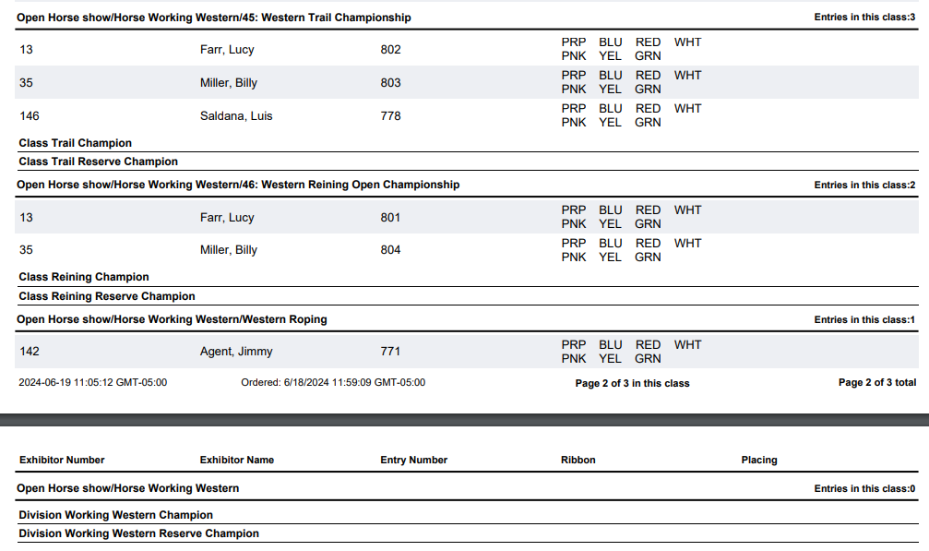
Classes with Class Breaks  In the example shown here, Championship Lines were configured at the class level (Angus Champion, etc.) and at the division level (Grand Champion Market Beef, etc.).  The class level Championship lines appear after the last of the class breaks for the Market Beef class. (This class was broken by breed and then weight). The breed champions were configured/listed as part of the class level Championship lines because they cannot be added to one level of the breaks.  The division level Championship lines appear after the last class/show class in the Market Beef division.  (In the example, both the division and the entry class were named “Market Beef” in the hierarchy). | 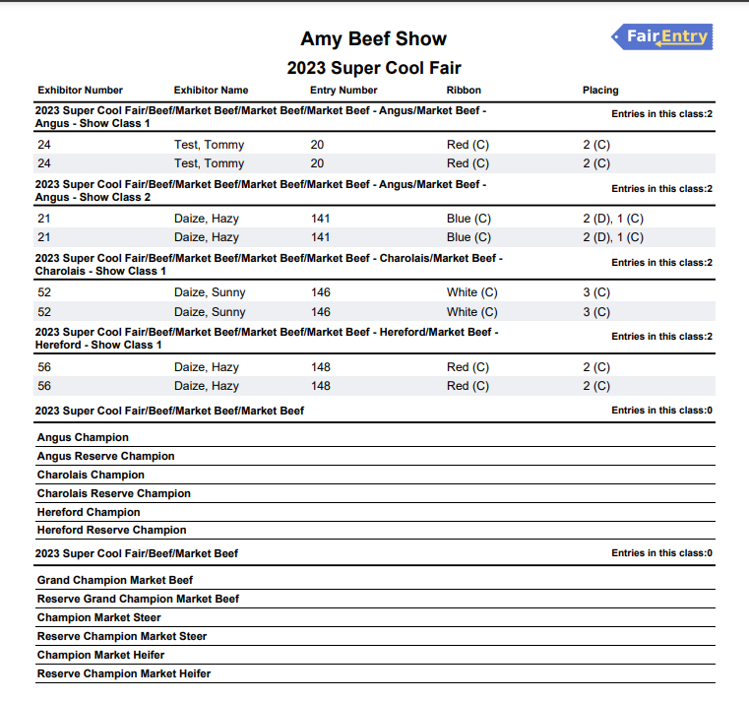

Classes with Defined Sub-classes  If you have added a level to the hierarchy, and are using sub-classes, the Championship lines for classes must be assigned at the lowest (sub-class) level.  Division level Championship lines appear after the last class in the division.  Sub-class level Championship lines appear after each sub-class.  Class-level Championship lines set at the Class level do not print when you have defined sub-classes, so you will need to list your class-level champions as part of the Division Championship lines.  (In this example, the division is Garden Crops, the Class is Beans, and the defined sub-classes are Drying, Green, etc. There is not a way to get a Championship line for “Beans” since that class contains defined sub-classes. | 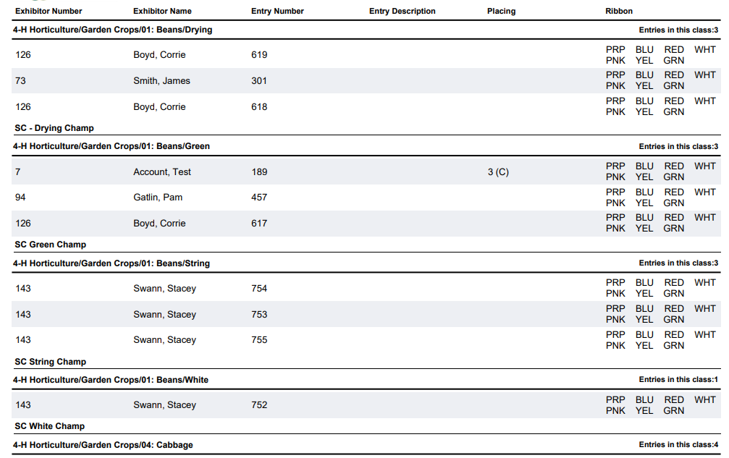
Tips
If your Custom Show Program “mixes and matches” classes within different divisions in the show order, you may get unexpected results in terms of the location of the Champion Lines. The most reliable option will be to group all the classes within a division together.

