Manager Entries
Before You Start

Sometimes it’s necessary for a manager to create entries, either pre-fair or at the fair, when an exhibit shows up that was not pre-entered. There are different considerations—are there fees associated you’re your fair, has this exhibitor/family made previous entries into this fair, is this a 4-H Online exhibitor, has an invoice already been started but not submitted, etc.

Before you begin the process for adding entries for an exhibitor, always check the Exhibitors tab to determine whether that person, or any other person in the same family, is listed as either an exhibitor (with entries) or a potential exhibitor. That will help you determine the correct process to use.

Creating a New Invoice (either new exhibitor or new entry for existing exhibitor/4-H Online exhibitor)
Editing Open Invoices
Quick Add for Multiple At-Fair Entries with No Fees

When an invoice (group of entries) is created by a manager on behalf of an exhibitor group (family or single exhibitor), the exhibitor group will receive an email notification of the entries submitted and any corresponding fees if a valid email address is entered for the family.

The views/screens that the manager sees during this process are similar to the ones that the families would see if they were doing the entry themselves, but managers will see the multi-entry process for all entries.

Creating a New Invoice
If the exhibitor is listed on the Exhibitors tab:  - Click to View the Exhibitor.  - Click Register Exhibitor via Invoice.  - Continue to Step 6. | 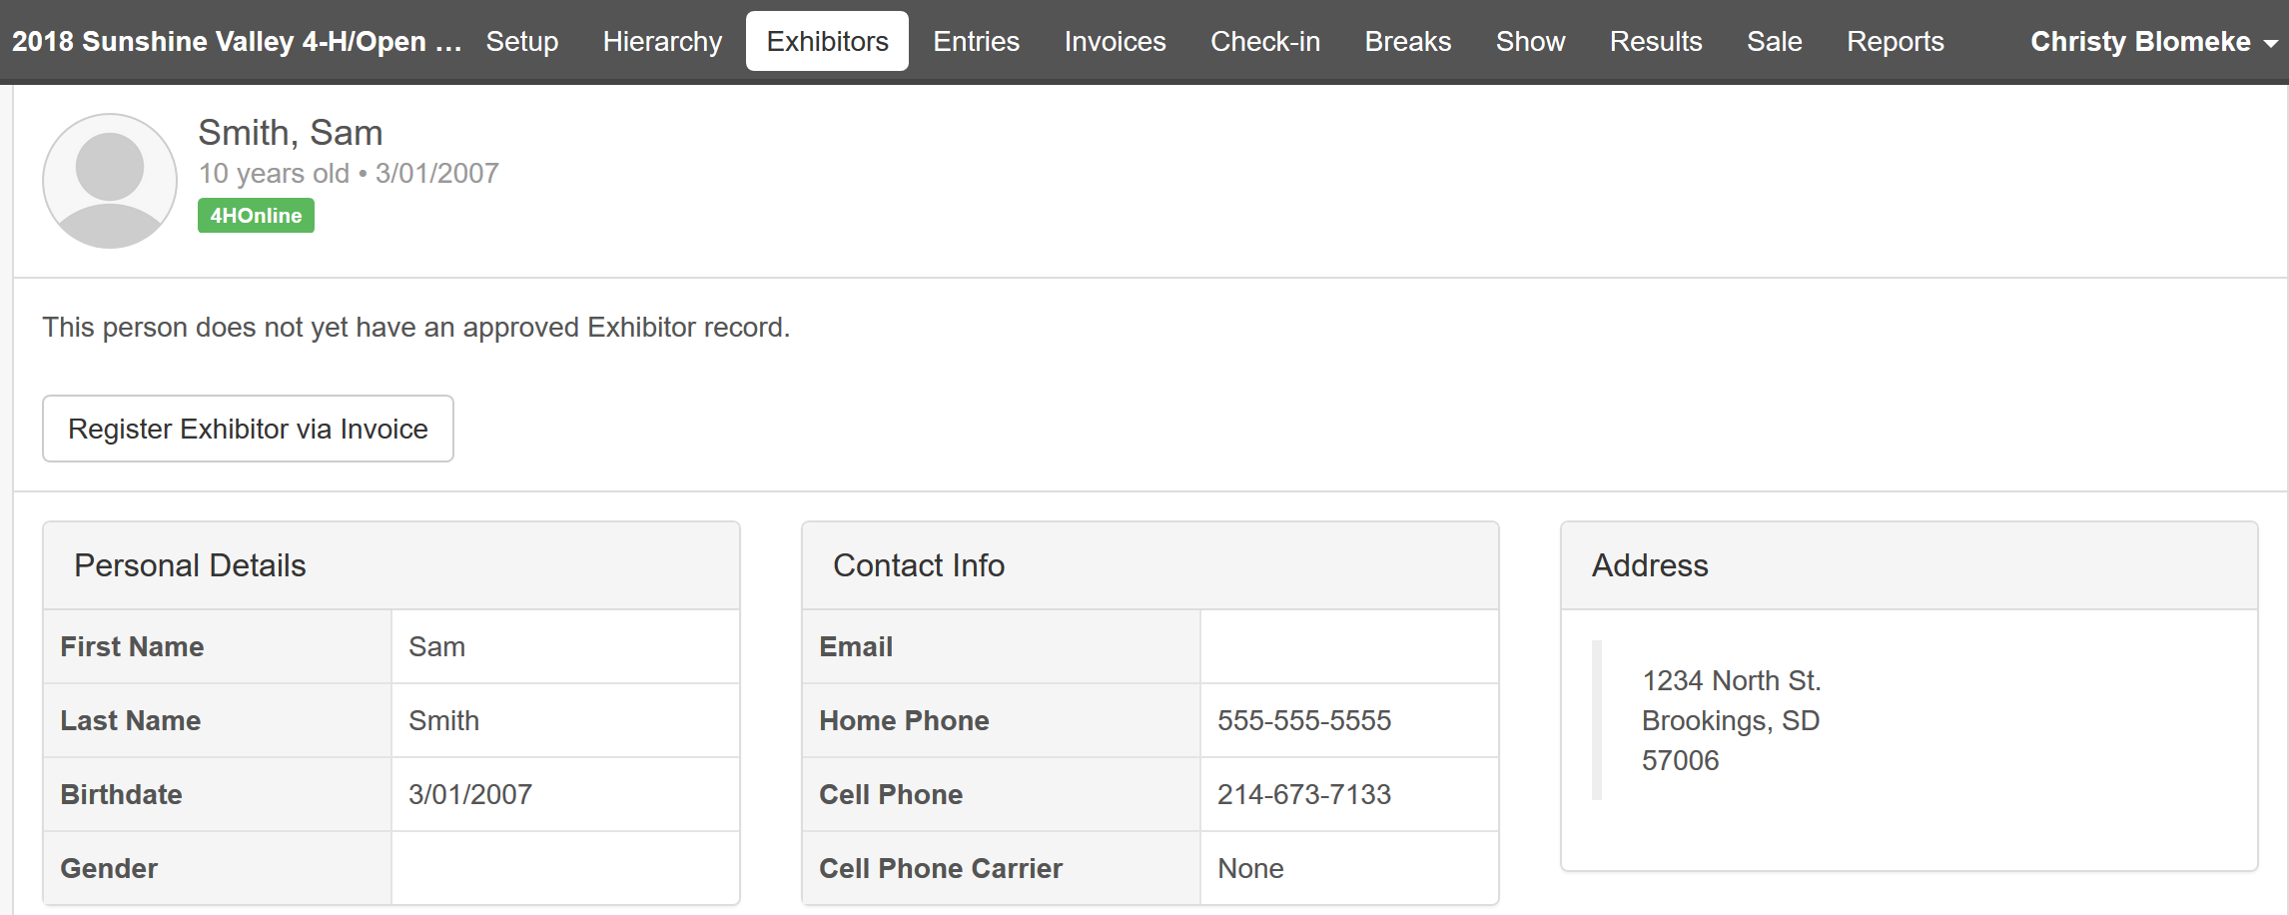

If the exhibitor is NOT listed on the Exhibitors tab:  - Click on the Invoices tab.  - Click on the Search subtab.  - Click Create Invoice.  - Enter the new Exhibitor Group details.  If the Exhibitor Group does not have a valid email address, an invalid email address may be entered as a placeholder (i.e. exhibitorname@nomail.com). Exhibitor Groups without a valid email address will not receive email notification when their entries have been submitted.  PLEASE NOTE: These emails are universal across all fairs, so a common one like jones@nomail.com may have been used at a fair in another state, and is no longer available. You may need to get creative like sallyjones@nomailmillscountyfair.com or sallyjonesmillscountyfair@nomail.com | 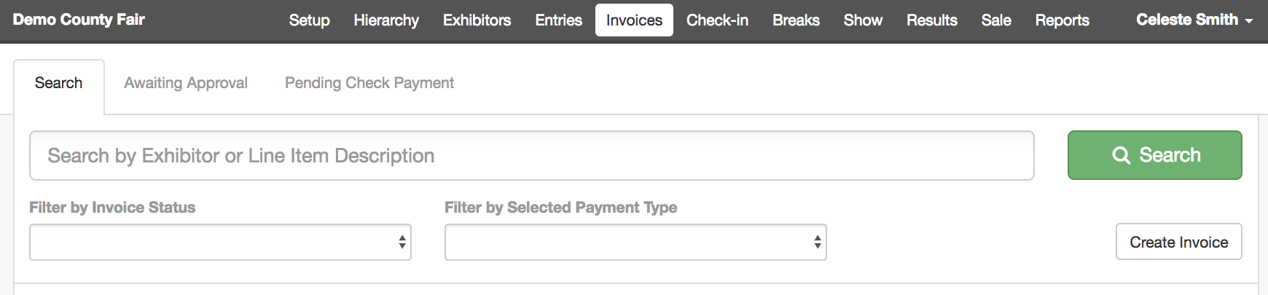
- Select to Register an Individual. | 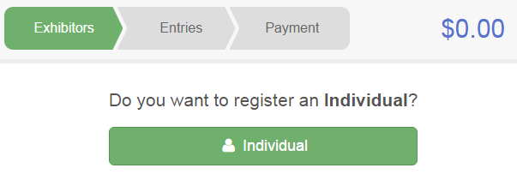
- Either select the existing 4-H Online member or select “Create an Exhibitor from Scratch” and click Continue.  NOTE: You may add non 4-H exhibitors (FFA, Open, etc.) to an invoice for a 4-H Online exhibitor group or family. | 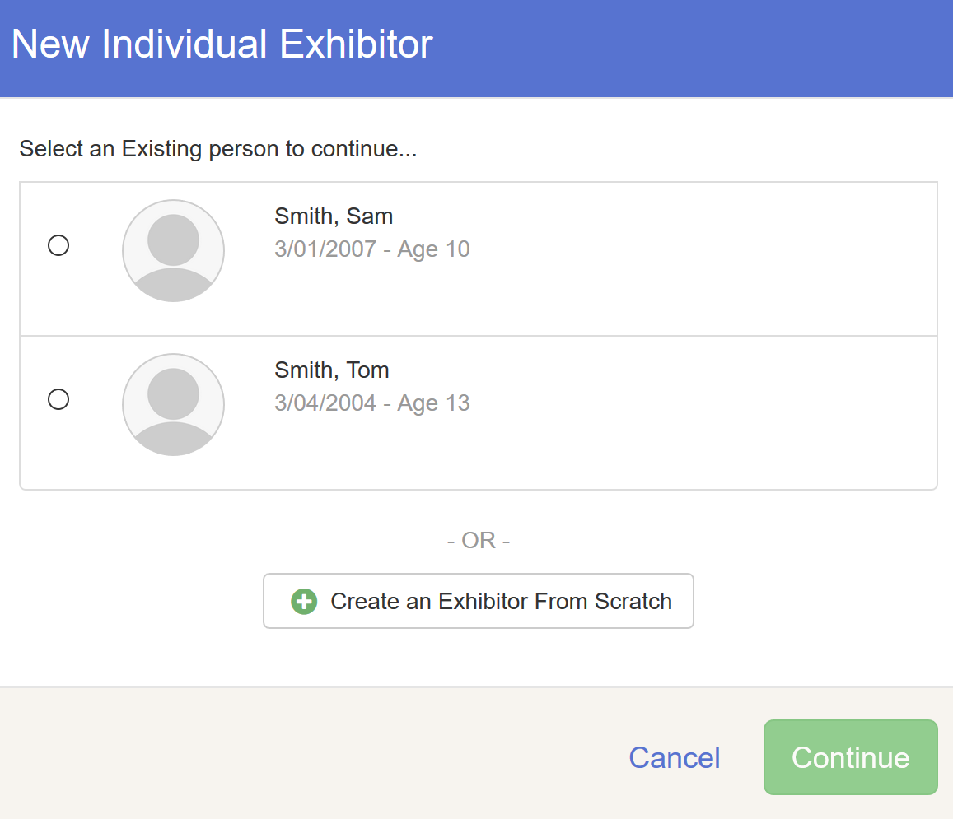
- Complete any Fair level (exhibitor) questions and file uploads, and review the information entered.  - Click Continue to Entries when all the information is entered and correct.  - Click Add an Entry. | 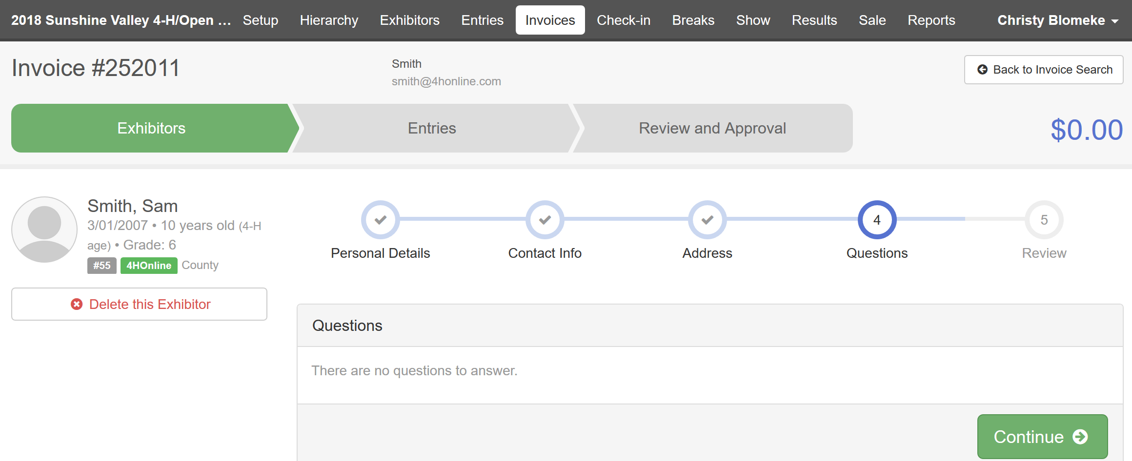
- Select Department and Division for the first entry. | 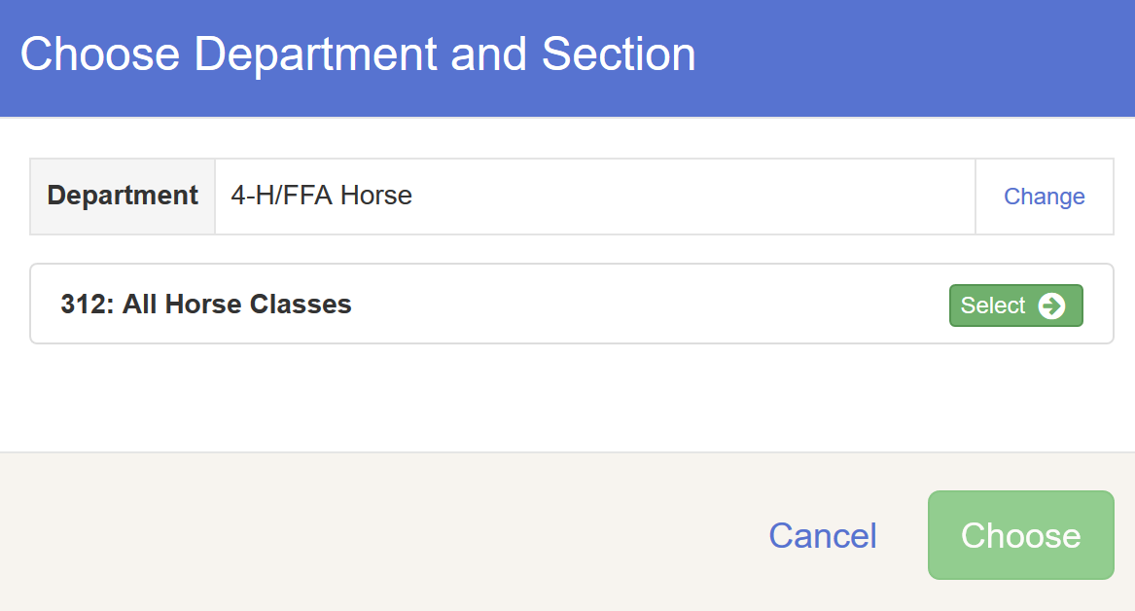
- Click “Change” to edit the club associated with the entry(ies) if necessary.  - If this is an animal entry, click Add Animal or select an animal to add to the entry. | 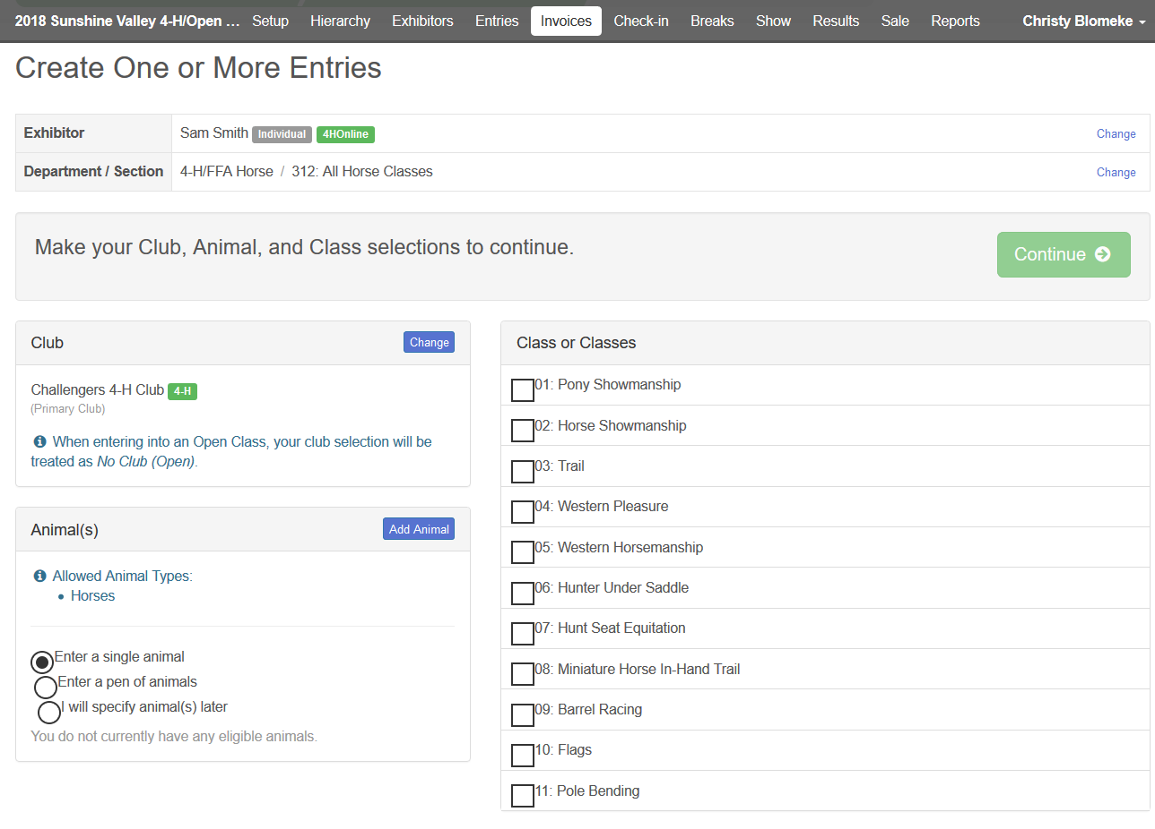
- If you selected Add Animal, select the animal to import from 4-H Online or click Add an Animal from Scratch, and add the animal information. | 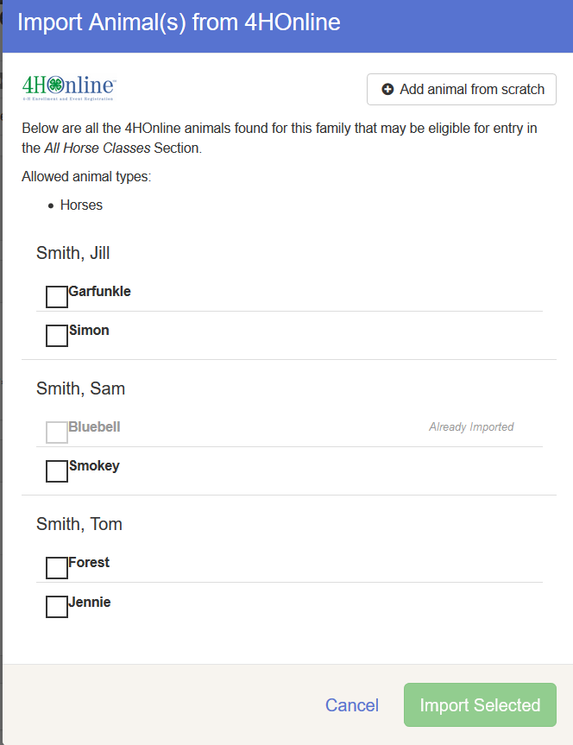
- Once the correct animal is listed, select the animal and/or Class(es) and click Continue. | 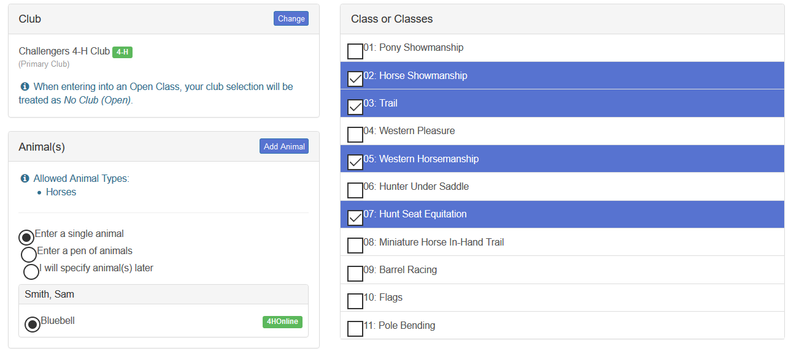
- Review the entries and click Create Entries when they are correct. | 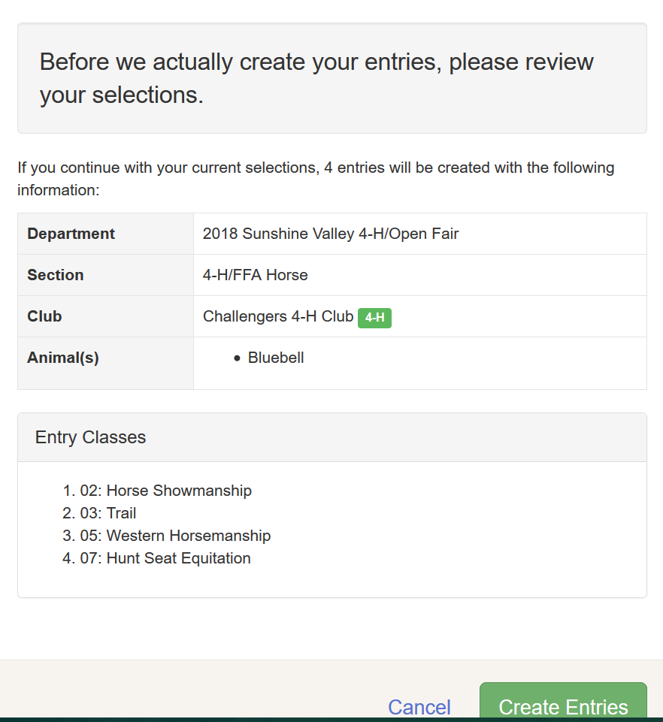
In addition to adding a new entry, you can also edit an existing entry, or delete an entry, with those changes being reflected in the total invoice amount.  - Click the Register another Exhibitor button to add new exhibitors to this invoice.  When you have completed all entries for the exhibitor group, select “Continue to Invoice Review”. | 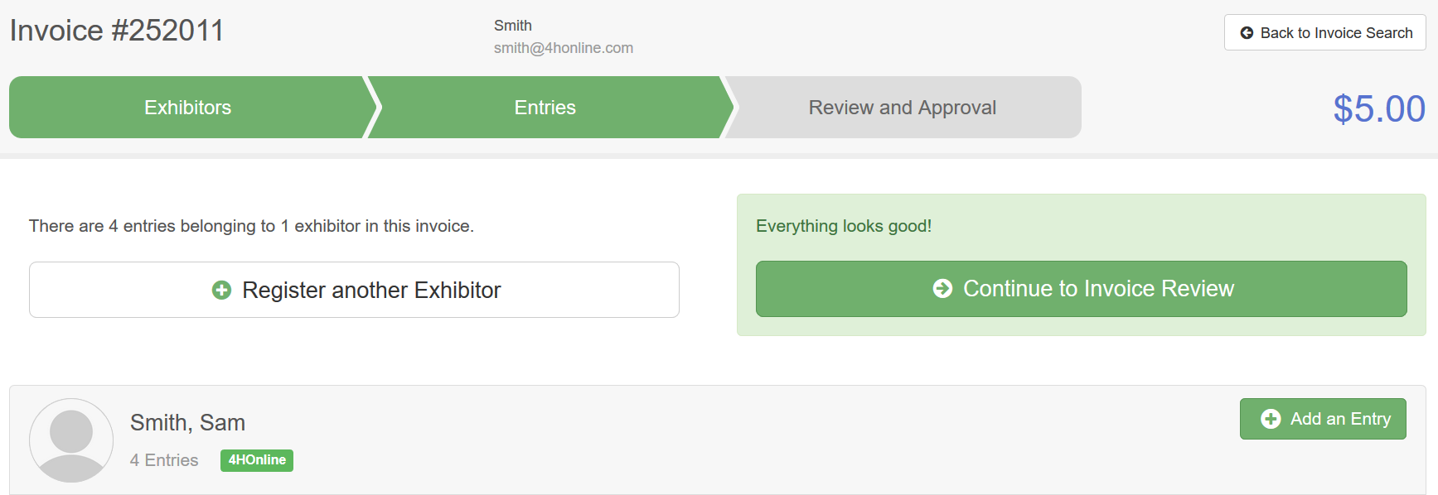
- Carefully note the text in the “After you Submit” section at the top:  - The family will be notified of the submission via email. (If you used a “fake” email, this doesn’t apply.)  - If this is a change to an existing invoice, and the family has selected a credit card, that credit card will be charged the full invoice amount.  - If the family has not selected a credit card (or this is a new exhibitor group), the invoice will be marked as Payment Pending with a Check payment type until a manager records the details of a received check.  - The records on the invoice will be approved automatically (there is no way to UNDO the manager-submission of an invoice).  - When you have reviewed the entries, and are satisfied that they are correct (see fourth bullet point above), click Submit. | 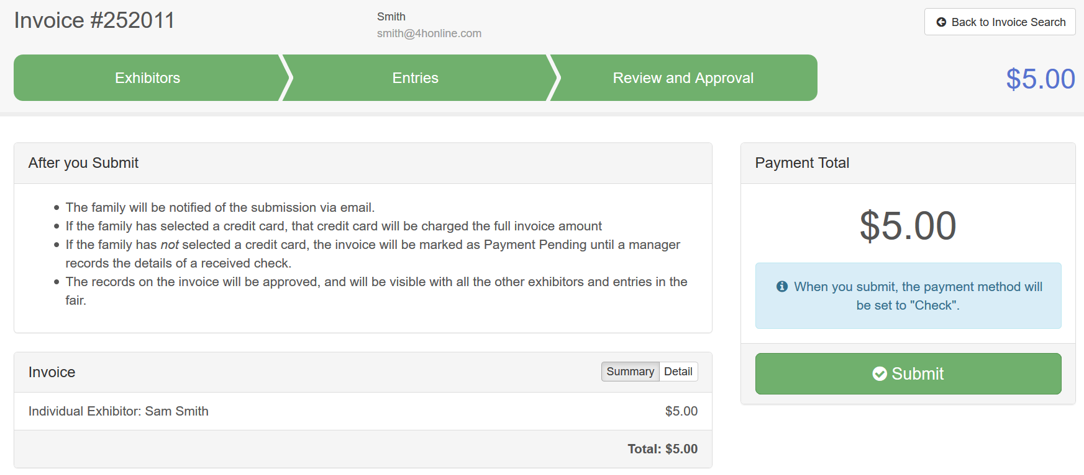

Editing Open Invoices
Before You Start
An open invoice can be edited by a manager, adding exhibitors/entries and their corresponding fees, under the following conditions:
- A family has begun entry, but not submitted it (all exhibitors/entries can be edited)
- A family submitted an invoice, but all or part of it was rejected (the rejected portion becomes an open invoice to be edited, the approved portion may not be edited from this area).
- A manager has started an open invoice, but has not yet submitted it.

The views/screens that the manager sees during this process are the same ones that the families would see if they were doing the entry themselves, but all entries added to an open invoice will use the multi-entry registration process.
- Click on the Invoices menu, Search tab.  - Either enter the exhibitor name in the Search box, or Filter by Invoice Status = Open.  - Click Edit beside the correct invoice. | 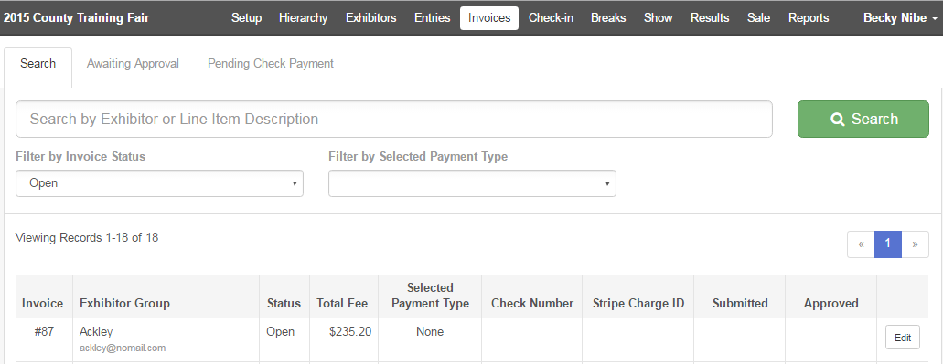
- If there are both non-registered exhibitors and registered exhibitors within the family, choose whether to:  - register a new (non-listed) exhibitor (Register an Exhibitor button),  - register an existing member as an exhibitor (blue Edit button), or  - edit/create entries for an existing exhibitor (green Create Entry button) | 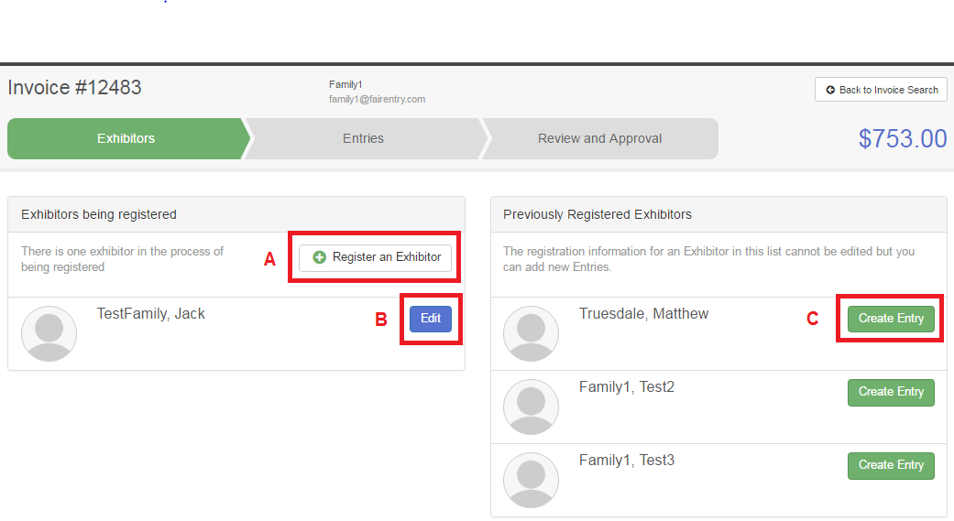
- Register a new exhibitor
See step 6 on the previous pages. The process steps are the same, beginning with entering the exhibitor information, and progressing on to entries.

- Register an existing family member  See step 6 on the previous pages. The process steps are the same, beginning with fair-level custom questions, and progressing to entries. Choosing “Delete this Exhibitor” moves that member back to non-registered status, but does not remove them from the Exhibitor list screen. | 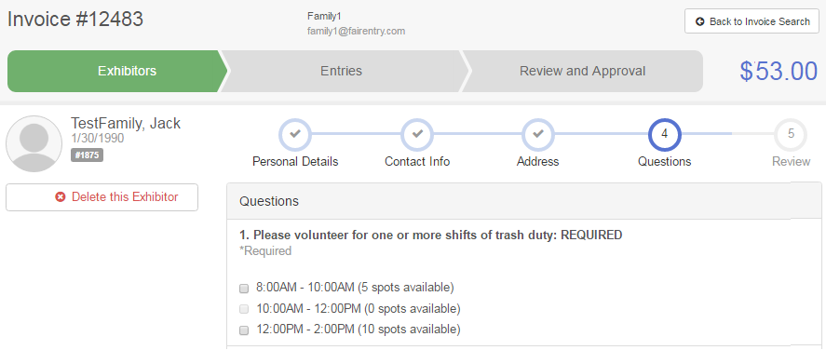
- Edit/create entries for an existing exhibitor  This takes you directly to the department/division/class selection process. As you add fee-based questions and classes, the invoice total at the top of the screen will change to reflect the new total. | 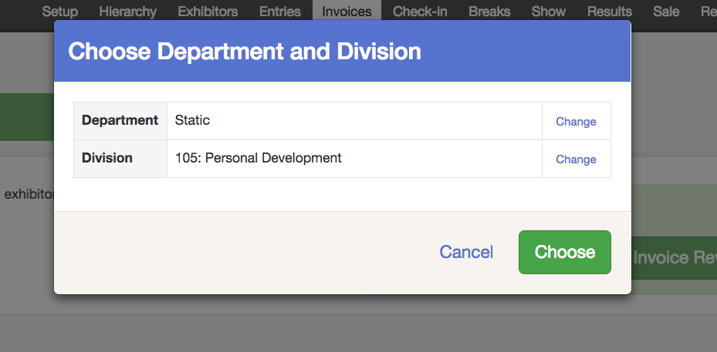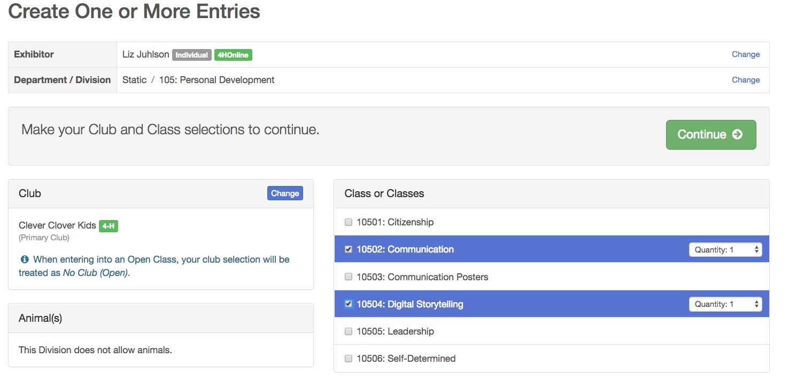
- In addition to adding a new entry, you can also edit an existing entry, or delete an entry, with those changes being reflected in the total invoice amount.  - When you have completed all entries, select “Continue to Invoice Review”. | 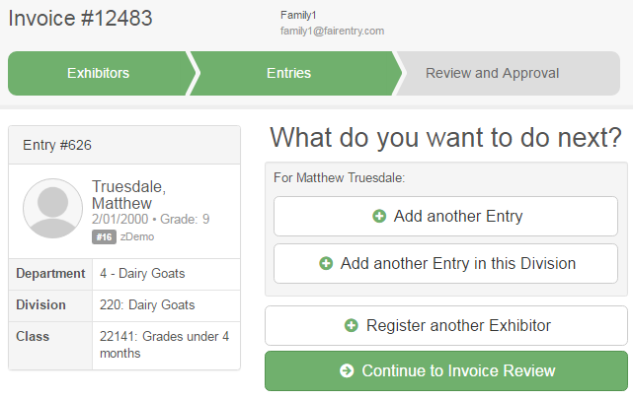
- Carefully note the text in the After you Submit box at the top:
- The family will be notified of the submission via email.
- If the family has selected a credit card, that credit card will be charged the full invoice amount.
- If the family has not selected a credit card, the invoice will be marked as Payment Pending until a manager records the details of a received check.
- The records on the invoice will be approved automatically, and will be visible with all the other exhibitors and entries in the fair.
- When you have reviewed the entries, click Submit.

Quick Add for Multiple At-Fair Entries with No Fees
Before You Start

This process works well for making entries for exhibitors who may not have internet access and/or email addresses. It ONLY works when there are no fees associated with the entries.

If you have fees to be charged to the exhibitors, you will need to create a separate invoice for each exhibitor, even if you use a “fake” email address on the entry. (See Creating a New Invoice for more information.)

Even though there is no limit on the number of exhibitors in any entry group, you should limit your exhibitor groups to about 10 individual exhibitors each, to avoid potentially long processing times for submitted invoices.
- Click on the Invoices tab.
- Click on the Search subtab.
- Click Create Invoice.
- Enter the new Exhibitor Group details. Use either the fair’s email address or a “fake” email address. Don’t use a real email address that is used for other exhibitor group entries. If you use the fair’s email address, you will receive the system/confirmation emails; if you use a “fake” address, there will be no emails, which is probably fine.  Even “fake” email addresses cannot be used more than once, across all fairs, so you may need to get creative with these—“sallyjonesmycountyfair@nomail.com”  - The Exhibitor Group Name could be something like “Flower Show Exhibitors” or something else descriptive.  - Click Create Invoice. | 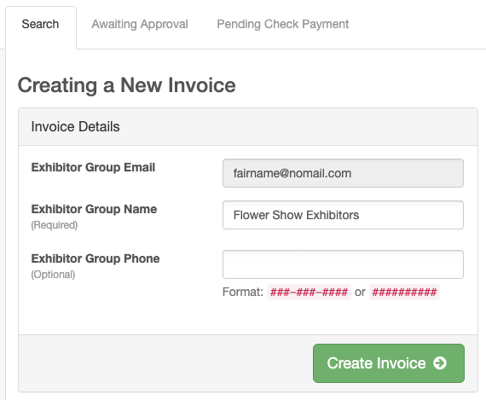
- Register a new exhibitor (Individual).

- If you are given a choice, elect “Create an Exhibitor From Scratch” and Continue. This will create the first exhibitor record for their entries.

- Enter the first exhibitor’s name and click Continue.  - If you have a phone number, enter that, or the fair’s number, or a “fake” number. All other fields are optional.  - Click Continue. | 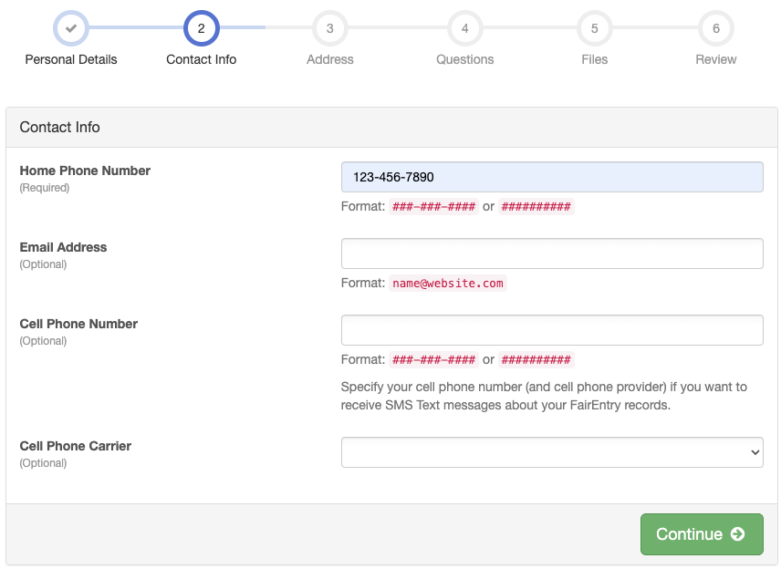
- Address: This step is important.  - If you pay premiums at your fair that will need to be sent to each exhibitor, you will need to enter their REAL address on this screen.  - If no premiums will be paid (or mailed), then this is not important and you can enter the fair’s address or a “fake” address.  - Click Continue | 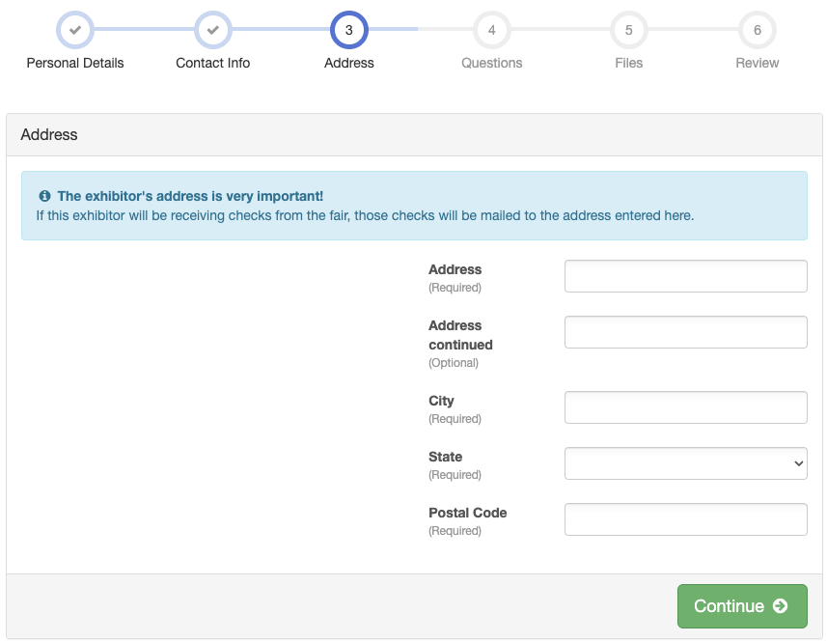
- If there are custom fields set up at the fair level, answer any of those that are required, then click Continue.  - If there are custom files set up at the fair level, upload any required files.  - On the Review screen, you can Edit info if it is incorrect, or click Continue to Entries. | 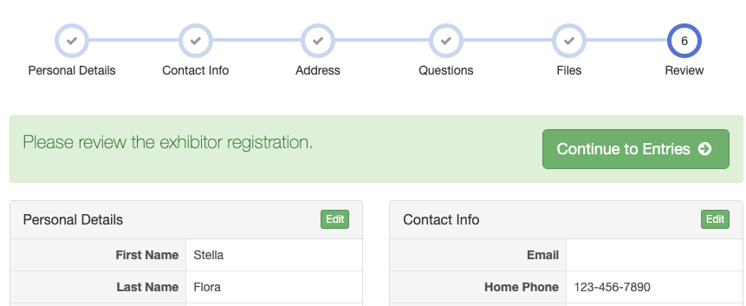
- Beside the current exhibitor’s name, click Add an Entry.  - This takes you directly to the department/division selection process.  - Classes will be listed in multi-entry format, allowing you to choose multiple classes within the division at one time if that is necessary.  - When you have selected all the classes for that division, click Continue and Create Entries.  - If there are more entries for this exhibitor in a different division, click Add an Entry again and repeat the process until all entries for this exhibitor have been entered. | 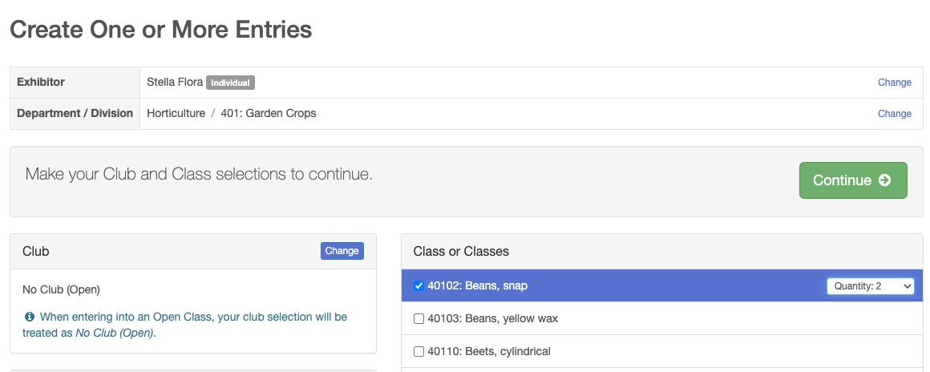
- When all entries for this exhibitor are entered, click Register another Exhibitor to enter the information for the second exhibitor in the same way.  - When you have completed all entries for all exhibitors, select “Continue to Invoice Review”.  Note: To avoid having extremely long invoices, which may take some time to process, you should limit these to about 10 or so exhibitors per invoice before submitting and starting with a new invoice. | 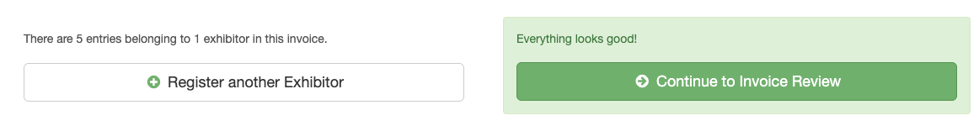
- The records on the invoice will be approved automatically.  - When you have reviewed the entries, click Submit.  - After you submit the invoice, click “Back to invoice search”, where you can begin a new invoice, using the same “family” information, for any remaining exhibitors.  REMINDER: This process should only be used for “free” (no-cost) entries, not for invoices that would need payment information, even though the screen prints of examples show payment info. | 