Online Auction – Manager Setup
After members have submitted their entries, they may edit their approved entries to add additional information for the auction including a video URL and an Auction narrative. These items will be visible to the buyers during the online auction. Entries should be checked in (if you need a weight) and marked for Auction (Sale Participation Status), the buyer list uploaded/added and the sale order should be created as per usual before following the steps below.

Preparing Buyer Accounts  - Log in to the fair and click on Sale tab.  - Click the Buyers subtab.  - Click to View a buyer. | 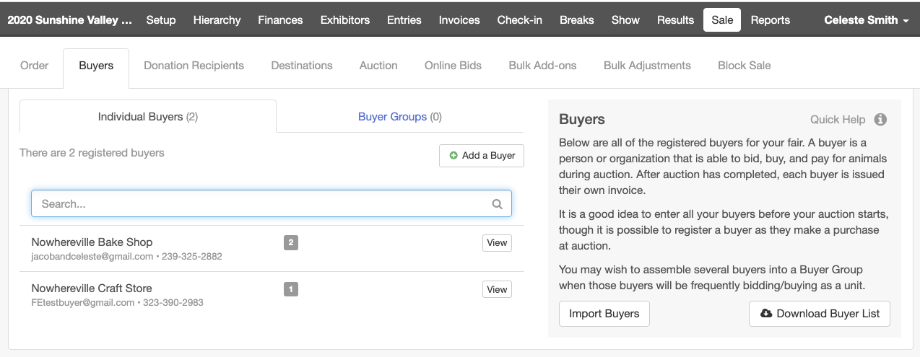
- Click to Edit the Online Account details.  - Select Yes for Allow Login  - Enter the buyer’s login email address.  - Click Save.  - The buyer will receive an email with their login information. | 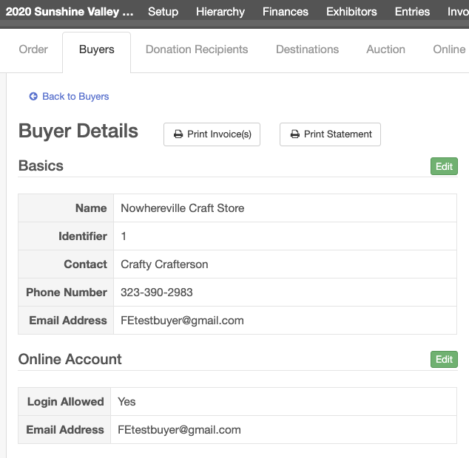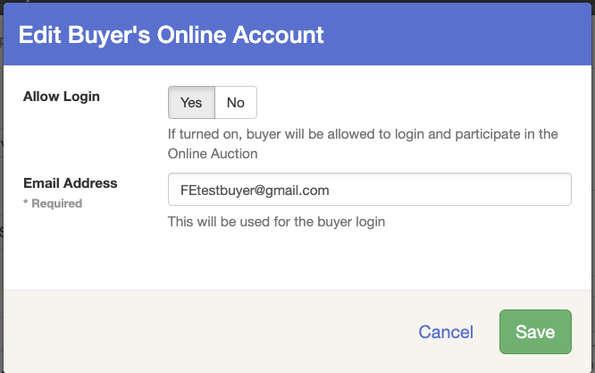
Preparing the Auction  - Click on the Sale tab and the Auction subtab.  - Select to View your Auction.  - Click Edit next to Online Auction is turned OFF.  - Select to Enable Online Auction (ON)  - Enter the Start Date and End Date.  - Click Save.  NOTE: The auction will begin at 12:01 a.m. CT on the Start Date and end at 11:59 p.m. CT on the End Date. If you would like to start and end the auction at a specific time, simply set the Auction Start Date to the Current Date to start the Auction immediate. Set the End Date to the previous day to end the auction immediately. | 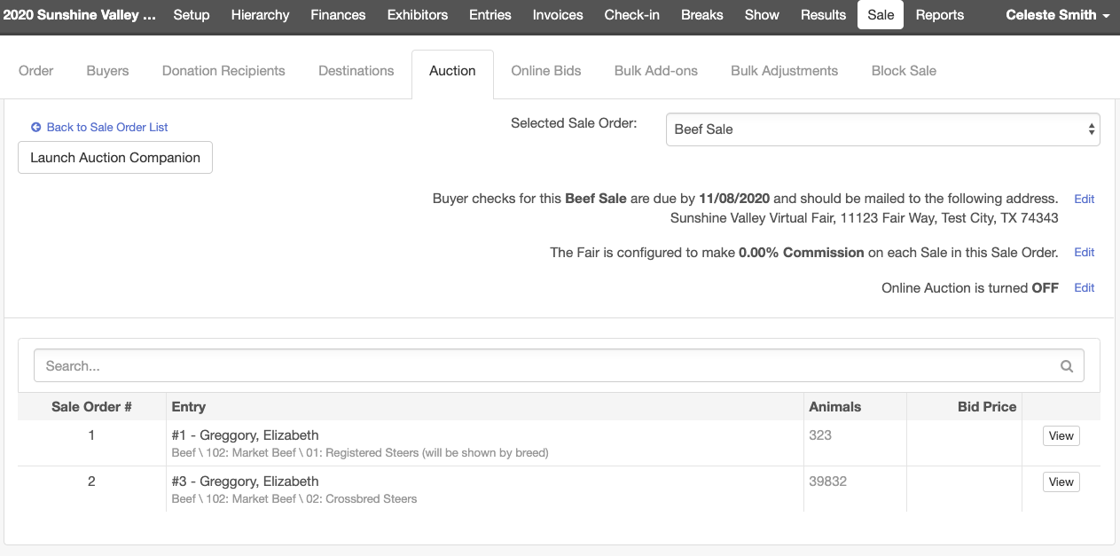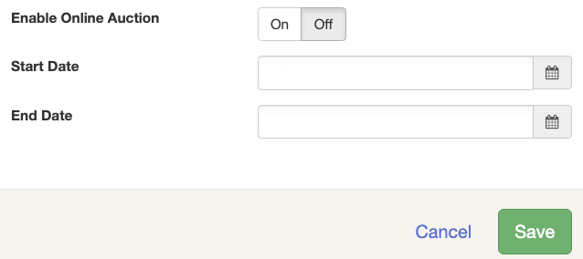

Bidding in the Online Auction – Existing Buyers
Instructions for Buyers  - Go to your Fair’s FairEntry site.  - Enter the login information you received via email from FairEntry (sent when your fair set up your buyer account). Do not use the 4-H Online sign-in option, if available.  - Click Sign In.  NOTE: If you forgot or would like to reset your password, click Forgot Your Password. | 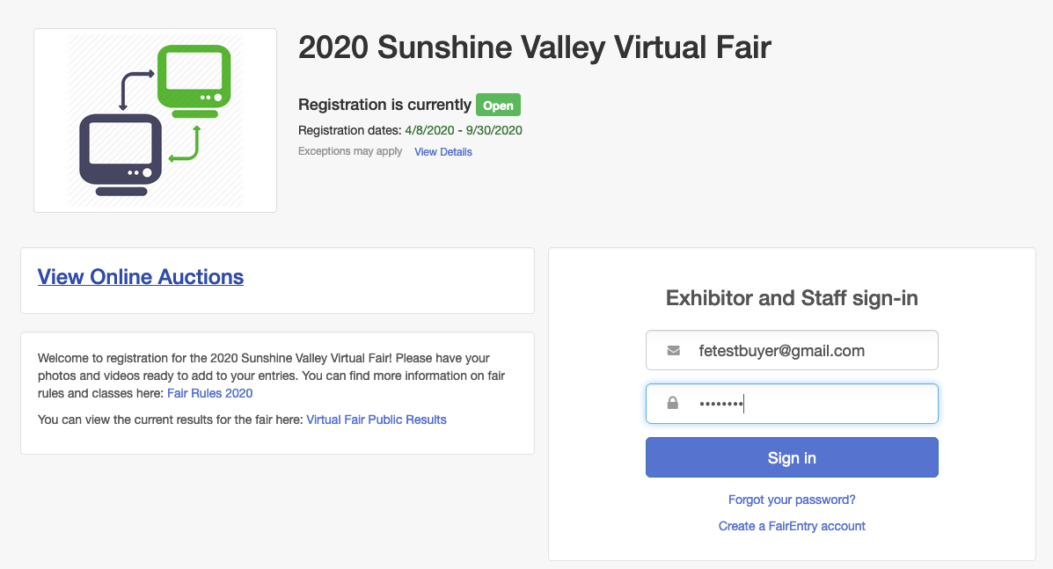
- Select the Auction you would like to view (if your fair has multiple auctions).  - Click View Details to enter a bid for an auction item. | 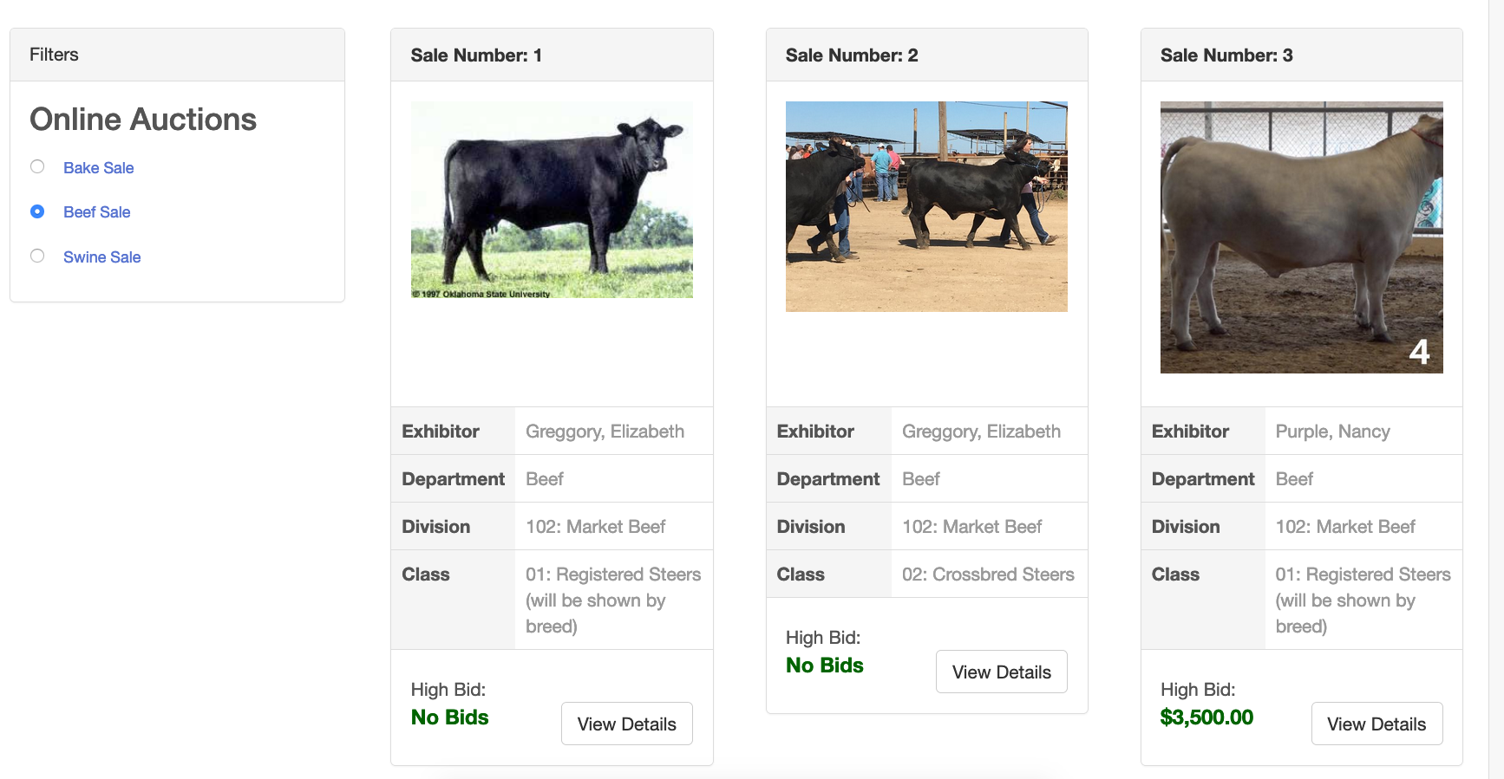
- You may view the exhibitor’s video, photos and introduction.  - Enter your bid and/or add-ons.  - Click Back at the top of the screen to select another item. | 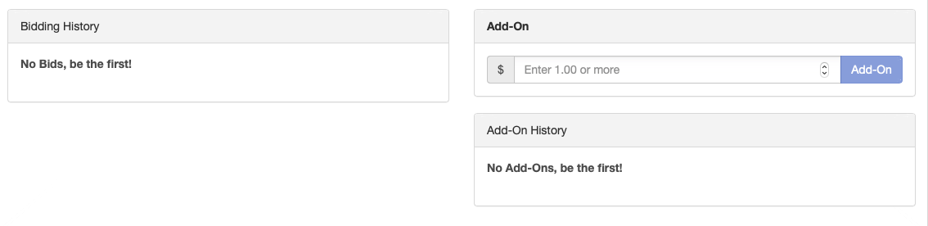  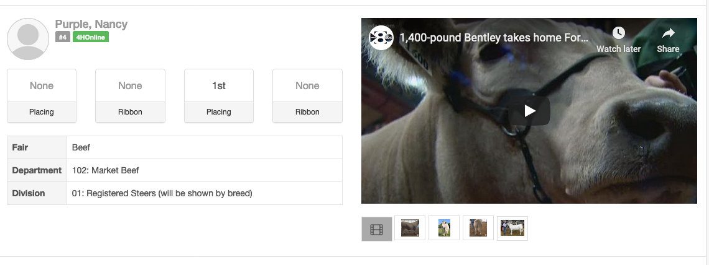

Bidding in the Online Auction – New Buyers
Instructions for Buyers
- Go to your Fair’s FairEntry site.
- Click View Online Auctions.

- Click Sign Up to Bid.  - Enter your Email Address, Account Name, Phone Number and create a Password.  - Click Create Account. | 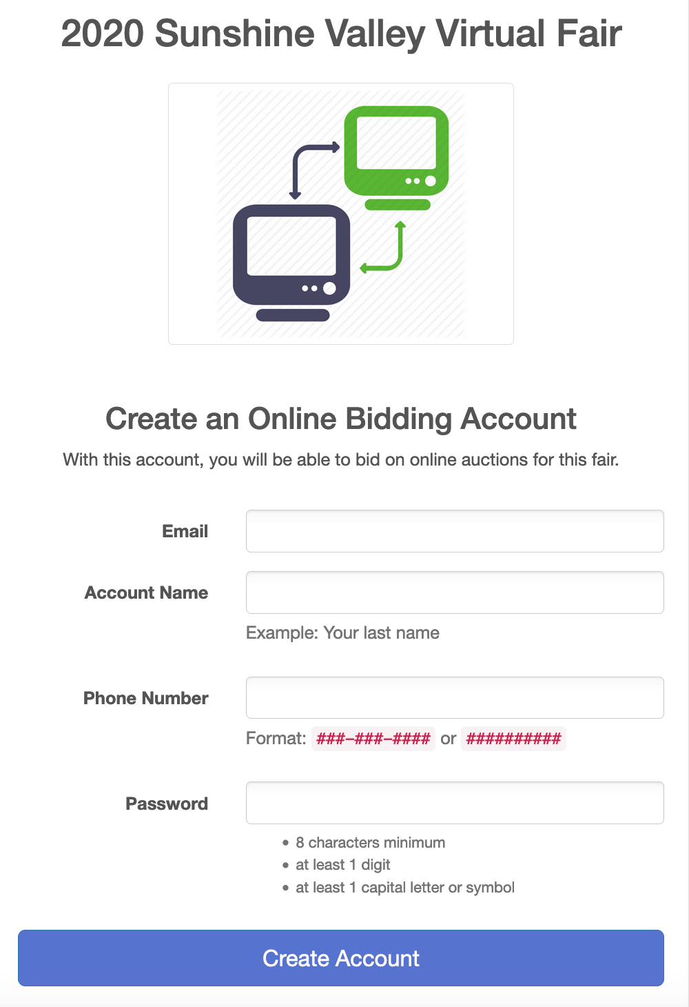  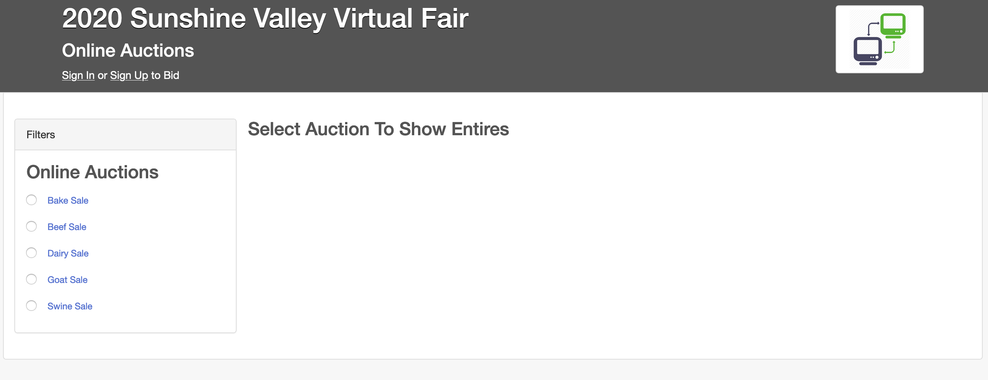
- You will be redirected to the login page for your fair.
- Enter your newly created buyer account information (Email Address and Password).
- Click Sign-In.
- Select the Auction you would like to view (if your fair has multiple auctions).
- Click View Details to add a bid or add-on for an auction item.
- You may view the exhibitor’s video, photos and introduction.  - Enter your bid and/or add-ons  - Click Back at the top of the screen to select another item. | 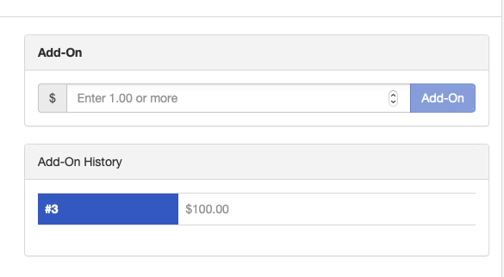

Paying for Your Purchase
After the Online Auction has closed, your Fair/Sale will need to accept the highest bids on each item and finalize the Sale. (You can pay for your add-ons at any time.) If you would like to pay for your purchases online, provided that your Fair/Sale has chosen to accept Credit Card payments, follow the instructions below.
- Go to your Fair’s FairEntry site.
- Enter the login information for your buyer account.
- Click the blue Sign-In button.

Click the Make Payment button. | 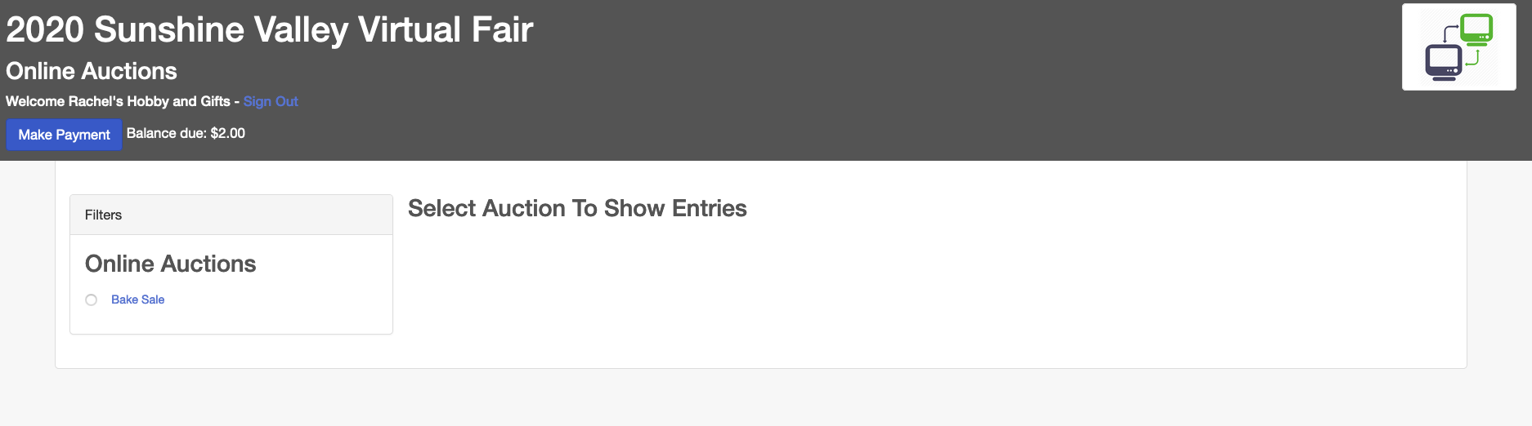
You will see Buyer Payment summary. Click Continue  If you have any questions about this total amount, contact your Fair/Sale office. | 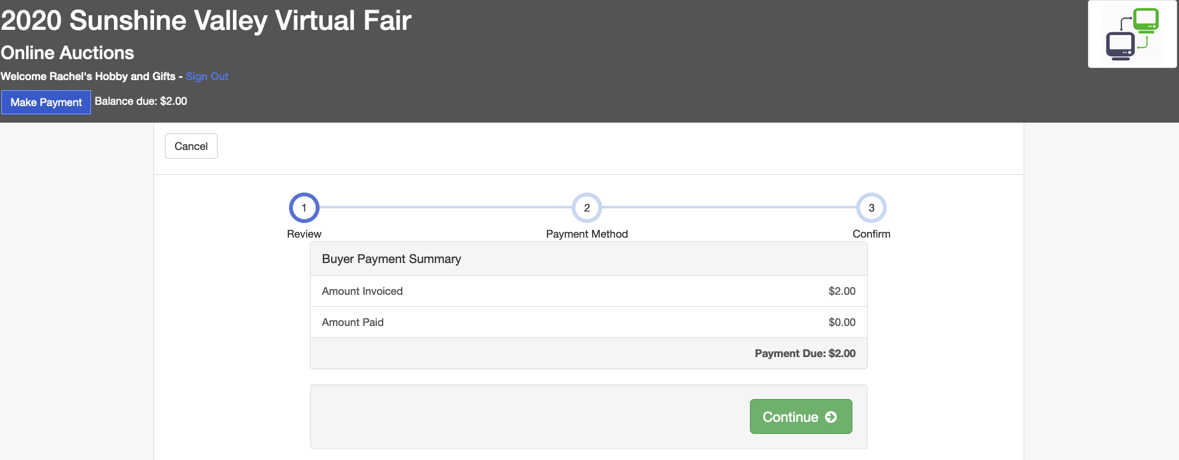
- Click the Add Credit Card button.  - Enter your credit card details.  Click Save. | 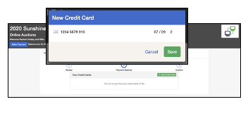
The credit card will be added to your list of payment methods.  Click Continue | 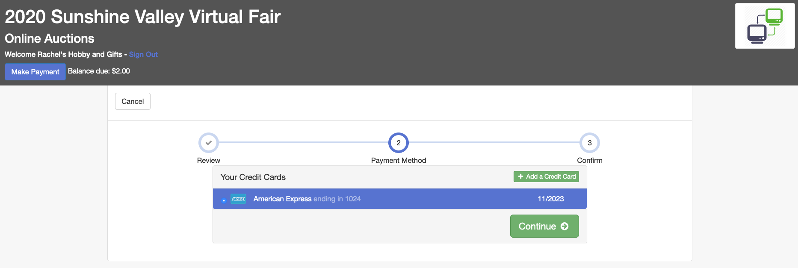
Click Submit. | 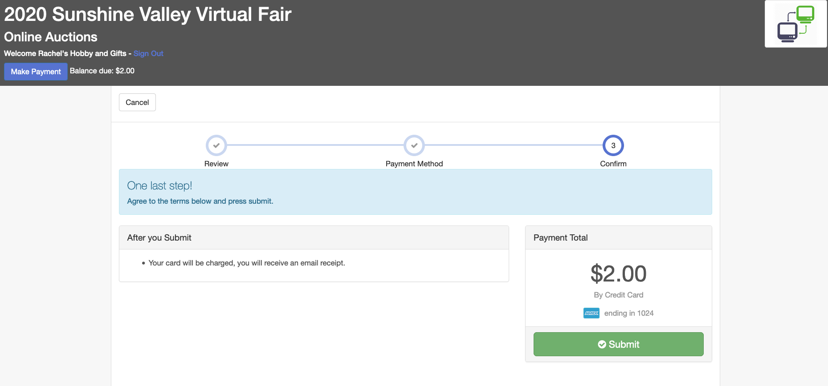
You will receive an email receipt confirming your payment.  For a detailed receipt, please contact your fair office. | 