Animal Entry Check-In

Note: This process can be used for individual non-animal entries, although there is a quicker way to check in all (non-animal) exhibits for one exhibitor—see the Bulk Check-in section for more details.
- Click on the Check-In tab.  - If you are using a scanner, click in the search box first, then scan the entry barcode.  - If you are not using a barcode scanner, enter the Entry Number or Exhibitor Name in the search box.  - If no additional check-in information is needed, click check-in.  - If additional check-in information is needed, enter the required information (weight, etc.) and click check-in. The ADG will be calculated when the weight is entered. It’s calculated using the beginning weight/date and check-in weight/date. If you need to adjust the Check-in Date, you can do that.  - Animal Entries—if an animal has been entered in multiple classes (for example, horses), you can check in all classes for that animal on this screen. (This option is located below the Check-In button.)  - Sale Participation and Virtual can be edited on this screen as well.  - If needed, click View All Entries for this Exhibitor to view a list of all of the exhibitor’s entries with their check-in statuses. |  | 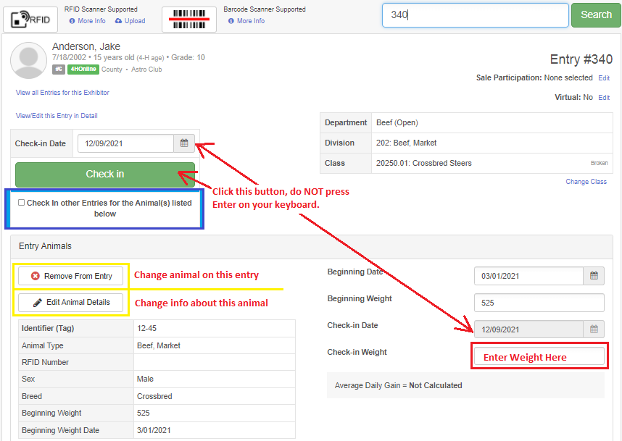
How to edit animals at check-In  - Click Edit Animal Details to change any of the animal’s information (often used in cases where an ID tag has been replaced).  - Edit the information and be sure to click Save Changes. |  | 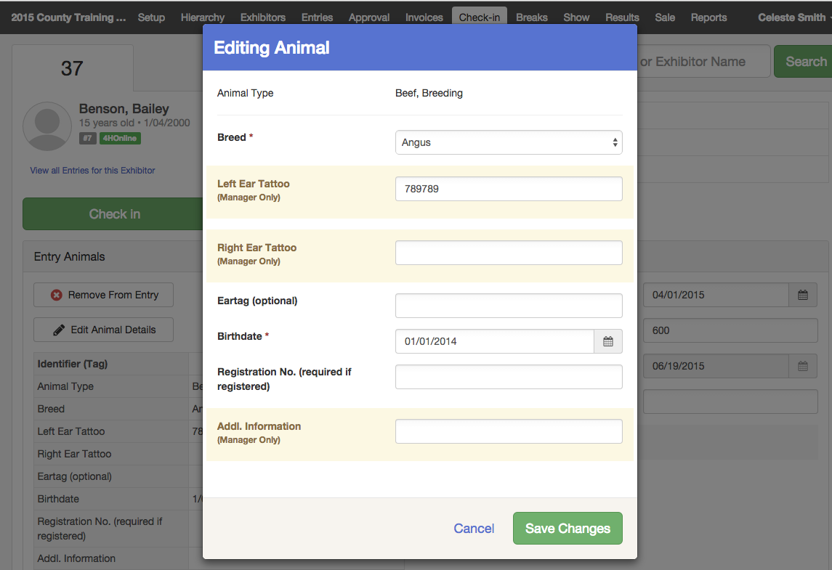
How to change the animal on an entry  - Click Remove from Entry to remove the existing animal.  - Click Add Animal to add the new animal.  - Select Add Existing Animal to choose an animal from 4-H Online or one that has been created in FairEntry. The 4-H Online note in green indicates 4-H Online animals.  - Select Create a New Animal to add a new animal that has not been previously created. | 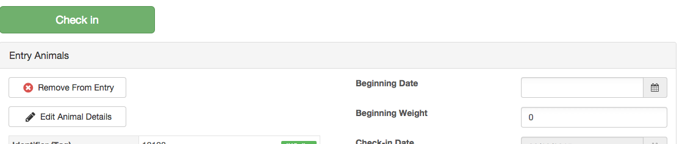  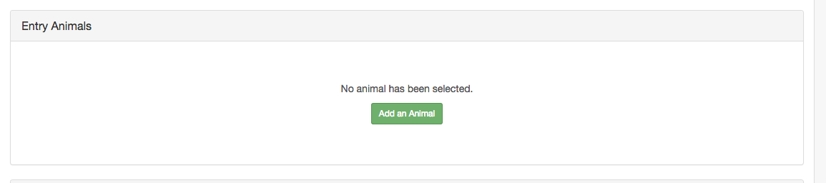  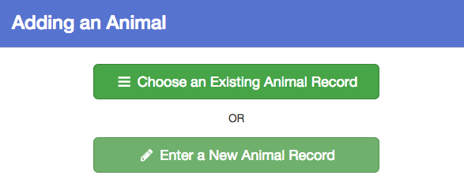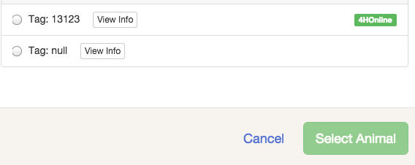
How to process entries that have been checked in, but will not show (Will Show status)  - If the entry is checked-in, the program automatically marks the entry “Will Show.”  - To change the “Will Show” status, either  - select the option “View/Edit this entry in Detail” on the Check-in screen, or  - click on the Entries tab and search for the entry, then View the entry.  - At the top-right of the screen is the Checked In and Will Show status (along with Sale Participation and Virtual). Click Edit to change the Will Show status to “This Entry will not show”.  - Click Save.  NOTES:  - The Will Show status is available on Custom Reports and can be used to filter out entries that will not show.  - The Will Show option is not checked for entries that are not checked in. | 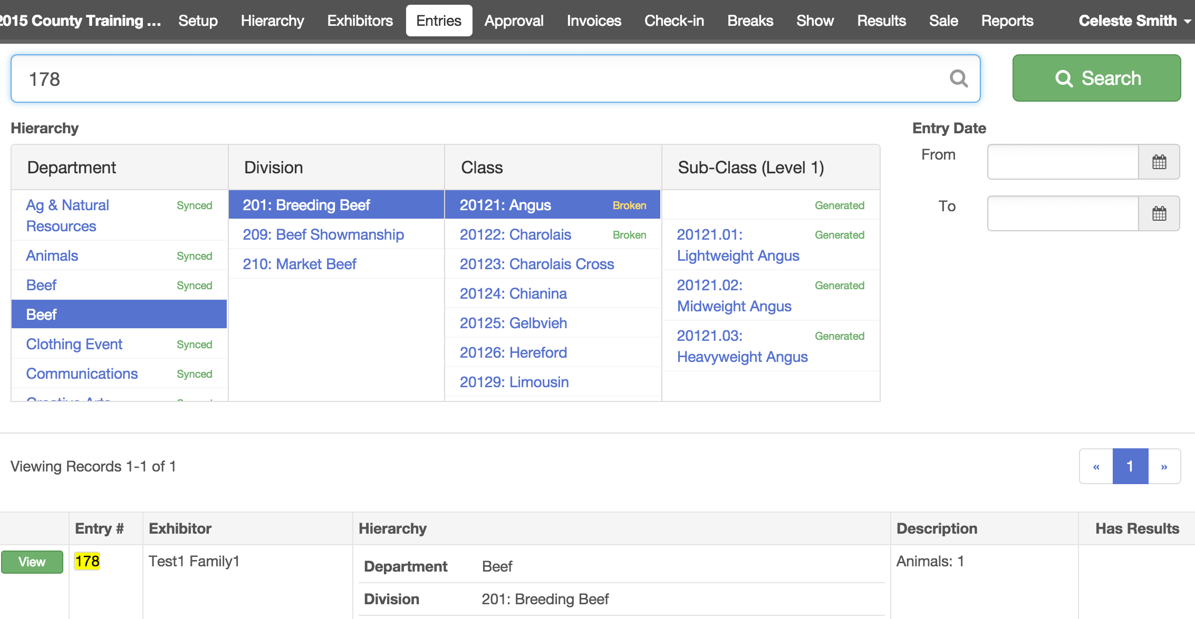  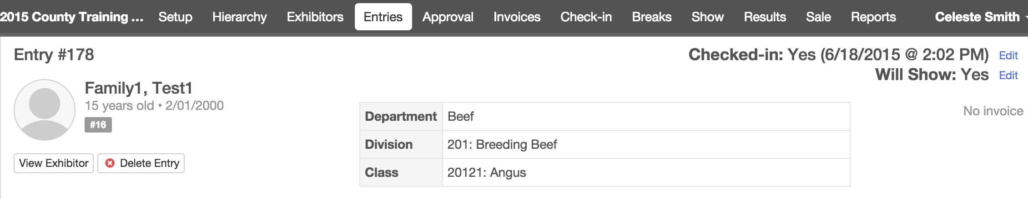  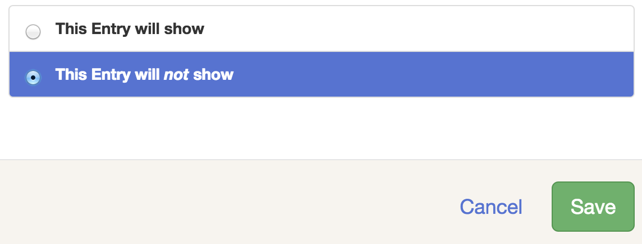

How to Change a Division and/or Class for an entry:  - From the check-in or entry screen click Change Class (blue link under the hierarchy list on the right). | 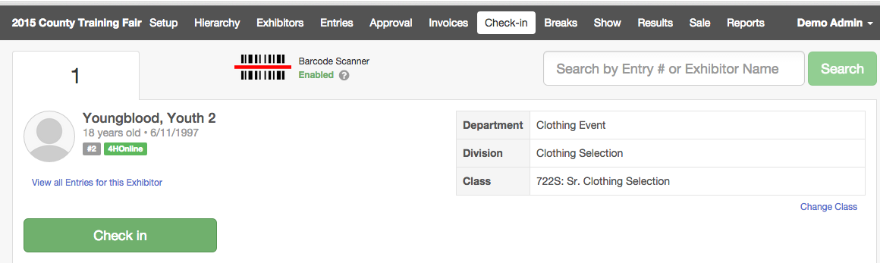
- Select the new Division and/or Class from the hierarchy.  - Click Save.  NOTE: When you move an entry to a different class or division, you may lose Custom Field selections and results for that entry, if those were assigned to the original class selection, but not the new one. | 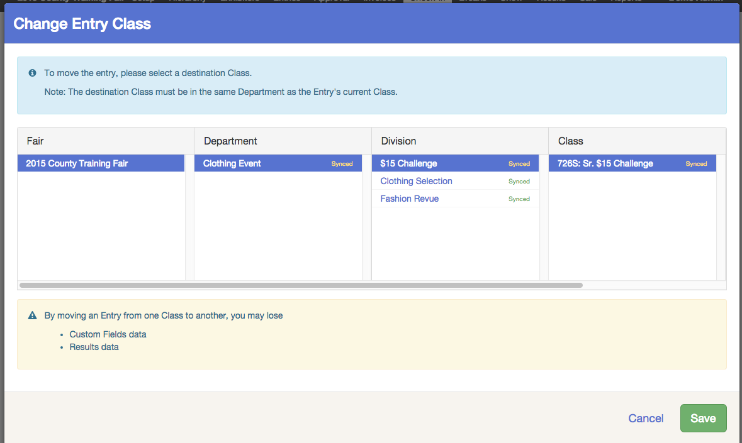

Will Show Bulk Updater
If you have entries to check in, but no additional information is required at check-in (ending weight, etc.), you can quickly mark many entries as “Will Show” at one time as an alternative to the check-in process. This could be done for dogs, horses, poultry—anywhere that no extra check-in information is required.

- Click on the Show menu, and then the Will Show Bulk Updater tab.  - Select a division or class for entries to be updated. | 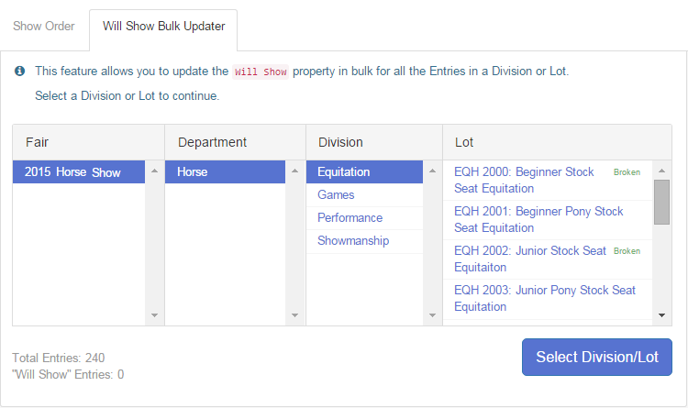
- All entries in the division/class will be listed, along with the entry number and the animal identifier, if it’s an animal division or class.  - Select specific entries, or use the Select All (or De-select All) buttons at the bottom of the screen.  - When the correct entries are selected (checkbox), click “Mark Selected as Will Show”.  Note: The red “will not show” button is to be used as an undo or quick status update when the entry was originally marked as “will show”. Using either of these buttons DOES NOT change the status of un-selected records.  - If you mark some in error, or if the entry status changes from “Will Show”, you can select them and change them to “Will Not Show” using the red button.  - If you have used the “regular” check-in process, and entries are removed from the show after being checked in, you can use the red button to change their show status, or you can go back to the entry (on the Entries menu) and change the show status there. | 