Class Breaks
Before you Begin:
Entry Class: The original class in which the exhibitor submitted the entry (listed as Class in the hierarchy).
Sub-Class: A subset of the entry class that can be broken in to smaller sub-classes and/or show classes (created from the Hierarchy Editor and available for exhibitor entry). Example: In the Breeding Beef Division, you have a Heifer Class. The Heifer Class has 2 sub-classes: Open Heifers and Bred Heifers. The exhibitor would know at entry time which Sub-class was the correct one to enter.
Show Class: Sometimes known as the “ring class” - the lowest/smallest class in which the entry will show (created by breaking classes/sub-classes). Show classes are NOT available to be broken further. Example: In the Market Beef Division, you have a Market Steers Class (no Sub-classes). The steers are broken by weight after they are checked in and weights are recorded. At entry time, the exhibitor would enter the Market Steers class, and their Show Class would be determined at the fair, based on Class Breaks.
NOTES:
- Only will-show entries are available to break into classes. (either checked in or marked will show)
- If you have a class that has defined sub-classes on the hierarchy, you cannot break the CLASS (because it already contains sub-classes), but you can break the first-level sub-class into show classes. Basically, what you break has to be at the lowest level of the hierarchy.
Steps:  - Click on the Breaks tab.  - Select a Class or Sub-class from the hierarchy to break in to show classes.  - Click Select Class.  Note that in the lower left, there is Entry Count—the number of checked-in entries in that class. | 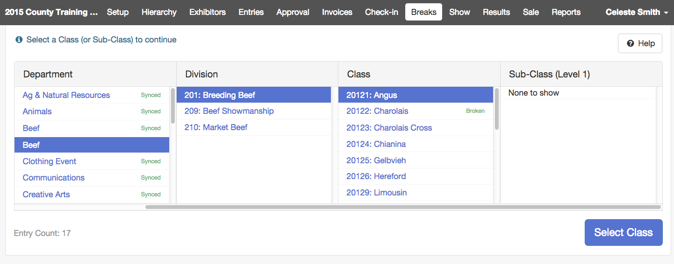
- First sort/break – Sub-Classes: Break by Animal Breed or Animal Sex (Those fields are part of the Animal record). Defaults to Yes with options not selected, effectively No.  - Second sort/break within those Sub-Classes: Show Classes: Break by Animal Check-in Weight, Animal Check-in Height, Animal Birthdate, Exhibitor Birthdate, Exhibitor Grade. If you use more than one criteria, click the arrows at the right drag to arrange the sort order.  If you use only 1 breaking strategy (either the Sub-Classes or Show Classes), the entries will be distributed into Show Classes 1 level deep.  If you use both breaking strategies, the entries will be distributed into Sub Classes that are then distributed into Show classes (2 levels deep).  - Select either the number of classes desired OR the number of entries in each class. (One of these two must be selected.)  - Select all Checked In, or only Will Show, and Virtual/In Person options if necessary. | 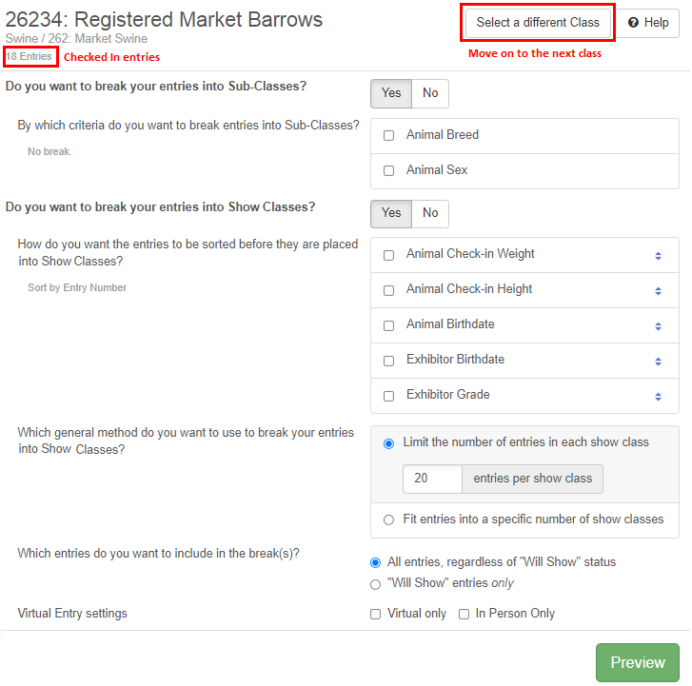
Examples
- Animal Breed and Animal Check-in Weight (5 entries per class): A class that contains 9 Angus steers and 13 Simmental steers would be broken into 5 show classes—two classes of Angus steers (light and heavy) and three classes of Simmental steers (lightest, medium, and heaviest).
- Animal Check-in Height and Animal Check-in Weight: The classes would be arranged with all the 46” animals listed in order of weight, then the 46.5” animals listed in order of weight, etc.
- Animal Check-in Weight and Animal Check-in Height: The classes would be arranged with all the 1100-lb. animals listed in order of height, then the 1105-lb. animals in order of height, etc.
- NO Sub-Classes or Show Classes criteria, only 10 entries per class: Divides the class into show classes of 10 each, sorted by entry number. This is basically a random class assignment, although exhibitors with more than one animal will likely be sorted into the same show class. They can be manually moved after you apply breaks, however.

- When you have your criteria selected, click Preview.  - Review the potential breaks. (You may have to scroll down to see them at the bottom of your screen.)  - Show class numbers default to the Entry Class Number followed by .01, .02, .03… to indicate the show class.  This is the quickest place to change the Show Class numbers or names if you wish to do that. They can also be changed after you have completed the breaks by going back to the Hierarchy menu, and using the Hierarchy Editor tab for each class/show class.  Tip: If you want your classes to show up in standard Show Programs in a different order than they now appear on screen, change the number of the show class to reflect the order that you want.  - You may move the entries into different sub-classes (columns) after the break has been saved.  - Click Apply Break(s) to save the breaks. | 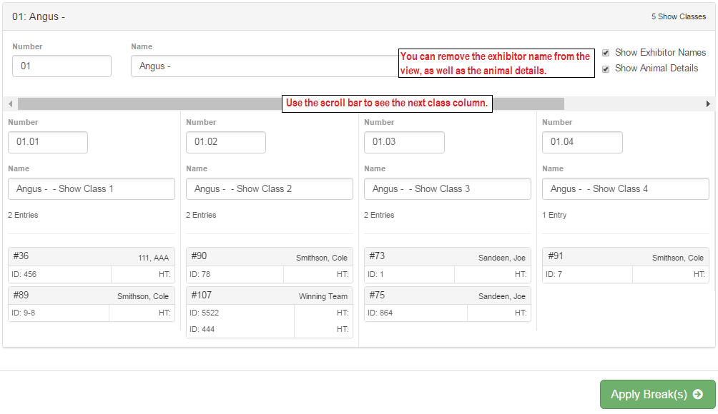  You can select to have the name visible/not, as well as animal identifier/info. Removing the animal info shortens the “blocks” to one line.
- At the top of the screen, you will briefly see a green message: “Breaks Saved”.  - Changes on the screen:  - No editing of show class names/numbers  - Range of sort criteria (smallest to largest) at the top of each column.  - A drop-down arrow on each entry. Click on this icon to move individual entries into different show classes (columns). Since entries to be moved are typically the first or last ones within the class (for weight, the lightest or heaviest), they move to the bottom of the previous class or top of the next class.  - When you are finished, click on “Select a different Class” to move on break another class. If you are completely finished, use the menu bar at the top to move on to your next task. | 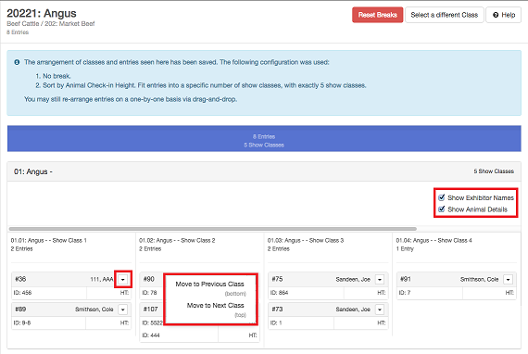  The entries stay on screen in the order they appear in the columns, but that is not the order in which they will appear in show programs unless Show Class order is selected when the Show Program is created. Show programs can be changed to order within classes by any other entry field (weight, height, etc.)
Tips
In the standard Show Programs, the order will be by Entry Class (order set on the Show menu), then numerically by the Show Class Number (if you remove the “.01” etc. numbers, they will be ordered alphabetically), and finally within the show classes by one of four options (on Standard Reports): Animal Birthdate (ascending, oldest to youngest); Animal Height (ascending, shortest to tallest); Animal Weight (ascending, lightest to heaviest); and Exhibitor Name (alpha).

In Custom Shows, you can include/arrange your classes by any means you wish, as well as determine the sort order within each class. For example, you may have broken your class by weight, but you wish to have the exhibitors in each show class ordered by their exhibitor number, not by the weight of the animal being shown. Or you may wish to have your classes ordered by animal birthdate descending (youngest to oldest) instead of ascending (oldest to youngest).

Class breaks are saved and can be re-arranged at any time by selecting the broken class from the Hierarchy under the Class Breaks tab. You can also start fresh on the breaks by using the red Reset Breaks button at the top right of the breaks screen.

If an entry is checked in or marked “Will Show” after class breaks have been saved, you will need to determine which show class is appropriate for that animal, and designate that show class on the entry. The other option is to Reset the class breaks for that class, and start over, including the new entry in that process.

