Approving Entries and Payments
Before You Start
After families submit their entries to your fair, they must be approved before they become active. Additionally, if there are fees associated with your fair, cash or check payments (not credit cards) must be recorded and verified.

NOTE: If you have turned on the option to bypass invoice approval of entries and payments made by credit card, the entries will be automatically approved. You must still approve invoices, entries and payments made by check/cash.

Approving Entries  - Click on the Invoices > Awaiting Approval menu.  - On the approval screen, there is a list of submitted invoices. Click Review next to the invoice/entries to be approved. (Note that the invoices are listed by family name, not by individual. More than one family member may be included on the invoice.) | 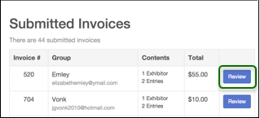
- On the Invoice review screen, there is a 1) Invoice amount (link) – click on the amount to view the invoice details, and 2) Approve drop-down option next to the exhibitor’s name and also next to each entry for that exhibitor.  - You can Approve or Reject all of an exhibitor’s entries (next to their name), or Approve or Reject a specific entry (next to the class).  - In most cases, you will select Approve next to the exhibitor’s name.  - Click View next to their name or class entry to show specific information for that exhibitor (answers to fair-level questions), or that entry (department questions, animal ID info, etc.)  - If you Reject an entry, a message option will appear in pink. Type in a specific message for the family with the error that needs corrected.  - When you have reviewed all entries, scroll down and Submit Approvals/Rejections. | 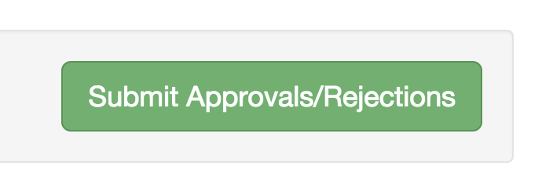  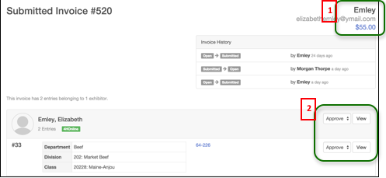

- If you reject an entry and Submit, an email will be sent to the exhibitor containing the message you typed in the pink section. The exhibitor can login, make the correction and re-submit, at which time the amended entry/exhibitor can be approved.
Approving/Recording Payments  (If fees are associated with entry to your fair)  After an entry has been approved, payment details must be entered (confirming payment received if it wasn’t submitted via credit card).  - Click the Invoices menu, Pending Check Payment tab. Search by Exhibitor if there is a long list.  - Click View next to the exhibitor/family whose payment you are recording.  - There is a Print Invoice button under the Invoice number. It may be important for you to print that invoice, either to attach to a check, or as a record of the entry/payment. If it is, print it before you enter payment details. | 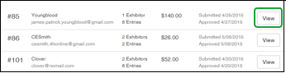  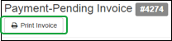
- On this screen, you can view a Summary of the money owed per exhibitor or view a Detail report of the entry & fees. Select the links for Summary or Detail in the Invoice title bar to view those. | 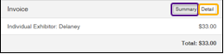
- After you have reviewed the invoice, click Add Check Payment to enter payment information. Enter the check number in the top box, amend the amount and date if necessary. Add notes to explain any unusual payment circumstances. **For cash payments, enter 0000 in the check number box, and note “cash” in the Notes box.  - When you are finished, Save Check Details. | 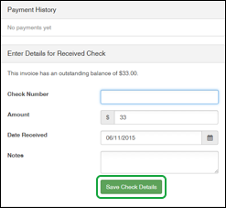
Tips
- After invoices have been approved, families will be able to login to FairEntry and create additional invoices (entries). They are not able to do that while the previously-submitted entries are Pending approval.
- Invoices can also be printed from the Invoices-Search screen, regardless of their payment status. Click View beside the appropriate invoice, and then on the details screen, the Print Invoice button is at the top of the screen.

